Toy Engineer Design Task

Scenario:
Congratulations! You have been hired by the Build-A-Toy Company to design, test, refine, and fix toys that incorporate batteries and moving parts such as motors, lights, and sounds. The toys you design will be sold on Amazon for children across the world to enjoy. It is important that all the toys designed by the Build-A-Toy Company work correctly so the children who buy the toys have a lot of fun.

Your new boss has asked you to be a part of a design team that will build a toy camera that will use flashing lights for young children to pretend to take pictures. However, the flashing light on your first design is not bright enough.


Photo by Tanaphong Toochinda on Unsplash

Use your knowledge about energy flow and circuit design to answer the following questions using the key ideas you and your team will need to make the flashing light brighter on your camera.

Part A:
A1: Before making the flash brighter, your team decides to think about how the current prototype of the camera works. Your team’s camera uses a battery, wires, a switch, and a light bulb that lights up. Draw and label a diagram to show how these materials work in your current prototype.

Use the symbols provided in the key below in your diagram.

Use the following symbols in your diagram
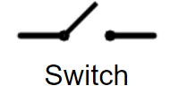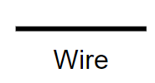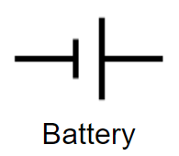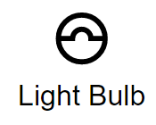

A2: How does your diagram help to explain why the prototype of the camera works? Use words from the word bank below in your explanations.
Word Bank
Battery
Wires
Open Circuit
Flash Bulb
Connect
Power Source
Closed Circuit
Switch
Speaker
Light
Energy
Flow
Energy Transfer

Part B:
B1: A teammate wonders how they could make the flash shine brighter when a pretend picture is taken. Draw a model or write to explain what you would change to make the flash brighter?

B2: Explain to your teammate why you think this change will work to make the flash brighter.

Part C:
The Build-A-Toy Company owner has asked to see the different prototypes the team has designed. Your team needs to make sure all the parts of your camera work together before your boss looks over the different designs.

Oops! You tested the four designs below and none of them work!

Redesign two out of the four designs below and write on the models to show how you would solve the problem before you show your boss.

Option 1: Draw your redesign over the diagram.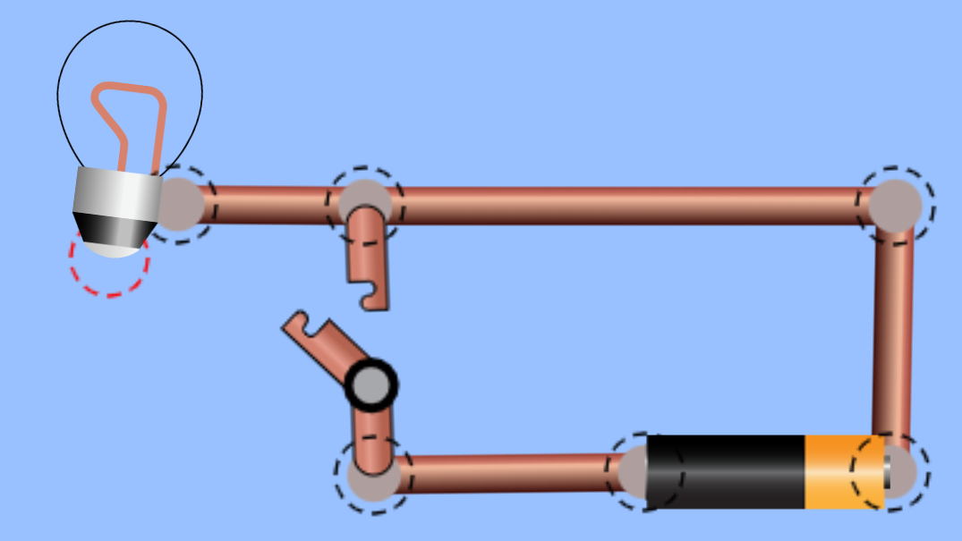 | Explain why the prototype will not work… ________________________________________________________________________________________________________________________________________________________________________________________________________
Option 2: Draw your redesign over the diagram.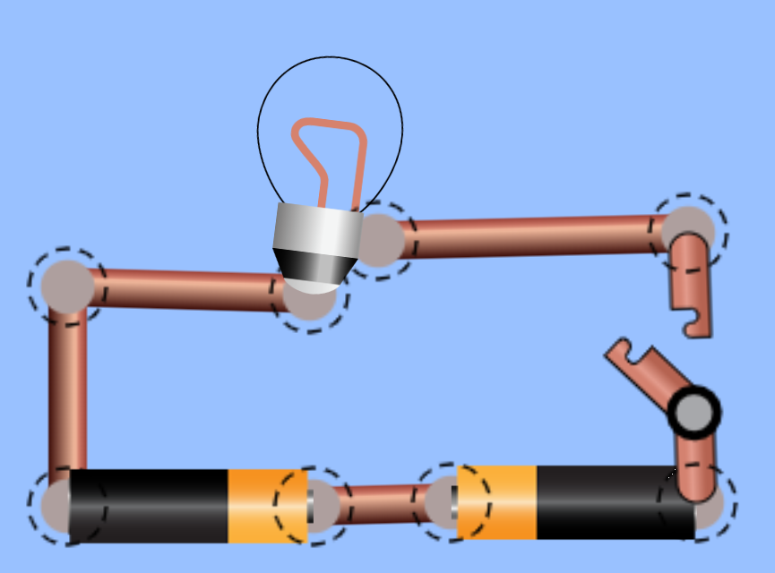 | Explain why the prototype will not work… ________________________________________________________________________________________________________________________________________________________________________________________________________
Option 3: Draw your redesign over the diagram.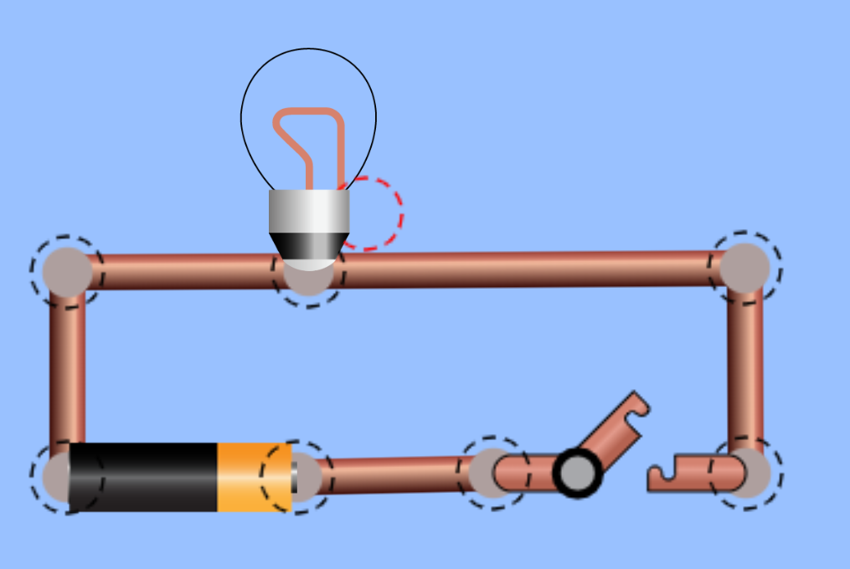 | Explain why the prototype will not work… ________________________________________________________________________________________________________________________________________________________________________________________________________
Option 4: Draw your redesign over the diagram.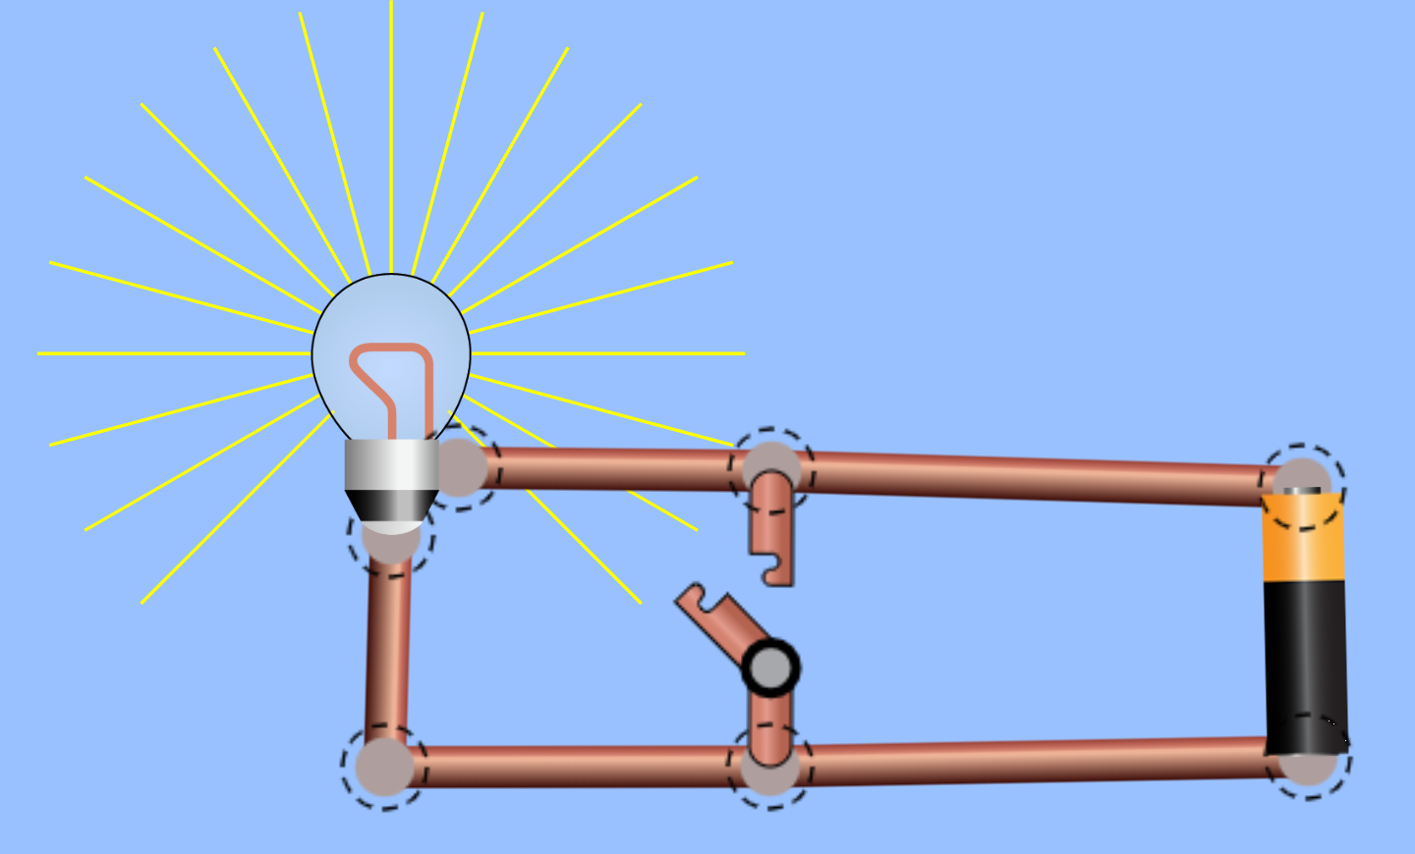 | Explain why the prototype will not work… ________________________________________________________________________________________________________________________________________________________________________________________________________

