Evolution of Swallows
In the 1970's along the I-80 highway in Keith County, Nebraska, drivers started noticing large numbers of dead swallows on the road. This led to a 45-year long study on swallow roadkill to figure out why this was happening.
Cliff Swallows traditionally built their nests on vertical cliff faces. However, with the expansion of roads, they have adopted many bridges, overpasses, and culverts as their colonial nesting sites. Their nests are grey or brown with openings at one end. Cliff Swallows zoom around in complicated aerial patterns to catch insects for food.
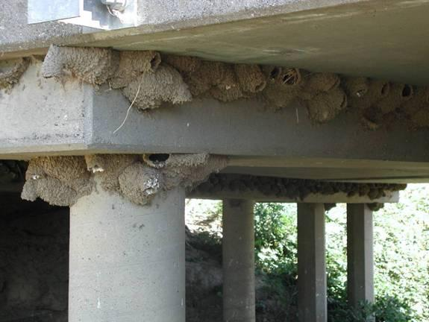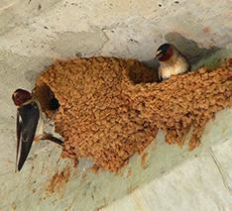
Image source: http://www.cell.com/cms/attachment/2021743115/2041577164/gr1_lrg.jpg
Source of data: Brown, C. R., & Brown, M. B. (2013). Where has all the road kill gone? Current Biology, 23(6), 233-234.

Question 1. What do you think are some of the challenges for cliff swallows living in this new environment that did not exist before the highway was built?
Nests are now near roads, so cars get in the way when Cliff Swallows are trying to catch insects and hit and kill the swallows.

Question 2 Short Answer Version. The table below shows some disadvantages and advantages of shorter and longer wings for bird flight. Consider the kind of flight the cliff swallows who live under highway bridges might need to get food from the road.

Do you think birds with longer wings or shorter wings are more likely to have an advantage that allows them to survive better in this new environment? Explain your answer.

Longer wings | Shorter wings
- Require less energy to use because there’s less drag  - Harder to change directions quickly, turning is slow  - Take off speed is slow | - Require more energy to use  - Easier to change direction quickly  - Allow birds to take off quickly

Shorter wings so they can dodge cars when hunting for insects.

Alternate Multiple-Choice Version
Birds with which wing length are more likely to have an advantage that allows them to survive better in this new environment?

a) Shorter wings, because they allow swallows to take off quickly after getting food.
b) Shorter wings, because there is more drag on their wings.
c) Longer wings, because they require less energy for flight.
d) Longer wings, because they can fly farther with them.

Question 3. As shown in the picture above, cliff swallows use human-made structures like bridges and overpasses as nest building sites.
Complete the table below using the pattern of data in the graph to explain what is happening in the cliff swallow population from 1984 to 2012. Note: Wing length is a heritable trait.
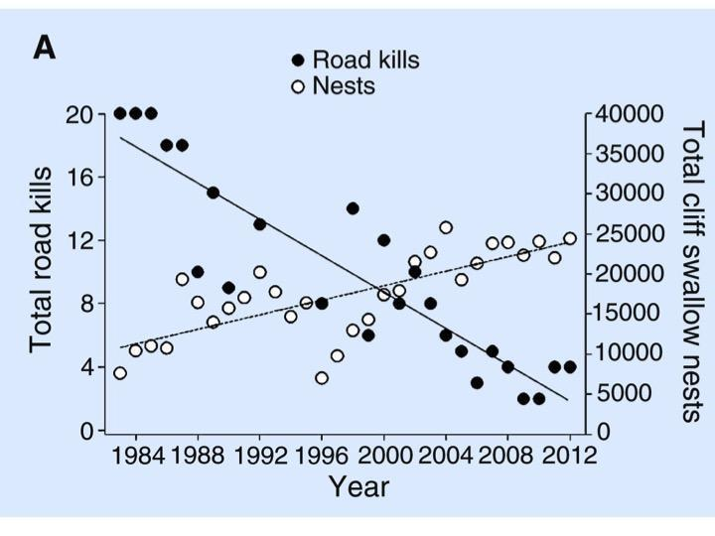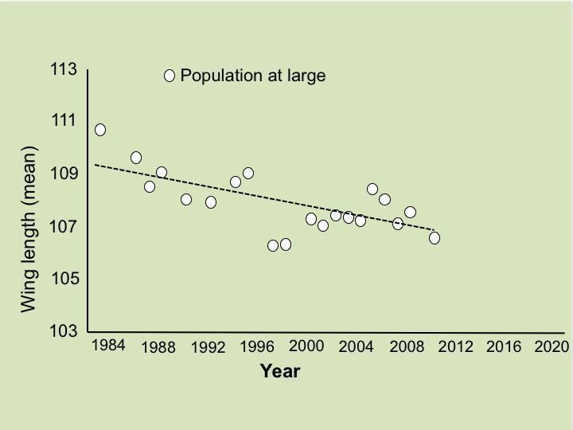
In chart A, The Y axis on the left side shows the total number of swallows killed by cars (road kill). The black dots show the number of swallows killed each year from 1984-2012. There is a second Y axis that shows the total number of cliff nests. The white dots show how many nests were observed each year from 1984-2012.

Question: | Your answer:
1. What is happening to the average wing length over time? | Choose one correct answer:  - Individual swallows’ wings are getting shorter.  - The proportion of swallows with shorter wings is increasing in the population.  - Individual swallows’ wings are getting longer.  - The proportion of swallows with longer wings is increasing in the population.
2. Describe the survival advantage of shorter versus longer wings for cliff swallows. Support your answer with a pattern you observe in the data. | Swallows with shorter wings are more likely to avoid getting hit by cars because they can move out of the way and change directions more quickly. The charts show the average wing span is getting shorter over years, and the number of road kills is also decreasing.
3. How could the total road kills go down, as the nests are going up? (Nests are something scientists use to estimate the size of adult swallows surviving long enough to reproduce.) | The charts show the average wing span is getting shorter over years, and the number of road kills is also decreasing. The number of nests is increasing, so we know the number of road kills going down isn’t because of fewer nests – thus, it may be because of the shorter wing spans.
4. What about the environment contributes to a change in the average wing length in the cliff swallow population over generations? | Those with longer wings are more likely to get hit by cars (because they turn directions more slowly), so they are more likely to die before reproducing. Because wing length is an inherited trait, swallows with short wings are more like to survive and reproduce, creating a bigger population with short wings.
5. What is the role of natural selection in explaining the change in average wing length in the population over generations? | Natural selection means the qualities that are helpful for survival are the qualities that allow an animal with those qualitive to survive, reproduce, and pass on. Short wings help swallows survive, so those are the qualities that pass on.

Question 3. Draw a dot on the chart below to indicate what you predict the average wing length will be in 2020. How did you estimate where to place the dot? What do you assume in the environment was changing or staying the same in the future?
I assume roads will either stay the same or increase

