The Pennsylvania Science, Technology & Engineering, Environmental Literacy Sustainability (STEELS) Assessment Foundations Toolkit
Facilitation Guide for Module 3:
Cultivating a System Where Assessments Work Together to Improve Student Learning
In 2022, Pennsylvania adopted the Science, Technology & Engineering, Environmental Literacy Sustainability (STEELS) standards, new learning goals for K–12 students based on research of how students learn best. The three professional learning modules in the STEELS Assessment Foundations Toolkit are designed to support participants in building a foundation in how to monitor and further student learning of Pennsylvania’s 2022 STEELS standards. To see an overview of the toolkit modules and goals, click here.
This document provides facilitation guidance for Module 3, which supports participants in building an assessment culture that focuses on how different types of assessment work together to improve student learning, not just check a box.

Table of Contents
Module 3 Description page 2
Goals page 3
Language Considerations page 4
Materials Required and Preparation page 5
Module 3 Overview page 7
Key Icons in Facilitator Guide page 10
Detailed Professional Learning Leader Notes page 11
Module 3 Evaluation Sample Questions page 38

Module 3 Description
Title: Cultivating a System Where Assessments Work Together to Improve Student Learning
Module 3 Description: In this session, participants will learn about using data from assessments to inform teaching and support learning, how assessments guide over a unit, and how assessments work together toward different purposes.
Timing: This session is designed as a 6-hour session with the following components:
- Opening: Introduction to the STEELS Standards and Module 3 (10 minutes)
- Session 3.1 Using Assessment Data to Improve Learning (1 hour, 25 minutes)
- Session 3.2 Assessments Throughout a Learning Sequence (2 hours, 40 minutes)
- Session 3.3 Different Assessments Working Together (1 hour, 45 minutes)
These time estimates do not include introductions, icebreakers, breaks, or lunch. Professional learning facilitators should incorporate those as needed.
Audience: The audience for this module is K–12 classroom teachers, school leaders, or curriculum coordinators.
Modifications for Different Grade Bands: While the featured lessons in Module 3 are designed for grade 5 students, the activity can provide helpful insights for teachers of any grade band. The purpose of the activity is not to prepare teachers to develop assessments, but to consider how assessments inform teaching and learning.
Prerequisite Knowledge: Participants must have prerequisite knowledge about phenomena/problems, multiple-dimensional learning, student sense-making, and how they look in assessments. This can be accomplished by completing Modules 1 and 2 in this toolkit or through other means. This session builds on that knowledge.

Goals
Module | Goal
Module 3:  Cultivating a System Where Assessments Work Together to Improve Student Learning | Participants develop a common understanding of an assessment culture that focuses on how different types of assessment work together to improve student learning, not just check a box. Just having quality science assessments is not enough — we need to create a culture that supports educators at all levels to appropriately use and know what the research shows is the most effective way to use assessment data.
Session 3.1  Using Assessment Data to Improve Learning | Participants deepen their understanding of using assessment data to improve student learning in meaningful ways.
Session 3.2  Assessments Throughout a Learning Sequence | Participants analyze varied assessment opportunities across time in a learning sequence and how those assessments support our vision for science teaching and learning.
Session 3.3  Different Assessments Working Together | Participants know different science assessments work together for different purposes, uses, and audiences to paint a full picture of student learning.

Language Considerations
- Multi-dimensional: Why “multi-dimensional” and not “three-dimensional”? The STEELS Standards often refer to the three dimensions, including the Disciplinary Core Ideas (DCIs), Science and Engineering Practices (SEPs), and Crosscutting Concepts (CCCs). This assessment toolkit refers to “multiple dimensions” for two reasons: (1) the STEELS includes Technology & Engineering standards, many of which are two-dimensional and include Technology and Engineering Practices (TEPs) in addition to the SEPs; and (2) some quality assessments elicit student learning of two dimensions at a time rather than three.
- Practices: Throughout this document, “practices” are often used broadly to mean both Science and Engineering Practices (SEPs) and Technology and Engineering Practices (TEPs), which are a part of the STEELS.

Materials Required and Preparation

Printouts Needed
Item | Session Needed | Description
Survivors Stranded Student Work Analysis | Session 3.1 | 1 per participant, double sided, stapled
Task Annotation Project in Science: Takeaways, page 2 (optional) | Session 3.1 | 1 per participant (optional)
Using Our Resources Wisely unit, Lessons 1–9 | Session 3.2 | Assign one lesson from the Using Our Resources Wisely unit to each group. Print 1 copy of the assigned lesson from the unit for each group member. Each group will read one lesson, so the number of copies of each lesson will depend on the number of participants.
Assessment Types chart | Session 3.3 | 1 per participant

Resources Needed
Item | Session | Description
Chart paper | All
Sticky notes (any color) | All | 1 stack per table
Green, blue, and pink highlighters (doing activity with STEELS colors) | Session 3.1 | 1 set for every 2 participants
Index cards | Session 3.3 | 1 per participant

Preparation
Item | Session | Description
Vision of Science Learning Chart | Session 3.1 and 3.3 | Vision Chart developed in Module 1; if you did not do Module 1 with your participants, you do not need to present the slides associated with this chart.

Module 3 Overview
Time | Purpose | Content
Opening  10 min | Participants understand the context and need for this assessment toolkit learning experience. | - Overview of STEELS standards  - Overview of toolkit big picture goals and Module 3 goals  - Any other logistics

Session 3.1 Using Assessment Data to Improve Learning
(1 hour, 25 minutes)
Time | Purpose | Content
Vision Reflection  5 min | Participants reflect on their visions of meaningful science teaching and learning and elicit initial ideas about how assessments work together to improve learning experiences. | - Reflect on and define vision for science education (Or refer to 1.1 Vision Chart).  - How are assessments working together to support our vision? How can data help us support our vision? Who are assessments for, and how are they helping to support student learning?
Student Work Trends  65 min | Participants deepen their understanding of the value of student work and analysis as a powerful tool for supporting leaders to make student-centered decisions with assessment data. | - Build on three-dimensional analysis completed in Module 1 and examine a process for using that data to make decisions to improve student learning.
Role-Alike Reflection  15 min | Participants identify potential action steps for roles at different levels in the system based on student data trends. | - Reflect on what different roles can do to improve student learning based on student work analysis data.

Session 3.2 Assessments Throughout a Learning Sequence
(1 hour, 40 minutes)
Time | Purpose | Content
Review Example Unit  75 min | Participants familiarize themselves with sample instructional unit. | - Participants split into reading groups, review lessons, and review (1) how student thinking changes throughout and (2) the targeted learning goals.
Assessment Opportunity Analysis  75 min | Each reading group will review their assigned lesson and gather evidence of short cycle and medium cycle assessment opportunities along the way. | - Participants will identify assessment opportunities and will chart types of assessment, their purpose, and dimensions assessed for each.  - In full group, participants tell the story of assessing student ideas and consider how the assessments support teaching and learning.
Connect to Context  10 min | Participants consider the extent to which these features are reflected in their current science programs. | Participants examine a model of assessment system and reflect on the importance of curriculum-embedded assessments.

Session 3.3 Different Assessments Working Together
(1 hour, 45 minutes)
Time | Purpose | Content
Opening  10 min | Participants consider the purposes of doing science assessments | - Participants consider different perspectives on science assessments and brainstorm purposes of assessments.
Model Analysis  65 min | Participants know different science assessments work together for different purposes, uses, and audiences to paint a full picture of student learning. | - Participants consider the purposes and uses of different assessments.  - Participants develop a chart to compare features of assessment types.
Connect to Context and Reflection  30 min | Participants consider the extent to which these features are reflected in their current science programs. | - Participants reflect on the assessments their students interact with and their features.

Key to Icons in Facilitator Guide
Throughout the following facilitation guidance, you’ll see three icons:

Resource Icon: This icon will appear when the toolkit references or uses a concrete resource that may be helpful for participants following the session. A complete list of these resources can be found in the Resource Folder.

Sense-Making Icon: Based on the research of how adults learn, we know it’s most effective for participants to construct learning and lead the learning with their ideas. Therefore, throughout these modules we want to avoid lecturing or simply providing the “right answer” — we need participants to grapple with the ideas and figure out key takeaways, with help and guidance from the facilitator. This Sense-Making Icon will appear in key moments when participants are making sense of something, indicated those conversations should not be cut or rushed.

Formative Assessment Icon: These are key moments when it may be particularly helpful for you as a facilitator to listen and gain insights about the current thinking of your participants and use them to inform your facilitation moves.

Detailed Professional Learning Leader Notes
Session: 6 hours
Slides 1–8 Opening (10 min)
Slides 9–29 Session 3.1 Using Assessment Data to Improve Learning (1 hour, 25 minutes)
Slides 30–39 Session 3.2 Assessments Throughout a Learning Sequence (2 hours, 40 minutes)
Slides 40–52 Session 3.3 Different Assessments Working Together (1 hour, 45 minutes)

Opening (10 minutes)
STEELS and Module Intro (10 minutes)
Slides | Process
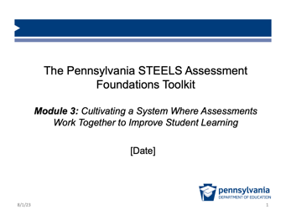 | Purpose of This Section: Engage participants in the goals and overview for Module 3 and prepare for the day’s learning.  Facilitation Step (<1 min):  Welcome participants to the Module 3 session and introduce the facilitation team.
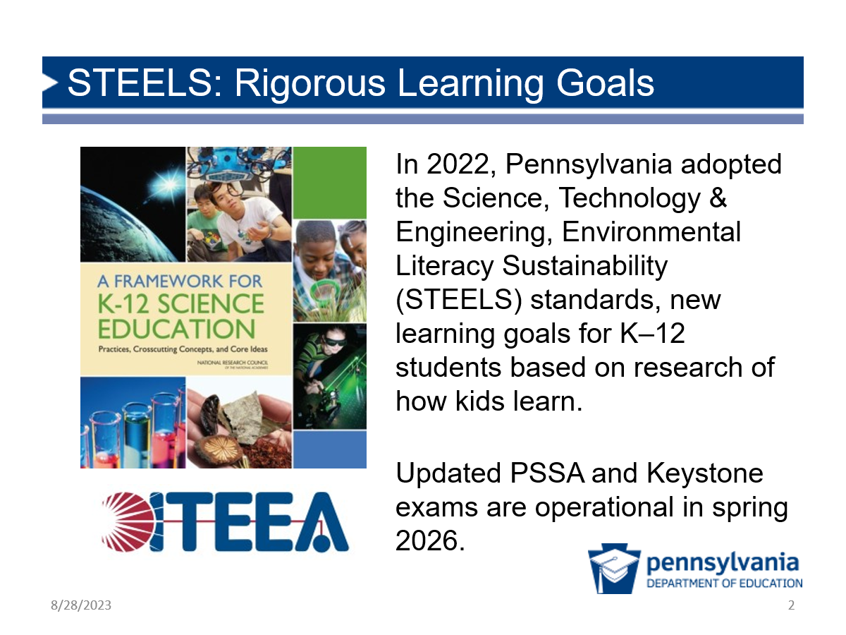 | Facilitation Note: Slides 2 and 3 are repeated across each module. If you are facilitating these modules together, you may choose to skip over these two slides.  Possible Narrative (<1 min):  In 2022, Pennsylvania adopted the Science, Technology & Engineering, Environmental Literacy Sustainability (STEELS) standards. These standards reflect the research about how students learn best.  PSSA and Keystone exams are being updated for the new standards and will be operational as of spring 2026.
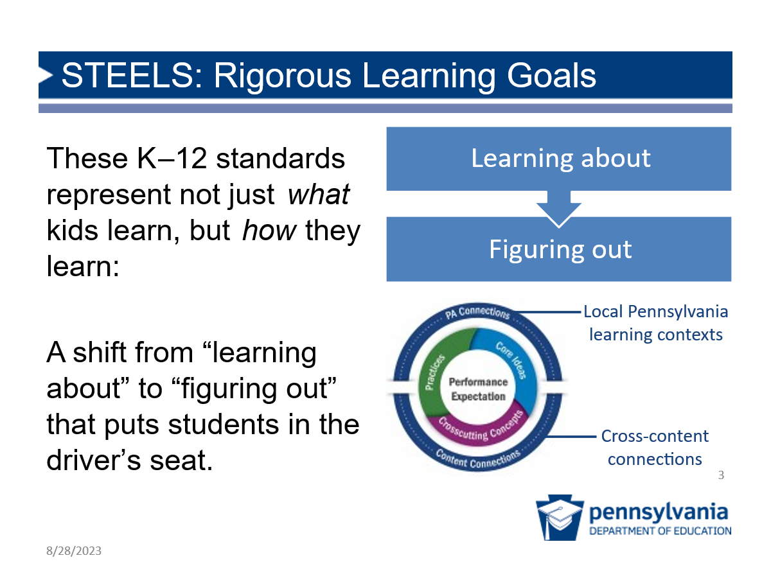 | Possible Narrative (<1 min):  - These K–12 standards represent not just what students learn, but how they learn.  - They offer a vision in which science and engineering instruction and assessments shift from “learning about” to “figuring out” through phenomenon- or problem-driven learning and performance.  - This is a move away from students memorizing disconnected facts; rather, students should be investigating phenomena as they engage in science practices and learn about disciplinary core ideas using crosscutting concepts.  - In addition, Pennsylvania is emphasizing the importance of local Pennsylvania learning contexts and cross-content connections to increase relevance and coherence of student learning.
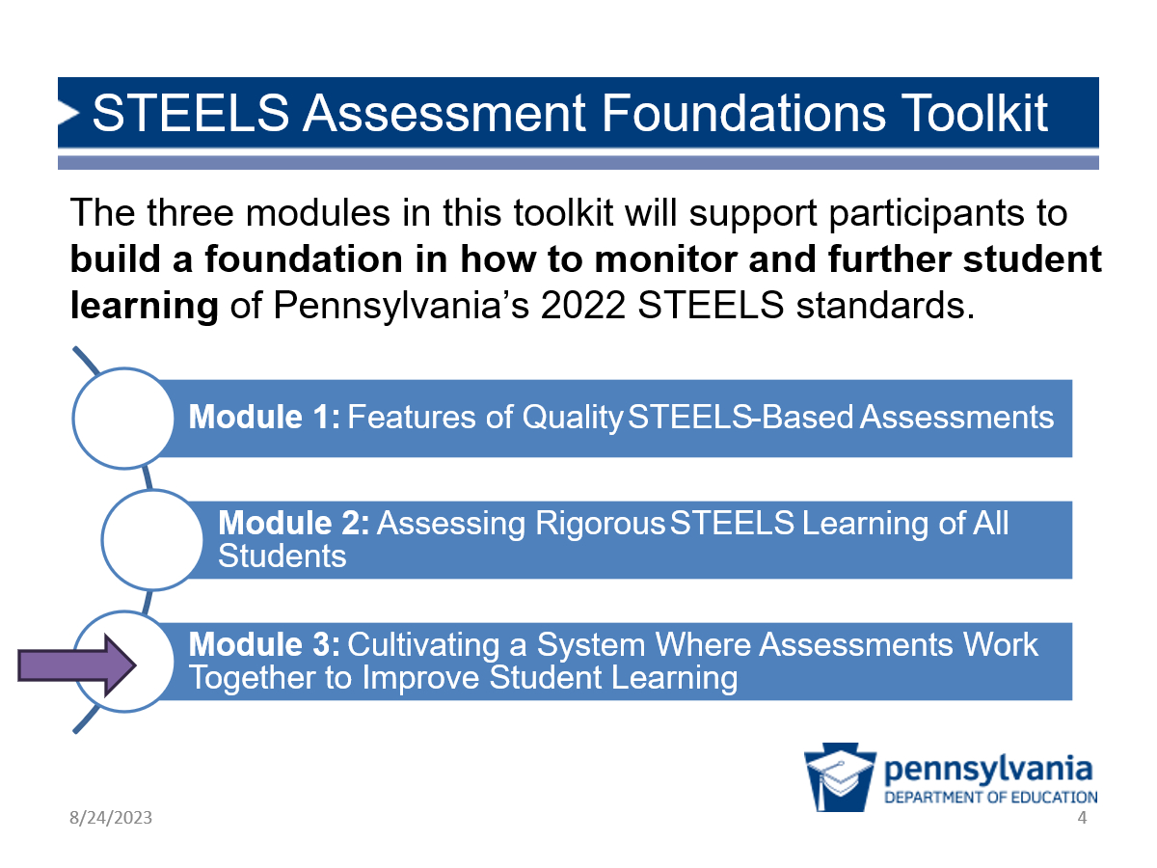 | Possible Narrative (<1 min):  - This toolkit is a professional learning experience that helps us understand the shifts in assessment that will support the Pennsylvania STEELS standards and how we can use assessments for high-quality teaching and learning.  - The first module focused on features of quality science assessments, and the second one built on that to help us consider how assessments elicit learning for all students and hold them to the rigorous expectations reflected in STEELS. In this third module, we will focus on how to create a system of assessments and how that can help to improve student learning.
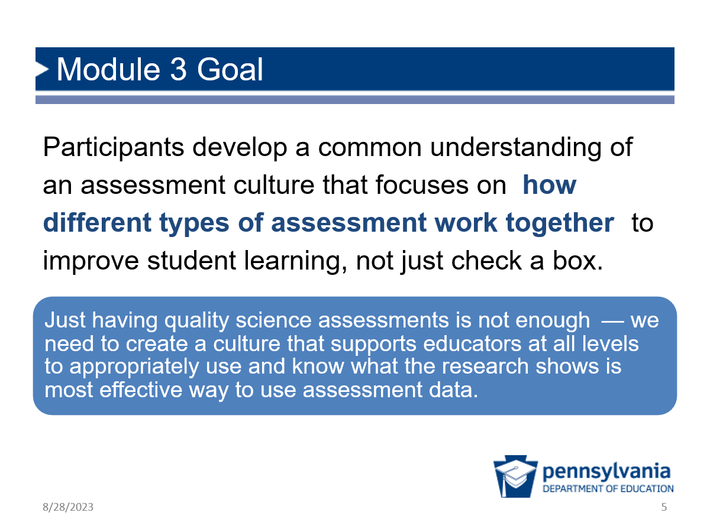 | Facilitation Step (1 min):  Share the Module 3 goal with participants. Highlight any aspects of the goal that you feel are important for your participants.
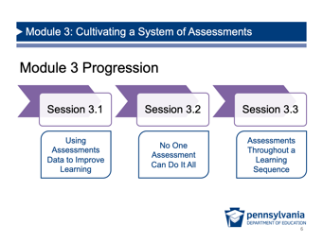 | Facilitation Step (2 min):  Share the progression of Module 3, including a brief description of each session.  - Session 3.1: This session explores how to use data from assessments to inform instruction and improve student learning.  - Session 3.2: This session allows participants to deepen their understanding of how assessments can build throughout a unit to enhance student learning.  - Session 3.3: This session helps participants to consider how to develop a system of assessments and why that is important for high-quality teaching and learning.
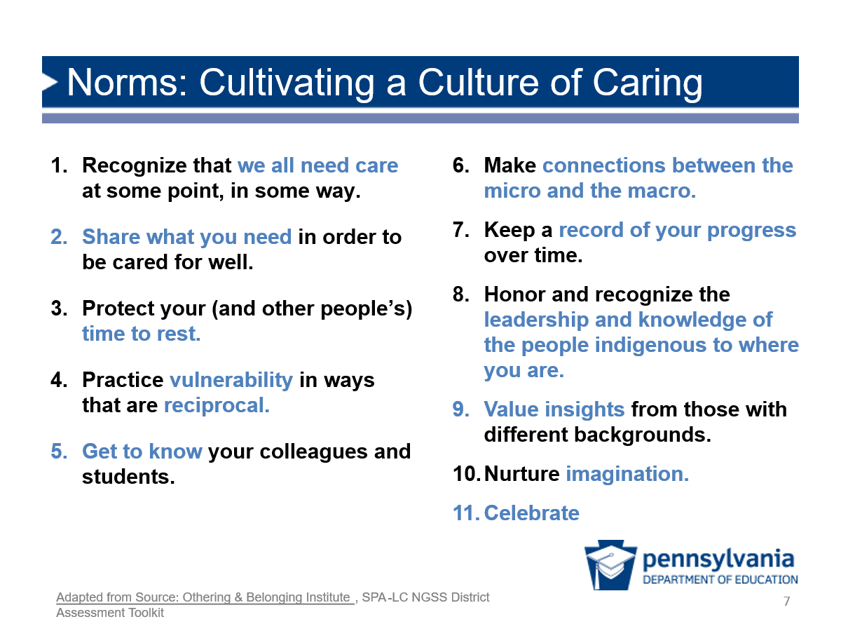 | Facilitation Note: If you have completed Module 1 or Module 2, you may not need to revisit this slide and the following one.  Purpose: This slide is meant to be a relatively quick reflection on caring as a way to frame norms for this professional learning session. In the following slide, we will also talk about what it would mean for assessment to be a “caring practice.”  Possible Narrative (1 min):  - This slide is based on a set of norms, which were developed by UC Berkeley’s Othering and Belonging Institute, which is a group committed to advancing more inclusive, fair, and just practices.  - For our work together to be meaningful and productive, I’d like you to think about what it means to cultivate a culture of caring in our professional learning environment.  - Take a moment to read the slide. While you read, think about what these features mean and how they might support our work together.  Facilitation Step (2 min):  Give a couple of participants a chance to share out ideas with whole group.
Facilitation Note (2 min):
- You may choose to provide a moment for participants to “get comfortable” before diving into this learning session.
- Feel free to adapt this slide or to include any other session logistics here that may help participants to get ready for the session.
Facilitation Step:
Give participants a couple of minutes to get situated and ready for the session.

Session 3.1 Using Assessment Data to Improve Learning
(1 hour, 25 minutes)
Where we are going in this session:
Participants deepen their understanding of using assessment data to improve student learning in meaningful ways.
Where we are NOT going in this session:
Participants may tend to think primarily of PSSA/Keystone exams when the conversation shifts to systems of assessments. Participants should consider all science assessment data, including those from curriculum-embedded assessments, and not just state-level assessments.
Vision Reflection (5 minutes)
Slides | Process
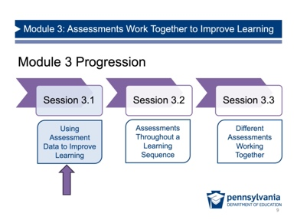 | Purpose of This Section: Remind participants of the vision for science learning and student performance and provide time to revise it if they have new ideas from their learning in previous modules.  Facilitation Step (<1 min):  Share that you are going to get started with Session 3.1.
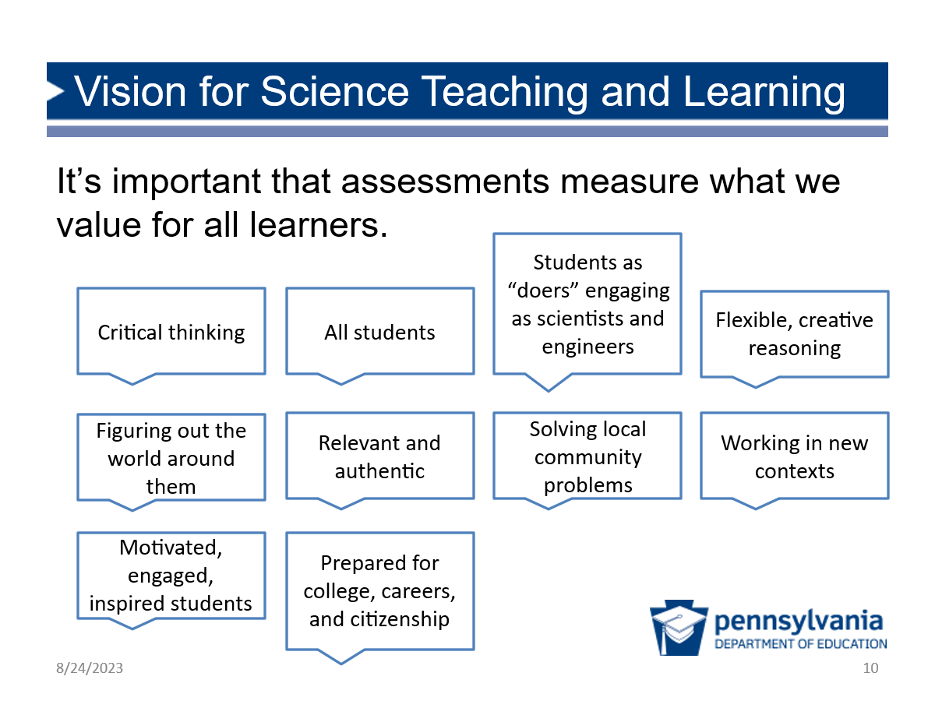 | Prep: If your group completed Module 1 or 2, display any artifacts you have from the Vision for Science conversation.  Vision (5 min)  - If your group has completed Module 1 or 2, remind participants about the vision conversation in the beginning of either of those sessions. Point to any artifacts you have (e.g., chart paper, summary) and invite participants to offer any revisions. Feel free to revise this slide to reflect that previous vision discussion.  - If your group did not complete Module 1 or 2, have them think about their ideal vision for science education, turn and talk with a partner, and discuss what on the screen most resonates with them, why, and what else they’d add/change. Take notes on chart paper as an artifact to point to throughout the module. (5 mins)  Possible Transition Narrative:  We are continuing to work to build a shared understanding of assessments that support this vision we developed together.

Student Work Trends (65 minutes)
Slides | Process
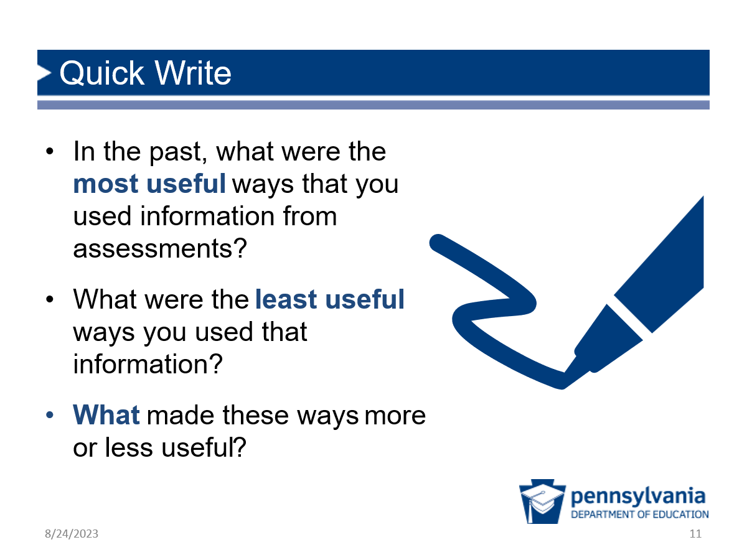 | Purpose of This Section: Participants learn a process to analyze student work for evidence of learning, identifying trends to guide instructional and leadership decisions.  Facilitation Step: (7 min)  - Individual write: Give participants 3–4 minutes to write quietly about the prompts.  - Ask for a few ideas: There are no right or wrong answers at this point, but consider highlighting some ideas if they come up, such as the following:  - Assessments are not useful if they are only used to document attendance or if they are not read.  - Assessments are not useful if they are created solely to have a grade in the gradebook.  - Assessments are useful when teachers and other audiences can analyze them in a timely manner and use data from them to inform next steps.  Formative Assessment. This quick share out is a helpful time to listen for your participants’ current relationship with assessments and the extent to which they are using assessments.
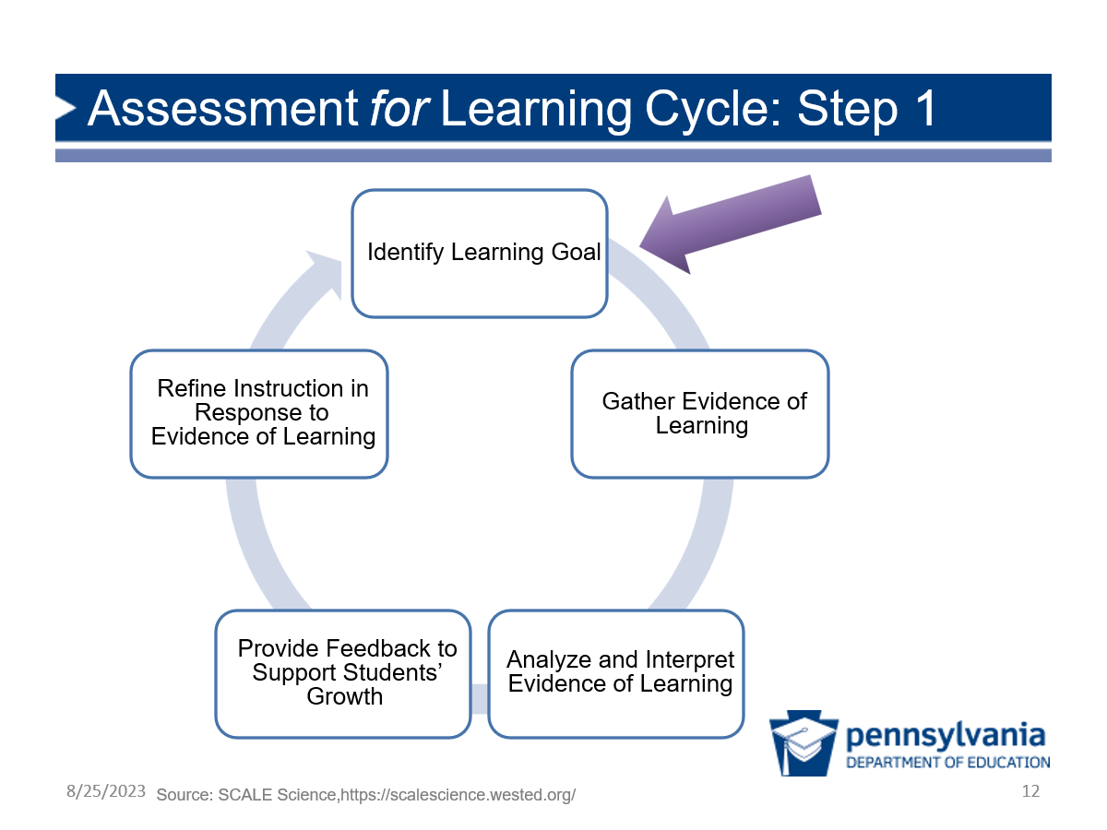 | Facilitation Step (2 min):  - Assessment for Learning description: Share that assessments are most useful when they can be used for learning (i.e., using the assessment data to further student learning in some way) rather than merely assessments of learning (i.e., assessments that are graded, entered as scores in a gradebook and never revisited).  - For example, assessments that support students in developing understanding and support teachers by informing instruction are assessments for learning.  Possible Transition Narrative:  - Assessment for Learning Cycle: In order to have assessment for learning, there are intentional steps that need to be done. In Session 3.1 we are going to take a closer look at how to carry out each of the steps in an assessment for learning cycle.  - Example task and student work: We will use a real, but simplified example task and student work to help us learn more about the kinds of data we can get from a multi-dimensional assessment.  - Introducing Step 1: The first step in the cycle is to identify the learning goal.
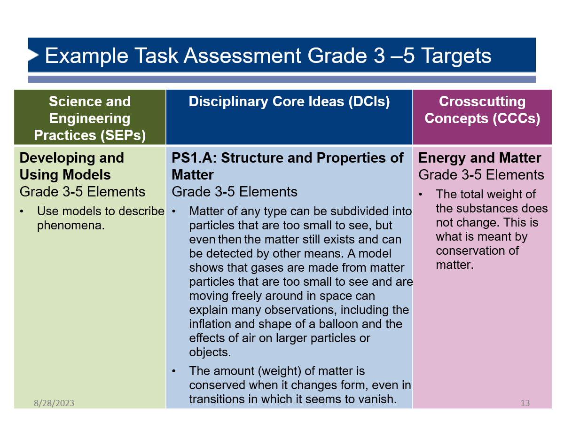 | Prep: Distribute the Survivors Stranded Student Work Analysis handout to participants along with the three colors of highlighters.  Facilitation Step (3 min):  - Survivors Stranded Task:  - If you have done Modules 1 or 2, remind participants of the Survivors Stranded task.  - Share that the Survivors Stranded task will be the one that supports developing a common understanding of the assessment for learning cycle.  - Individual reading time: Give participants a moment to read through the elements of each dimension that the task is meant to address. This can be found both on the first page of the handout or on screen.  - Highlight that the task is meant to assess students’ ability to use models to describe structures and properties of matter, particularly changes in state that affect the movement and conservation of matter in a system.  - Note that these are the targets for the whole task, but participants will only analyze one prompt with just a portion of these assessment targets.  Possible Transition Narrative:  - To prepare us to analyze our performance outcomes, we’re going to look at two example performance outcomes.
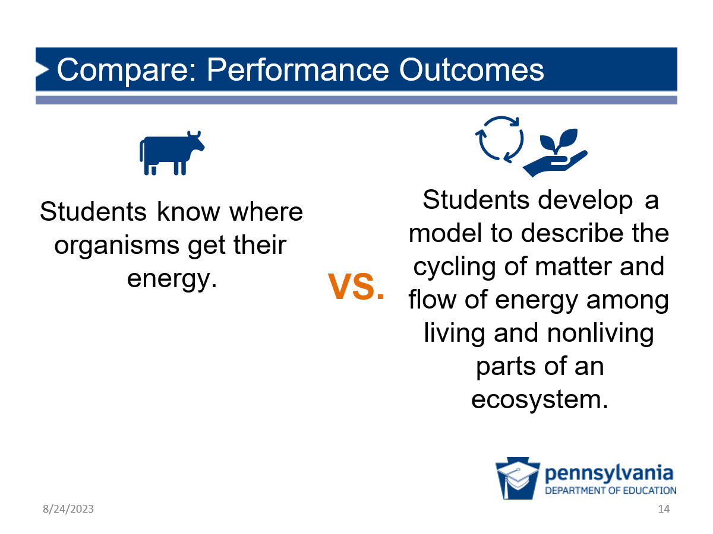 | Facilitation Step (2 min):  - Notice/Wonder: Give participants a moment to read both performance outcomes and consider what they notice and wonder about these two assessment targets.  - Share out: Points to highlight include:  - Multi-dimensional outcome: The left one is one-dimensional, and the one on the right is multi-dimensional. We want to see evidence of students integrating dimensions in assessments, so our target performance outcome needs to integrate the dimensions as well.  - Integration: When we want to see evidence of a student’s ability to integrate knowledge and practice through an assessment, we call it a “performance outcome” — and this is also why Pennsylvania STEELS standards are called “performance expectations.” They represent the integration of multiple dimensions and are the performance we want to see from students.  - No need to focus at this point on the specific dimensions participants may notice in the example prompts.  - Transition: Let participants know they will apply this type of analysis to identify our multi-dimensional performance outcome in their Survivors Stranded task prompt.
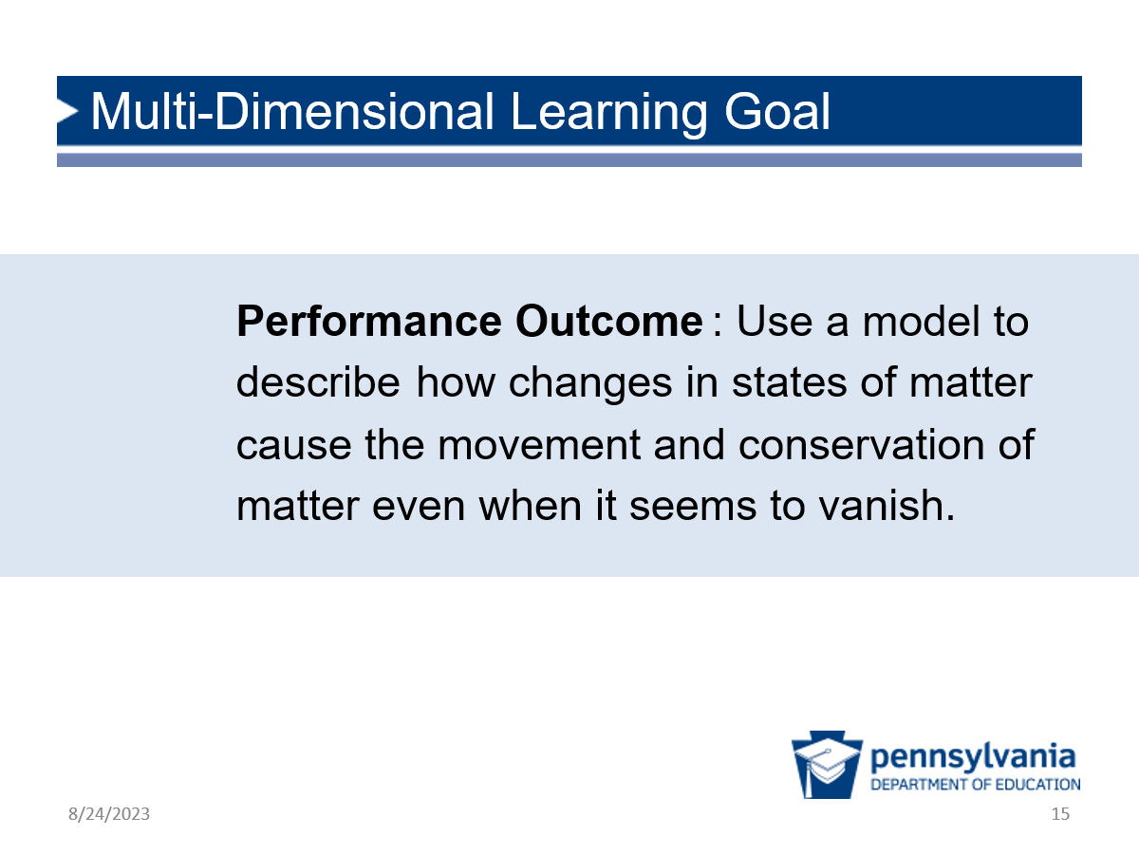 | Possible Narrative (<1 min):  - First, we need to get really clear about which parts of those dimensions we are going to gather and analyze evidence for.  - We’ll do this by narrowing in on an integrated performance outcome.  Note: The following three slides use colors of the STEELS dimensions.
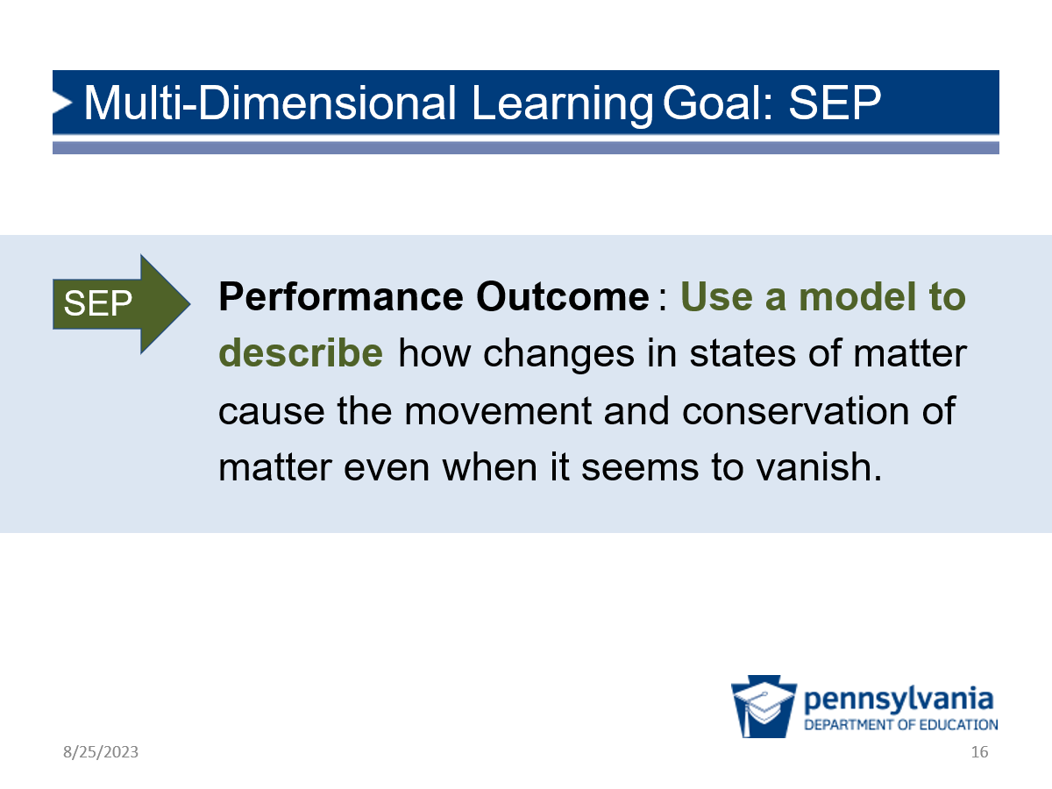 | Possible Narrative (<1 min):  For evidence of the SEP, we are really looking for how students use the model as evidence for their explanation of how the solar still works.
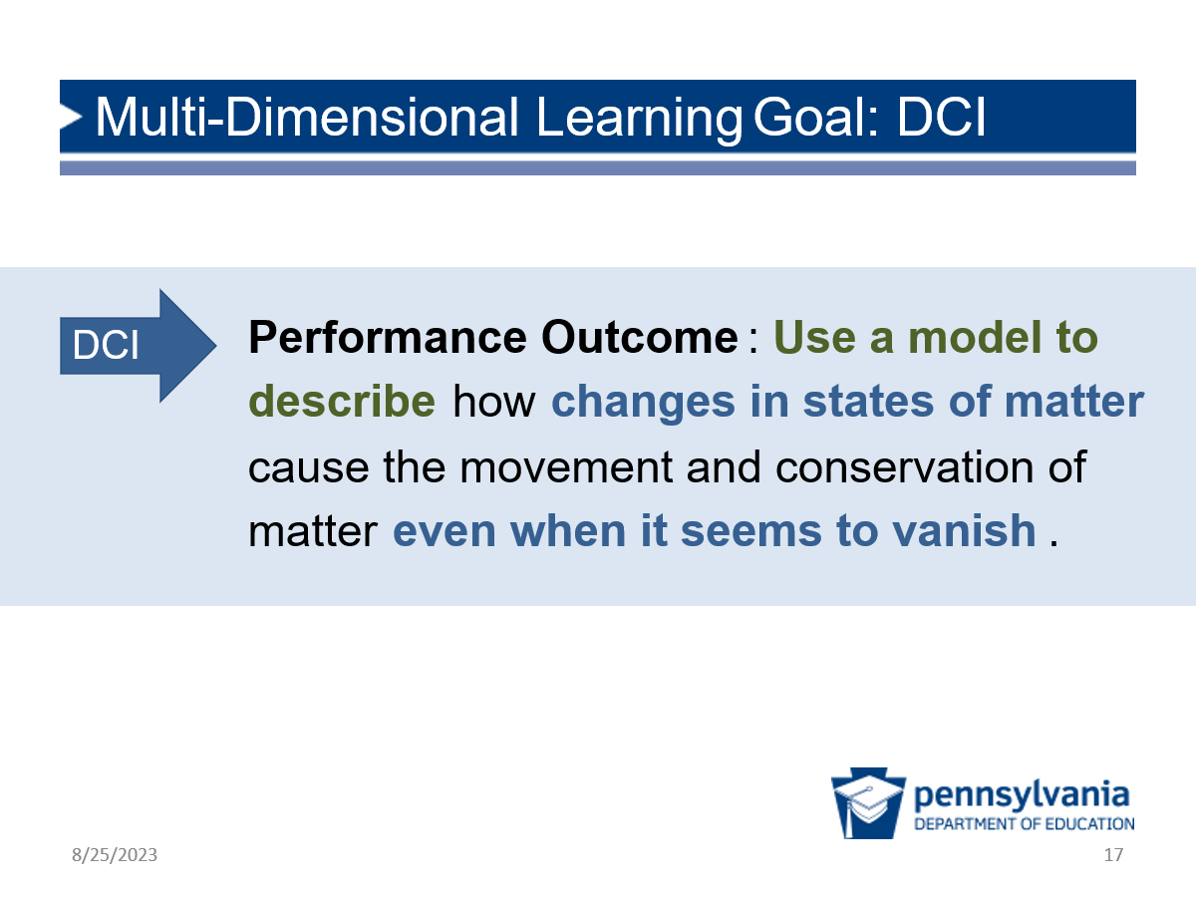 | Possible Narrative (<1 min):  For the DCI, we want to see how students are using their knowledge about how matter changes state within the solar still and can explain how matter moves even when it seems to vanish.
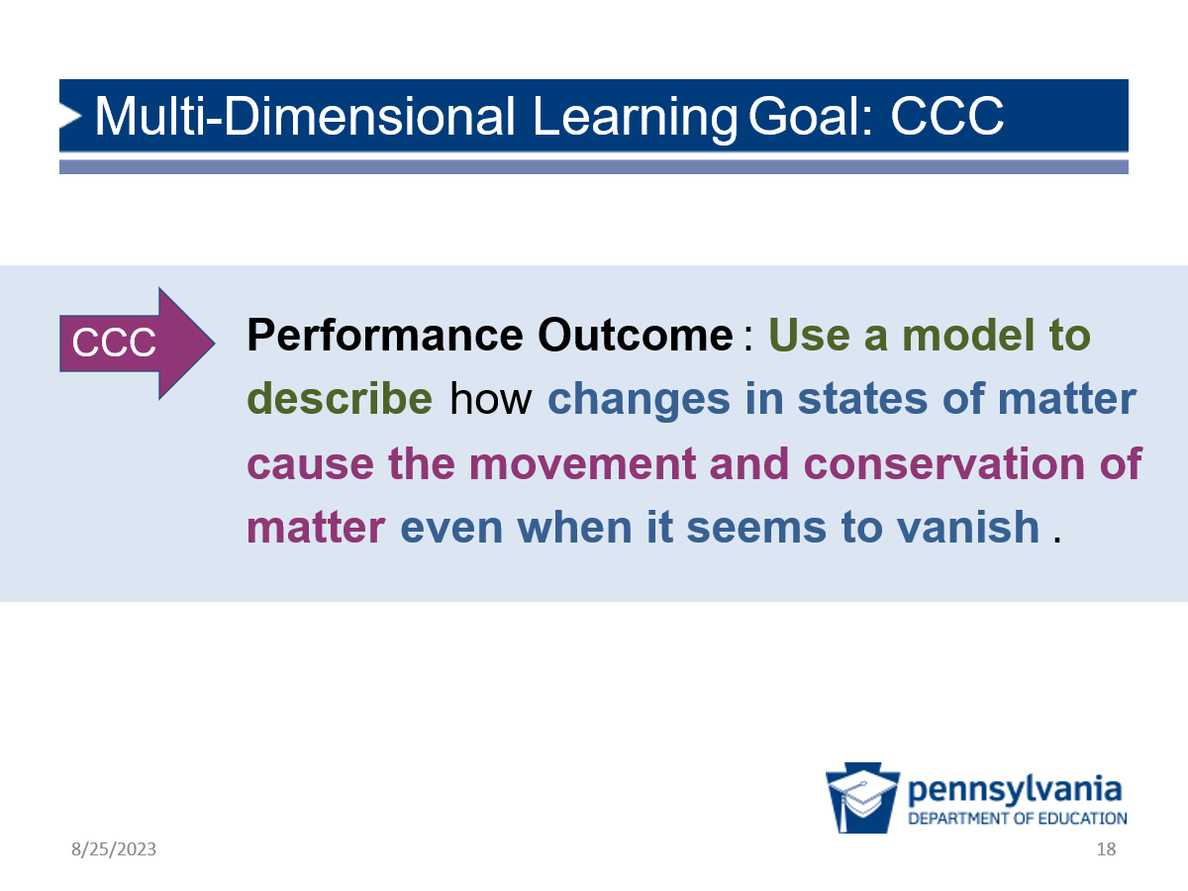 | Possible Narrative (<1 min):  Last but not least, related to the CCC, we are looking for whether students are able to clearly describe the movement and conservation of matter within the system.  Now that we’ve identified what exactly we want to assess, let’s look at the process for gathering evidence.
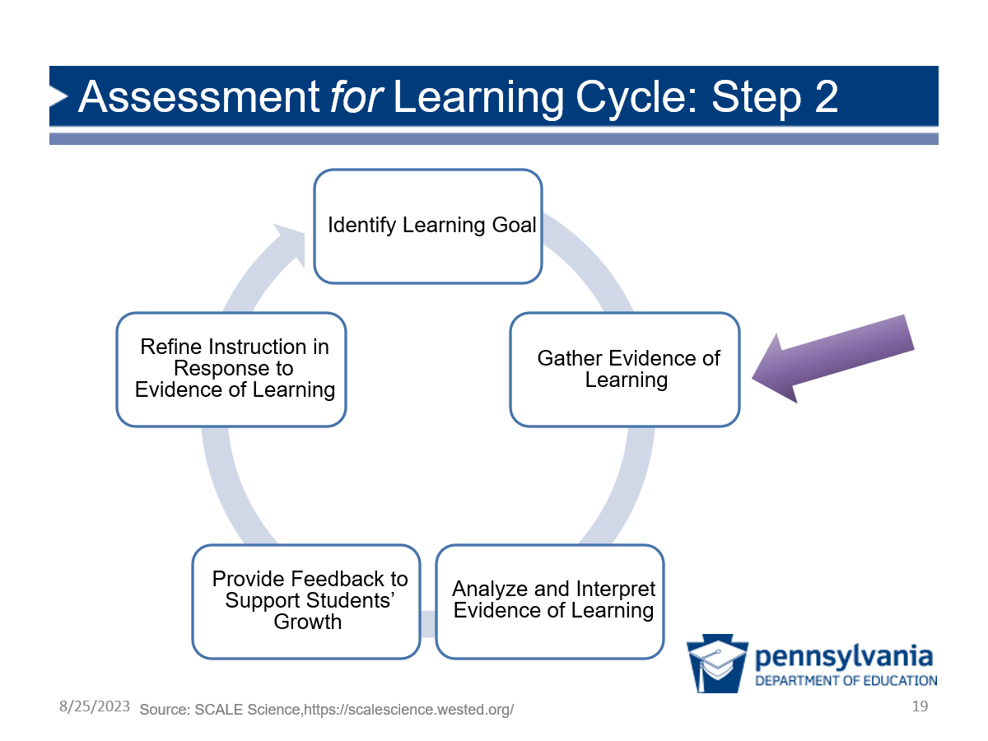 | Facilitation Step (<1 min):  Share the following ideas.  - Learning goals come first. After learning goals are identified, developers determine what kind of task will help us collect evidence of student progress toward the learning goals.  - Our task was designed specifically to elicit the three-dimensional performance outcome (learning goal) we just discussed.
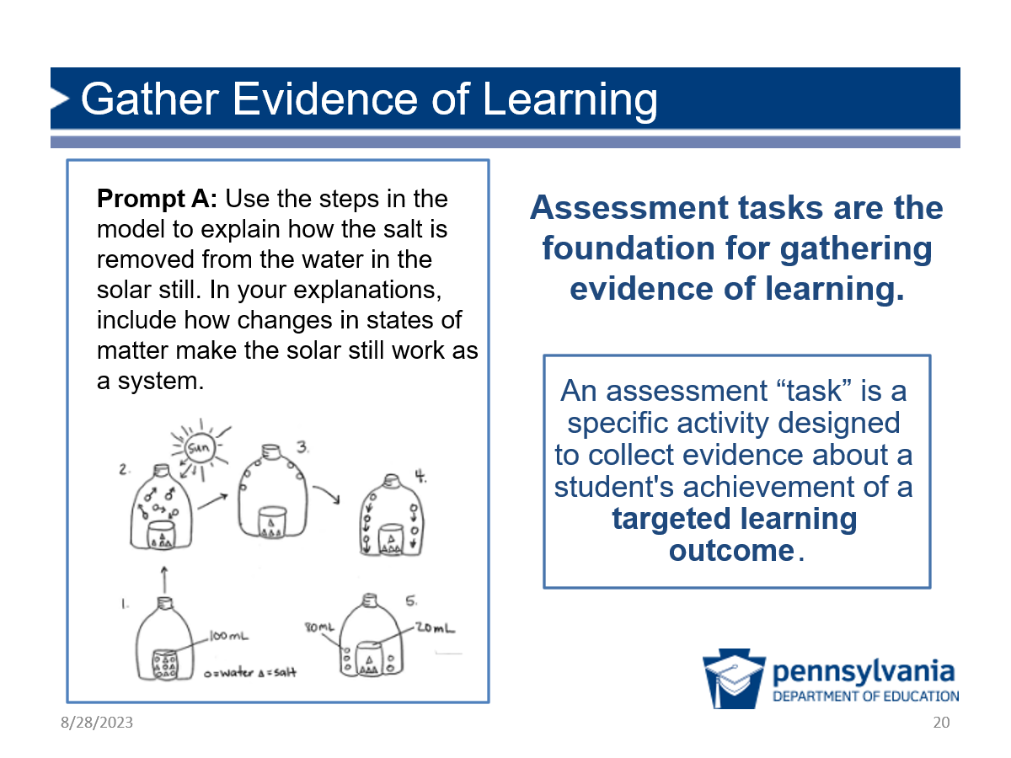 | Facilitation Step (<1 min):  - Tasks: Share that assessment tasks are the way we collect evidence of student learning. The task itself is designed to help us determine students’ achievement of the targeted learning outcome.  - Survivors Stranded: If participants have taken part in Module 2, share that we will be using Version B of Survivors Stranded, which we determined was a better example of multi-dimensional sense-making.  - Gather evidence: Ask participants to imagine that they have collected student work—gathered evidence—in response to the prompt.
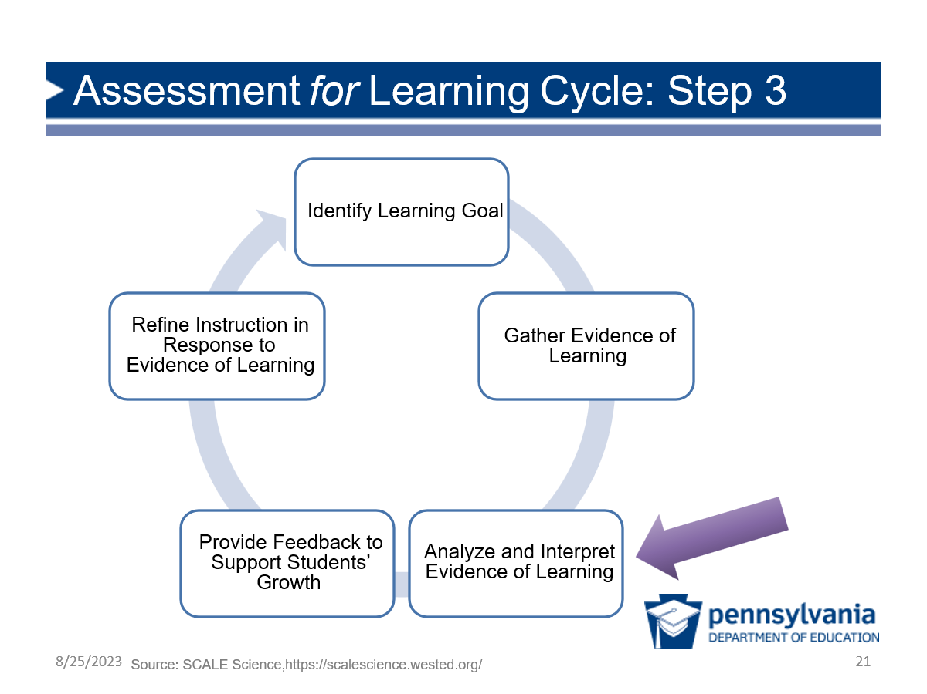 | Facilitation Step (<1 min):  - Student work samples: Share with participants that they have five samples of student work as evidence.  - Analyze and interpret evidence: In the next few slides, participants will analyze that evidence to interpret what students have learned and the progress they are making.
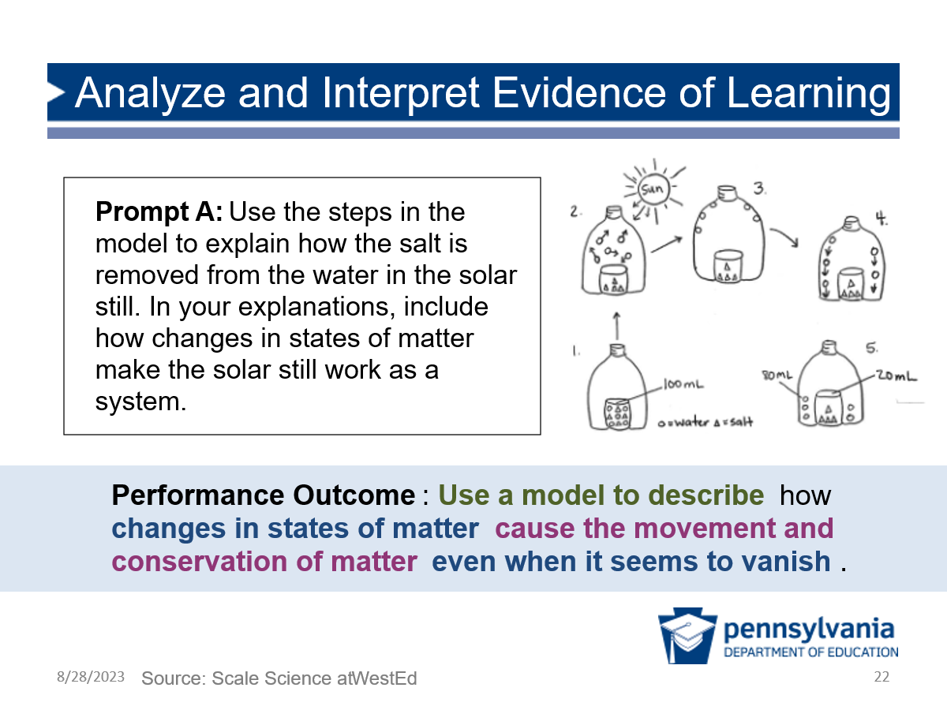 | Facilitation Step (<1 min):  - Back to our performance outcome: To analyze evidence, participants will examine student work relative to the performance outcome.  - Prompt A only: Let participants know they will focus on analyzing student work for just the first prompt of this task. This is an example of a three-dimensional prompt that addresses the phenomenon of the assessment, and we can get lots of useful information about our students just from this prompt.
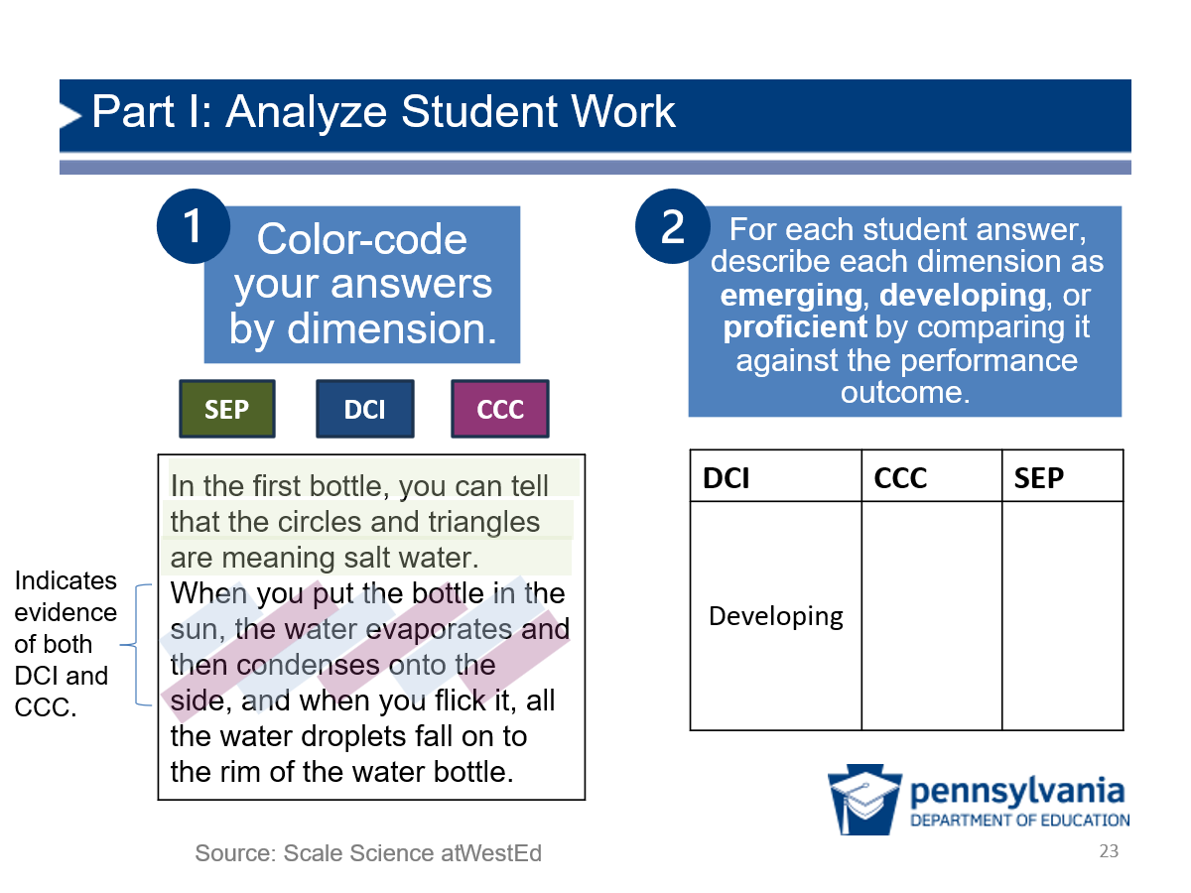 | Facilitation Step (15 min):  - Share that for the sake of time, participants will only have five student work samples to analyze, but that the next few steps would usually be done with a full class set.  - Remind those who have completed Module 1 that they highlighted their own work for this same prompt. We’ll now being doing a similar activity with a group of students to identify trends and implications.  - Describe the task: Tell participants that once you have gone through the process and example, you will give them time to work on the Survivors Stranded Student Work Analysis handout.  - First, participants should color code the student responses by dimension, using highlighters or colored pens.  - Note the colors highlighted in the example on the screen. In this case, the DCI and the CCC are demonstrated by the same part of the student answer, so they may need to be a bit creative on how to represent it, as we were by highlighting with both colors.  - Next, participants should describe the level of student proficiency for each dimension. They may need to refer back to the specific elements for each dimension or the “Evidence that students have met this performance outcome” description on page 2 of the handout.  - The DCI cell is completed as an example. There is evidence of the DCI in the student’s work, but it does not show full proficiency.  - Ask participants to look back to the performance outcome. This student does use the model, but they do not fully explain how the water still works. They do mention changes in states of matter and describe some movement of water within the system, they don’t describe the conservation of matter within the system even when it seems to vanish. For this reason, the DCI cell is labeled as a “developing” response.  - The slide only describes proficiency for the DCI, but participants should describe proficiency for all three dimensions.  - There is not a “right” answer — the powerful learning comes from the discussions partners have when reconciling their ideas and the insights into student knowledge and skills gained.  Work Time in Partners to Complete Part I on Handout (12 minutes)  Sense-Making: This activity is a key moment for participants to see concrete examples of task prompts that elicit evidence of multi-dimensional learning. There may be disagreements about what “counts” as evidence, but ultimately participants will see the insights into student thinking they gain from these brief examples and the power of these assessment design features.  Formative Assessment: Consider listening to comments about the value of student work analysis to highlight later. In addition, listen for which areas participants are struggling with. Keep these in mind for Part II when you are identifying trends across student work, and it may be helpful to note that it is the trends that matter for this analysis. This big picture can take the pressure off when there are disagreements about how to categorize an individual student’s answer.  Facilitation Note:  - Do this analysis with STEELS colors.
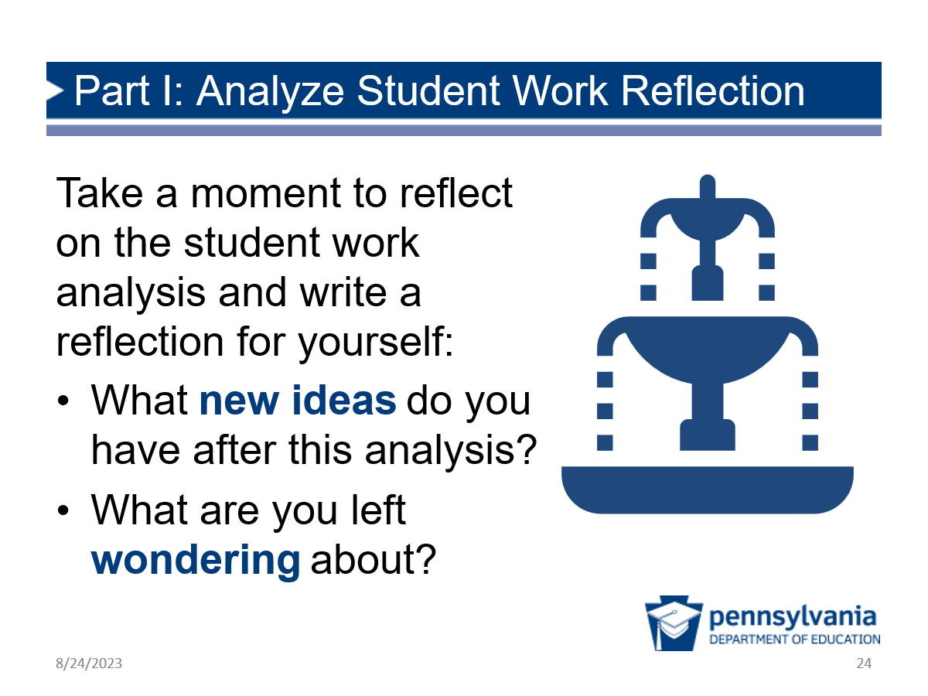 | Part I: Quick Reflection (2 min)  Ask participants to briefly take a step back and individually reflect before moving on to Part II.  - What new ideas do you have after this analysis?  - What are you left wondering about?
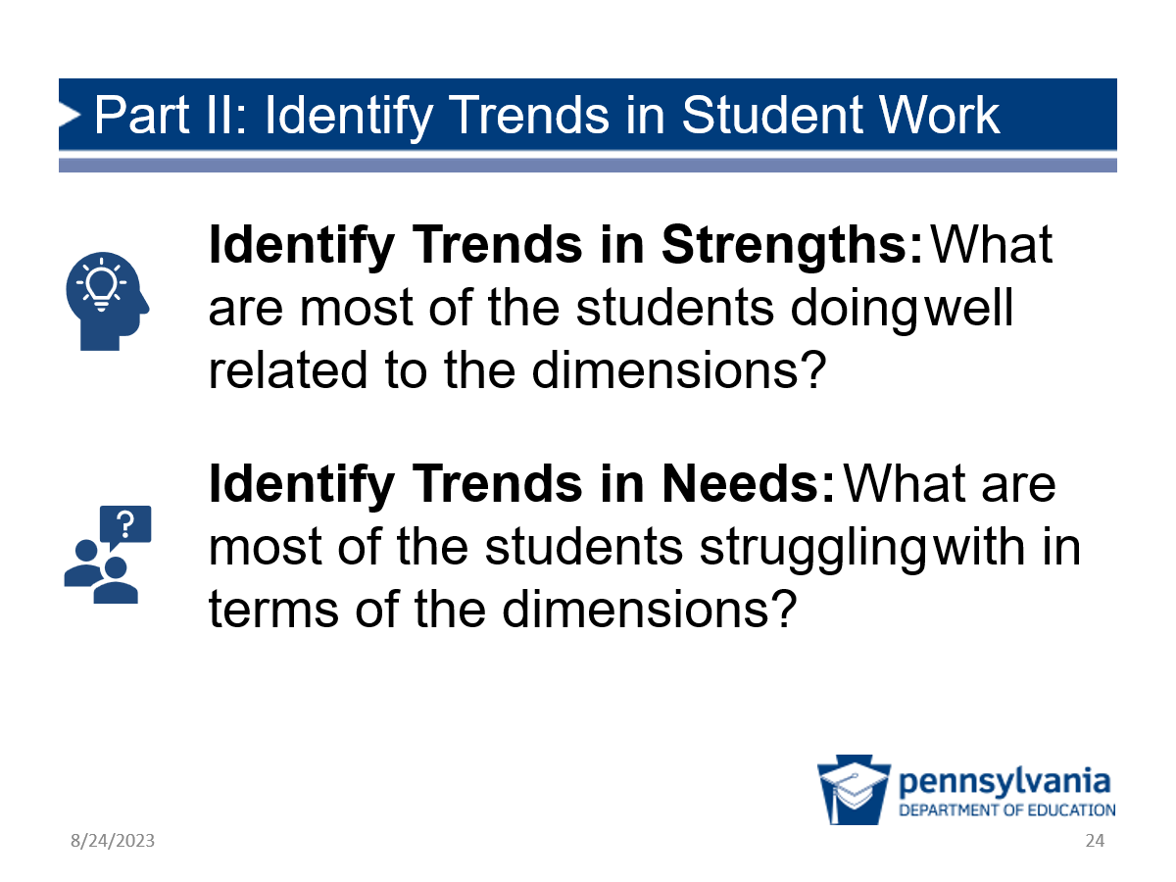 | Facilitation Step:  Part II: Complete Handout Part (12 minutes)  - Individual: Provide participants with a few minutes to work individually to identify the trends.  - Partners: Have participants discuss their ideas with their partners or another type of grouping.  This discussion should be limited to the trends in strengths and needs, not how they would address them, as that is the next step in the cycle.
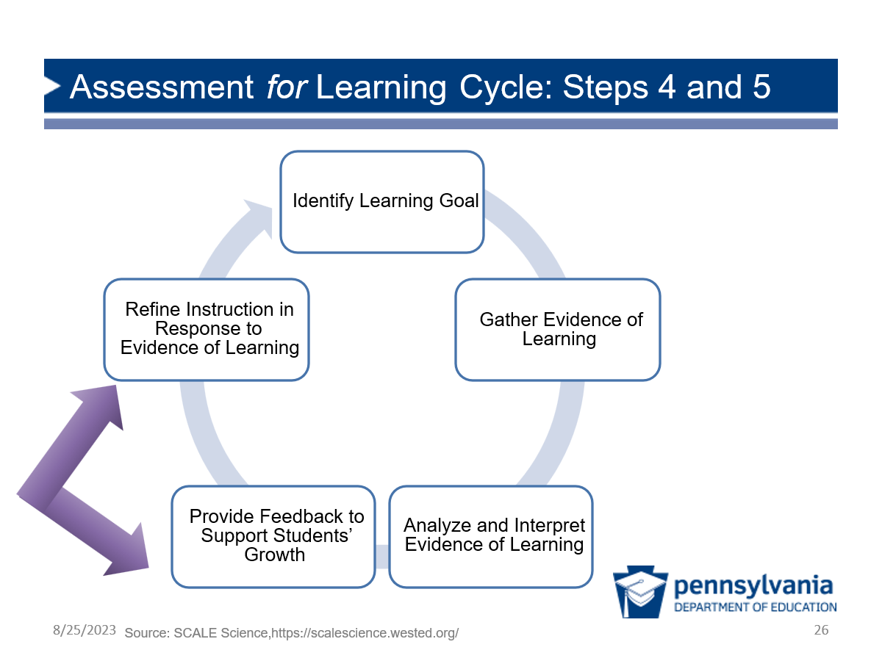 | Facilitation Step (<1 min):  Share that the last two steps of our Assessment for Learning Cycle are about using the data to determine feedback to offer the student and ways to refine instruction.
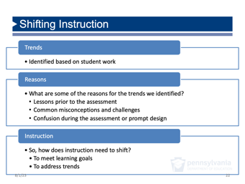 | Purpose of This Section: Participants deepen their understanding of the value of student work analysis as a powerful tool for supporting teachers and other leaders to make student-centered decisions with assessment data.  Facilitation Step (15 min total):  - Trends, Reasons, Instruction (<1 min): Share that when educators are using assessment for learning, they identify the trends, then think of possible reasons for the trends. They intentionally try to think of a variety of reasons, then narrow down what might have led to the student responses, rather than assuming the first reason they think of is right. At that point they start to consider how to shift instruction or other program-level supports for larger trend analyses.  - Team Discussion of Reasons and Implications (10 min): Ask participants to discuss with their teams why they might have seen the trends that they found and what they might do to respond.  - If you have participants who are not in the classroom, encourage them to consider and discuss what actions they might take in their own role after this analysis (e.g., how might you better support teachers to address certain things in the classroom?).  - Whole Group Debrief (5 min): Lead a discussion about the ideas that came out in the table conversations.  - If there are different roles represented among participants, be sure to have them share some ideas to reinforce that analyzing evidence of student learning is not just the responsibility of classroom teachers and that other roles can support the process.  - Participants will discuss supporting assessment from their roles in the next part of the session.
Facilitation Step (5 min):
Share the quote from the blog post, then ask participants to write a reflection about the prompts on the slide. Emphasize that they should consider how they can support assessment for learning from their role.
Resource: The quote on this slide comes from a blog post that describes the benefits of student work analysis and cultivating a community of practice to improve science programs based on data. See the full post here.

Role-Alike Reflection (15 minutes)
Slides | Process
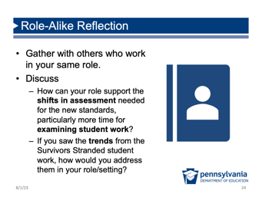 |  | Purpose of This Section: Participants consider how people in their role can support assessment, then identify potential action steps they could take.  Facilitation Step (15 min total):  - Get into role-alike groups (1 min): Have participants gather into role-alike groups (see Preparation section for more information and ideas about how to organize these groups).  - Discuss (13 min): Ask them to use the prompts on the slide to have a discussion with their group.  - Build community (1 min): At the end of 15 minutes, you may wish to prompt participants to thank their group for the discussion and gather contact information if they don’t already have it.  Resource and Facilitation Note:  If you have an audience with many roles and would like more structure for this activity, you may choose to pass out the role-alike discussion cards on page two of the Task Annotation Project in Science: Takeaways resource.  If using this resource, provide an additional five minutes for participants to read the card associated with their role before beginning their discussion.

Session 3.2 Assessments Throughout a Learning Sequence
(2 hours, 40 minutes)

Where we are going in this session:
Participants analyze various assessments across a learning sequence and consider how those assessments support our vision for science teaching and learning.
Where we are NOT going in this session:
It’s important that participants are familiar with the learning goals of the instructional unit to appreciate how the assessments fit in, but the focus of the session is on the coherence of the assessments and not in-depth analysis of individual assessments or details of the example unit.
Review Example Unit (75 minutes)
Slides | Process
Facilitation Step (<1 min):
Share that in Session 3.1, participants considered how to use analysis of student work to inform teaching and learning. In Session 3.2, they will have an opportunity to consider how assessments are used across a unit of learning to support student learning over time.
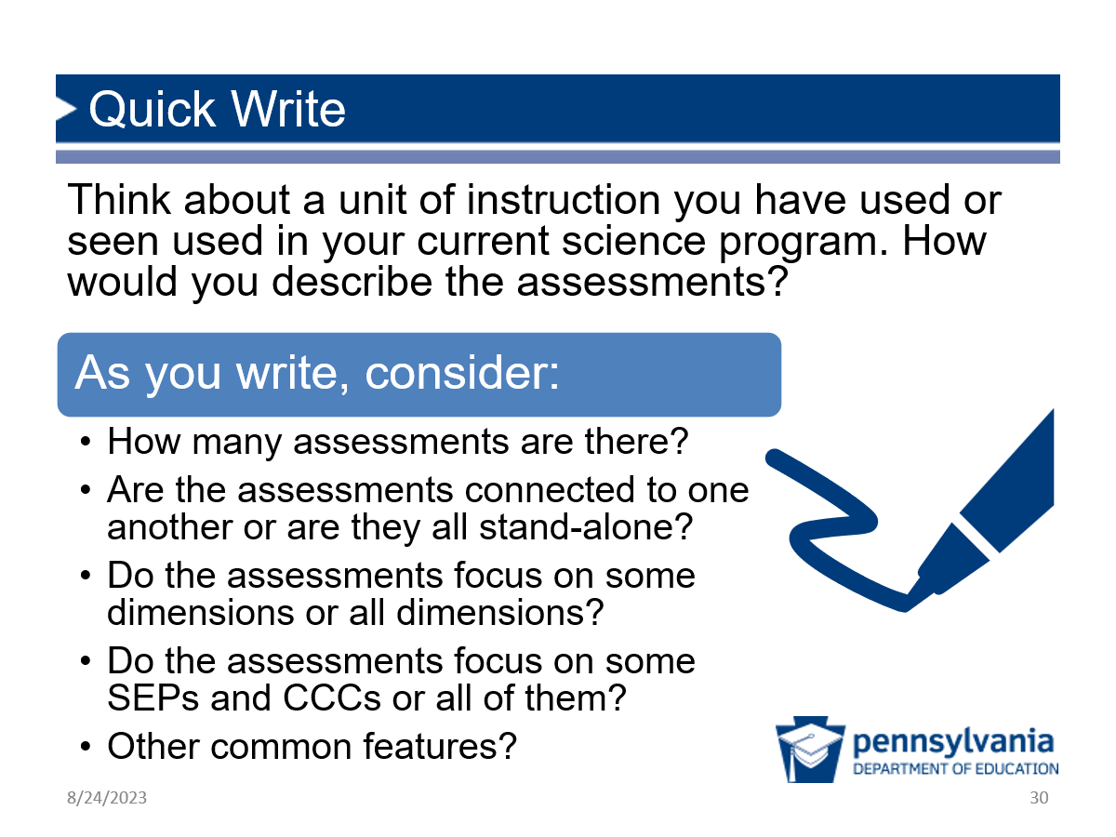 |  | Facilitation Step (5 min):  - Ask participants to think of a unit, either that they’ve used or are familiar with.  - Consider how they would characterize the assessments across the unit of instruction.  - Share that they do not have to answer all the questions on the slide directly, but rather, that those are meant to prompt their thinking.
Preparation:
Divide participants into 9 groups ahead of time. (This is a good opportunity to mix the group up.) Assign one lesson from the Using Our Resources Wisely unit to each group. Distribute 1 copy of the assigned lesson from the Using Our Resources Wisely unit to each group member. Each group will read one lesson, so the number of copies of each lesson will depend on the number of participants.
Purpose of This Section: Participants analyze an instructional unit to determine the learning goals and how student thinking changes. This will set the stage for thinking about how different types of assessments work together in Session 3.3.
Timing (for this and the following two slides) (70 min total):
- 5 minutes to describe task and assign groups;
- 15 minutes to read;
- 15 minutes to create chart paper; and
- 35 minutes to tell the story.
Facilitation Step:
- Share that participants are going to have an opportunity to think about assessments across a unit, but that before they dig into the assessment opportunities, we want to give them a chance to understand the unit overall.
- The unit has nine lessons, so assign participants to nine groups, each responsible for one lesson. Have groups move to a table together.
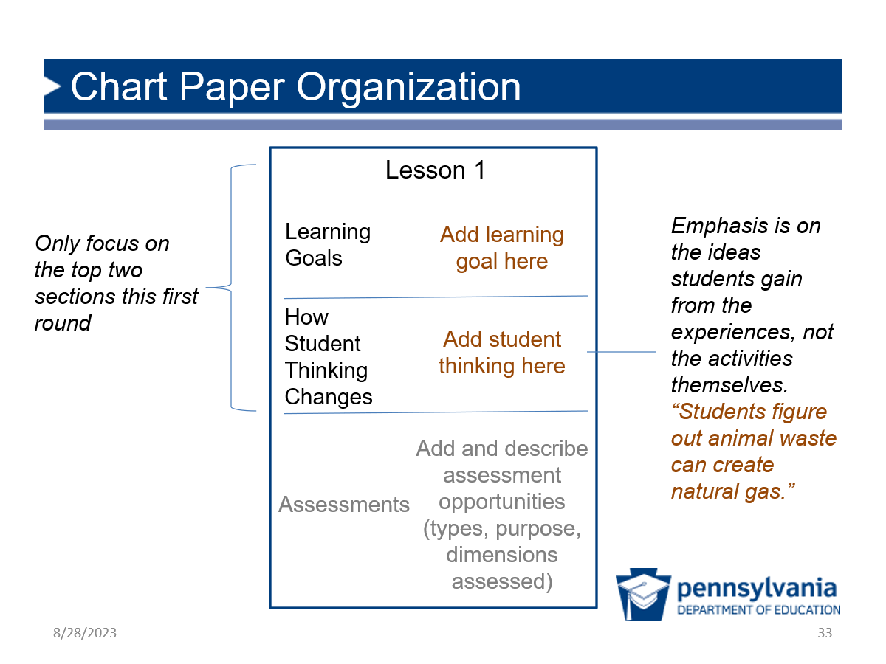 |  | Prep: Provide each small group with a piece of blank chart paper while participants are reading.  Facilitation Step:  - Chart paper organization: Provide instructions so that each group can begin working once they have finished reading. Each table group will create a chart paper to represent their lesson. They should divide their chart paper into 3 sections, as shown on the slide. During the initial reading, the groups should complete only the top two sections: Learning Goals and How Student Thinking Changes.  - Note: How student thinking changes is an emphasis on the ideas students gain from the activities, not the activities themselves.  - Give participants time (15 min) to read their assigned lesson (all 5 Es) and make notes about what the learning goals are for the lesson and how student thinking changes.  - Once all members of a group are finished reading, they should work together to complete the top two sections of the chart.
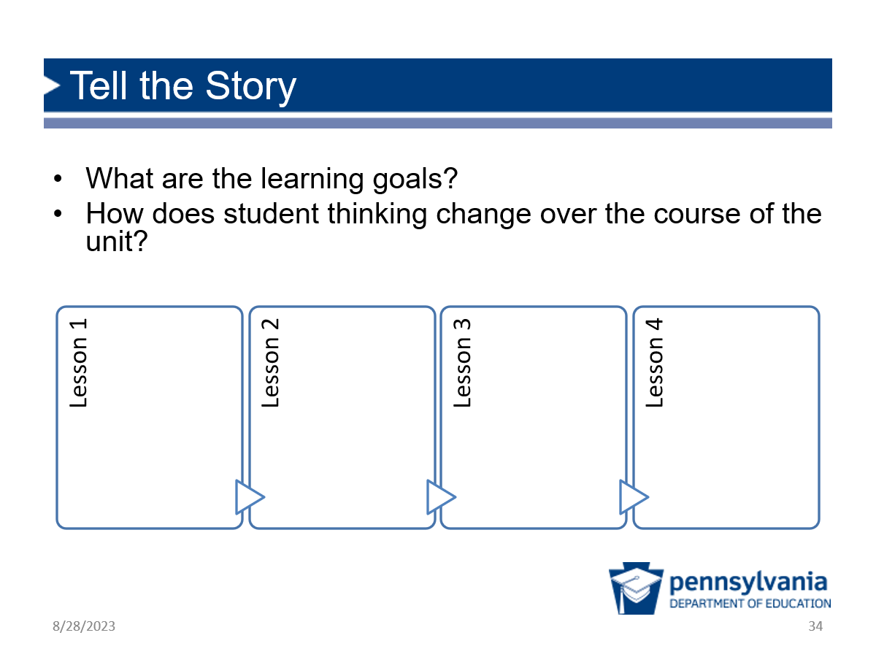 |  | Facilitation Step:  - Tell the “story” of the unit from the lens of the learning goals and the way student thinking changes over the course of the unit. Consider having participants stand near the charts to better hear and see one another.  - Ask each group to pick a speaker and share their charts with goals and student thinking, starting with the group that read lesson 1 and continuing in order all the way to lesson 9. Encourage the groups to make connections to the previous lessons. Try to stick to 3–4 minutes per lesson.  - Check-ins: To keep the group engaged, pause after lesson 3 and lesson 7 to have participants retell the “story” of how student thinking changes in the unit so far to a shoulder partner and consider to what extent the story feels coherent.

Assessment Opportunity Analysis (75 minutes)
Slides | Process
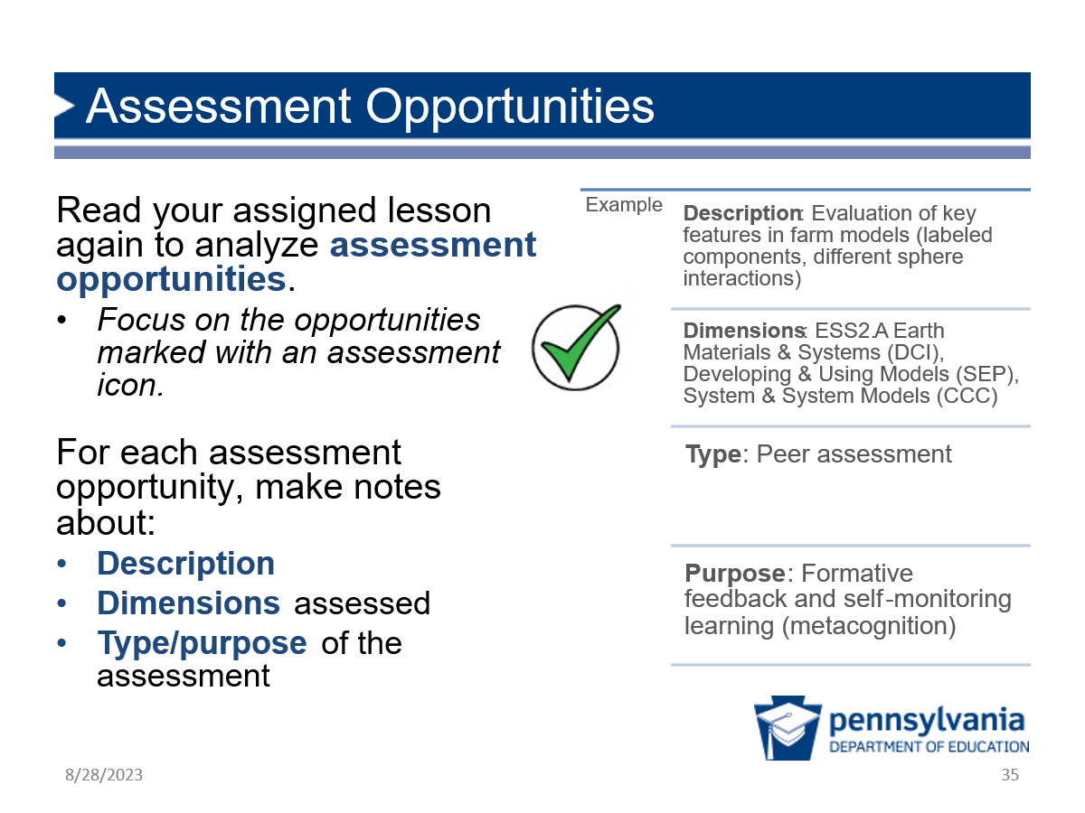 |  | Purpose of This Section: Participants gather evidence of the types and purposes of assessments in the instructional unit example and consider how the assessments relate to goals and student thinking.  Facilitation Step (15 min):  - Introduce next step: Tell participants that they are going to have a chance to read through the lesson again to see how assessments support student learning.  - Individually collect evidence of assessments: Ask participants to use the prompts on the slide to learn about the assessments in the unit.  - Highlight that they should first focus on the assessments that have the icon shown on the slide and if they have extra time to go back and look for other assessment opportunities.  - Each lesson will have 1 or 2 opportunities highlighted by the icon.  - Example: If helpful, discuss the example description of an assessment opportunity on this slide.  - Note that participants shouldn’t worry about what exactly we mean by “type” or “purpose” at this point — the point is to be as descriptive as possible to give people a sense of what the assessment is.
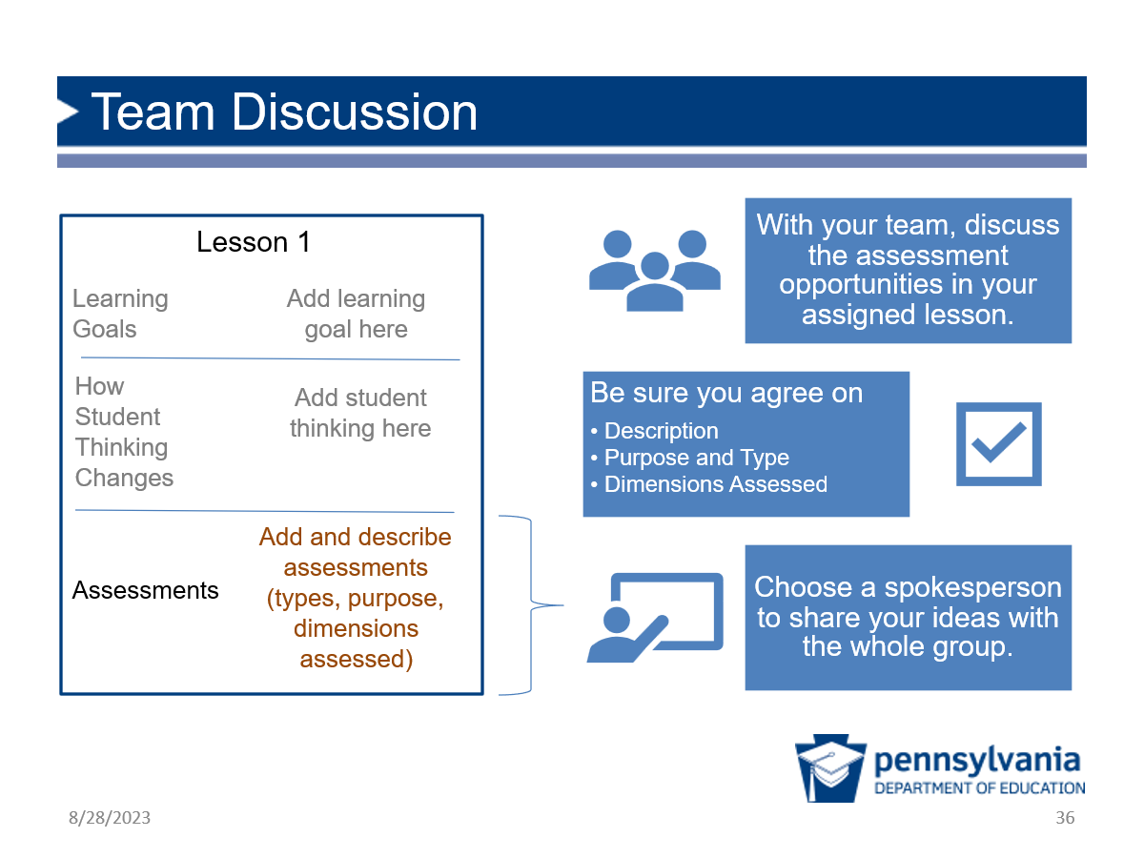 |  | Facilitation Step (45 min):  - Group discussion and chart paper update (10 min): Once all members of a group have finished reading, they should discuss the assessments in their unit, focusing on the prompts on the slide. Ask them to add their ideas to the third section on their chart paper.  - Share the story (30 min): Once teams have had time to prepare, share the story of the assessments across the unit.  - Beginning with lesson 1, ask each group to share the assessment opportunities in their lessons and how these assessments connect to the learning goals and student thinking.  - Prompt the groups to share how the assessments could elicit evidence of current student thinking, identified in the first round of analysis.  - Ask participants to listen for and think about how the assessments build across the unit.  - Keep participants focused on the assessments so that they can listen for coherence and not be distracted by other ideas.  - Debrief (5 min): After participants have shared all the lessons, lead a discussion focused on their ideas about how they would describe the assessments across the unit. (There are no wrong answers here, but possible responses may include: frequent, integrated into the learning, multi-dimensional, and mostly formative.)
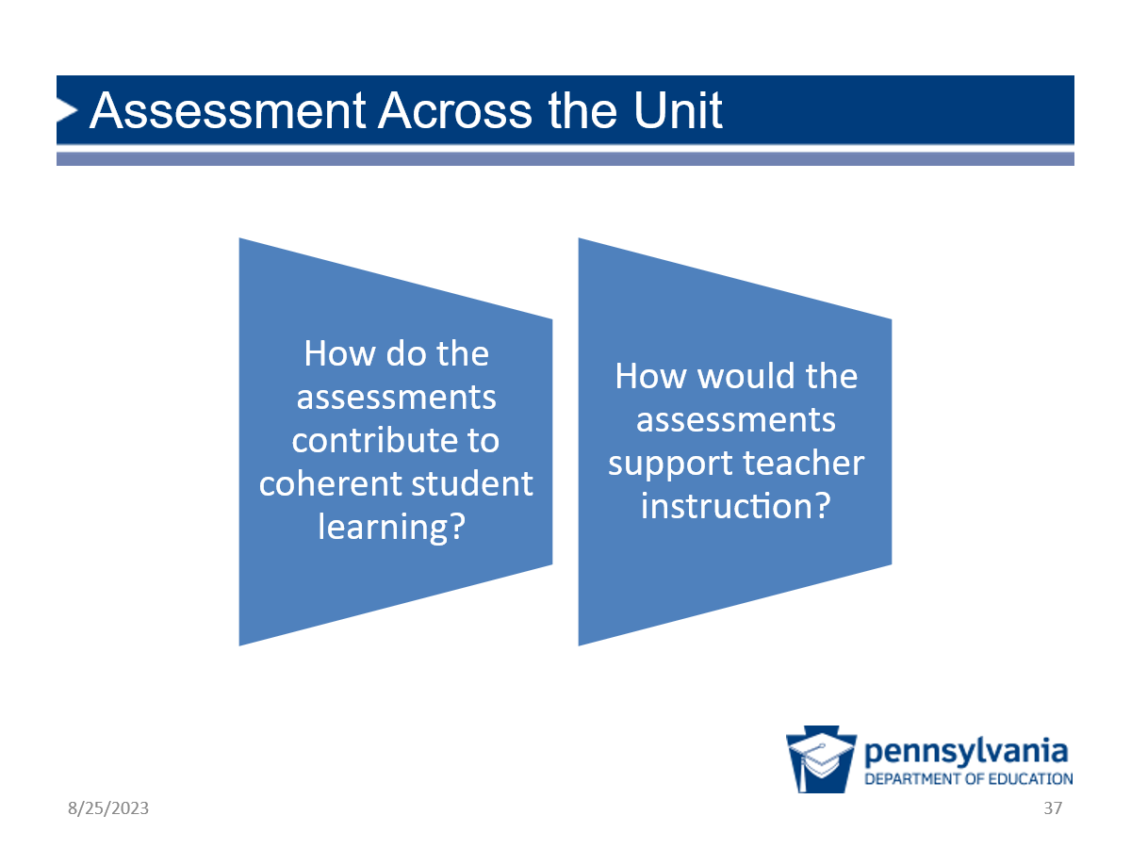 |  | Facilitation Step (15 min):  Whole Group Debrief: Lead a whole group discussion around the prompts on the screen. Participants will have a variety of ideas. In particular, make sure they highlight the following ideas.  - The farm model is continuously revised and builds over time, so students have many opportunities to add to their thinking and revisit their ideas. Not only does this support learning, but the practice of revising models helps them think of science as a process, rather than a discipline where they are right or wrong.  - There is a focus on just a few practices and crosscutting concepts so students can iteratively develop their skills.  - There are many opportunities for teacher feedback, and also peer feedback, across lessons. This can help students be aware of their own learning and develop their confidence that their ideas are valued and do not always have to look to the teacher as the sole source of information.  - Assessments are built into the learning throughout and not just a separate item at the end of the learning. This is critical for supporting learning along the way.  Sense-Making: This group debrief is a chance for participants to put the pieces together and make connections between unit learning goals, student thinking, and assessments in an instructional unit.

Connection and Reflection (10 minutes)
Slides | Process
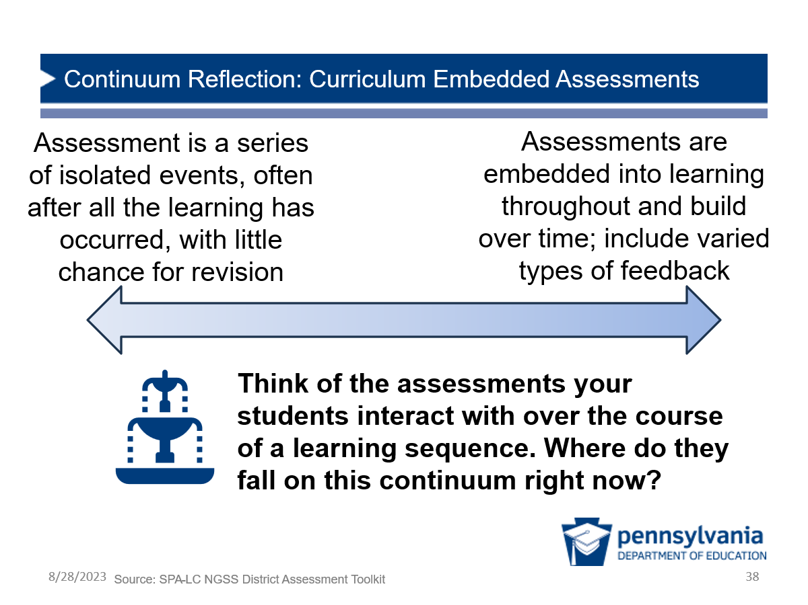 |  | Purpose of This Section: Participants consider the extent to which features of a coherent assessment system are reflected in their current science programs.  Possible Narrative (5 min):  - Now that we have dug into assessment throughout an instructional unit and the value of coherence, think about the current assessments your students interact with during an instructional unit.  - Where do your current assessments fall on the continuum of coherent assessment systems within a unit? Take a moment to reflect.  Facilitation Step:  Ask for a few participants to share out if they’re willing.
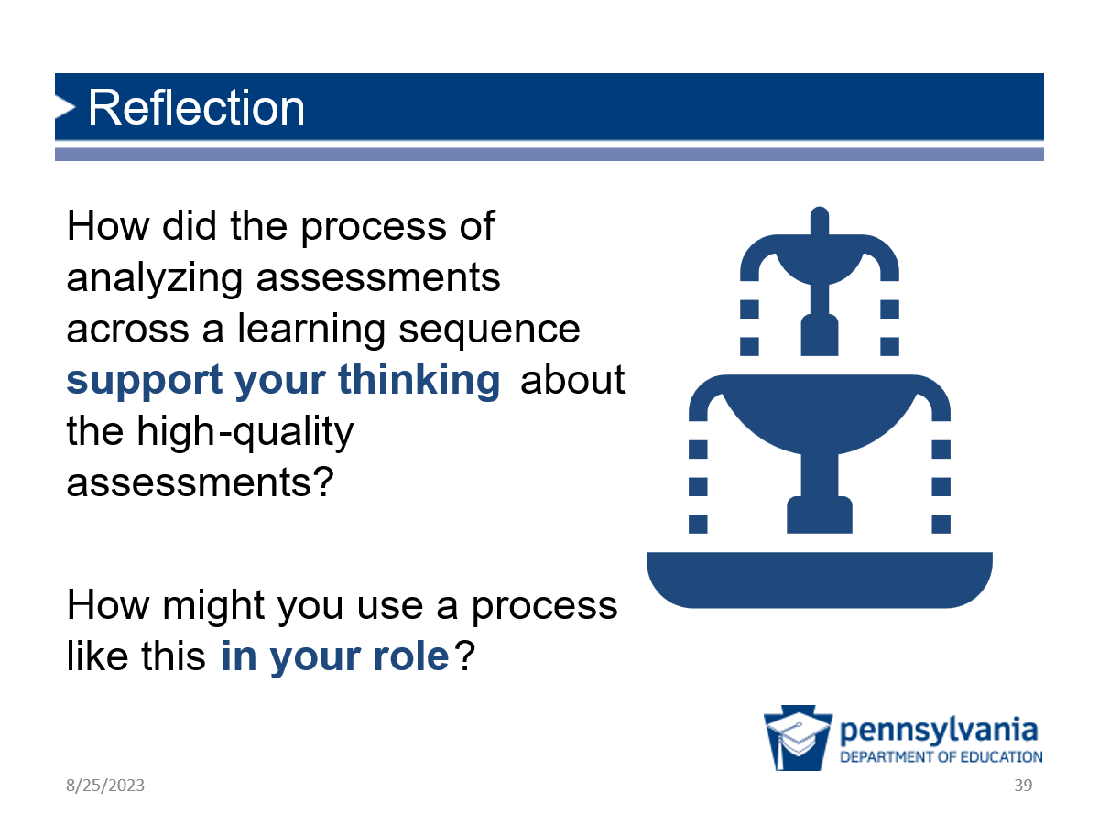 |  | Facilitation Step (5 min):  - Have participants take a moment to individually reflect in their notebook on their own learning and the value of the process we just went through.

Session 3.3 Different Assessments Working Together
(1 hour, 45 minutes)

Where we are going in this session:
Participants know different science assessments work together for different purposes, uses, and audiences to paint a full picture of student learning.
Where we are NOT going in this session:
The purpose of this session is not to focus on the constraints associated with the state test or other assessment types in one system, but rather to think carefully about what we can control and the assessments in the system that can have the most impact on student learning.
Opening (10 minutes)
Slides | Process
Facilitation Step (<1 min):
- Share that this module has focused so far on using assessments for learning and how those units develop over the course of a unit to support student learning.
- In Session 3.3, participants will have an opportunity to think about how to work toward a system of assessments where different assessments with different purposes are working together to provide a coherent picture of student learning.
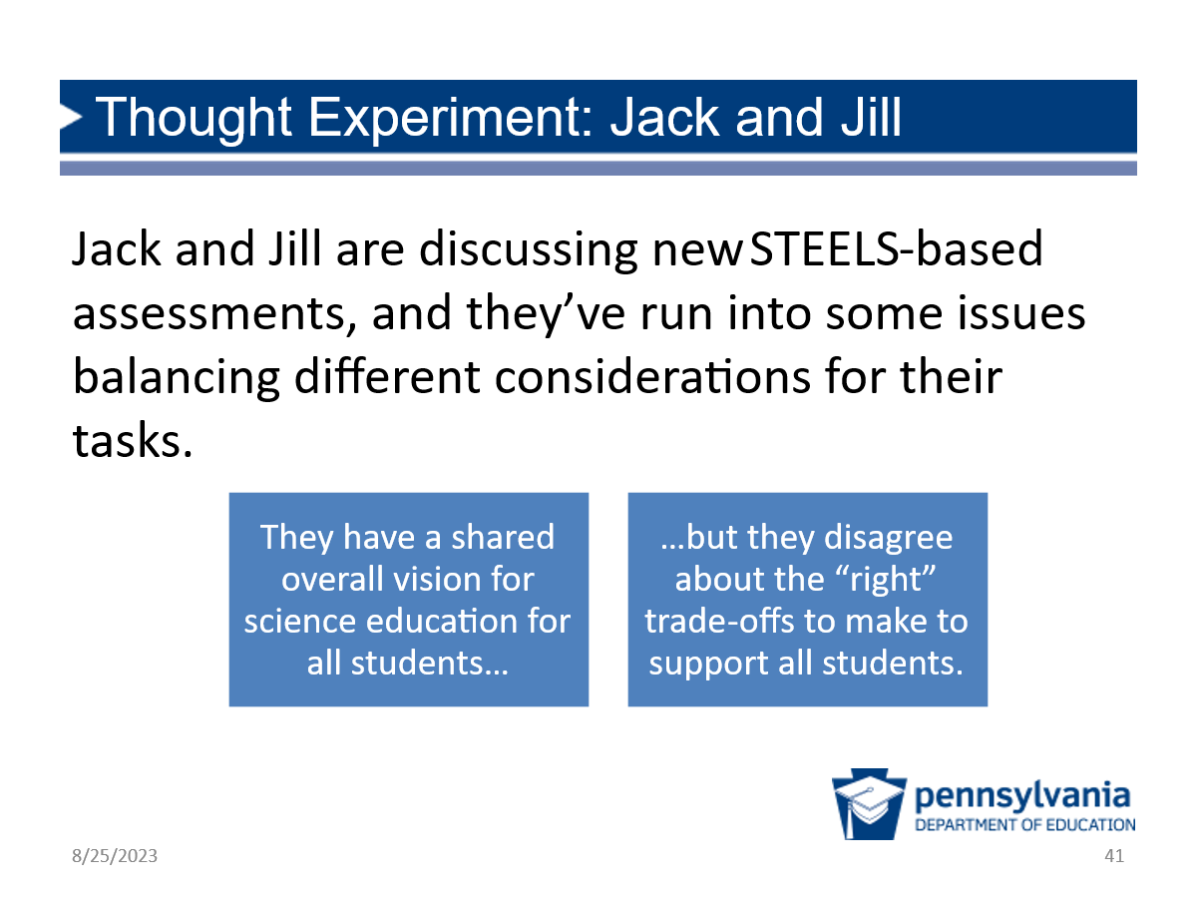 |  | Jack and Jill Introduction (<1 min)  Possible Narrative:  - We’re going to try a thought experiment, which are two ideas from individuals, who we’ll call “Jack” and “Jill.”  - They’ll be visiting us a couple times throughout the session. Please note: Neither one represents the “right” answer.  - This thought experiment can help us elicit our own thinking about science assessment.  Jack and Jill have a shared overall vision for science education for all students, but they disagree about the “right” trade-offs to make to support all students.
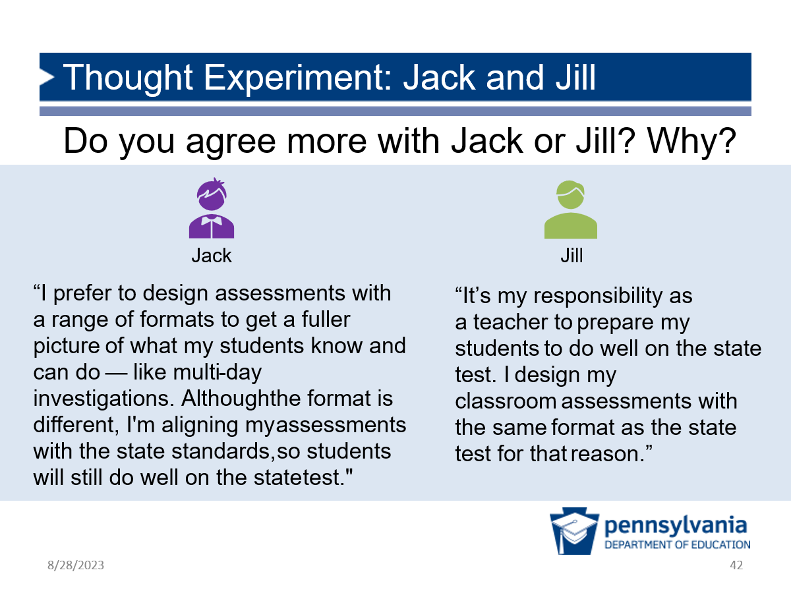 |  | Purpose of This Section: Participants consider the purposes and types of assessments and which types of classroom assessments can provide a full picture of student learning while preparing students to meet end-of-course learning goals.  Facilitation Step (4 min):  - Read: Give participants time to read each perspective. Express that there’s no “right” answer.  - Think: Ask participants to decide who they agree with more.  - Choose one: Remind participants this is a safe space where we can disagree respectfully with each other.  - Share out: Ask a few pro-Jill participants to share their reasoning, then pro-Jack. Ending with some pro-Jack points of view will open up the conversation about how different assessments are complementary.
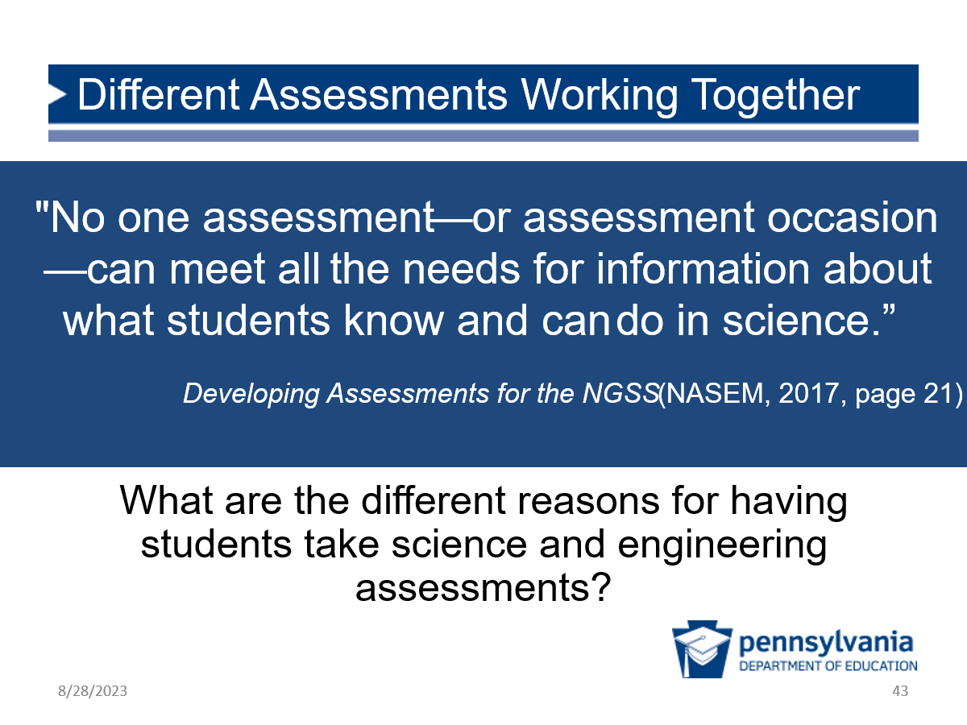 |  | Facilitation Step (5 min):  - Share the quote on the screen then ask participants to discuss their ideas about the prompt with a shoulder partner.  - After they have had a couple of minutes to discuss, elicit a few ideas from the whole group.  Possible Responses:  - Grade/signal to the student or parent how they’re doing  - To let the teacher know how they are doing / how they might adjust instruction  - To let district leaders know what district-level or school-level adjustments they may need to make in a science and engineering program  - To inform state-level policy decisions or resource allocation  - To graduate from high school  - To qualify for a class or program  - To determine whether special services are required to support a student academically

Model Analysis (65 minutes)
Slides |  | Process
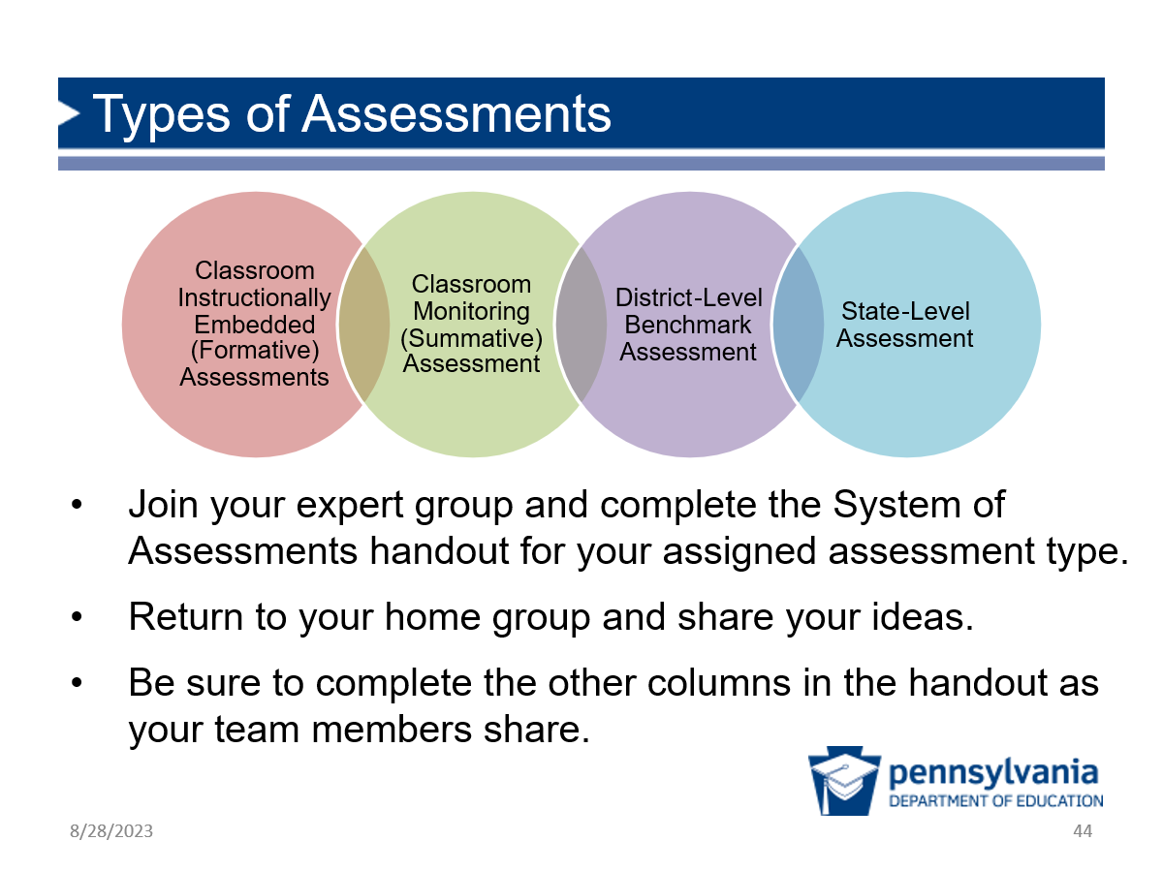 | Prep: Distribute Assessment Types Chart to each participant.  Facilitation Step (35 min):  - Share the types of assessments shown on the slide.  - Divide participants into “expert” groups (3 min): Each group will be assigned one type of assessment to be an expert in. Ideally, the number of groups will be a multiple of 4, and each group will have 3–4 members.  - For example, one way to divide them is to have them count off. For example, if there are 30 participants, have them count off 1 to 8 (a multiple of 4) and gather with others of the same number. This should give 6 groups of 4 and 2 groups of 3.  - Participants complete column for assigned assessment type (15 min): Assign one type of assessment to each expert group and have them work together to complete the appropriate column on the Assessment Types Chart.  - Share out at original tables (17 min): Once groups have completed their discussion and column, have them return to their original seat or a group of 4 that has one expert for each assessment type.  - Have each person in the group share their discussion and responses.  - Remind others to take notes to complete their charts and contribute their own expertise as well.  Resource  This Science Assessment System Continuum resource from the SPA-LC NGSS District Assessment Toolkit may be useful for you to review before facilitating this portion as it has some potential answers and considerations listed.
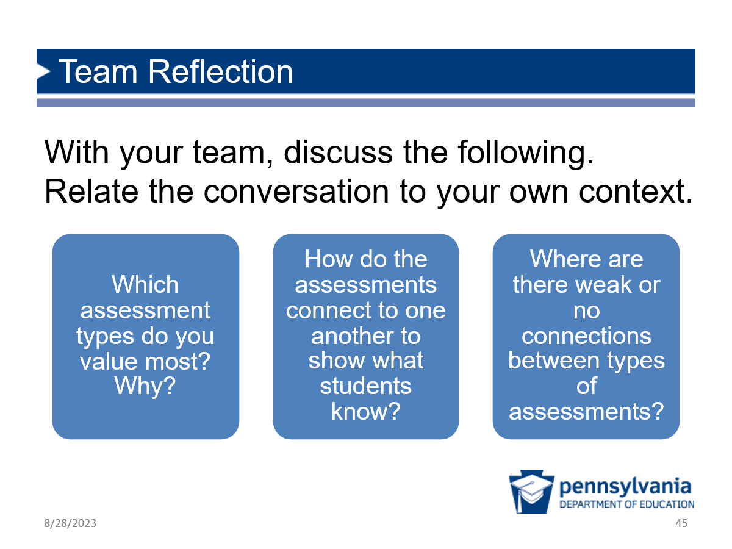 | Facilitation Step (10 min):  Ask participants to discuss the prompts on the slide, focusing on their own contexts.
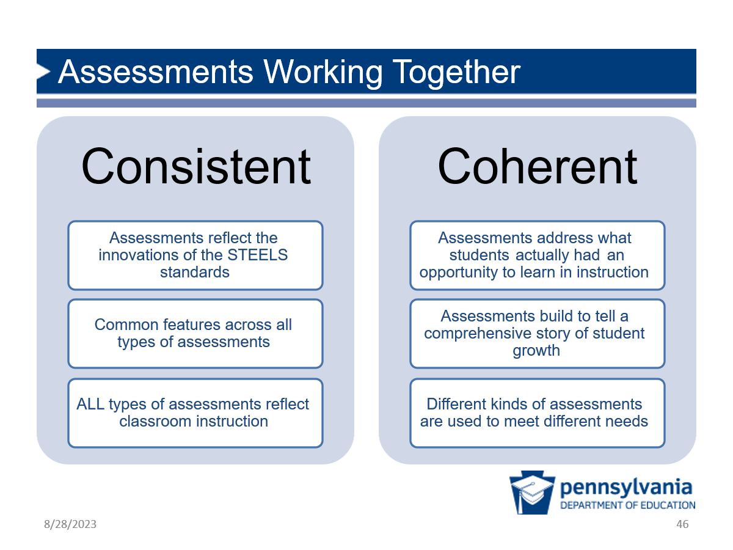 | Possible Narrative (3 min):  You have started thinking about assessments in your own context and thinking about how those assessments connect. As you consider assessments working together, there are two areas that must be taken into account.  The first of these is whether the tasks students do are consistent across all the different types of assessments from classroom-based tasks that are embedded in instruction to district- and state-level assessments. Consistency means that:  - All types of assessments reflect the innovations of the STEELS standards;  - There are common features across the types of assessment to help support students in their learning; and  - All types of assessment reflect instruction and what happens in the classroom.  A second area to consider is whether assessments are coherent. This means that:  - Students have had an opportunity to learn the content that is addressed in the tasks;  - Assessments build on each other so they really tell a story of student growth and progress; and  - Different kinds of assessments are used to meet different needs.
Facilitation Step (15 min):
- System Graphic: Share that working toward a system of assessments is a great way to have the consistency and coherence that supports student learning.
- Notice/Wonder: Ask participants to study the graphic quietly for a moment, then share what they notice.
- In the discussion, be sure to highlight the following points.
  - Teacher learning arrow: Learning opportunities for teachers come first, shown by the blue arrow that starts at the far left. The teachers must develop their own understanding about assessments before student learning can begin. The blue “teacher learning” arrow continues all the way across because teachers need opportunities to continue practicing and reflecting on their use of assessments and the data from them.
  - Student learning arrow: The green arrow begins a little after the blue arrow and represents learning opportunities for students. They must have learning opportunities followed by corresponding assessments to be successful.
  - Four assessment types: The four types of assessments are represented by the purple circles. Their size and shading represent the amount of data that comes from each type. The bigger and darker the circle, the more opportunities we have to learn how students are progressing and to adjust instruction to support their learning.
  - Assessment source and purpose: The turquoise arrows and box at the bottom show that classroom assessments are more tied to curriculum and instruction while the state assessment is more tied to PDE. These assessments are linked and should be consistent and coherent with each other in key ways. We want to make sure that across all of these we have common types of assessments that are trying to reach common learning goals and a common vision, but for a different purpose. For example, both state and classroom assessments measure progress towards STEELS standards, but:
    - State assessments provide information to improve long-cycle system-wide policies and resource allocation, whereas:
    - Curriculum-embedded assessments can provide information for minute-by-minute adjustments in the classroom.
    - By all of these working toward a complete system of assessments, we can really support student learning.
  - Classroom data: But, notice that most of the data we can get and most of the places we can shift instruction to support students is in the classroom, and that is where we have most control.
    - There is significantly less data and opportunity to support student learning from state assessments, so we really have an opportunity to shape student learning best by focusing on all the data we get from the classroom.

Connect to Context and Reflection (30 minutes)
Slides |  | Process
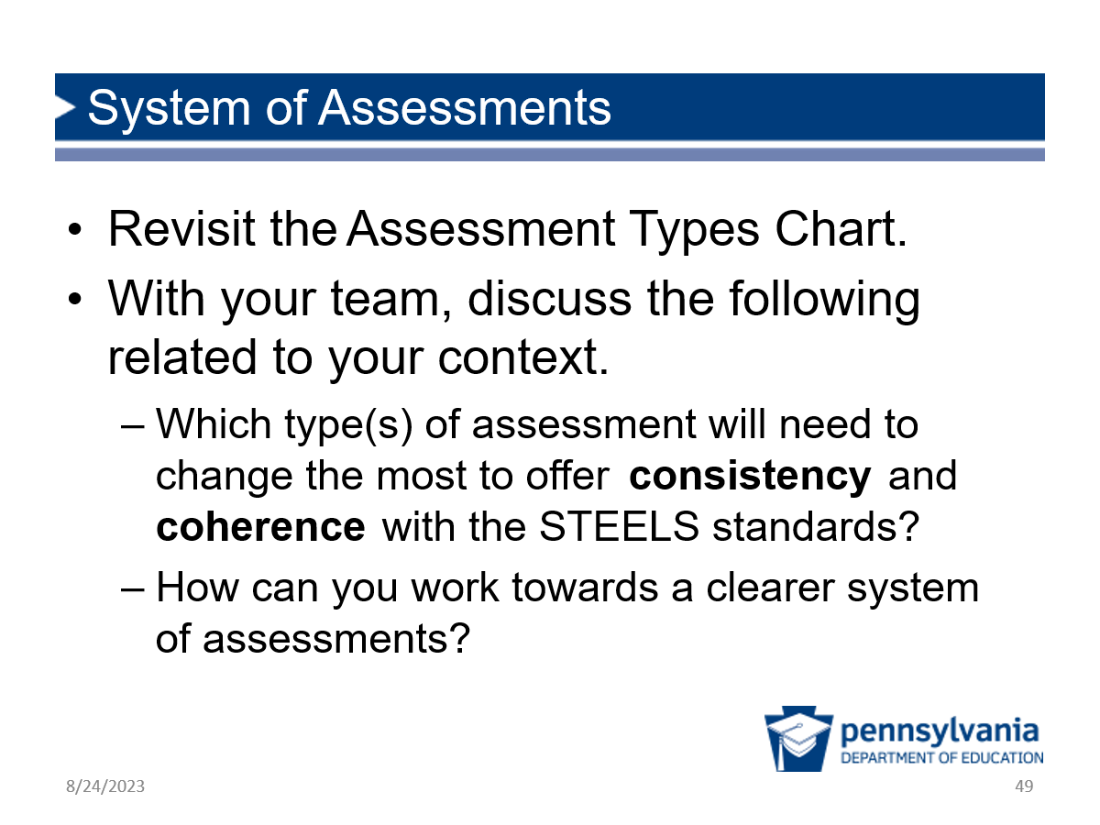 | Purpose of This Section: Participants consider the current assessments in their contexts and consider how they can move toward a clearer system of assessments.  Facilitation Step (15 min):  Ask participants to discuss the prompts on the screen in light of the System of Assessments handout and the graphic from the previous slide.  Sense-Making: Participants are able to use this time to make connections between the System of Assessments analysis and their own context and what it means for them.  Formative Assessment: Circulate and listen to the conversations happening to better understand how people are making connections to assessments in their own system and where opportunities for action might be.
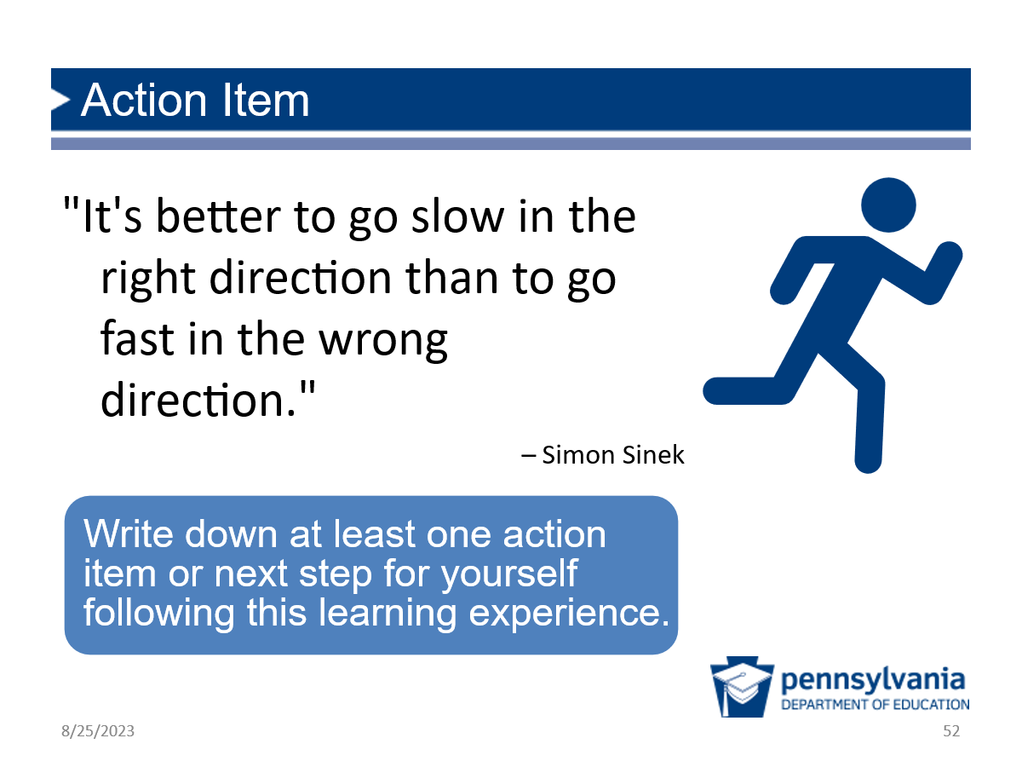 | Facilitation Step (3 min):  Finally, give participants one last opportunity to individually think and write an action item for themselves following this session.  Ask one or two to share out, highlighting any opportunities for action you heard in previous conversations.
Prep: Distribute index cards or sticky notes to all participants.
Facilitation Step (10 min):
- Ask participants to revisit the Vision Chart you created in Module 1 (if completed) and added to at the start of Module 3. Have them add any new ideas or revise ideas if their thinking has changed.
- Distribute index cards or sticky notes and have participants write the vision from their own perspective and role on the card.
- Ask them to stick it into their notebooks or another place where they will see it often.

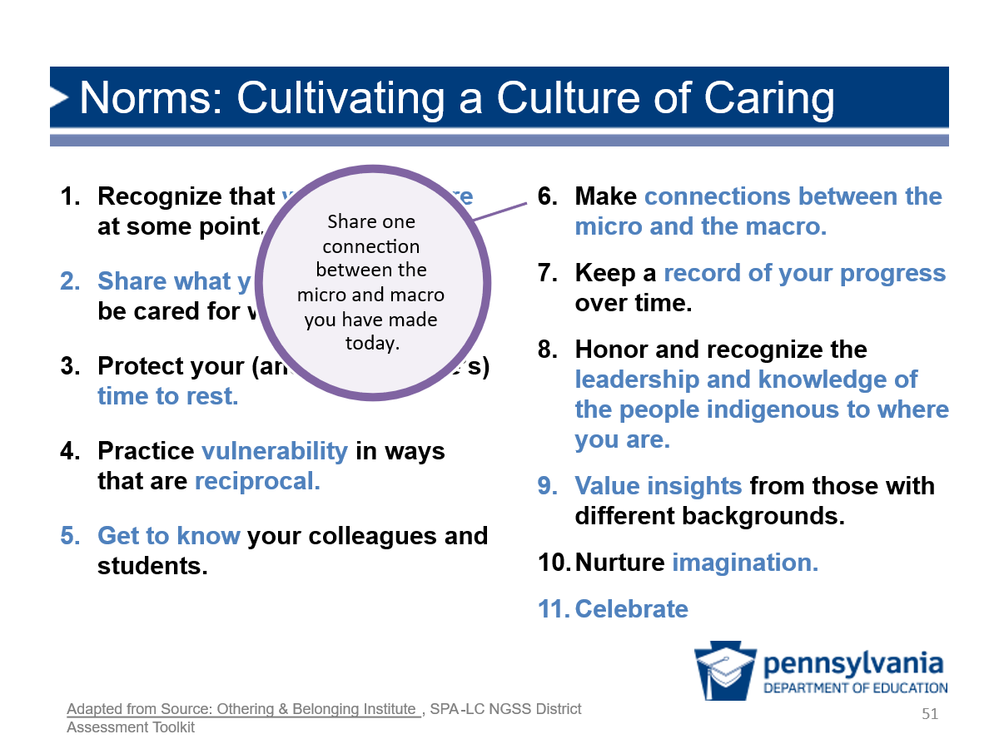 | Facilitation Step (2 min):  - Returning to our Culture of Caring slide, prompt participants to consider connections to the micro and macro they have made today and why that might be important to a culture of caring.  Possible Responses:  - Participants may raise the idea that teachers are not in this alone and should not bear the weight of this change on their shoulders. Change needs to happen at all levels of the system coherently with one another.  - Encourage empowering people to advocate for changes they see the need for in their systems.
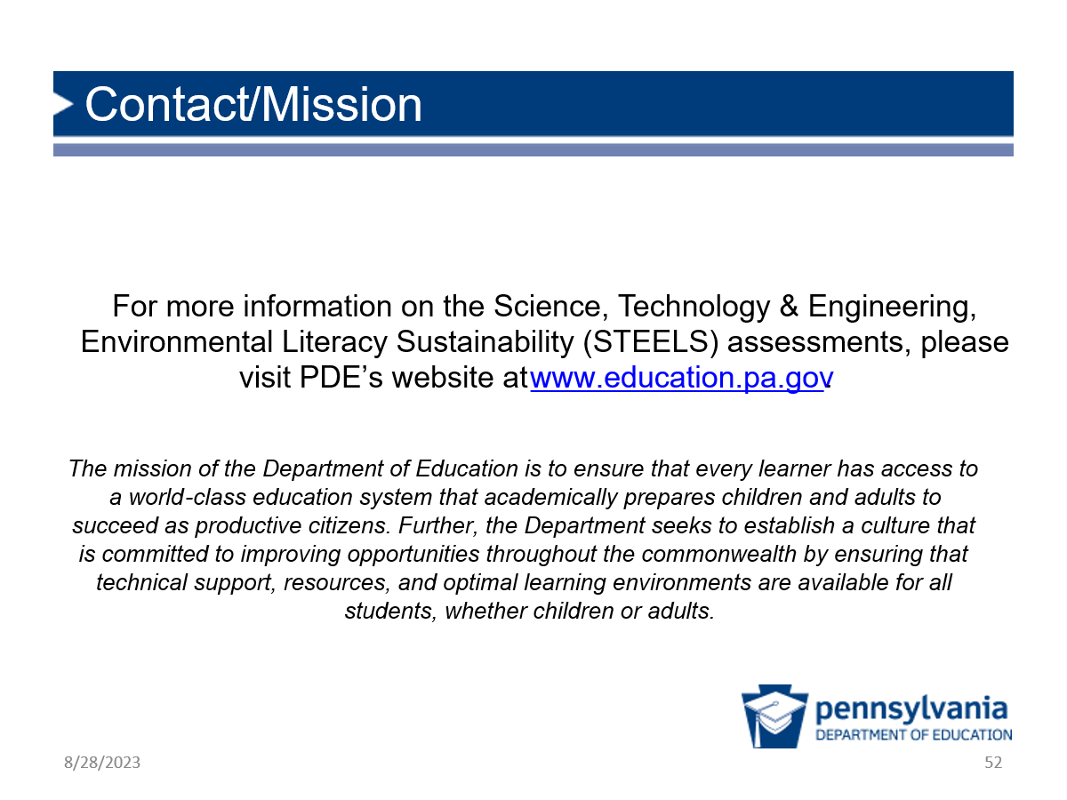

Module 3 Evaluation Sample Questions
How important was each activity in deepening your understanding of the features of high-quality assessments? (Not Important, Somewhat Important, Important, Very Important, N/A)
- Analyzing student work to consider how data can be used to improve student learning.
- Reflecting on what people in different roles can do to improve student learning, based on student work data.
- Gathering and analyzing evidence of how different assessment opportunities can support student learning and progress across a unit.
- Analyzing different types and purposes of assessment in a system of assessments.
- Reflecting and making connections between new learning about assessment and my own context.
How important was this activity in helping you connect and apply the learning to your own context? (Not Important, Somewhat Important, Important, Very Important, N/A)
- Analyzing student work to consider how data can be used to improve student learning.
- Reflecting on what people in different roles can do to improve student learning, based on student work data.
- Gathering and analyzing evidence of how different assessment opportunities can support student learning and progress across a unit.
- Analyzing different types and purposes of assessment in a system of assessments.
- Reflecting and making connections between new learning about assessment and my own context.
The timing of this activity was (Too long, about right, too short, N/A):
- Analyzing student work to consider how data can be used to improve student learning.
- Reflecting on what people in different roles can do to improve student learning, based on student work data.
- Gathering and analyzing evidence of how different assessment opportunities can support student learning and progress across a unit.
- Analyzing different types and purposes of assessment in a system of assessments.
- Reflecting and making connections between new learning about assessment and my own context.
Thinking about the module overall, how well do you think the module prepared you to do the following? (Not at all, slightly well, somewhat well, extremely well, N/A)
- Describe key steps in the Assessment for Learning Cycle (i.e., formative assessment process to analyze student work, look for trends, and identify implications for instruction and teacher support).
- Analyze and interpret evidence of multi-dimensional learning, including trends in strengths and needs across a variety of responses.
- Use data from student work analysis of multi-dimensional learning to make recommendations for adjustments in instruction.
- Describe different types of assessments in a system of assessments, their purpose, and how they work together to paint a full picture of student learning to varied audiences.
- Make recommendations for which assessments in my system need to change the most to offer consistency and coherence to support students to meet rigorous learning goals set by the STEELS standards.
How, if at all, will you use the knowledge or skills gained from this module in your work? [Open Ended]

What questions do you have after completing this module? [Open Ended]

Is there any additional feedback you’d like to provide? [Open Ended]

PDE doesn't endorse or recommend any curriculum. This OER unit is being used in this Toolkit as a tool to illustrate key features of curriculum-embedded assessment.

