The Pennsylvania Science, Technology & Engineering, Environmental Literacy Sustainability (STEELS) Assessment Foundations Toolkit
Facilitation Guide for Module 1:
Features of Quality Assessments for the STEELS Standards

In 2022, Pennsylvania adopted the Science, Technology & Engineering, Environmental Literacy Sustainability (STEELS) standards, new learning goals for K–12 students based on research of how students learn best. The three professional learning modules in the STEELS Assessment Foundations Toolkit are designed to support participants in building a foundation that how to monitor and further student learning of STEELS standards. To see an overview of the toolkit modules and goals, click here.

This document provides facilitation guidance for Module 1, which supports participants in building a common understanding of features of quality STEELS-based assessments, including tasks that are phenomenon/problem-based and multi-dimensional tasks.
Table of Contents
Module 1 Description page 2
Goals page 3
Language Considerations page 4
Materials Required and Session Preparation page 5
Module 1 Overview page 8
Key to Icons in Facilitator Guide page 11
Detailed Professional Learning Leader Notes page 12
Module 1 Evaluation Sample Questions page 50

Module 1 Description
Title: Features of Quality Assessments for the Science, Technology & Engineering, Environmental Literacy Sustainability (STEELS) Standards.
Module 1 Description: In this session, participants will learn about key features of high-quality STEELS-based assessments including phenomenon- and problem-based scenarios and multi- dimensional prompts. Participants will consider the extent to which these features connect with their own vision for meaningful science, engineering, and environmental literacy learning.
Timing: This session is designed to be facilitated in one day, as an approximately 5.5-hour session:
- Opening: Introduction to the STEELS Standards and Module 1 (10 minutes)
- Session 1.1: Assessments that Reﬂect Our Vision (1 hour 55 minutes)
- Session 1.2: Phenomenon/Problem-Based Assessment Scenarios (1 hour 15 minutes)
- Session 1.3: Multi-Dimensional Assessments (1 hour 10 minutes)
- Session 1.4: Evidence of Phenomena and Multiple Dimensions (55 minutes)

These time estimates do not include introductions, icebreakers, breaks, or lunch. Professional learning
facilitators should incorporate those as needed.

Audience: The audience for this module is K–12 classroom teachers, school leaders, or curriculum coordinators.
Modiﬁcations for Diﬀerent Grade Bands: The purpose of the example tasks in this module are to illustrate instructional shifts that are applicable to all grade bands; thus, it is helpful for teachers of grades K–12. While the featured example tasks in Module 1 span all grade bands, most are middle level task options. Example alternatives are occasionally provided to gear this module towards a particular grade band if needed.
Prerequisite Knowledge: We recommend that participants have previously participated in an immersive learning experience to feel these instructional shifts as learners. This is key to spark cognitive dissonance about prior beliefs and start to build trust in the eﬀectiveness of the new vision of teaching, learning, and assessing reﬂected in the STEELS standards.
Participants should have a working understanding of phenomena, engineering and environmental problems, and the idea that students are integrating knowledge and practice known as “three-dimensional” or “multi-dimensional” learning. It may be helpful for participants to review as prework (1) this resource about instructional shifts, (2) this resource about the engineering design process, and watch (3) this video about phenomena and (4) this video about the three dimensions of today’s science standards.

Goals
Module | Goal
Module 1:  Features of Quality Assessments for the STEELS Standards | Build a common understanding of features of quality STEELS-based assessments, including tasks that are phenomenon- and problem- based and multi-dimensional.
Session 1.1  Assessments that Reﬂect Our Vision | Participants reﬂect on their visions of meaningful science, engineering, and environmental literacy learning and the features of assessments that support that vision.
Session 1.2 Phenomenon/Problem-Based Assessment Scenarios | Participants deepen their understanding about phenomena/problems and their role in making student thinking visible and analyze features of eﬀective phenomena/problems in tasks assessing scientiﬁc, engineering, and environmental literacy learning.
Session 1.3  Multi-Dimensional Assessments | Participants deepen understanding of features of assessments that reveal how well students understand and can use multiple dimensions in the STEELS standards.
Session 1.4  Evidence of Phenomena and Multiple Dimensions | Participants identify evidence of phenomena and multi-dimensional learning in an example task.

Language Considerations
- Multi-dimensional: Why “multi-dimensional” and not “three-dimensional”? The Pennsylvania STEELS standards refer to three dimensions, including the Disciplinary Core Ideas (DCIs), Science and Engineering Practices (SEPs), and Crosscutting Concepts (CCCs). The PA STEELS standards have those three dimensions, but this assessment toolkit refers to “multiple dimensions” for two reasons: (1) the STEELS includes Technology & Engineering standards, many of which are two-dimensional and include Technology and Engineering Practices (TEPs) in addition to the SEPs; and (2) some quality assessments elicit student learning of two dimensions at a time rather than three.
- Practices: Throughout this document, “practices” are often used broadly to mean both Science and Engineering Practices (SEPs) and Technology and Engineering Practices (TEPs), which are a part of the STEELS. The TEPs are from the ITEEA Standards for Technological and Engineering Literacy.

Materials Required and Session Preparation
Printouts Needed
Item | Session Needed | Description
Three tasks for task comparison  - Snow Day Task  - Sea Star Reproduction Task  - Hurricane Destroys Boardwalk Task | Session 1.1 | 1 copy of all task documents per participant (Note: These tasks have symbols in the corner to help participants keep track. However, if available, consider printing these tasks on three diﬀerent colors of paper.)
Grades K–5 Phenomena, Problems, and Topics Card Sort  Grades 6–12 Phenomena, Problems, and Topics Card Sort | Session 1.2 | Depending on your audience, there are two sets of card sorts provided: one for audiences familiar with grades K–5 and one for audiences familiar with grades 6–12.  1 set for every 2 participants, printed on card stock
Task Annotation Project in Science  (TAPS) Scenario Resource (page 2) | Session 1.2 | 1 per participant  *Both pages of this resource have been provided, but we will only refer to page 2 in this session.
Gallery Walk Tasks | Session 1.2 | 1 copy of each of the ten tasks linked in the document  For larger groups, you may want to make multiple copies of each task. (See Preparation section below.)
CCC TAPS resource | Session 1.3 | 1 per participant
SEP TAPS resource | Session 1.3 | 1 per participant
Survivors Stranded Prompt A | Session 1.4 | 1 per participant

Item | Session Needed | Description
Survivors Stranded Analysis of  Participants’ Own Answers | Session 1.4 | 1 per participant
Optional: Standards Bookmark | Optional | 1 per participant, printed on card stock

Resources Needed
Item | Session | How many
Chart paper | All | 1 pack
Sticky notes (green, blue, orange,  purple, yellow, OR any ﬁve colors) | Session 1.2 | 1 pad of each color per table
Green, blue, and pink highlighters (if doing activity with STEELS colors) | Session 1.4 | 1 set for every 2 participants
Chart paper markers | All | A set for facilitators in all sessions; A handful of markers per group in Session 1.1 for Task Comparison activity
Reﬂection notebooks and pens  (optional) | All | 1 set per participant
Preparation
Item | Session | Description
Vision Chart paper | Session 1.1 | 1 piece of chart paper titled, “Science Education Vision,” posted at the front of the room for the whole group discussion
Task Comparison Chart paper | Session 1.1 | 1 blank piece of chart paper for  each group
Features of Quality Tasks | Session 1.1 | 1 piece of chart paper titled the “Features of Quality Tasks” posted

Item | Session | Description
 |  | at the front of the room for the whole group discussion
Phenomena/Problems Card Sort | Session 1.2 | Cut each card separately and prepare sets for groups of 2.
Features of Phenomena/ Problems | Session 1.2 | 1 piece of chart paper titled “Features of Phenomena/Problems,” posted at front of the room for the whole group discussion
Gallery Walk Task | Session 1.2 | Print 1 copy of each of the 10 tasks. Tape each individual task on a piece of chart paper and post them around the room.  Alternatively, consider a seated Gallery Walk with multiple copies of the same task in folders placed at diﬀerent tables around the room. This allows for people to examine the task individually while sitting.
NGSS vs. STEELS dimension color comparison chart (Optional) | Session 1.4 | Create a chart paper (with colored markers) that indicates the three dimensions color diﬀerence in the NGSS vs. PA STEELS. Use this example as reference.
Audio-visual capabilities | Session 1.4 | Ensure room has ability to play a  video with sound to participants.
Standards Bookmark | Optional | Print 1 copy of the Standards Bookmark on cardstock for each participant if you feel it would be helpful to have as a reference during the Module.

Module 1 Overview
Time | Purpose | Content
Opening  10 min | Participants deepen understanding about the context and need for this assessment toolkit learning experience. | - Overview of 2022 STEELS standards  - Overview of toolkit big picture goals and Module 1 goals  - Any other logistics
Session 1.1 Assessments that Reﬂect Our Vision (1 hour, 55 minutes)
Time | Purpose | Content
Vision Reﬂection  25 min | Participants reﬂect on their visions of meaningful science learning and the role assessments play in supporting and monitoring student learning. | - Reﬂect on and deﬁne a vision for science, engineering, and environmental literacy education.  - Consider what that vision means for assessment.
Task Comparison  80 min | Participants identify features of assessments that support their collective vision for meaningful learning for all students. | - Evaluate three tasks using participant initial ideas about STEELS-based assessments.  - Elicit valued features of high-quality assessments.
Connect to Context  10 min | Participants consider the extent to which these features are reﬂected in assessments in their current science, engineering, and environmental literacy programs. | - System-level reﬂection  about current state.  - Revisit the vision and add any new ideas as needed.

Session 1.2 Phenomenon/Problem-Based Assessment Scenarios

(1 hour, 15 minutes)
Time | Purpose | Content
Phenomena/ Problems 20 min | Participants examine the diﬀerence between topics, phenomena, and problems. | Card sort to distinguish between topics, phenomena, and problems.
Quality Scenarios  45 min | Participants deepen understanding about the role that phenomena/problems play in high- quality STEELS-based assessments by analyzing assessment scenarios across a variety of assessments. | - Gallery Walk to examine a variety of tasks for quality scenario features.  - Debrief for each feature.
Connect to Context  10 min | Participants consider the extent to which assessments in their current science programs include high- quality scenarios driven by phenomena/problems. | Reﬂection on the assessments that participants’ students interact with and their features.

Session 1.3 Multi-Dimensional Assessments (1 hour, 10 minutes)
Time | Purpose | Content
Multi-Dimensional Non-Negotiables 25 min | Participants will deepen understanding that multi- dimensional assessments must:  - Require students to use both science ideas and practice together;  - Focus on making sense of a phenomenon or problem to reveal use of multiple dimensions; and  - Require student reasoning. | Share examples that require students to use just ideas, just a practice, and ideas and practices together in order to successfully complete the task.  Reﬂect: In the examples where ideas and practices are used separately, are they more or less likely to engage in sense-making about a phenomenon/problem?

Time | Purpose | Content
SEPs and CCCs  40 min | Participants will deepen understanding of measuring proﬁciency in CCCs:  - Must explicitly assess whether students can use CCCs to make sense of something; and  - Can be done in various ways, with CCCs used as a lens, tool, or bridge to deepen and advance thinking to make sense of something.  Participants will deepen understanding of measuring proﬁciency in SEPs:  - Skills vs. practices; and  - Representing vs. sense-making. | - Consider diﬀerent uses of  CCCs.  - A-B-Each-Teach with TAPS CCC and SEP resources.  - Debrief and identify common pitfalls in multidimensional assessments.
Connect to Context  5 min | Participants consider the extent to which these features are reﬂected in their current science programs. | Reﬂection

Session 1.4 Evidence of Phenomena and Multiple Dimensions
(55 minutes)
Time | Purpose | Content
Task Analysis  45 min | Participants will identify evidence of phenomena and multi-dimensional learning in an example task. | - Participants analyze a three-dimensional claim, task, and student work for grade-appropriate targeted dimensions.  - Reﬂection: What insights did this create in your understanding of quality science assessments and the STEELS standards?
Time | Purpose | Content
Connect to Context  10 min | Participants consider the extent to which these features are reﬂected in | - System-level reﬂection: What can you do to move towards this vision?
 | their current science, engineering, and environmental literacy programs. | - Next steps and preview of  Module 2 and 3.

Key to Icons in Facilitator Guide

Throughout the following facilitation guidance, you’ll see three icons:
Resource Icon: This icon will appear when the toolkit references or uses a concrete resource that may be helpful for participants following the session. A complete list of these resources can be found in the Resource Folder.

Sense-making Icon: Based on the research of how adults learn, we know it’s most eﬀective for participants to construct learning and lead the learning with their ideas.
Therefore, throughout these modules we want to avoid lecturing or simply providing the “right answer” — we need participants to grapple with the ideas and ﬁgure out key takeaways, with help and guidance from the facilitator. This Sense-making Icon will appear in key moments when participants are making sense of something, indicated those conversations should not be cut or rushed.
Formative Assessment Icon: These are key moments when it may be particularly helpful for you as a facilitator to listen and gain insights about the current thinking of your participants and use them to inform your facilitation moves.

Detailed Professional Learning Leader Notes

Session: 5 hours, 40 minutes (including one 10-minute break)
Slides 1–7 (10 min — Intro/Welcome)
Slides 8–28 (1 hour, 55 min — Session 1.1 Assessments that Reﬂect Our Vision)
Slides 29–42 (1 hour, 15 min — Session 1.2 Phenomenon/Problem-Based Assessment

Scenarios)
Slides 43–59 (1 hour, 10 min — Session 1.3 Multi-Dimensional Assessments)
Slides 60–71 (45 min — Session 1.4 Evidence of Phenomena and Multiple Dimensions)
Slides 72–77 (10 min — Reﬂection and Closing)
Opening (10 minutes)
STEELS Introduction (5 minutes)
Slides | Content
The Pennsylvania STEELS Assessment Foundations Toolkit  Module 1: Features of Quality Assessments for the Science, Technology & Engineering, Environmental Literacy Sustainability (STEELS) Standards  [Date]    7/26/2023 1 | Title Slide (<1 min)  Purpose:  Introduce the module and how this learning connects to  overall goals for transitioning to the STEELS.  Facilitation Step:  - Welcome participants to the Module 1 session and introduce the facilitation team.  - Share any meeting logistics information.
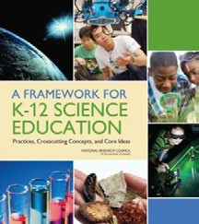    STEELS: Rigorous Learning Goals  In 2022, Pennsylvania adopted the Science, Technology & Engineering, Environmental Literacy & Sustainability (STEELS) standards, new learning goals for K–12 students based on research of how students learn.  Updated PSSA and Keystone exams are operational in spring 2026.  8/27/2023 2 | STEELS Standards Introduction (4 min for next two slides)  Possible Narrative:  In 2022, Pennsylvania adopted the Science, Technology & Engineering, Environmental Literacy Sustainability (STEELS) standards. These standards reﬂect the research about how students learn best.  PSSA and Keystone exams are being updated for the new  standards and will be operational as of spring 2026.

Slides | Content
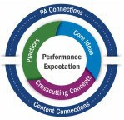  STEELS: Rigorous Learning Goals  These K–12 standards Learning about  represent not just what  kids learn, but how they  learn: Figuring out  Local Pennsylvania  learning contexts  A shift from “learning  about” to “figuring out”  that puts students in the Cross-content  driver’s seat. connections  3  8/27/2023 | Possible Narrative:  - These K–12 standards represent not just what students learn, but how they learn.  - They oﬀer a vision in which science and engineering instruction and assessments shift from “learning about” to “ﬁguring out” through phenomenon- or problem- driven learning and performance.  - This is a move away from students memorizing disconnected facts; rather, students should be investigating phenomena as they engage in science practices and learn about disciplinary core ideas using crosscutting concepts.  - In addition, Pennsylvania is emphasizing the importance of local Pennsylvania learning contexts and cross-content connections to increase relevance and coherence of student learning.
Toolkit Introduction (5 minutes)
Slides | Content
STEELS Assessment Foundations Toolkit    The three modules in this toolkit will support participants to build a foundation in how to monitor and further student learning of Pennsylvania’s 2022 STEELS standards.  Module 1: Features of Quality STEELS Assessments  Module 2: Assessing Rigorous Science Learning of All Students  Module 3: Cultivating a System Where Assessments Work Together to Improve Student Learning  7/26/2023 4 | Toolkit and Module 1 Introduction (5 min for next 4 slides)  Facilitation Step:  Provide a quick overview of the STEELS Assessment Foundation structure: it includes three connected modules. Explain that the ﬁrst module focuses on features of quality science assessments.
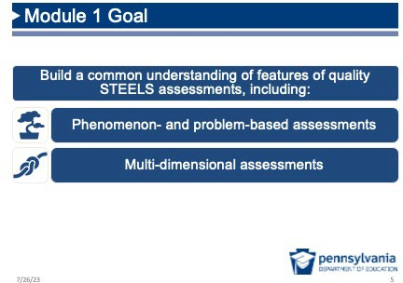 | Facilitation Step:  Share Module 1 Goal. Explain that in Module 1 you’ll be thinking about features connected to two areas: (1) phenomena and problems and (2) multi-dimensional assessments.

Slides | Content
Module 1: Features of Quality STEELS Assessments  Module 1 Progression  Session 1.1 Session 1.2 Session 1.3 Session 1.4  Phenomenon  Assessments /Problem - Multi - Evidence of that Reflect Based Dimensional Phenomena Our Vision Assessment Assessments and Multiple Scenarios Dimensions  6 | Facilitation Step:  Highlight that Module 1 is divided into four sessions:  - Session 1.1: Assessments that Reﬂect Our Vision  - Session 1.2: Phenomenon /Problem-Based Assessment Scenarios  - Session 1.3: Multi-Dimensional Assessments  - Session 1.4: Evidence of Phenomena and Multiple  Dimensions
Create Your Workspace  - What could set you up to do your best learning, collaborating, and thinking in this context?  - How do you want your workspace arranged today?  - What resources do you want to have pulled up?  8/27/2023 Source: SPA-LC NGSS District Assessment Toolkit 7 | Facilitation Note:  - You may choose to provide a moment for participants to “get comfortable” before diving into this learning session.  - Feel free to adapt this slide or to include any other session logistics here that may help participants to get ready for the session.  Facilitation Step:  - Give participants a couple of minutes to get situated and  ready for the session.
Session 1.1 Assessments that Reﬂect Our Vision (1 hour, 55 minutes)

Where we are going in this session
Participants reﬂect on their visions of meaningful science learning and the role assessments play in supporting and monitoring student learning. The vision brainstorm and task comparison are designed to elicit current initial ideas of participants so we can build on them throughout the rest of Modules 1 and 2. Welcome a variety of perspectives and encourage participants to explore them and make connections to one another’s ideas.

Where we are NOT going in this section
Participants will bring a variety of ideas into the session. Avoid suggesting that there are right or wrong answers during the vision, task comparison, or phenomena card sort activities.
Participants will have the opportunity to revise their initial ideas based on their learning throughout the module.

Vision Reﬂection (25 minutes)
Slides | Content
Module 1: Features of Quality STEELS Assessments  Module 1 Progression  Session 1.1 Session 1.2 Session 1.3 Session 1.4  Phenomenon  Assessments /Problem - Multi - Evidence of that Reflect Based Dimensional Phenomena Our Vision Assessment Assessments and Multiple Scenarios Dimensions  8 | Facilitation Step (<1 min):  Transition to Session 1.1.
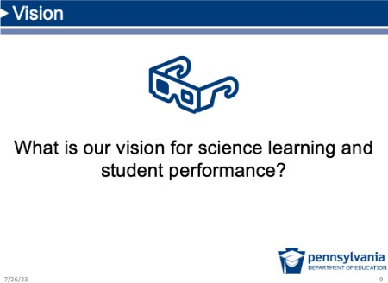 | Possible Narrative (<1 min):  Introduce topic: Let’s start by centering students in this work. Next, we’ll talk about our vision for learning in science classrooms.
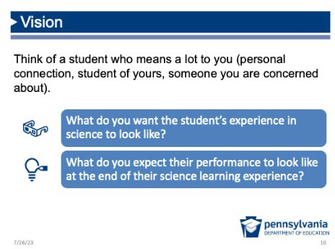 | Purpose of This Session: Participants develop an initial vision  for science learning and teaching.  Vision (10 min)  Prep: One piece of chart paper titled,  “Science Education Vision,” posted at the front of the room  for the whole group discussion.  Possible Narrative:  Think of a student who means a lot to you. This could be a student you’ve taught before or someone in your family or community. What do you want that student’s experience in science to look like? What do you hope their performance would look like at the end of their science learning experience?  Facilitation Steps:  - Individual Reﬂection: Give participants 2–3 minutes to  reﬂect individually.

Slides | Content
- Shoulder Partner: Ask participants to share with a
partner.
- Whole Group Debrief: Ask some participants to share their ideas with the whole group and record them on the “Vision Chart” at the front of the room. Throughout the session, use this chart to make connections, as they arise, to the group’s vision for science teaching and learning.
- Synthesize the Vision (Optional): If there is more than one facilitator, have one facilitator take the items on the Vision Chart and summarize them as a brief sentence that begins with “Students….” This is a way to have a concise sentence that summarizes the group’s vision, but not spend too much time wordsmithing as a group. A concise sentence that captures the important ideas can be revisited throughout the module and help remind participants of the kind of teaching and learning we want assessments to support. There will be opportunities to revisit the vision statement later in the session.
Common Answers  Students as  “doers” engaging  Critical thinking All students as scientists and Flexible, creative  engineers reasoning  Figuring out the Relevant and Solving local Working in new  world around authentic community contexts  them problems  Motivated, Prepared for  engaged, college, careers, inspired students  and citizenship  8/22/2023 11 | Facilitation Step (<1 min):  - This slide shows some common answers received in other sessions like this one in response to the vision question. (Not necessarily the “right” answer — just some examples if they’re needed.)  - This is meant to be a quick slide. Point out there are connections to the list that the group has just created.
Assessments That Measure What We Value  If that vision is what we value in science and engineering education…  How many of our current assessments measure what we value?  8/27/2023 12 | Purpose: Connect this vision for what we value in science teaching and learning to the current reality of assessments. For the rest of Module 1, we are going to think about how we can make our assessments better support this vision.  Possible Narrative (<1 min):  - If this is what we value in science, raise your hand if ~50% of the assessments you see measure what we value.

Slides | Content
[Anticipated response: few to no participants raise their
hands.]
Vision  It’s important that assessments measure what we value for all learners and support us in reaching our vison.  8/22/2023 13 | Possible Narrative (<1 min):  - Assessments can and should measure what we value. In this module, we’re going to talk about some of the features of assessments that will more closely reﬂect the vision you all just described.
Assessments That Support Our Vision  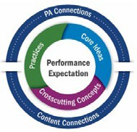  The 2022 STEELS standards require us to think about assessment differently.  Learning about topics in science  Figuring out phenomena / problems  8/27/2023 14 | Possible Narrative (<1 min):  - The K–12 STEELS standards require us to think diﬀerently not just about instruction, but assessment too.  - This is an opportunity for our assessments to support what we value in science and engineering education — students ﬁguring out the world around them and solving problems in their communities.
Norms: Cultivating a Culture of Caring  - Recognize that we all need care 6. Make connections between the at some point, in some way. micro and the macro.  - Share what you need in order to 7. Keep a record of your progress be cared for well. over time.  - Protect your (and other people’s) 8. Honor and recognize the time to rest. leadership and knowledge of  the people indigenous to where  - Practice vulnerability in ways you are.  that are reciprocal. 9. Value insights from those with different backgrounds.  - Get to know your colleagues and  students. 10. Nurture imagination.  11. Celebrate.  Adapted f rom Source: Othering & Belonging Institut,eSPA -LC NGSS District 15  Assessment Toolkit | Purpose: This slide is meant to be a relatively quick reﬂection on caring as a way to frame norms for this professional learning session. In the following slide, we will also talk about what it would mean for assessment to be a “caring practice.”  Possible Narrative (2 min):  - This slide is based on a set of norms developed by UC Berkeley’s Othering and Belonging Institute, which is a group committed to advancing more inclusive, fair, and just practices.  - For our work together to be meaningful and productive, I’d like you to think about what it means to cultivate a culture of caring in our professional learning environment.  - Take a moment to read the slide. While you read, think about what these features mean and how they might support our work together.  Facilitation Step:

Slides | Content
Give a couple of participants a chance to share out ideas with
whole group.
What if… Assessment Were a Caring Practice?  How would What might What might student this look like in  this look like in experience  assessment? change with our work  assessments? together?  8/27/2023 Source: SPA-LC NGSS District Assessment Toolkit 16 | Purpose: Participants reﬂect on how the culture around assessments will change if the purpose of assessments shifts from evaluating students to caring for and supporting students to improve their learning. This is part of a larger goal of shifting the vision of assessments towards a more caring system to support all students to meet the learning goals.  Assessments as a Caring Practice (3 min)  Facilitation Step:  - Ask participants to turn and talk about the questions on  the screen.  - Invite three to four participants to share out ideas from  their discussion.  Possible Narrative After Share Out Discussion:  - A lot of the ideas I’m hearing connect to the idea that this is not just a change in assessments themselves, it’s a change in the culture around assessments and how we use data.  - To do that, we can think about the focus on using data to work with students to improve student learning rather than just evaluating them.
Thought Experiment: Jack and Jill  Jack and Jill are discussing new STEELS assessments, and they’ve run into some issues balancing diﬀerent considerations for their tasks.  They have a shared …but they disagree overall vision for about the “right” science education for trade-oﬀs to make to  all students… support all students.  8/21/2023 15 | Jack and Jill Introduction  Possible Narrative:  - We’re going to try a thought experiment, which are two ideas from individuals, who we’ll call “Jack” and “Jill.”  - They’ll be visiting us a couple times throughout the session. Please note: Neither one represents the “right” answer.

Slides | Content
- This thought experiment can help us elicit our own thinking about science assessment.
- Jack and Jill have a shared overall vision for science education for all students, but they disagree about the “right” trade-oﬀs to make to support all students.
Thought Experiment: Jack and Jill  Do you agree more with Jack or Jill?  Jack Jill  “Assessments are for gaining “Assessments are for insight into students’ ideas generating a score or that can help us build on grade that shows their current thinking and student progress for  further their learning.” several audiences.”  8/21/2023 16 | Jack and Jill (4 min)  Facilitation Step:  - Read. Give participants time to read each perspective. Express that there’s no “right” answer.  - Think. Ask participants to decide who they agree with  more.  - Choose One. Have participants raise their hands if they agree with Jack, then with Jill. Remind participants this is a safe space where we can disagree respectfully with each other.  - Share Out. Ask a few pro-Jill participants to share their  reasoning, then pro-Jack.  - Ending with the pro-Jack arguments will help set the stage for a conversation about how assessments can support our vision.  Possible Transition Narrative:  - There is no right or wrong answer here, but I will invite you to consider how assessments can best support our vision for science and engineering for all students.  - For tasks to really support our vision, we need the tasks to be designed in a way so they give us insights about the things we value in science education. That’s what we’re going to focus on after a quick reﬂection.

Slides | Content
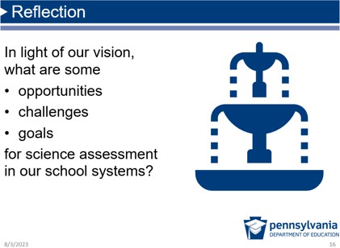 | Reﬂection (5 min)  Facilitation Step:  - Give participants a few minutes to journal their ideas about opportunities, challenges, and goals.  - Let participants know that we won’t share out our ideas with the whole group, but they will have a chance to revisit their ideas about their own system throughout our time together.  Possible Transition Narrative:  Now that we’ve reﬂected on some potential opportunities and goals for assessments in our school systems, let’s think about the actual design of assessments that might help us reach those goals.
Task Comparison (80 minutes)
Slides | Content
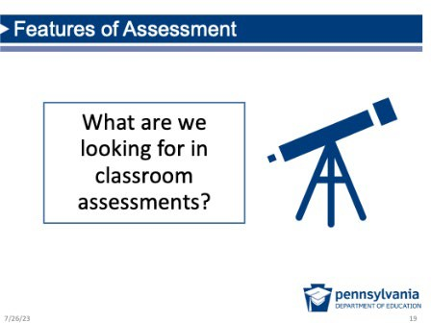 | Purpose of the “Task Comparison” Section: Participants will elicit their current thinking and surface common themes of high-quality assessments that will be used to drive their learning for the rest of Module 1 and Module 2 (if using).  Features of Assessment Intro Slide (<1 min) Possible Narrative:  - The next section will elicit our current thinking about  high-quality assessments.  - To help us get started, let’s turn to our friends Jack and Jill to hear about another disagreement they are having.

Slides |  | Content
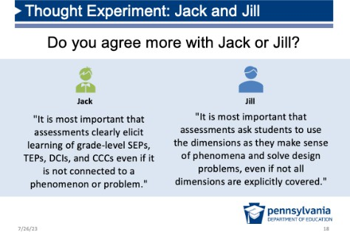 |  | Purpose: Participants consider two diﬀerent perspectives of science assessments and discuss tradeoﬀs of each viewpoint.  Jack and Jill (4 min) Facilitation Step:  - Read. Give participants time to read each perspective.  Emphasize to participants that there’s no “right” answer.  - Think. Ask participants to decide who they agree with more. (While participants might agree with ideas from each, they will be asked to just pick one.)  - Choose one. Have participants raise their hands if they agree with Jack, then with Jill. Remind participants this is a safe space where we can disagree respectfully with each other.  - Share out. Ask a few pro-Jack participants to share their reasoning, then pro-Jill. Encourage participants to build on each other’s ideas and responses.  Ideas to Elicit:  - There are many tradeoﬀs to consider with assessments  designed for the STEELS standards.  - We have a lot of diﬀerent ideas, and throughout this meeting we’re going to spend some time reconciling them.  Possible Transition Narrative:  To more deeply examine diﬀerences in our ideas about  quality assessments, let’s start by looking at some examples.
      Three Tasks | These tasks are not  exemplars. T y are | Prep:  - Distribute the three tasks and their corresponding assessment targets. (Note: Two are middle school and one is elementary.)  Possible Narrative:  - We’re going to start looking at sample assessment tasks.
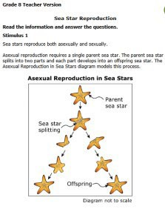
meant to spark
discussion.

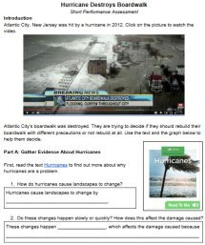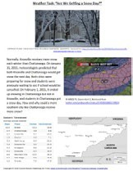
*An assessment task is a specific activity designed to collect evidence about a student's achievement of a targeted learning outcome.

Slides | Content
- Note the deﬁnition of task on the screen: It’s not just any activity that happens to create an artifact of learning, it’s an intentional activity that seeks to elicit evidence of a targeted learning outcome.
- That’s why you’ll also receive the targeted learning outcome for each task with STEELS-speciﬁc learning targets.

Facilitation Steps (2 min):
- Describe that these three tasks are not perfect and are not meant to be exemplars — they’re meant to spark discussion. They are Open Education Resources (OER), which means they’re free and publicly available, example tasks from the ﬁeld that we’re sharing as examples to elicit our initial ideas and features we value in assessments.
  - Share that the symbol in each task corner (or color of paper, if you have printed tasks on diﬀerent colors) can help your discussion and keep them straight.
- Task Purpose: If somebody asks about task purpose (e.g., formative/summative), share that the teacher guidance portions are not being shared and their analysis is limited to the student experience. They can assume students have had the opportunity to learn the content being assessed.

Resource: Concrete example tasks are a valuable resource. The resource page has links to these tasks in addition to teacher guidance if participants are
interested in learning more following the session.

Slides | Content
What Do We Look for in Assessments? You have three tasks.By yourself:  - Work through each task as a student might. For each task, jot down what you like about the task and what concerns you about the task.  - Order the tasks from most likely to support your vision of science education to least likely.  - Make notes about what patterns in the tasks are driving your decisions, referring to evidence from each task.  8/27/2023 23 | Explain Task (5 min)  Individual Analysis (25 min) Facilitation Steps:  - Provide time. Give participants approximately 25 minutes to work through each task as a learner, writing their answers.  - Ask them to take notes. As they complete the tasks, have them make any notes about what they like about the task and what concerns them about the task.  - Ask participants to order the tasks from most likely to support their vision of science education to least likely.  - Note evidence. As participants order the tasks, ask them to make notes about what is driving their decisions, referring to evidence from each task.
What Do We Look for in Assessments?  With your group, construct an argument for the “right” order of the tasks on chart paper. In your argument, make sure you include:  - The order your group agreed upon;  - An alternative order you considered;  - Your evidence and reasoning for why the order you agreed on is right; and  - A summary of the top 3–5 features that drove your decision making as a group.  8/27/2023 24 | Prep:  - One blank piece of chart paper for each group.  - One piece of chart paper titled the “Features of Quality Tasks” posted at the front of the room for the whole group discussion.  Facilitation Step for Group Analysis (20 min)  - New Groups. Divide participants into groups of three to four people. It may be good at this point to mix up groups, so participants are interacting with new people for this activity. Participants often appreciate not sitting with the same people throughout an entire learning experience and can gain new insights.  - Group Task:  - Discuss the key features and evidence for their individual rankings of each task.

Slides | Content
- Work together to determine a “right” order for the tasks and record the bulleted items on the screen on their group’s chart paper.

Sense-making: This is an important sense-making moment for participants reconciling their current beliefs about assessments and coming to consensus
with their group. This small group and subsequent full group debrief can help participants articulate new and important ideas about STEELS-based assessments.
Formative Assessment: This is a good opportunity to walk around and formatively assess participants’ current priorities in assessment tasks. This may
help determine some areas to address during the full group debrief.
Full Group Debrief (25 min):
- Share out. Ask some or all groups to share their
argument with the whole group.
- Record on chart paper. During this discussion, record common themes that participants discussed when ranking the tasks on the “Features of Quality Tasks” chart paper. Only record positive features — if one states something negative about a task (“it’s too confusing”) reframe it to a positive to add to the chart (“clear and coherent”). The list should not be limited, and you should write down all shared participant ideas, but pay special attention and be sure to write down (in participants’ own language) anything about:
  - Phenomena/problems or real-world connections to motivate and engage students. Listen for Pennsylvania-speciﬁc modiﬁcations participants talk about to increase the relevance of the task scenario (e.g., Pennsylvania-speciﬁc location for Hurricane task) and note these local connections are a priority of the STEELS standards.

Slides | Content
- Integrating knowledge and practice by using the three dimensions.
- Students using reasoning or making sense of something rather than regurgitating rote knowledge.
- Fair, equitable, or accessible features (e.g., using both text and pictures, appropriate scaﬀolds, oﬀering multiple ways to make thinking visible).
- If those don’t come up, consider some prompts to elicit them if possible:
  - You mentioned a “real world connection” and that the task would be relevant to students, can you say why you think that is helpful for students? [May elicit something connected to real-world phenomena/problems as a motivating and engaging context for learning]
  - You mentioned that you liked that these were “hands-on” or not "regurgitating vocabulary and facts,” can you say more about why that’s important to you? [May elicit the idea that students are applying practices and knowledge together to make sense of something or use reasoning]
  - You mentioned there were lots of visuals and reading support in one task. Why is that important? [May elicit accessibility or equitable features]
- These features will be on the following summary slide, so it will be good to make connections between the whole group answers to create more buy-in for the list.

Slides | Content
Themes    Phenomena and Problems  Multi- Dimensional  Sense-Making  / Reasoning  Fair and Equitable  8/27/2023 25 | Facilitation Step (<1 min):  - Share that when we’ve done this task comparison activity in the past, these are some common themes we’ve heard.  - Make connections to any themes that were just shared in the whole group discussion and highlight ones that were not discussed during the task evaluations.  - Tie to Vision. Make connections between these and the vision conversation in the opening session.  - Building on our ideas. Share with participants that we will be developing a deeper understanding of each of these features of STEELS-based assessments.
Connect to Context (10 min)
Slides | Content
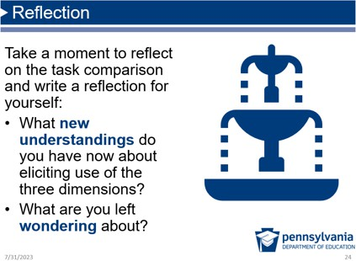 | Reﬂection (5 min)  Facilitation Step:  - Purpose Reminder. Participants may feel overwhelmed at this point. It may be helpful to remind them the purpose of this session was to begin digging into the features of assessments for STEELS, not with the expectation that they’ll need to immediately implement all of this tomorrow. It’s a marathon, not a sprint.  - Reﬂection. Ask participants to individually journal in response to the two reﬂection questions on the slide.
Revisiting Our Vision  Do you have any new ideas you'd add to our vision?  What do you want the student’s experience in science to look like?  What do you expect their performance to look like at the end of their science learning experience?  8/22/2023 29 | Purpose: Participants reﬂect on their vision for science education and revise it based on their learning from Session 1.1.  Revisiting Our Vision (5 min) Facilitation Step:  - Refer to the chart paper with the group’s vision for  student learning and performance. If you developed a

Slides | Content
sentence summary of the vision, this may be a good time to introduce and reﬂect on it. Oﬀer a brief opportunity to adjust the sentence (while emphasizing it does not need to be perfect).
- Provide an opportunity for participants to reﬂect on whether there is anything they’d add or edit after our task comparison activity.
- Allow for a moment of individual reﬂection followed by
share out.
- Use a diﬀerent color marker or sticky notes to show which items are revisions on the Vision Chart paper.
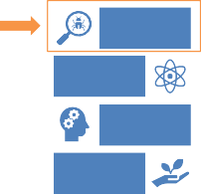  Themes  Phenomena and Problems  Multi- Dimensional  Sense-Making  / Reasoning  Fair and Equitable  8/27/2023 28 | Facilitation Step (<1 min):  Display slide to transition to the ﬁrst feature: The ﬁrst feature of quality assessments we will be focusing on is phenomena and problems as a context for student assessment tasks.

Session 1.2 Phenomenon/Problem-Based Assessment Scenarios

(1 hour 15 minutes)

Where we are going in this session
Participants develop a common understanding of phenomenon- or problem-based assessment scenarios and the role they play in assessments.

Where we are NOT going in this section
The point is not to get caught up in right or wrong categories for answers during the card sort; rather, it is to elicit the instructionally productive features of phenomena and problems.
Phenomena/ Problems (20 minutes)

Slides | Content
Module 1: Features of Quality STEELS Assessments  Module 1 Progression  Session 1.1 Session 1.2 Session 1.3 Session 1.4  Phenomenon Evidence of  Assessments /Problem - Multi - Phenomena  that Reflect Based Dimensional and Multiple  Our Vision Assessment Assessments Dimensions  Scenarios  29 | Possible Narrative for Transition (<1 min):  Now that we’ve identiﬁed some of the features of high-quality assessments and how they connect to our vision, we’re going to take a look at what we mean by phenomenon- and problem-based assessment scenarios.  Purpose of the Phenomena/Problems Section: Participants will examine the diﬀerence between and key features of topics, phenomena, and problems.  Facilitation Step:  Transition to Session 1.2.
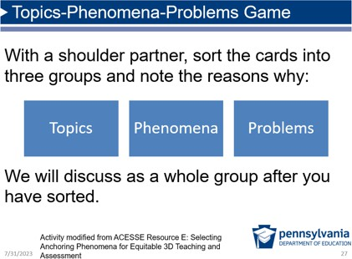 | Prep:  - Distribute the “Phenomena/Problems Card Sort” set to  teams of two.  - Post the “Features of Phenomena/ Problems” chart paper  in the front of the room for the whole group discussion.  Purpose: Participants ﬁgure out the qualities of an eﬀective phenomenon and problem for use in STEELS-based assessments. We are purposely not providing the deﬁnition beforehand because we want participants to elicit their thinking, but you can clarify topics are basically core ideas in science.  Facilitation Step:  - Describe Task (2 min): Let participants know they will engage in a card sort to help us determine what is, and isn’t, an instructionally productive phenomenon and problem through concrete examples. Your task is to work in pairs to sort these cards into three piles: Topics, phenomena, and problems.  - Work as Teams (7 min): Have them discuss and note their thinking: What makes this a phenomenon, problem, or topic (disciplinary core idea)?

Slides | Content
Formative Assessment: This is a good opportunity to walk around and formatively assess participants’ current understanding of phenomena and problems.
This may help determine some areas to address during the full group debrief.


Sense-making: This is an important sense-making moment for participants, which is why we do NOT want to provide the deﬁnitions or answer key up
front. Examining the diﬀerences in the cards will apply and build on their understanding of quality phenomena and problems.

- Full Group Debrief (10 min): After giving teams time to sort piles, ask questions to elicit Features of Phenomena/Problems on chart paper. Possible questions include:
  - What are some that you are sure are phenomena and why?
  - What are some that you are sure are topics and why?
  - What are some that you are sure are problems and why?
  - What are some you are unsure of?
  - Do you see connections to both Technology & Engineering and Environmental Literacy learning goals represented? [This question drives home that phenomena and problems are necessary and appropriate for all of STEELS.]
- After each group shares, invite the whole group to respond to their placement of the cards and how they deﬁned problems or phenomena.
  - Do other groups agree with their placement?
  - Did other groups deﬁne problems or phenomena similarly/diﬀerently? How?

As participants share how they deﬁne phenomena and problems, record their ideas on the “Features of Phenomena/Problems” chart paper. Possible answers include:

Slides | Content
- Phenomena: Observable events (though not necessarily
with the naked eye);
- Problems are situations somebody wants to change (e.g., children get too hot on a sunny playground), not a "design for design’s sake” challenge (e.g., build the tallest structure possible out of paper and tape);
- Needs to be a real-world speciﬁc instance (e.g., A 1998 earthquake in NW PA caused minor structural damage but impacted the local groundwater) rather than a general idea (e.g., earthquakes) to improve relevance and motivation;
- Relevant to students;
- Can be explained with science, engineering,
environmental literacy ideas;
- Local (especially for K–5 students — older students can
and should start learning beyond their own backyard);
- Puzzling/Compelling so students are motivated to ﬁgure it out; and
- Clear and doesn’t include a bunch of unnecessary
information.

Resources: These may be helpful additional resources to dig into the role of phenomena and problems in instruction. In the next section, we’ll
focus on the role of phenomena and problems in assessment.
- Problems with Problems: Improving the Design of Problem-Driven Science and Engineering Instruction
- Using Phenomena
- This card sort activity is modiﬁed from ACESSE Resource E: Selecting Anchoring Phenomena for Equitable 3D Teaching and Assessment, an OER professional learning session. To learn more about the ACESSE project, click here.

Slides |  | Content
Uncertainty Is Key  - Uncertainty is inherent in scientific understanding.  - A good phenomenon or problem in both instruction and assessment poses uncertainty to students.  8/27/2023 31 |  | Possible Narrative (<1 min):  - One of the things we just heard in this discussion is the importance of uncertainty when it comes to quality phenomena and problems.  - Remember that science is a way of knowing and making sense of the world, not a set of facts. This is true across the board for STEELS: Science, Technology & Engineering, and Environmental Literacy Sustainability.  - This uncertainty that gets students asking questions and wondering is important for both instruction and assessment.  - We’re going to continue to explore what it looks like to  have phenomena and problems in assessments.
Topics-Phenomena-Problems |  | Facilitation Step (1 min):  - Show some working deﬁnitions of topics, phenomena, and  problems.  - Again, this should not override the robust conversation you and your participants had. Make connections to your discussion and any similarities and diﬀerences.
 | Working Deﬁnition Example
 | Topics General categories like Plants and animals in an those you might see in a ecosystem rely on each science textbook other.
 | Phenomena Events that can be When Melody hit the explained with science plunger against the wall, it ideas stuck.
Problems Situations somebody People are getting sick when wants to change (that eating a lot of ﬁsh from the might be solved through Susquehanna River.
science, technology, and
engineering practices)
Adapted f rom: Phenomena &Problem Solv ingBite-Sized Module, National
8/27/2023 Center f or the Improv ement of Educational Assessment in collaboration with The 32
Alabama Math, Science, and Technology Initiativ e.

Quality Scenarios (45 minutes)

Slides | Content
Phenomena and Problems in Assessment  We’ve thought about qualities of phenomena and problems themselves, but what do they look like in assessment?  8/22/2023 35 | Purpose of Quality Scenarios Section: While the previous section was more about examining the phenomena or problems themselves, this section focuses on the role they should play in quality assessments.  Facilitation Step (<1 min):  Display slide to transition to next section by asking the question that we are about to explore: What do phenomena and problems actually look like in science assessments?
Phenomenon → Scenario  Presenting a phenomenon in an assessment task creates a “scenario,” which carefully provides students with the context to make sense of the phenomenon or problem using science, engineering, and environmental ideas and practices.  Adapted f rom: Phenomena &Problem Solv ingBite-Sized Module, National  8/27/2023 Center f or the Improv ement of Educational Assessment in collaboration with The 34  Alabama Math, Science, and Technology Initiativ e. | Facilitation Note (<1 min):  The purpose of this slide is to describe the relationship between an assessment task “scenario” and phenomena and problems.  Possible Narrative:  - Scenario Deﬁnition: Phenomena and problems appear in what we call the task “scenario,” which is all the information students need in order to successfully answer the question prompts (usually an “introduction,” but information can appear between prompts in longer tasks).  - Connect to Earlier: From the three tasks that you evaluated earlier, you may have noticed that tasks most often have a “scenario” that presents the problem or phenomenon that students are going to be designing solutions for or ﬁguring out.  - Next Task: This scenario provides a context to show what they know and can do using the assessment targets. Let’s think about what a quality scenario looks like.

Slides | Content
Quick Read: Quality Assessment Scenario Table    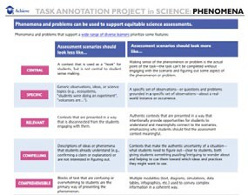  These features will provide a lens for us to analyze the quality of example assessments in a “Scenario Gallery Walk.”  8/27/2023 Source: Task Annotation Project f or Science (TAPS), nextgenscience.org 35 | Prep: Distribute one copy of the TAPS Scenario Resource to  each participant.  Purpose: Participants become familiar with the features of  high-quality scenarios.  Facilitation Step:  - Individual Reading (5 min): Provide participants with time to read page two of the Task Annotation Project in Science (TAPS) Scenario Resource to learn about the ﬁve features of science task scenarios (central, speciﬁc, relevant, compelling, and comprehensible).  - Purpose for Reading (<1 min): Share that these features will help provide a lens for us to analyze the quality of scenarios in example assessment tasks.  - Connect to the Previous Conversation (<1 min): As the facilitator, be sure to acknowledge the conversations that have happened in the room and the connections to the list of quality features of scenarios. That will help participants know their expertise is valued and this aligns with many of their own ideas.  Resource: This resource is a result from a Task Annotation in Science (TAPS) project conducted by a nonproﬁt called Achieve in 2019. The project  supported expert reviewers to analyze dozens of science and engineering tasks, annotate them, and release several resources detailing features of tasks that ask students to demonstrate evidence of multi-dimensional learning. Learn more about the project here, and see the resource on phenomena here.

Central
Specific
Relevant
Compelling
Comprehensible

Slides | Content
Scenario Gallery Walk Directions  - Choose one criterion as your focus.  - Take a stack of the assigned  color sticky notes for your criterion.  - Visit and read each scenario  (move at your own pace).  - For each, leave a note with one thing you notice/one piece of feedback related to your criterion.  Example for Comprehensible (blue)  - Notice: Text is long and uses one modality.  - Feedback : Consider shortening and adding relevant images.  8/27/2023 36 | Prep: Print one copy of each of the ten  tasks. Tape each individual task on a piece of chart paper and post them around the room. Ensure participants have ﬁve diﬀerent sticky note colors that match the colors on the screen.  Alternatively, consider a seated Gallery Walk with multiple copies of the same task in folders placed at diﬀerent tables around the room. This allows people to examine the task individually while sitting.  Purpose: Participants use the features of high-quality scenarios to analyze various science tasks to develop a common understanding of task scenarios.  Scenario Gallery Walk (15 minutes) Facilitation Steps:  - Criteria Assignments: Direct participants to have one  person in their group/table choose one of the ﬁve features of scenarios as their focus for the gallery walk (or count oﬀ 1–5).  - Sticky Notes: Have participants ﬁnd the correct color sticky note that matched their assigned criterion.  - Scenario Gallery Walk: Direct participants to visit each of the tasks posted around the room and leave one thing they notice and/or one piece of feedback for each related to their assigned criterion.  - Acknowledge there is a lot of other feedback they will want to give on these tasks, but for the purposes of this session, emphasize the importance of leaving feedback only related to their assigned criterion.

Slides | Content
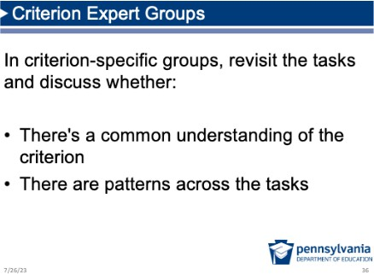 | Expert Group Conversations (10 min)  Facilitation Step:  - “Expert” Groups Gather. Direct participants to ﬁnd the others in the room who have the same scenario criterion. Consider assigning a spot in the room for each criterion to make this step easier.  - Small Group Discussion. Direct criterion-speciﬁc “expert” groups to visit some of the tasks from the gallery walk to discuss:  - Whether they had a common understanding of the criterion (i.e., do their sticky notes feedback look similar?); and  - If they noticed any patterns across the tasks.  Formative Assessment: This is a good opportunity to walk around and formatively assess participants’ current understanding of the role and qualities of  phenomena and problems in assessment tasks. Grey areas    will be good to note and surface during the debrief.  Sense-making: This is an important sense-making moment for participants building on each other’s ideas and clarifying what quality tasks really  look like.  Whole Group Debrief (10 min) Facilitation Step:  Ask each criterion-speciﬁc group to share their ﬁndings and discuss one task from the gallery walk that is a quality example of their scenario criterion.  Possible Transition Narrative:  Your analysis of tasks gives us insight into what scenarios that present problems or phenomena in tasks look like. Now let’s reﬂect on what our current assessments look like.

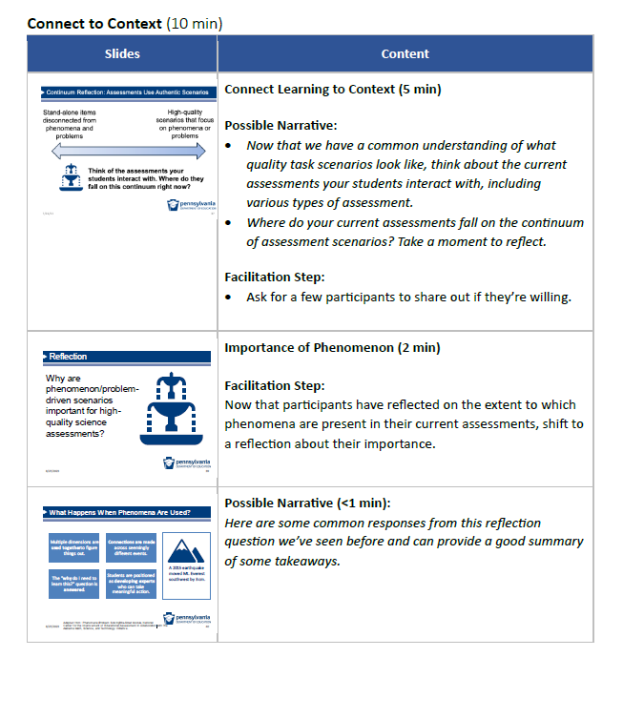

Slides | Content
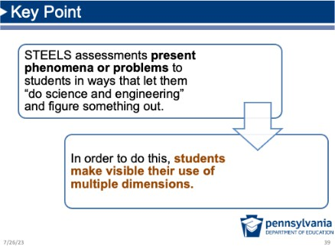 | Possible Narrative (<1 min):  Bottom line is that STEELS-based assessments provide phenomena and problems to create an opportunity for students to ﬁgure something out.  In order to ﬁgure something out, students make visible their use of multiple dimensions and we learn about their ability to engage in science, engineering, and environmental literacy.
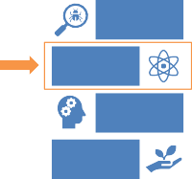  Themes  Phenomena and Problems  Multi- Dimensional  Sense-Making  / Reasoning  Fair and Equitable  8/27/2023 42 | Facilitation Step (<1 min):  Use this slide to transition to Session 1.3, noting that we’ll move on next to digging into what it means to be “multi- dimensional.”

Session 1.3 Multi-Dimensional Assessments (1 hour, 10 minutes)

Where we are going in this session
Participants will deepen their understanding of multi-dimensional assessments, including what
measuring proﬁciency in CCCs and SEPs looks like.

Where we are NOT going in this section
In sample prompts used in this section, we are not focusing on identifying the CCC or SEP elements that are explicitly or implicitly present; but rather, how integrated use of targeted SEPs and CCCs are necessary to ﬁgure out a phenomenon or problem in a task.
Multi-Dimensional Non-Negotiables (25 minutes)

Slides | Content
Module 1: Features of Quality STEELS Assessments  Module 1 Progression  Session 1.1 Session 1.2 Session 1.3 Session 1.4  Phenomenon Evidence of  Assessments /Problem - Multi - Phenomena  that Reflect Based Dimensional and Multiple  Our Vision Assessment Assessments Dimensions  Scenarios  43 | Facilitation Step (<1 min):  In Session 1.3 of Module 1, we will develop a common  understanding of multi-dimensional assessments.
Compare: Are They Multi-Dimensional?  How do producers Create a model to  differ from explain what effect consumers? VS. the reintroduction of  wolves had on the  food web in  Create a model of a Yellowstone National food web. Park in 1990.  8/27/2023 44 | Purpose: Participants elicit their initial understanding of integrating knowledge and practice together (i.e., multiple dimensions) to make sense of a phenomenon or problem. The point of this slide is NOT to try to identify speciﬁc practices, crosscutting concepts, or core ideas they think are being assessed.  Quick Prompt Comparison (5 min) Facilitation Step:  - Ask participants: What do you notice and wonder  about these two prompts? Are they both multi- dimensional?  - Ask for 1–2 to share out.  - The big idea that should come out of this comparison is that the dimensions are being assessed in an integrated

Slides | Content
way (i.e., at least two dimensions in the same prompt) rather than separately (i.e., one dimension per prompt).
- Connect to examples in previous section. As we saw in the previous session examples, the presence of a phenomenon is key to assessing the dimensions together.
Integrated Performance Expectations    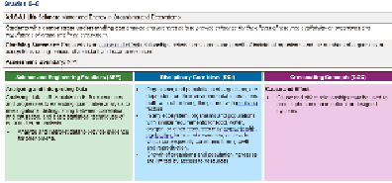  STEELS performance expectations integrate multiple dimensions for a reason.  Reflect: Why don’t the STEELS just list the dimensions separately?  8/27/2023 45 | Facilitation Step (10 mins):  - Describe that the STEELS “performance expectations” (i.e., the standards) are learning goals that integrate multiple dimensions: Disciplinary Core Ideas, Crosscutting Concepts, Science and Engineering Practices, and sometimes Technology and Engineering Practices. The performance expectation combines content from the three dimensions listed below it.  - Ask participants to reﬂect: Why are these performance expectations designed into integrated statements rather than just a list of all the separate dimensions?  - Individual (2 min)  - Partner (3 min)  - Share out (3 min)  - The big idea on this slide is that the dimensions should be integrated in both instruction and assessment — that’s why they are not listed separately in STEELS standards documents.  - This integration is necessary to truly know if students can use the targeted learning goals to make sense of phenomena and problems.  - The performance expectations were written to communicate a “big idea” that combined content from the three colorful foundation boxes below, each describing the grade-appropriate dimension.  Facilitator Note (if it comes up):  The STEELS performance expectations are not a set of instructional or assessment tasks. They are statements of what students should be able to do after instruction.

Slides |  |  |  |  |  |  |  |  |  | Content
 |  |  |  |  |  |  |  |  |  | Decisions on how best to help students meet these expectations are left to districts, schools, and teachers. Speciﬁc combinations of which dimensions are developed and used together can be mixed and matched in curriculum and assessments as long as they remain integrated.
Quick Review: What are the dimensions?  Disciplinary Crosscutting  Core Ideas Concepts  Science and Technology and Engineering Engineering  Practices Practices  8/23/2023 48 |  |  |  |  |  |  |  |  |  | Facilitation Step (<1 min):  - Share that the next few slides provide a quick review of each of the dimensions along with a concrete example of their use.
Disciplinary Core Ideas (DCIs)  What are they?  Earth Engineering,  Foundational ideas in Life Physical and Technology,  each science discipline &  focused onin greater Science Science Space Applications  depth rather than Science of Science  shallow coverage of a  larger number of topics  Includes Environmental Literacy  Example  Students need to know “the amount (weight) of matter is conserved when it changes form, even in transitions in which it seems to vanish” (PS1.A: Structure and Properties of Matter, Grade 3–5) when explaining how a solar still works to produce fresh water.  8/27/2023 47 |  |  |  |  |  |  |  |  |  | Facilitation Step (2 min):  Referring to the slide, review the following for DCIs:  - What they are; and  - An example of their use.
Crosscutting Concepts (CCCs)  What are they? |  |  |  |  |  |  |  |  |  | Facilitation Step (2 min):  Referring to the slide, review the following for CCCs:  - What they are; and  - An example of their use.
Concepts and intellectual tools that bridge and help | Patterns |  | Cause and Effect |  | Scale, Proportion, and Quantity |  | Systems and System Models
deepen understanding  of core ideas and make sense of things |  | Energy and Matter |  | Structure and Function |  | Stability and Change
Examples
- Students use the idea that “a system can be described in terms of its components and their interactions” Systems and System Models, Grade–3 5) to help them think about how a solar still works to produce fresh water
- Students use the idea that “relationships can be classified as causal or correlational, and correlation does not necessarily imply causation” (Cause and Effect, Grade 6–8) to make sense of the relationship between mountain growth and earthquakes.

*CCCs are not included in Technology and Engineering Standards.
8/27/2023 48
Crosscutting Concepts: Additional Example  The goal is for students to build and use CCCs as thinking skills.  Like other thinking skills (e.g., the process of elimination), students become much more proficient using them when they realize they are using them.  They think about the CCC element Students have been working toward “systems may interact with other explaining the phenomenon of how a systems; they may have sub - seed became a tree (where did all that systems and be a part of larger mass come from?). They are prompted complex systems ” and that leads to think about the different CCCs they them to think about:  have used before and consider which • Whether a tree interacts with a larger system,  one they want to use to help them start and if so, what the components of that system  figuring out the phenomenon. are; and  - what sub-systems might operate within a tree.  8/27/2023 49 |  |  |  |  |  |  |  |  |  | Facilitation Step (2 min):  - Because it often beneﬁts participants to see additional examples of CCCs, an extra one is provided here.  - Give participants a moment to read the example.  - If your participants are very familiar with CCCs, feel free to skip.

Asking questions (for
engineering)

Using mathematics and computational thinking | explanations (for  science) and designing solutions (for engineering) | Engaging in argument from evidence | Obtaining, evaluating, and communicating  information

Attention to  Ethi cs | Sys tems  Thinking | Creativity | Making and  Doing

Critical Thinking | Optimism | Collaboration | Communicatio

Slides | Content
Science and Engineering Practices (SEPs)  What are they?  Practices used by scientists and engineers to build, deepen, and apply DCI and CCC knowledge  Example  Students “Develop a model using an analogy, example, or abstract representation to describe a scientific principle or design solution” (Developing and Using Models, Grade 3 – 5) when showing evaporated water on a model to explain how  a solar still works to produce fresh water.  8/27/2023 50 | Facilitation Step (2 min):  Referring to the slide, review the following for SEPs:  - What they are; and  - An example of their use.
Technology and Engineering Practices (TEPs)  What are they?  Skills and abilities students have to successfully apply  technology and n  engineering DCIs  Examples  - Students “develop written and oral communication skills” (Communication, Grade 3–5) while engaging in argument from evidence about whether a solar still design will work.  - Students “exhibit safe, effective ways of producing technological products, systems, and processes”(Making and Doing, Grade 6–8) while designing a solution to prevent a garden from flooding.  *TEPs are only included in Technology and Engineering Standards. They are represented  8/27/2023 by the same color as CCCs. 51 | Facilitation Step (<1 min):  - One reason we say “multi-dimensional” is because STEELS have a speciﬁc dimension for the Technology and Engineering standards.  - The Technology and Engineering standards do not have crosscutting concepts incorporated; instead, they have Technology and Engineering Practices.  - Review what they are and the examples.
Performance Expectations  STEELS standards require students to use ideas and practices represented by these dimensions  together, not separately  to make sense of the world and solve problems.  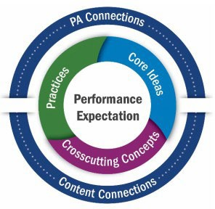  8/27/2023 52 | Possible Narrative (<1 min):  - From exit tickets to ﬁnal exams, Pennsylvania STEELS standards require students to use at least practices and core ideas together as part of their sense-making process.  - This is the ﬂoor, not the ceiling: the more comprehensive the assessment, the higher the bar for what students need to demonstrate.

SEPs and CCCs (40 minutes)
Slides | Content
Assessing Multiple Dimensions  How do we  know we're NGSS  really assessing colors  all the  dimensions? Pennsylvania  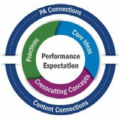  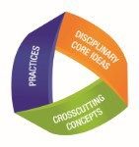  colors  7/30/2023 47 | Purpose of This Section: Participants will deepen their understanding of measuring proﬁciency of the dimensions, focusing on CCCs and SEPs as students engage in sense-making.  Facilitation Step (2 min):  - Display this slide to transition to the next part to focus on SEPs and CCCs in particular.  - Note that we’re all probably familiar with assessing science disciplinary core ideas (DCIs): we know the task requires that students come in with DCI knowledge in order to successfully complete it.  - We may be less familiar with assessing the other  dimensions, however. Let’s focus on those next.  Facilitation Note on PA vs. NGSS Colors:  - The Pennsylvania STEELS colors diﬀer slightly from the colors used typically in the science education community. Both are here to acknowledge that Pennsylvania educators will likely be using resources marketed to NGSS and should be familiar with both.
Compare: CCCs  Should the survivors  What are the be worried about qualities of open and losing water they can  closed systems? VS. drink from the solar  still system? Use evidence from your model to explain why or why not.  7/30/2023 48 | Purpose: The purpose is a quick notice/wonder activity to show an example of a prompt that is (1) one-dimensional and not in service of explaining a phenomenon or problem and (2) at least two-dimensional in service of making sense of a phenomenon. The purpose is NOT to try to ﬁgure out which CCC (or other dimensions) are being elicited.  Facilitation Step (2 min):  - Display two sample prompts to elicit CCC learning.  - Ask participants: What do you notice about the two  prompts? What do you wonder?  - Acknowledge participants don’t have all the information from these task examples, and that’s ok.

Slides | Content
It’s meant to be a quick notice/wonder based on the information they do have.
Takeaway:
One is assessing just the idea of a CCC and the other is an integrated assessment question that is phenomenon- based.
Compare: SEPs  Draw a model that Use the model to  shows how matter explain how the salt changes state. VS. is removed from the  water in the solar  still. Include how the changes in states of matter makes the solar still work.  7/30/2023 49 | Facilitation Step (2 min):  - Display two sample prompts to elicit SEP learning.  - Ask participants: What do you notice about the two  prompts? What do you wonder?  - Acknowledge participants don’t have all the information from these task examples: the purpose is a quick notice/wonder activity to show an example of a prompt that is and is not in service of explaining a phenomenon.  - Participants may make an argument that they are both technically two-dimensional. Ask which version seems “better” or more rigorous and why. [They may connect it to the phenomenon of the idea of “making sense of something.” This is what we are going to dig into next.  Takeaway:  Both may be assessing an SEP and DCI, but the phenomenon-based one is stronger. Let’s dig in a bit more and see if we can ﬁgure out why.
A B Each Teach    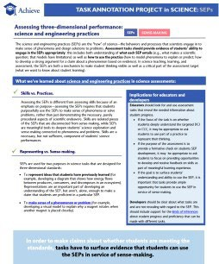    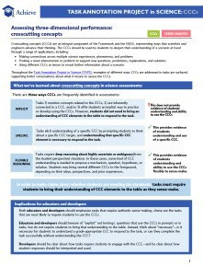  Resource A: SEPs Resource B: CCCs Find a partner  One partner reads Resource A  One partner reads Resource B  Teach each other what you learned  7/30/2023 50 | Prep: Distribute one copy of the CCC TAPS resource and SEP TAPS resource to each participant.  Purpose: Participants deepen their understanding of the explicit use of CCCs and SEPs to make sense of phenomena or problems in science assessments.  A B Each Teach (30 min) Facilitation Step:

Slides | Content
Direct participants to partake in a “A B Each Teach”
strategy where they:
- Find a partner (2 min).
- Individually read (10 min).
  - One partner reads Resource A: CCCs
  - The other partner reads Resource B: SEPs
- Teach (10 min). When both partners are ready, they each teach the other about their resource.

Formative Assessment: While participants are teaching each other, you may want to walk around and listen for points of confusion or
areas that can be addressed during the full group debrief.
- Debrief Full Group (8 min):
Question prompts may include:
  - What did you take away about how assessment tasks can provide evidence of students’ ability to engage in the SEPs appropriately?
  - What did you take away about how assessment tasks can provide evidence of students’ ability to engage in the CCCs appropriately?
Resource: Find resources related to assessing SEPs and CCCs here:
- TAPS: Assessing Science and Engineering Practices
- TAPS: Assessing Crosscutting Concepts
- STEM Teaching Tools: Prompts for Integrating Crosscutting Concepts Into Assessment and Instruction
- STEM Teaching Tools: Integrating Science Practices Into Assessment Tasks

Slides |  | Content
What Else Should Be on the List? |  | Facilitation Step (<1 min):  - After whole group share out, share the big ideas on  the screen as a summary of common takeaways.  - Verbally add anything else the group came up with  that isn’t included on the slide.
SEPs for making sense CCCs are explicit
Not just
Not just completing implicitly
the mechanics/skill related
Requires use  Not just representing of a specific  what the student CCC  already knows (“rote”  knowledge)  8/27/2023 | 57

Connect to Context Reﬂection (5 minutes)
Slides | Content
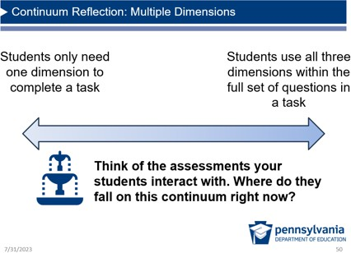 | Facilitation Step:  - Now that the group has a common understanding of what it looks like to elicit multi-dimensional understanding, think about the current assessments your students interact with, including various types of assessment.  - Display First Continuum: Multiple Dimensions (2 min):  - Where do your current assessments fall on the “less-like, more-like” continuum on the slide? Take a moment to reﬂect.  - Ask for a few to share out if they’re willing.
Continuum Reflection: Integrated Multiple Dimensions Dimensions assessed Most questions  in isolation / separate require students to      prompts use two dimensions  together  Think of the assessments your students interact with. Where do they fall on this continuum right now?  8/27/2023 Source: SPA-LC NGSS District Assessment Toolkit 59 | Facilitation Step:  - Display Second Continuum: Integrated Multiple Dimensions (2 min)  - Where do your current assessments fall on the “less-like, more-like” continuum on the slide? Take a moment to reﬂect.  - Ask for a few to share out if they’re willing.
Session 1.4 Evidence of Phenomena and Multiple Dimensions

(55 minutes)

Where we are going in this session
Participants will identify evidence of phenomena and multi-dimensional learning in an example task.

Where we are NOT going in this section
When analyzing the example tasks, the focus is not on how many additional elements from each dimension being present, but rather whether the targeted elements assessed are actually elicited and grade-level appropriate.

Task Analysis (45 min)

Slides | Content
Module 1: Features of Quality STEELS Assessments  Module 1 Progression  Session 1.1 Session 1.2 Session 1.3 Session 1.4  Phenomenon Evidence of  Assessments /Problem - Multi - Phenomena  that Reflect Based Dimensional and Multiple  Our Vision Assessment Assessments Dimensions  Scenarios  60 | Purpose of This Session (<1 min):  In Session 1.4 of Module 1, we will develop a common understanding of what evidence of using multiple dimensions to make sense of phenomena and problems looks like.
Example  What does evidence of multiple dimensions look like in an example task?  8/27/2023 61 | Facilitation Step (<1 min):  Display slide and describe that we’re going to explore the question of what multiple dimensions look like in student work by analyzing an example task prompt. Note that this is not necessarily an exemplar, but a task to elicit our ideas and determine level of multi-dimensionality.
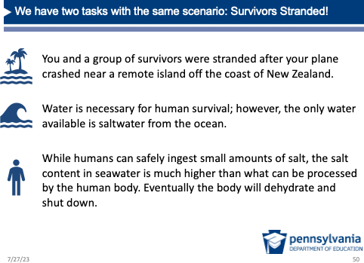 | Possible Narrative (5 min including next slide):  - To develop a common understanding of features of multi-dimensional, phenomenon-based assessment, we will be analyzing a task called Survivor Stranded.  - To do so, we’ll take a look at a scenario together. Then, working with a partner, you will have a chance to respond to one part of the task and analyze your responses.  Facilitation Step:  Introduce the scenario of the task by reading the text.

Slides |  |  |  |  | Content
 | Survivor Stranded  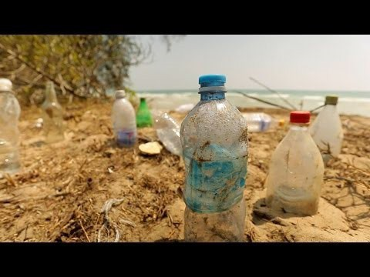  This survival expert recommends you use a solar still made from plastic bottles washed up on the shore.  Source: Discovery, How to Desalinate Water on  8/23/2023 a Desert Island, YouTube |  |  | 65 | Facilitation Step:  Click the play button on the slide to play the scenario video for the Survivor Stranded task (1 min 34 sec): https://www.youtube.com/watch?v=rUET3PnPZng&featur e=youtu.be
 | 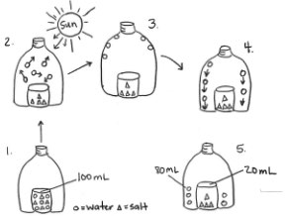  Survivors Stranded Excerpt  Prompt A: Use the steps in the model to explain how the salt is removed from the water in the solar still. In your explanations include how changes in states of matter make the solar still work as a system.  8/27/2023 |  |  | 64 | Prep: Distribute one copy of the Survivors Stranded  Prompt A for participants to complete in partners.  Facilitation Step (8 min):  - Share that this is only a portion of a larger task, but we’ll just focus on the ﬁrst prompt.  - Give participants 7–8 minutes to complete the prompt  in partners.  - Note that participants have the option of answering as themselves or as a student they have worked with and answering the way they think that student might. This may make participants feel more comfortable discussing answers.
Example Task Assessment Grade 3 –5 Targets |  |  |  |  | Facilitation Step (<1 min):
 | Science and Engineering Practices (SEPs) | Disciplinary Core Ideas (DCIs) | Crosscutting Concepts (CCCs) |  | at the Grade 3–5 Band: students' ability to use models (SEP) to describe structures and properties of matter (DCI), particularly changes in state that aﬀect the movement and conservation of matter in a system (CCC).
 | Developing and Using Models Grade 3 -5 Elements  - Use models to describe phenomena.  8/27/2023 | PS1.A: Structure and Properties of Matter  Grade 3 -5 Elements  - Matter of any type can be subdivided into particles that are too small to see, but even then the matter still exists and can be detected by other means. A model shows that gases are made from matter particles that are too small to see and are moving freely around in space can  explain many observations, including the inflation and shape of a balloon and the effects of air on larger particles or  objects. | Energy and Matter  Grade 3 -5 Elements  - The total weight of the substances does not change. This is what is meant by conservation of matter.
 |  | - The amount (weight) of matter is conserved when it changes form, even in transitions in which it seems to vanish. | 65
 |  |  |  |  | These are the goals for the whole task (which has many
 |  |  |  |  | questions), but we’re just looking at only one prompt of
 |  |  |  |  | the task that you have taken.

Slides | Content
Multi-Dimensional Assessment Claim  Prompt A: Use the steps in the model to explain how the salt is removed from the water in the solar still. In your explanations include how changes in states of matter make the solar still work as a system.  Performance Outcome: Use a model to describe how changes in states of matter cause the movement and conservation of matter even when it seems to vanish.  8/27/2023 Task Source: Tennessee District Science Network 66 | Possible Narrative (<1 min):  - We ﬁrst need to get really clear about which aspects of the dimensions Prompt A assesses by looking at the performance outcome, or the learning goal claimed by the task developers for this portion of the task.  - We’ll unpack this performance outcome to help us understand what we are looking for when we analyze our responses.
Multi-Dimensional Assessment Claim  Prompt A: Use the steps in the model to explain how the salt is removed from the water in the solar still. In your explanations include how changes in states of matter make the solar still work as a system.  Performance Outcome: Use a model to describe how  SEP changes in states of matter cause the movement and conservation of matter even when it seems to vanish.  8/27/2023 Source: Scale Science atWestEd 67 | Possible Narrative (<1 min):  For evidence of the SEP, we are really looking for how students use the model as evidence for their explanation of how the solar still works.
Multi-Dimensional Assessment Claim  Prompt A: Use the steps in the model to explain how the salt is removed from the water in the solar still. In your explanations include how changes in states of matter make the solar still work as a system.  Performance Outcome: Use a model to describe how  DCI changes in states of matter cause the movement and conservation of matter even when it seems to vanish.  8/27/2023 Source: Scale Science atWestEd 68 | Possible Narrative (<1 min):  And for the DCI, we want to see how students are using their knowledge about how matter changes state within the solar still and can explain how matter moves even when it seems to vanish.
Multi-Dimensional Assessment Claim  Prompt A: Use the steps in the model to explain how the salt is removed from the water in the solar still. In your explanations include how changes in states of matter make the solar still work as a system.  Performance Outcome: Use a model to describe how  CCC changes in states of matter cause the movement and conservation of matter even when it seems to vanish.  8/27/2023 Source: Scale Science atWestEd 69 | Possible Narrative (<1 min):  And last but not least, we are looking for whether students are able to clearly describe the movement and conservation of matter within the system.

SEP | DCI | CCC

Slides | Content
Assessing Use of Multiple Dimensions  Color-code Compare against the performance outcome to  your answers determine whether the  by dimension. assessment prompts fully require use of the intended  three dimensions.  Why or why not?  In the first bottle, you can tell Performance Outcome:  that the circles and triangles Use a model to describe how are meaning salt water. changes in states of matter cause  Indicates When you put the bottle in the the movement and conservation evidence sun, the water evaporates and of matter even when it seems to of both then condenses onto the  DCI and side and when you flick it, all vanish.  CCC. the water droplets fall on to  the rim of the water bottle.  Source: Scale Science atWestEd 70 | Prep: Distribute one copy of the Survivors Stranded  Analysis of Participants’ Own Answers to each participant.  Facilitation Step (10 min):  - Share directions, using the example response on the slide to talk through the process. (Possible Narrative below)  - Provide ten minutes of work time to complete analysis in partners. At the end of the ten minutes, participants should be prepared to share their discussion of the second question: “Did the assessment prompts fully require you to use the targeted three dimensions, why or why not?”  Facilitation Note:  - Make it clear to participants which is which (perhaps with an NGSS vs. STEELS Color Comparison Chart).  Possible Narrative:  We’re going to analyze our own responses for evidence of the targeted three dimensions.  - First, color-code student responses by dimension with highlighters. For example, in this student response, we can see which parts of their response show the SEP, DCI, and CCC. Note that this is not always the case. Sometimes you will only see some dimensions elicited in a student response. As you review your own responses, you may want to write in the margins which evidence each highlighted piece is showing.  - Next, consider whether your answers fully require use of each of the targeted three dimensions. Here I want to highlight that even though this student showed evidence of all three dimensions in this example, they didn't show full proﬁciency with these dimensions.  - SEP. If we look back to the performance outcome, this student does use the model, but not comprehensively

 | K–2 Elements | 3–5 Elements | 6–8 Elements
DCI: PS1.A:  Structure and Properties of Matter | Different kinds of matter exist and many of them can be either solid or liquid, depending on temperature. Matter can be described and classified by its observable properties. | The amount (weight)of matter is conserved when it changes form, even in transitions in which it seemsto  vanish. | In a liquid, the molecules are  constantly in contact with others; in a gas, they are widely spaced except when they happen to collide.
SEP:  Developing and Using Models | Develop and/or use a model to represent amounts, relationships, relative scales (bigger, smaller), and/or patterns in the natural and designed world(s). | Use modelsto describe phenomena. | Develop or modify a model—based on evidence—to match what happens if a  variable or component of a system is changed.
CCC: Energy  and Matter | Objects may break into smaller pieces,  be put together into larger pieces, orchange shapes. | The total weight of the substances does not change. This is what is meant by conservation of matter. | Matter is conserved because atoms are conserved in physical and chemical  processes.

Slides | Content
to explain how the water still works. So, there is
evidence of the SEP Developing and Using Models.
- DCI and CCC. And while they do mention changes in states of matter and describe some movement of water within the system, they don't describe the conservation of matter (CCC) within the system even when it seems to vanish. Thus, while there is evidence that the prompt elicits a DCI, we would consider this more of a developing response.

Whole Group Share Out (10 min):
Did teams ﬁnd the assessment prompt elicited all three
dimensions? Why or why not?
Anticipated response:
- Participants may have found evidence for SEP and DCIs, but they will likely point out their answers did not have evidence of the targeted CCC. You may share in this case it may be because the prompt did not adequately elicit the CCC in responses.
- At this point, we are just looking for evidence in “student” responses, not analyzing why a response may be inadequate in one area (e.g., a needed adjustment to instruction vs. a needed adjustment to the prompt wording itself).

Transition: When analyzing a task, one consideration is looking at student work to see if it elicited the targeted dimensions. Another consideration is whether it elicits grade-appropriate use of the dimensions.
Is It Grade Appropriate?  8/27/2023 71 | Facilitation Step (9 min):  - Elements: The dimensions in STEELS all have grade- speciﬁc “elements” that progress from K–2 to 9–12, increasing in sophistication and building on learning from prior years. The elements are in the colorful boxes under the performance expectation.

Slides | Content
- Grade-Appropriateness: One last consideration for participant analysis is grade appropriateness and whether you are assessing the right element.
- Progressions Page: You’ll ﬁnd a brief table on the back of your analysis document of a small excerpt of these progressions.
- Analysis in Partners (5 min): Ask participants to consider whether the ideas elicited are in the 3–5 grade band, over, or under for each dimension.
- Share Out (2 min): Provide an opportunity for 1–2 groups to share out whether they thought the response was grade appropriate.

Transition: While we don’t need to assess an entire element at a time, it’s important to note in what ways the ideas become more sophisticated at each grade band and make sure we’re assessing the part that makes it grade appropriate.
Resource: Find the progressions for the dimensions here:
  - DCI Progressions
  - SEP Progressions
  - CCC Progressions
Reﬂection and Closing (10 minutes)
Slides | Content
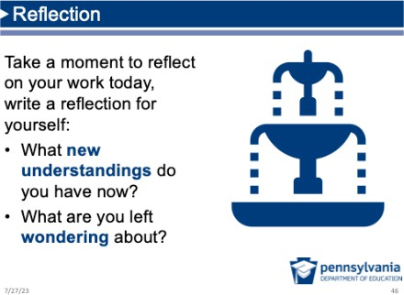 | Facilitation Step (3 min):  Encourage participants to take a moment of reﬂection and capture any new takeaways from the session so far and if they have any questions that they’re wondering about.

Slides | Content
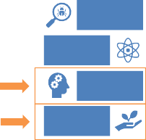  Module 2  Phenomena and Problems  Multi- Dimensional  Sense-Making  / Reasoning  Fair and Equitable  8/27/2023 73 | Facilitation Step (<1 min):  Share that in the next module we build on this learning and focus more on sense-making and equitable features in assessment.
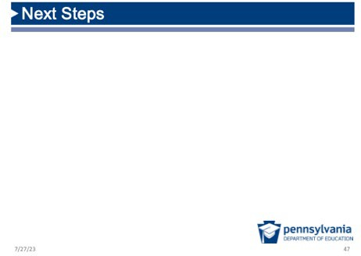 | Facilitation Step (1 min):  Share any next steps with participants as needed.
What's one act of caring you  Cultivating a Culture of Caring experienced in  today's  session?  - Recognize that we all need care 6. Make connections between the at some point, in some way. micro and the macro.  - Share what you need in order to 7. Keep a record of your progress be cared for well. over time.  - Protect your (and other people’s) 8. Honor and recognize the time to rest. leadership and knowledge of  the people indigenous to where  - Practice vulnerability in ways you are.  that are reciprocal. 9. Value insights from those with different backgrounds.  - Get to know your colleagues and  students. 10. Nurture imagination.  11. Celebrate.  Adapted f rom Source: Othering & Belonging Institut,eSPA -LC NGSS District 75  Assessment Toolkit | Facilitation Step (2 min):  Refer back to the Culture of Caring slide from the session  introduction.  Have participants take a moment to reﬂect on one act of caring you experienced in today's session.
A Parting Thought  A man came upon a construction site where three people were working. He asked the first, “What are you doing?”  “I am laying bricks.”  He asked the second, “What are you doing?” and the man replied,  “I am building a wall.”  As he approached the third, he heard him humming a tune as he worked, and asked, “What are you doing?” The man stood, looked up at the sky, and smiled,  “I am building a castle!”  8/27/2023 Source: SPA-LC NGSS District Assessment Toolkit 76 | Facilitation Step (<1 min):  Provide participants with time to read this parting thought or ask one volunteer to read it aloud.

Slides | Content
Contact/Mission

For more information on the Science, Technology & Engineering, Environmental Literacy & Sustainability (STEELS) assessments, please visit PDE’s website at www.education.pa.gov .

The mission of the Department of Education is to ensure that every learner has access to a world -class education system that academically prepares children and adults to succeed as productive citizens. Further, the Department seek s to establish a culture that is committed to improving opportunities throughout the commonwealth by ensuring that technical support, resources, and optimal learning environments are available for all students, whether children or adults.

8/27/2023 77

Module 1 Evaluation Sample Questions

How important was each activity in deepening your understanding of the features of high- quality assessments? (Not Important, Somewhat Important, Important, Very Important, N/A)
- Creating an initial vision for science assessments and revising that vision throughout the
session.
- Comparing three sample tasks to surface our ideas about what makes a “quality” science
assessment.
- Sorting cards to distinguish between phenomena, problems, and topics.
- Reading about features of eﬀective scenarios and analyzing tasks for these features.
- Reading about and discussing key considerations for assessing SEPs and CCCs.
- Analyzing the Survivors Stranded Prompts for evidence of CCCs, DCIs, and SEPs.
- Reﬂecting and making connections between new learning about assessment and my own context.

How important was this activity in helping you connect and apply the learning to your own context? (Not Important, Somewhat Important, Important, Very Important, N/A)
- Creating an initial vision for science assessments and revising that vision throughout the
session.
- Comparing three sample tasks to surface our ideas about what makes a “quality” science
assessment.
- Sorting cards to distinguish between phenomena, problems, and topics.
- Reading about features of eﬀective scenarios and analyzing tasks for these features.
- Reading about and discussing key considerations for assessing SEPs and CCCs.
- Analyzing the Survivors Stranded Prompts for evidence of CCCs, DCIs, and SEPs.
- Reﬂecting and making connections between new learning about assessment and my own context.

The timing of this activity was (Too long, about right, too short, N/A)
- Creating an initial vision for science assessments and revising that vision throughout the
session.
- Comparing three sample tasks to surface our ideas about what makes a “quality” science
assessment.
- Sorting cards to distinguish between phenomena, problems, and topics.
- Reading about features of eﬀective scenarios and analyzing tasks for these features.
- Reading about and discussing key considerations for assessing SEPs and CCCs.
- Analyzing the Survivors Stranded Prompts for evidence of CCCs, DCIs, and SEPs.
- Reﬂecting and making connections between new learning about assessment and my own context.

Thinking about the module overall, how well do you think the module prepared you to do the following? (Not at all, slightly well, somewhat well, extremely well, N/A)
- Distinguish between phenomena, problems, and topics.
- Describe the features of a quality scenario in a science assessment task.
- Explain the diﬀerence between one-dimensional and multi-dimensional science assessments.
- Describe the connection between phenomena and three dimensions in a science assessment.
- Analyze a science task to determine if it measures at least two of the three dimensions
(CCCs, SEPs, and DCIs) in an integrated manner.

How, if at all, will you use the knowledge or skills gained from this module in your work?
[Open Ended]

What questions do you have after completing this module? [Open Ended] Is there any additional feedback you’d like to provide? [Open Ended]

