
Earth and Space Systems:
Natural Resources, Earth Systems,
Renewable and Non-Renewable Energy,
Human Impacts

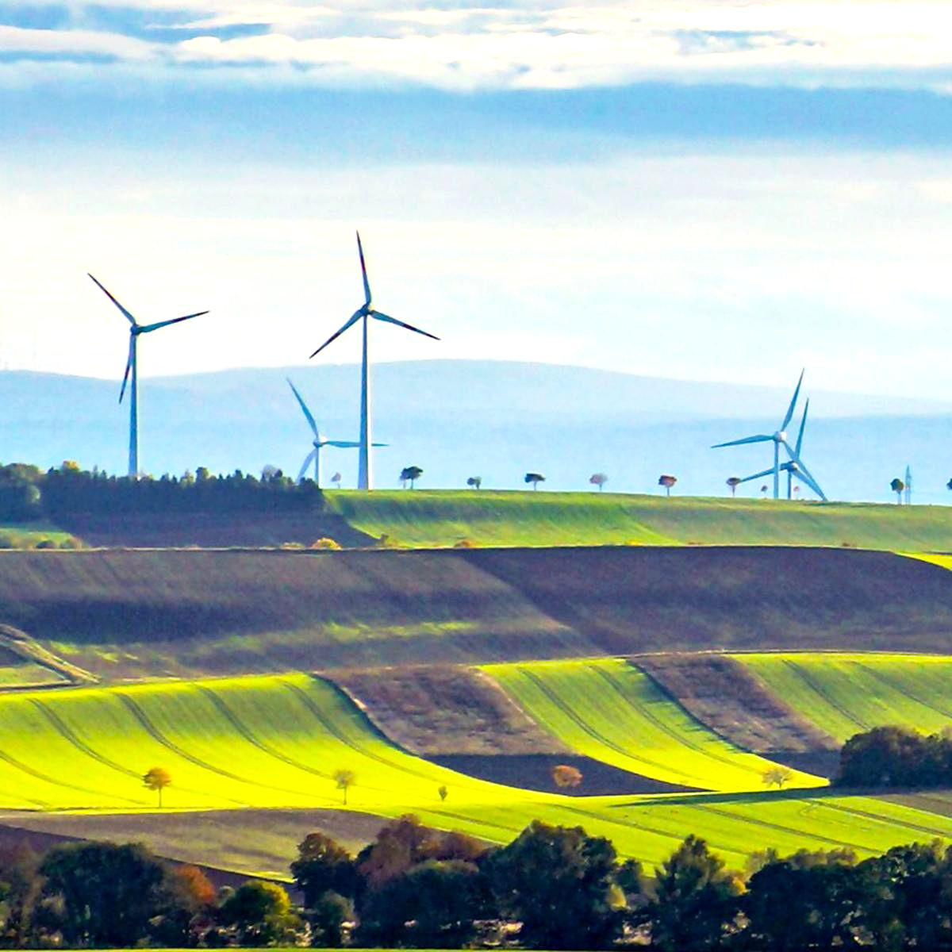 | Teacher Guide  mySci Unit 22:  Using Our Resources Wisely





Verify badge
Table of Contents
mySci Symbols Key 3
Unit 22: Quick View Using Our Resources Wisely 4
Unit 22: Sections Quick View 6
Links to Resources for this Unit 7
Unit 22: Fast Track Pacing Guide 8
Section 1: Quick View How are farms part of Earth’s systems? 9
Lesson 1: Summary 10
Lesson 1: Five E Quick View 11
Lesson 1: Prep List 12
LAUNCHING THE UNIT 13
L1 – Five E Lesson Plan 17
Lesson 2: Summary 24
Lesson 2: Five E Quick View 25
Lesson 2: Prep List 26
L2 – Five E Lesson Plan 27
Section 2: Quick View 33
How does our use of natural resources on farms affect Earth’s systems? 33
Lesson 3: Summary 35
Lesson 3: Five E Quick View 36
Lesson 3: Prep List 37
L3 – Five E Lesson Plan 38
Lesson 4: Summary 46
Lesson 4: Five E Quick View 47
Lesson 4: Prep List 48
L4 – Five E Lesson Plan 49
Lesson 5: Summary 57
Lesson 5: Five E Quick View 58
Lesson 5: Prep List 59
L5– Five E Lesson Plan 60
Lesson 6: Summary 69
Lesson 6: Five E Quick View 70
Lesson 6: Prep List 71
L6 – Five E Lesson Plan 72
Section 3: Quick View How can farmers use resources wisely to protect Earth’s systems? 79
Lesson 7: Summary 81
Lesson 7: Five E Quick View 82
Lesson 7: Prep List 83
L7 – Five E Lesson Plan 84
Lesson 8: Summary 91
Lesson 8: Five E Quick View 92
Lesson 8: Prep List 93
L8 – Five E Lesson Plan 94
Lesson 9: Summary 103
Lesson 9: Five E Quick View 104
Lesson 9: Prep List 105
L9 – Five E Lesson Plan 106

mySci Symbols Key
 | Indicates an opportunity for students to write |  | Indicates an opportunity for assessment |  | Indicates an opportunity to employ a driving question board
 | Indicates an opportunity for the teacher to make a chart |  | Indicates an opportunity to attend to equity and inclusion |  | Indicates appropriate time to administer the post assessment
 | Indicates an opportunity for reading |  | Indicates an opportunity to differentiate instruction |  | Indicates link to a teacher facing mySci tutorial explaining how to set up the activity for students
 | Indicates an opportunity for discourse |  | Indicates a key science idea |  | Indicates a multimedia resource

Unit 22: Quick View Using Our Resources Wisely

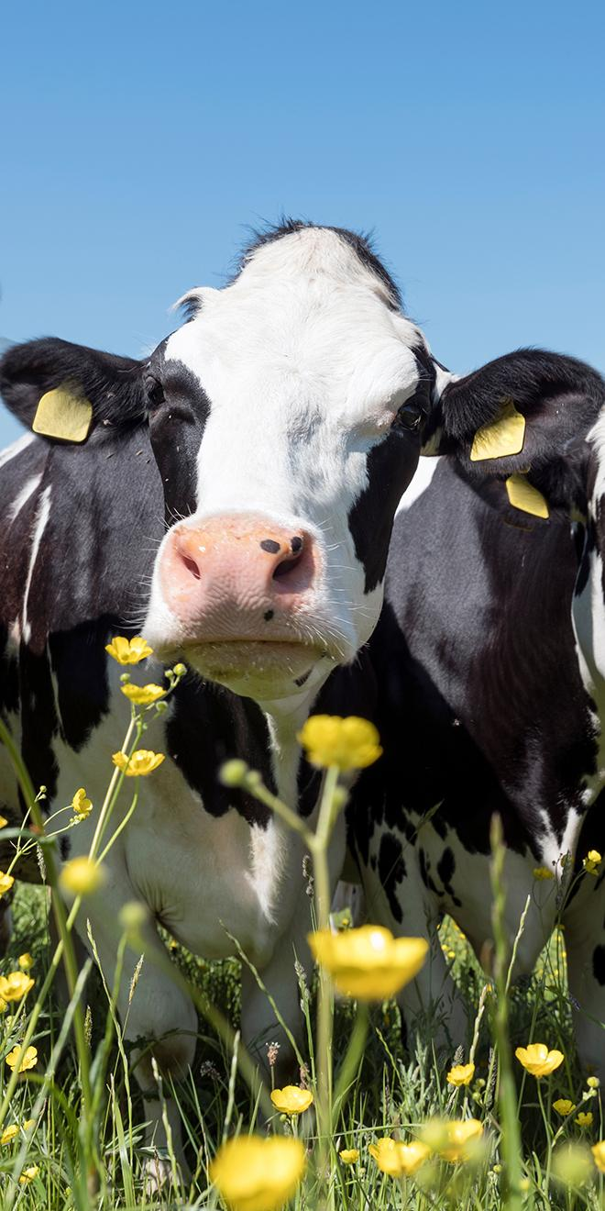 | ANCHORING PROBLEM:  We need farms to grow food, but the process of producing food for all of us can harm Earth systems.  DRIVING QUESTIONS:  How are farms part of Earth’s systems?  How does our use of natural resources on farms affect Earth’s systems?  How can farmers use resources wisely to protect Earth’s systems?  These questions are provided for you as model driving questions to support categorizing individual student questions and organize the learning progression. Each section is designed to intentionally build toward defining the anchoring problem and designing a solution. You can use these questions to guide your instruction, however, you are encouraged to adapt these questions using the language you develop with your students.

Throughout mySci Units color coding is used to call out specific connections to each of the 3 dimensions of the NGSS standards:  Orange text highlights connections to DCIs (Disciplinary Core Ideas)  Blue text highlights connections to the SEPs (Science and Engineering Practices)  Green text highlights connections to the CCCs (Cross-Cutting Concepts) | STORYLINE  In this unit, students will make sense of Earth’s systems and natural resources, ways that humans use natural resources, human impacts on Earth systems, and how humans can change behaviors to reduce impacts on the environment.  This unit intentionally develops the Crosscutting Concept of System and System Models and also uses Scale, Proportion, and Quantity and Energy and Matter for sensemaking.  This unit intentionally develops the Science and Engineering Practices of Developing and Using Models and Obtaining, Evaluating, and Communicating Information.  The unit also incorporates Using Mathematical and Computational Thinking, Constructing Explanations and Designing Solutions, and Planning and Carrying Out Investigations for sensemaking.  - First, students will explore the four Earth systems (hydrosphere, biosphere, atmosphere, and geosphere) and learn how these systems interact.  - Next, students will learn about natural resources and how humans use them for things like energy, food, and shelter. They will investigate some of the impacts of using natural resources, including the effects of fossil fuel consumption. Students will also examine the hydrosphere in detail, including the distribution of water on Earth. They will learn that water is a limited resource, and the amount and quality of available water can be affected by human activities.  - Finally, they will learn about strategies humans can use to decrease our impact on the environment. They will examine a case study of an island in Denmark that changed from using non-renewable to renewable energies and then engage in a design challenge to design, build, test, and refine a wind turbine to perform a specific task. Students will also consider how farms can repurpose animal waste to generate energy using biodigesters.

Unit 22: Sections Quick View
Section 1  How are farms part of Earth’s systems? | Section 2  How does our use of natural resources on farms affect Earth’s systems? | Section 3  How can farmers use resources wisely to protect Earth’s systems?
Total time: 6 days  LESSON 1  How can we describe the different parts of the Earth?  (3 days)  LESSON 2  How do Earth’s systems interact?  (3 days) | Total time: 11 days  LESSON 3  What are natural resources and how do humans use them?  (3 days)  LESSON 4  How does our use of fossil fuels affect Earth’s systems?  (3 days)  LESSON 5  How does our use of water affect Earth’s systems?  (3 days)  LESSON 6  How does animal waste affect the environment, and what can we do about it?  (2 days) | Total time: 9 days  LESSON 7  How can people use resources in a way that is less harmful to the Earth?  (3 days)  LESSON 8  How can we use farms to harness wind energy?  (3 days)  LESSON 9  How can farms make better use of animal waste?  (3 days)

 | Links to Resources for this Unit
 | SECTION 1 SLIDE DECK SECTION 2 SLIDE DECK  SECTION 3 SLIDE DECK  PARENT/GUARDIAN LETTER  English Version  STUDENT JOURNAL:  Digital Student Journal Answer Key  Print Student Journal Answer Key  ASSESSMENT DOCS:  Answer Key  LITERACY LINKS:  Epic Booklist Unit 22  Quizlet Unit 22  Printable Glossary  Google Slide Vocabulary Cards English  Google Slide Vocabulary Cards English/Spanish  APPENDICES:  Teacher Background Information: Appendix A  Read-Aloud Guides: Appendix B  Handouts/Teacher Pages: Appendix C  NGSS/MLS: Appendix D  Safety Guidelines: Appendix E | Performance Expectations Addressed
  4-ESS3-1. Obtain and combine information to describe that energy and fuels are derived from natural resources and their uses affect the environment.
  3-5-ETS1- 3. (5.ETS1.C.1) Plan and carry out fair tests in which variables are controlled and failure points are considered to identify aspects of a model or prototype that can be improved.
  5-ESS2-2. (5.ESS2.C.1) Describe and graph the amounts of saltwater and fresh water in various reservoirs to provide evidence about the distribution of water on Earth.
  Performance Expectations Partially Addressed
  5-ESS3-1. (5.ESS3.C.1) Obtain and combine information about ways individual communities use science ideas to protect the Earth’s resources and environment.
  3-5-ETS1- 2. (5.ETS1.B.1) Generate and compare multiple possible solutions to a problem based on how well each is likely to meet the criteria and constraints of the problem.
  5-ESS2-1. (5.ESS2.A.1) Develop a model using an example to describe ways the geosphere, biosphere, hydrosphere, and/or atmosphere interact.
  4-PS3-2.( 4.PS3.B.1) Make observations to provide evidence that energy can be transferred from place to place by sound, light, heat, and electric currents.

Unit 22: Fast Track Pacing Guide
Unit 22 Fast Track Pacing Guide
These suggestions can be used if you do not have the full amount of time required to dedicate to the whole unit.
Lesson | How to Adapt
Lesson 1 | - Explore: Omit going outside..  - Elaborate: Only show one video, or shorten the length of each video.  - Elaborate: Provide students with the Gotta Have It checklist instead of co-constructing it.
Lesson 2 | - Explore: Use the virtual adaptation of the activity to reduce setup time.  - Explain: Omit the Crash Course Kids videos.  - Elaborate: Only show one video, or shorten the length of each video. Provide students with the Gotta Have It checklist instead of co-constructing it.
Lesson 3 | - Explore: Omit comparing and sorting the self-documentation data, and only do the class chart about it.  - Elaborate: Provide students with the Gotta Have It checklist instead of co-constructing it.
Lesson 4 | - Explore: Omit the student choice research and only do the asthma research. Alternatively, skip the asthma research and allow for student choice.  - Explain: Based on what you omitted in the Explore section, only do one cause and effect sphere interaction activity.  - Elaborate: Provide students with the Gotta Have It checklist instead of co-constructing it.
Lesson 5 | - Omit all portions except for the Explore graduated cylinder, graphing activity, and development of a claim.
Lesson 6 | - Keep as is.
Lesson 7 | - Elaborate: Omit returning to the model. Students will revise the model again in Lesson 9.
Lesson 8 | - Explain: Only have students draw their model and how energy is transferred. Omit drawing an actual wind turbine for comparision.  - Elaborate: Read The Boy Who Harnessed the Wind or watch the video.
Lesson 9 | - Keep as is.

Section 1: Quick View How are farms part of Earth’s systems?
LESSON /  LEARNING TARGET | VIDEO & TEXT RESOURCES | REMOTE LEARNING |  | KEY TAKEAWAY | VOCABULARY  Quizlet Link  Glossary Link
LESSON /  LEARNING TARGET | VIDEO & TEXT RESOURCES | INTERACTIVES & MINI LESSON VIDEOS | HANDS-ON AT HOME SUGGESTIONS | KEY TAKEAWAY | VOCABULARY  Quizlet Link  Glossary Link
Lesson 1:  How can we describe the different parts of the Earth?  Observe patterns in the environment to describe the components of Earth’s major systems  Develop a model to show the different Earth systems present on a farm.  (3 days) |  Crash Course Kids #6.1  Crash Course Kids #6.2  Dairy Farm  Immigrant Farmers Put Down New Roots | What Are the Components of Each Earth System and How Do They Interact? Mini-Lesson | Students can go for a walk and take a photograph or sketch a picture of the different spheres around their home. | We can classify the parts of the Earth by what they are made of- hydrosphere (liquid water), atmosphere (air), geosphere (land), and biosphere (organisms). Farms are human-designed, but they still have these spheres. | atmosphere  biosphere  geosphere  hydrosphere
Lesson 2:  How do Earth’s systems interact?  Use models to explain the complex interactions between Earth systems.  Revise a model to show the interactions of Earth systems on a farm.  (3 days) | Dairy Farm  Immigrant Farmers Put Down New Roots  What on Earth  Weathering and Erosion | How Does the Water Cycle Involve All of Earth's Systems? Mini-Lesson | Have students look for evidence of system interactions in their yard or neighborhood. | They figure out that different Earth systems interact and that the interaction of one Earth system can affect the function of another Earth system. Similar to the natural world, the Earth systems present on a farm interact. | interact  system

Lesson 1: Summary | How can we describe the different parts of the Earth?

Time: 3 days  Learning Targets  Observe patterns in the environment to describe the components of Earth’s major systems  Develop an initial model to show the different Earth systems present on a farm.  Summary  - Prior to this earth science unit, students may have knowledge that energy makes things happen. Students may understand that energy can move from place to place and be transformed from one form of energy to another (NGSS 4-PS3). They have considered the environment as an ecosystem of parts that interact.  - In this lesson, students research the components of the hydrosphere, atmosphere, geosphere, and biosphere. They will develop and use a model to illustrate these systems on a farm.  - Students figure out that we can classify the parts of the Earth by what they are made of- hydrosphere (liquid water), atmosphere (air), geosphere (land), and biosphere (organisms). Farms are human-designed, but they still have these systems.  - In the next lesson, students consider how the different spheres of the Earth interact. |  | Building Towards  5-ESS2-1. (5.ESS2.A.1)
 |  | NGSS 3-Dimensions:
ESS2.A: Earth Materials and Systems
Developing and Using Models
System and System Models

 |  | CCSS(MLS):
ELA
- 5.R.1.B.a
- 5.SL.1.A.a
- 5.SL.1.A.b

Lesson 1: Five E Quick View
UNIT LAUNCH | Students view photos and data charts to make observations and ask questions about the unit ANCHORING PROBLEM.
ENGAGE | Students co-construct an initial model showing the different parts of our environment.
EXPLORE | Students make observations about the parts of the environment and classify them according to patterns.
EXPLAIN | Students obtain information about the systems that make up Earth.
ELABORATE | Students develop a model of a farm and illustrate the different Earth systems on it.
EVALUATE | Students evaluate each other’s farm models.

Lesson 1: Prep List
Inside mySci kit you will find: | Items you must supply: | Preparation:
 | Colored pencils or markers | Review mySci Safety Guidelines  Send parent/guardian letter home  English Version Spanish Version  Lesson 1 Student Journal pages or Printed Student Journals

Literacy Connections | Remote Learning
Key Vocabulary  atmosphere: the air that surrounds the Earth  biosphere: parts of the Earth that contain organisms  geosphere: Earth’s crust and mantle (soil, rocks, and molten rock)  hydrosphere: liquid water on Earth’s surface, in the ground, and in the air  Supplemental Reading Resources  What is Earth’s core made of?  What is air made of? | Interactive & Mini Lesson Videos  What Are the Components of Each Earth System and How Do They Interact? Mini-Lesson  Hands-on at Home Suggestions  Students can go for a walk and take a photograph or sketch a picture of the different spheres around their home.

LAUNCHING THE UNIT
Introducing the ANCHORING PROBLEM and DRIVING QUESTIONS
Attending to Equity:  Students will find the anchoring phenomenon/problem more compelling if it is presented as a meaningful, real-world scenario that connects to their lives. You could ask students what their favorite foods are. Students may make specific dietary choices for a variety of reasons (allergies, culture, health, religion). Encourage students to be respectful about these choices. This can foster productive scientific discussion about real-world problems.  If you want to change the ANCHORING PROBLEM for your context, keep the following questions in mind:  → Is it going to be relevant to my students’ lives and/or particularly engaging to them?  → Is it going to motivate students to want to explain:  - Our use of natural resources  - How Earth’s spheres interact  - Energy consumption  - How humans interact with our environment  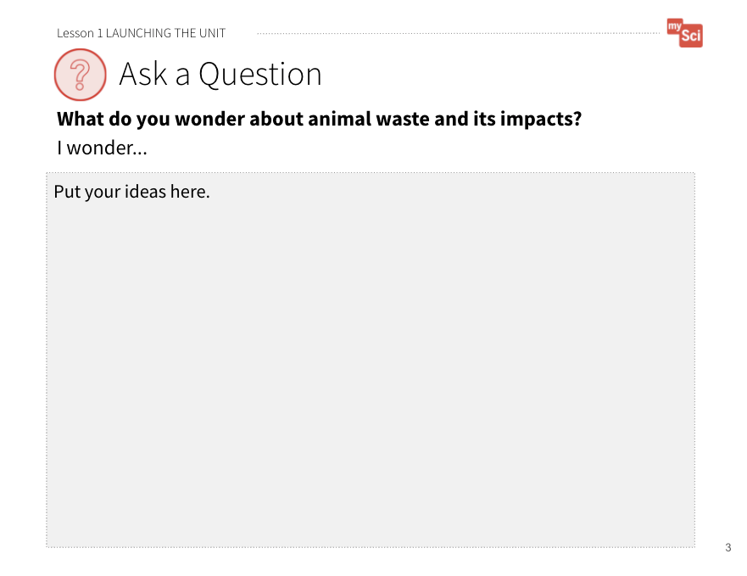  Launching the Unit Student Journal Page  Teaching Tip:  Try using the crosscutting concepts as a way to categorize student questions.  Also, see Appendix C for an example of a DQB.  Guidance for engaging students in a Turn and Talk: Turn and talks will be used throughout the unit. If students are not already familiar, take time to introduce the Turn and Talk strategy. Emphasize that students should share their ideas, listen carefully to their partner’s ideas, and build on each other’s ideas. It is also important to stay on topic.  To support students to Turn and Talk, consider using: Conversational Support for Sharing and Expanding on Each Other's Ideas from STEM Teaching Tools. | SETTING UP YOUR DRIVING QUESTION BOARD:  In this unit, you will use a Driving Question Board. This is a tool that allows you to organize student questions about the anchoring phenomenon or problem and track how the learning progresses throughout the unit, in order for students to make sense of the phenomenon or problem. You will revisit it after each lesson to see what you figured out as a class and add new questions.  Your Driving Question Board should include the Anchoring Problem statement, with space for student questions that are generated throughout the unit, and 3 columns:  - One to track the activities students have engaged in and their observations.  - One for the scientific ideas they have learned.  - One for how those ideas connect to the anchoring problem and driving questions for the unit.  See Appendix C for an example of a driving question board with sample responses that would be filled in throughout the unit.  Use bulletin boards, chart paper or a digital resource like Google Jamboard to develop your Driving Question Board. Student questions and initial explanations about their questions can be recorded on post-its. This way once the class has addressed a question it can be removed from the DQB and you could store these in a separate space so students can see how many questions they have answered throughout the unit. Artifacts from activities can be included as well.
ELICITING STUDENT THINKING:
Students come to the classroom with prior knowledge, or partial knowledge from previous learning as well as life experiences. Use the Driving Question Board to elicit student thinking and access students prior knowledge.
Take notice about what students understand about the DCIs, or how what they know could connect to the DCIs as they progress through the unit. This will help you figure out how to best meet individual student needs as you teach the unit, and gauge how much student knowledge and skills grow as a result of the unit.
ANCHORING PROBLEM:
We need farms to grow food, but the process of producing food for all of us can harm Earth’s systems.
Students view a video to make observations and ask questions about the unit ANCHORING PROBLEM.
Introduce the ANCHORING PROBLEM:
Ask students:
- What is your favorite food? Why?
Provide students with the opportunity to think and then have them turn and talk to a partner. Call on students to share and record their responses. Take a poll to indicate common favorite foods in your classroom.
Ask students:
- Where does this food come from?
Provide individual think time and then ask students to share with a partner. As they share, circulate and listen for students’ prior knowledge about food and farms. Identify a student or student to share their ideas during the whole class discussion. To begin the discussion ask these students to share where food comes from.
Then say to students:
- Most of the food that we eat comes from a farm. In order to produce the food we eat, farms use resources.
- Have you ever thought about how farms produce the food we eat?
- What are the side effects of producing the food?
- How do you think we could reduce some of the side effects?
Show the following: What is Farming from PBS. Watch the video all the way through the first time. Then, ask students to write down 2 observations and 2 questions from the video before showing it again.
It may be helpful to pause the video as different processes of the farm are shown (i.e. using tractors to plant seeds, watering the plants, housing for animals, etc.). Give students time to write down their observations and individual questions on Launching the Unit Student Journal Page as you go through the video.
Ask students:
- What observations did you make?
- What do these observations make you wonder?
Allow students to turn and talk to discuss their observations and questions. Then, have students record initial questions on their Post-It Notes, writing one question per Post-It.
Now that students have their questions, you will guide students in creating categories for their questions on the DQB using the following steps:
- Select one student to share their question, create a category, and ask other students to share any questions they have that are similar and post them all on the DQB under this category.
- Ask: “Does anyone have a question they don’t think fits with these?” Place this question in a new category (and label that category). Invite other students to share similar questions that would fit in this new category and post them on the DQB.
- Repeat this procedure until all student questions are represented on the DQB. If students come up with additional questions during this process, provide them with a Post-It note and allow them to place them on the DQB
- Once all categories are created, you can guide the class in collapsing categories into bigger categories that have closer alignment to the driving questions provided in the unit.
DO NOT answer questions at this time or correct their thinking – students will explore their questions and explain this anchoring phenomenon throughout the unit. For example, if a student says something incorrect, you can say: Hmm. How could we figure that out? How might we investigate that?
SAMPLE DRIVING QUESTIONS:
Section 1: How are farms part of Earth’s systems?
Section 2: How does our use of natural resources on farms affect Earth’s systems?
Section 3: How can farmers use resources wisely to protect Earth’s systems?
These questions are provided for you as model driving questions to support categorizing individual student questions and organize the learning progression. Each section is designed to answer this larger question. You can use these questions to guide your instruction, however, you are encouraged to adapt these questions using the language you develop with your students..
Orient students to the categories they developed and explain that these are the Driving Questions for the unit.
Say to students:
- If we want to be able to answer these driving questions, what do you think we need to know about the problem? (We need to think about how very different locations and parts of Earth are connected, how our use of natural resources affects the environment, and how we farmers can protect the environment. We can use this knowledge to design and test solutions to this problem.)

L1 – Five E Lesson Plan
ENGAGE
Students co-construct an initial model showing the different parts of our environment.
Guidance for engaging students in modeling: Modeling is an important science and engineering practice in this unit. This practice is initially done as a whole class, as a scaffold for students to engage in the practice. Students will develop and revise their own models as they progress through the unit. | Begin the lesson by revisiting the Driving Question Board. Highlight questions connected to the learning goals of this lesson by calling attention to questions about what makes up a farm. If no questions directly relate, use prompts to build on student questions, supporting them to think about the components of a farm system.  Say to students:  - Today’s activity will support us in answering this question (ex: How can we describe the different parts of the Earth?). By answering this question, we will be able to build on our understanding of how farms are a part of Earth’s system.  Say to students:  - Think back to previous science lessons. How would you describe the different parts of a farm environment, using science ideas?  Allow students to Turn and Talk, then share a few answers with the whole class. Listen for students discussing ideas from previous grade levels and possibly previous units in your class. They may have ideas about ecosystems, matter, and energy.  Draw a picture of the environment students describe on chart paper. Discuss with students the importance of models in science, and what parts are generally included in models. Ask students:  - What labels should we put on our drawing?  - Why is it important to include labels?  - What are some different ways we can add labels to our drawing?  Say to students:  - This is our initial model of a farm environment. We will refine our model over time in this unit and have a lot more ideas to add to it.

EXPLORE
Students make observations about the parts of the environment and classify them according to patterns.
Attending to Equity:  When students go outside, they are considering how their own environment has the same scientific principles as a farm or other parts of the natural world. Students can use self-documentation technique to take photos of the environment around their school or at home to make the experience “inclusive and meaningful”.  Attending to Equity:  When creating groups, we advise that the teacher creates the groups in order to make them more equitable. It is best to have students in groups of 3 or 4 that consist of mixed ability, gender, and cultural background. The article, Designing Group Work, from Ambitious Science Teaching has more information on group arrangements and facilitating discussions.  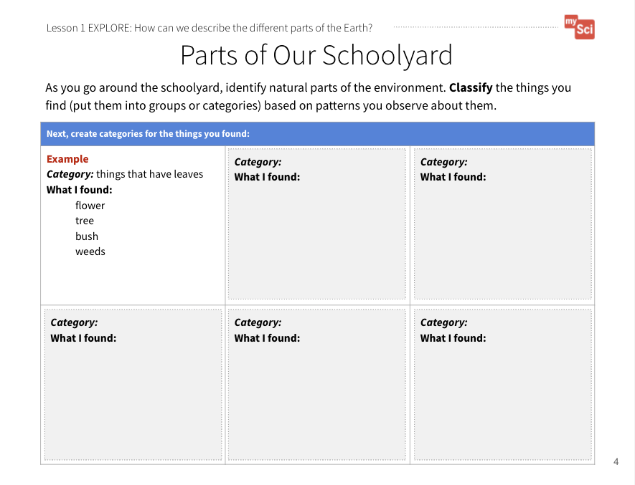  Parts of the Our Schoolyard Student Journal page | Say to students:  - How might we learn about the different parts of a farm system?  Listen for students to make connections to the natural environment around them and the environment of a farm. Build on these suggestions in order to support a student exploration of the environment around their school.  Say to students:  - Let’s go outside and do a nature walk! To learn about our environment we will record as many observations of natural things as possible. Before we go, let’s discuss observations as a part of science.  - Why do you think scientists make observations?  - What are some observations we can make about our classroom?  Have students work in small groups to identify natural parts of the environment. Students can create a list of their observations on a blank piece of paper. They may write or draw their observations.  As students are walking around, visit the groups and guide them as they explore their environment. If students need support in making observations ask:  - What observations can you make about things above you? Below you?  - Remember your environment does not just include what you are walking on.  Point out things that might not be immediately obvious to them, such as air, clouds, a puddle of water, soil, or rocks. Encourage them to look closely, and in ways that they might not normally look at the world.  Have students organize them into categories based on similarities on the Parts of Our Schoolyard Student Journal page. If students need support you can ask:  - Do you see any similarities between the objects you identified?  - How could we group these based on those similarities?
d
EXPLAIN
Students obtain information about the systems that make up Earth.
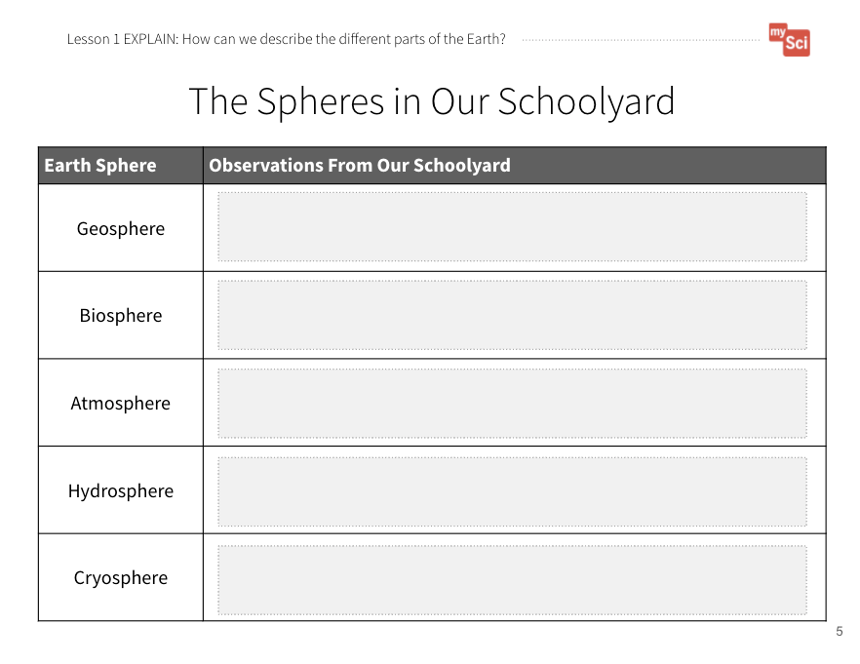  The Systems in Our Schoolyard  Student Journal page    Formative Assessment  ESS2.A: Earth Materials and Systems Earth’s major systems are the geosphere (solid and molten rock, soil, and sediments), the hydrosphere (water and ice), the atmosphere (air), and the biosphere (living things, including humans). These systems interact in multiple ways to affect Earth’s surface materials and processes. The ocean supports a variety of ecosystems and organisms, shapes landforms, and influences climate. Winds and clouds in the atmosphere interact with the landforms to determine patterns of weather | Once students return to class, have them share their observations and the different classifications they made. Push students to provide reasoning for how they categorized the different parts of the environment.  Say to students:  - Scientists have words to describe the different parts of our Earth. There are four different categories, or systems, that we can use to describe our planet.  Now is a good time to introduce geosphere, biosphere, atmosphere, and hydrosphere to students. You can direct their attention to the Latin roots (geo, bio, atmo, hydr).  Ask students:  - Have you ever heard these are part of any other words? (Students may have exposure to these roots as part of words like geode, geology, biology, biography, hydrate.)  When introducing vocabulary, refer to the vocabulary slides that provide students with images to associate with these words as well as Spanish translations to support ELL.  Next, have students watch the following videos:  - Four Spheres Part 1 (Geo and Bio): Crash Course Kids #6.1 (4:00)  - Four Spheres Part 2 (Hydro and Atmo): Crash Course Kids #6.2 (3:30)  These videos are used to introduce the terms to students. Each video covers two systems. After each system is discussed, pause the video.  Direct students to work with a partner or small group to come up with their own definition of the term. You can then have the students share their definitions with the class to come up with a class definition of each term.  Then, return to the “investigate” portion of the video. This portion should be used as practice before they re-categorize their observations from nature.  Next, have students re-categorize the parts of the environment they observed into the appropriate sphere using The Systems in Our Schoolyard Student Journal page.  This activity is a chance to formatively assess students' understanding of part of DCI ESS2.A. If students are struggling to categorize their observations into the different systems, rewatch the videos and go over the examples as a class.

ELABORATE
Students develop a model of a farm and illustrate the different Earth systems on it.
Attending to Equity:  The “Gotta Have It Checklist” is a tool from the book Ambitious Science Teaching. By having students co-construct this checklist, rather than the teacher providing this up front, they are active participants in deciding what counts as important in their scientific explanations. This list can evolve over time, and you can provide an example or two at first so that you scaffold this process for them. Watch the Creating Gotta Have it Checklist Video from AST to support you in co-constructing this with your students.  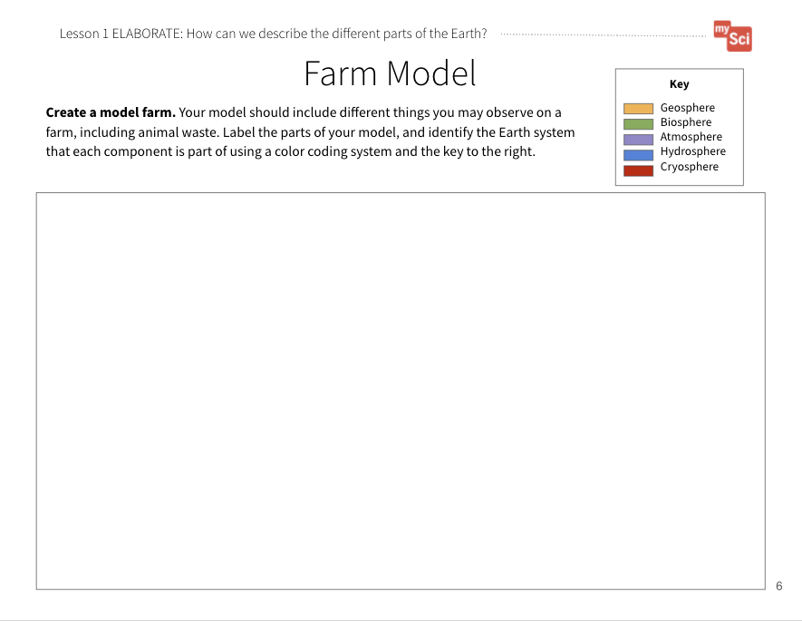  Farm Model  Student Journal page | Show students the following videos of a farm:  Dairy Farm (5:33) by ADAMideast and  Immigrant Farmers Put Down New Roots by Maryland Farm and Harvest.  Pause the videos routinely to allow students to make observations about the things they see on the farm.  Say to students:  - You are now going to create your own initial model of a farm that you will revise throughout this unit.  - Let’s develop a “Gotta Have It checklist” that tells us what we want to show on our model.  To do this, ask students:  - What have we learned about so far in this unit that we might want to include in our models? Examples of things the model’s “gotta have” include:  - Representations of different things you would find on a farm  - Labels correctly identifying the systems these things are part of  When co-constructing the “Gotta Have It” checklist with your students, actively moderate the discussion using discourse moves such as probing, turn-and-talks, follow-up questions, revoicing, and wait time. During this process, students often challenge or build on a peer’s suggestion so it may be helpful to refer to your classroom norms around how to comment on another’s ideas.  Emphasize to your students that the “Gotta Have It” checklist items should not be vocabulary words. They should be phrased as an idea that typically expresses a relationship. If key ideas are not mentioned by students, you must suggest or prompt students to look back at the DQB and ask them:  - Should any ideas here be part of our final explanations?  Students will create their models on the Farm Model Student Journal page. Students can create a digital drawing, a paper-based drawing that is uploaded, or a physical model. They can also represent their ideas through writing.  Allow students to add in components they may know about that occur on farms, but were not included in the video. Students should identify each component, and label which of Earth’s systems it falls under. For example, a student may observe a cow and categorize this as being part of the biosphere, while categorizing a farm pond as the hydrosphere.  Note that students can construct these models individually, or in small groups, throughout this unit. Provide students with colored pencils, markers, or crayons so that they can use colors to identify features of their farm if they would like.

EVALUATE
Students evaluate each other’s farm models.
Formative Assessment  ESS2.A: Earth Materials and Systems Earth’s major systems are the geosphere (solid and molten rock, soil, and sediments), the hydrosphere (water and ice), the atmosphere (air), and the biosphere (living things, including humans). These systems interact in multiple ways to affect Earth’s surface materials and processes. The ocean supports a variety of ecosystems and organisms, shapes landforms, and influences climate. Winds and clouds in the atmosphere interact with the landforms to determine patterns of weather  Developing and Using Models  Develop a model using an example to describe a scientific principle.  System and System Models  A system can be described in terms of its components and their interactions. | Have students share their models with a partner and give each other feedback.  - Did they have something to represent each system?  - Did they label all parts of their model?  - How do their models compare with each other’s?  Bring the class back together, and ask students to share out the differences and similarities in their models. This supports students to see the different ways you can represent and label things in models. Based on their discussion, students should change their models to reflect feedback.  This is the beginning of a model that will be used across all lessons as students explain the resources used on a farm, and how they impact the environment.  Return to the class consensus model that was created in the Engage portion of lesson 1. Revise the class model to include the Earth systems students identified.  This activity is a chance to formatively assess students' understanding of the SEP Developing and Using Models, DCI ESS2.A, and the CCC System and System Models. Look for students to have met the criteria of the “Gotta Have It” checklist. See the student journal answer key for an example. If students are struggling to apply what they have learned in developing a model, use the initial class model you created in the Engage to show students how to further develop a model.  To support student sensemaking across the unit, orient students back to the DQB. Ask students:  - What did we observe during today’s activity?  Record the activity and their observations. Next, ask students:  - What did we learn today?  Record their responses. If students need a reminder, they can reference their student journals.  Ask students:  - How might this help us figure out how farms are part of Earth’s systems?  To support students in making connections, ask:  - What do we know about the environment?  - What systems are present on farms? (Students may discuss that there are different parts of the natural environment (biosphere, geosphere, atmosphere, hydrosphere), and that these parts exist on human-managed farms as well.)  Next, ask students:  - What new questions do you have? (They may have new questions, such as: How can animals and plants on a farm affect the different Earth systems? How do the parts of our environment interact with one another? What happens to one part of the environment if there is a change in another? What role do humans play in the environment?)  Option A: Direct students to write down 2-3 questions they have. Then, write student responses on the driving question board.  Option B: Have students record their questions on sticky notes and then they can post their notes on the class driving question board.  Do not provide these questions for students, instead help them start thinking about these ideas by focusing their attention to the different systems that they labeled on their models and how that could relate to the anchoring problem: We need farms to grow food, but the process of producing food for all of us can harm Earth systems. Have students place their questions into existing categories, or create new categories.

Lesson 2: Summary | How do Earth’s systems interact?

Time: 3 days  Learning Targets  Use models to explain the complex interactions between Earth systems .  Revise a model to show the interactions of Earth systems on a farm.  Summary  - In the last lesson, students identified the different systems of Earth and gave examples of each. They created an initial model of a farm that included the parts of the farm and the systems they are part of.  - In this lesson, they will use different models to investigate how Earth systems interact with one another.  - They figure out that different Earth systems interact and that the interaction of one Earth system can affect the function of another Earth system. Similar to the natural world, the Earth systems present on a farm interact.  - In the next lesson, students will learn about natural resources and how humans use them. |  | Building Towards  5-ESS2-1. (5.ESS2.A.1)
 |  | NGSS 3-Dimensions:
ESS2.A: Earth Materials and Systems
Developing and Using Models
System and System Models
 |  | CCSS/MLS:
ELA
- 5.SL.1.A.a
- 5.SL.1.A.b

Lesson 2: Five E Quick View
ENGAGE | Students co-construct an initial model showing how different parts of the environment interact.
EXPLORE | Students use a model to explore how systems interact on Earth.
EXPLAIN | Students use a model to explain how systems interact on Earth.
ELABORATE | Students refine a model of a farm and illustrate the different Earth systems interactions on it.
EVALUATE | Students evaluate each other’s farm models and give feedback.

Lesson 2: Prep List
Inside mySci kit you will find: | Items you must supply: | Preparation:
20 clothespins  20 interaction cards  String  Index cards | Chart paper  Student devices | Lesson 2 Student Journal pages or Printed Student Journals

Literacy Connections | Remote Learning
Key Vocabulary  system: a group of related parts that function together as a whole  interact: have an effect on each other  Supplemental Reading Resources  Learn About Earth's Spheres | Interactive & Mini Lesson Videos  How Does the Water Cycle Involve All of Earth's Systems? Mini-Lesson  Hands-on at Home Suggestions  Have students look for evidence of system interactions in their yard or neighborhood.

L2 – Five E Lesson Plan

ENGAGE
Students co-construct an initial model showing how different parts of the environment interact.
Begin the lesson by revisiting the Driving Question Board. Highlight questions connected to the learning goals of this lesson by calling attention to questions about the interactions between Earth’s systems. If no questions directly relate, use prompts to build on student questions, supporting them to think about how the different parts of their school environment or a farm might interact.
Say to students:
- Today’s activity will support us in answering this question (ex: How do we make electricity using dams?). By answering this question, we will be able to better understand why there is a dam in Glen Canyon.
Say to students:
Say to students:
- We are trying to figure out how farms are part of Earth’s systems in order to address the anchoring problem that producing food uses a lot of resources and that can harm Earth’s systems. In the previous lesson, we described the different parts of a farm environment. We considered what Earth systems these things were part of.
Have students name the Earth systems they worked on in the previous lesson (hydrosphere, geosphere, biosphere, and atmosphere). They can refer back to their models to help them remember the names of the systems. Write them on the board or chart paper.
Ask students:
- How do you think the different Earth systems interact with each other?
- Can you give an example from something you have observed in your life?
Allow students to Turn and Talk, then share a few answers with the whole class.

EXPLORE
Students use a model to explain how systems interact on Earth.
Teaching Tip:  Example of possible system interactions:  Fast flowing water erodes rocks (hydro/geo). The water is the cause, and erosion is the effect.  Water vapor creates clouds (atmo/hydro). Water vapor is part of the atmosphere, and when it condenses to form clouds, water drops are part of the hydrosphere.  Plants use carbon dioxide and give off oxygen. (bio/atmo). The plants are part of the biosphere, and the oxygen they give off is part of the atmosphere.  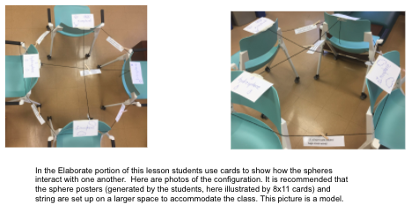   Tutorial | Say to students:  - Let’s explore ways that the systems of the Earth interact with each other. We’re going to look at examples of things that happen on our planet. Each group will decide which systems are interacting, and pin the card on the string that links the two systems. Then, we will look at what other groups decided and ask questions about why they made those choices.  Label the walls, chairs or desks: Atmosphere, Biosphere, Hydrosphere, Geosphere using the index cards. Tape a string between each of the four walls, chairs, or desks at the site of the posters, so that each sphere is connected to every other sphere (it will look like a box with an x in it — six pieces of string).  Explain that each student or group will get cards that show spheres interacting, and they should clip it on the correct string with the clothespin you will give them. To facilitate student discussions about the cards, as you walk around you can ask:  - What interactions do you see happening in your cards?  - How do you know those interactions are taking place?  - Which string do you think this card should go on? Why?  If students are struggling, use the examples in the Teaching Tip to support them. Pass out Interaction Cards and clothespins to the students. Have the students use a clothespin to clip the interactions on the correct strings.  Here is a teacher tutorial for this activity. You can also do this activity virtually using the Earth Systems Interaction game.

EXPLAIN
Students use a model to explain how water moves through and influences systems on Earth.
Teaching Tip:  If you teach Unit 23 “Our Place in the Universe” first, this will be a review for your students. If they do not remember, you can remind them by giving them an example from Unit 23. One example could be our solar system, that is composed of the different parts including the planets, moons, and the sun. | Once students have placed their card, have each student or group share their card, explain which systems are interacting, and the evidence that supports why they think that. Give students time to ask questions and make alternative claims about which spheres are interacting. To support students to do this, consider using: Conversational Support for Sharing and Expanding on Each Other's Ideas from STEM Teaching Tools.  Now is a good time to introduce or review* what a system is with students – a group of related parts that function together as a whole. You may ask them what they think a system is, and what it is like.  Say to students:  - Earth is actually one big system. The different spheres are smaller systems within the larger whole of the Earth. The parts of a system interact, or have an effect on each other.  Next, ask students to use the model to explain why these interactions matter. Ask students:  - How does one of the systems in your example affect the function of the other system?  - What would happen if one of the systems was removed?  You can also show the following videos to help students see an example of how the hydrosphere and geosphere interact and how the hydrosphere affects the geosphere:  What on Earth (3:42) and  Weathering and Erosion (4:05) by Crash Course Kids.

ELABORATE
Students refine a model of a farm and illustrate the different Earth systems interactions on it.
Farm Model  Student Journal page | Show students the following videos of a farm:  Dairy Farm (5:33) by ADAMideast and  Immigrant Farmers Put Down New Roots (6:04) by Maryland Farm and Harvest.  Have students identify where they observe interactions occurring between the things on the farm. Students may observe cows eating the grass. They may also make note of the farmer who discusses drinking the water, and breathing the air on the farm.  After watching, say:  - What could we add to our Farm Model to show the interactions of the different Earth systems?  - Let’s develop a “Gotta Have It checklist” that tells the relationships we want to show on our model. What interactions should we include in our model?  - Think of all the possible interactions we discussed in this lesson. Students can refer back to the activity from the Explain phase.  - What else should we include as part of our model so that other people know what we drew?  As students come up with suggestions, add them to the “Gotta Have It Checklist.” Examples of things the model’s “gotta have” include:  - How the atmosphere interacts with the geosphere  - How the atmosphere interacts with the biosphere  - How the atmosphere interacts with the hydrosphere  - How the geosphere interacts with the biosphere  - How the geosphere interacts with the hydrosphere  - How the biosphere interacts with the hydrosphere  - A way of showing the interactions taking place (with a key or legend – for example, students may decide to use arrows to show waste particles moving into the geosphere or atmosphere)  Have students add these interactions to their model (Farm Model Student Journal page).  Note: students are only expected to be assessed on two system interactions at a time. However, they may identify more than two interactions as part of their model. If students are struggling to make connections among systems, ask students:  - Are there components you could add to your farm model that would help you identify interactions?

EVALUATE
Students evaluate each other’s farm models and give feedback.
Farm Model  Student Journal page  Formative Assessment  ESS2.A: Earth Materials and Systems Earth’s major systems are the geosphere (solid and molten rock, soil, and sediments), the hydrosphere (water and ice), the atmosphere (air), and the biosphere (living things, including humans). These systems interact in multiple ways to affect Earth’s surface materials and processes. The ocean supports a variety of ecosystems and organisms, shapes landforms, and influences climate. Winds and clouds in the atmosphere interact with the landforms to determine patterns of weather  Developing and Using Models  Develop a model using an example to describe a scientific principle.  System and System Models  A system can be described in terms of its components and their interactions. | Have students share their models with a partner and give each other feedback. Did they have an example of the different sphere interactions? Did they label all parts of their model? How do their models compare with each other’s?  Bring the class back together, and ask students to share out the differences and similarities in their models. This supports students to see the different ways you can represent and label things in models. Based on their discussion, students should change their models to reflect feedback.  Return to the class consensus model that was created in the Engage portion of lesson 1. Revise the class model to include the interactions the students described from their individual models.  Ask students what labels you should put on your drawing. This helps scaffold the revision process that students will engage with throughout this unit.  This activity is a chance to formatively assess students' understanding of the SEP Developing and Using Models, DCI ESS2.A, and the CCC System and System Models. Look for students to have met the criteria of the “Gotta Have It” checklist. See the student journal answer key for an example. If students are struggling to apply what they have learned in developing a model, use the class consensus model you created in the Engage of lesson 1 to support students to further develop their models.  To support student sensemaking across the unit, orient students back to the DQB. Ask students:  - What did we observe during today’s activity?  Record the activity and their observations. Next, ask students:  - What did we learn today?  Record their responses. If students need a reminder, they can reference their student journals.  Ask students:  - How might this help us figure out how farms are part of Earth’s systems?  To support students in making connections, ask:  - What do we know about Earth systems?  - Are they isolated from one another? (Students may say that the parts of the environment interact with one another. These interactions affect how different Earth systems function. Animals (biosphere) on farms drink water (hydrosphere). Plants (biosphere) grow in soil (geosphere).)  Next, ask students:  - What new questions do you have? (They may have new questions, such as: Are all interactions between Earth systems beneficial? Can some interactions cause problems?)  Do not provide these questions for students, instead help them start thinking about these ideas by focusing their attention to the interaction of different systems that they labeled on their models and how that could relate to the anchoring problem: We need farms to grow food, but the process of producing food for all of us can harm Earth systems. Have students place their questions into existing categories, or create new categories.

Section 2: Quick View

How does our use of natural resources on farms affect Earth’s systems?
LESSON /  LEARNING TARGET | VIDEO & TEXT RESOURCES | REMOTE LEARNING |  | KEY TAKEAWAY | VOCABULARY  Quizlet Link  Glossary Link
LESSON /  LEARNING TARGET | VIDEO & TEXT RESOURCES | INTERACTIVES & MINI LESSON VIDEOS | HANDS-ON AT HOME SUGGESTIONS | KEY TAKEAWAY | VOCABULARY  Quizlet Link  Glossary Link
Lesson 3:  What are natural resources, and how do humans use them?  Obtain information about what natural resources are, how they form, and how they are used.  Develop a model to show how natural resources are used as part of a farm system.  (3 days) | EIA Energy Kids  Nine Surprising Things Made with Oil  Welcome to the Neighborhood | What Are Natural Resources? Mini-Lesson | Have students walk around their home or neighborhood to record data about uses of natural resources. | Natural resources are Earth materials, such as air, water, soil, and energy that are used by humans to live. | fossil fuel  natural resource  non-renewable resource
Lesson 4:  How does our use of fossil fuels affect Earth’s systems?  Obtain information about how the use of fossil fuels on a farm system affects the environment.  Develop a model to show how fossil fuel use as part of a farm system affects the environment.  (3 days) | What Causes Air Pollution  Clean Air Outdoors  Greenhouse Effect |  | Have students write a list of what types of fossil fuels they use in their home or that they see being used in their neighborhood. Describe how that might be affecting the air where you live. | The use of fossil fuels for energy causes pollution and can have negative impacts on human health, and Earth systems. Burning fossil fuels causes the Earth to heat up due to the greenhouse effect. | pollution
Lesson 5:  How does our use of water affect Earth’s systems?  Analyze and graph data to explain the distribution of the salt and freshwater on Earth in terms of volume.  Revise a model to explain how water use and waste production on farms interacts with Earth systems.  (3 days) | Water cycle maps  River Runner  What is Eutrophication?  The Ogallala Aquifer | How Is the Water on Earth Distributed? Mini-Lesson  How Does Your Water Use Compare to the Rest of the World? Mini-Lesson | Have students track what they use water for, and how many minutes they use water per day. | The amount of freshwater available for human use is limited. Many activities, including farming, can cause water to become polluted, and deplete water resources. It is important for humans to conserve this natural resource. | aquifer  freshwater  saltwater
Lesson 6:  How can we use animal waste as a natural resource?  Plan and conduct an investigation to see how we can use animal waste as a natural resource on the farms.  (2 days) | Biodigester Timelapse |  | Have students collect kitchen scraps and watch them decompose either outside or in a cup covered with cellophane. What factors make them decompose faster or slower? | Students figure out that animal waste can create natural gas. We can use experimental design to consider how to opitimize the amount of gas produced from waste in a biodigester. This idea will be further investigated in Lesson 9, as a solution to energy use on farms. | biodigester  Decomposer  Constraint  Criteria

Lesson 3: Summary | What are natural resources, and how do humans use them?

Time: 3 days  Learning Targets  Obtain information about what natural resources are, how they form, and how they are used.  Develop a model to show how natural resources are used as part of a farm system.  Summary  - In the last lesson, students explained complex interactions between Earth systems. They refined their farm models to include interactions between the components on the farm.  - In this lesson, students track their daily routines and research to see how natural resources can be used as energy for our daily lives.  - Students figure out that natural resources are Earth materials, such as air, water, soil, and energy that are used by humans to live.  - In the next lesson, students will learn about how the use of natural resources by humans can affect the environment. |  | Building Towards  4-ESS3-1.
 |  | NGSS 3-Dimensions:
ESS3.A: Natural Resources
Obtaining, Evaluating, and Communicating Information
Developing and Using Models
System and System Models
 |  | CCSS (MLS):
ELA
- 5.R.3.A.a
- MLS 5.R.3.C.e
- 5.SL.1.A.a
- 5.SL.1.A.b

Lesson 3: Five E Quick View
ENGAGE | Students gather data about things they do and use in their daily lives.
EXPLORE | Students analyze data about their daily lives to see patterns of natural resources they commonly use.
EXPLAIN | Students obtain information to explain how energy resources form.
ELABORATE | Students refine a model of a farm and illustrate the natural resources used and produced there.
EVALUATE | Students evaluate each other’s farm models and give feedback.

Lesson 3: Prep List
Inside mySci kit you will find: | Items you must supply: | Preparation:
 | Student devices or printed articles | Lesson 3 Student Journal pages or Printed Student Journals

Literacy Connections | Remote Learning
Key Vocabulary  fossil fuel: a fuel that formed from the decayed remains of ancient plants and animals (coal, oil, and natural gas)  natural resource: materials in Earth’s systems that are useful to people  non-renewable resource: resource that is not replaced by nature as fast as it is used  Supplemental Reading Resources  What are Fossil Fuels?  What are Fossil Fuels? | Interactive & Mini Lesson Videos  What Are Natural Resources? Mini-Lesson  Hands-on at Home Suggestions  Have students walk around their home or neighborhood to record data about uses of natural resources.

L3 – Five E Lesson Plan

ENGAGE
Students gather data about things they do and use in their daily lives.
Attending to Equity:  Self-documentation technique is a powerful way to make learning meaningful and relevant for all students. This helps students see that their cultural connections and knowledge are valued and useful in the science classroom.  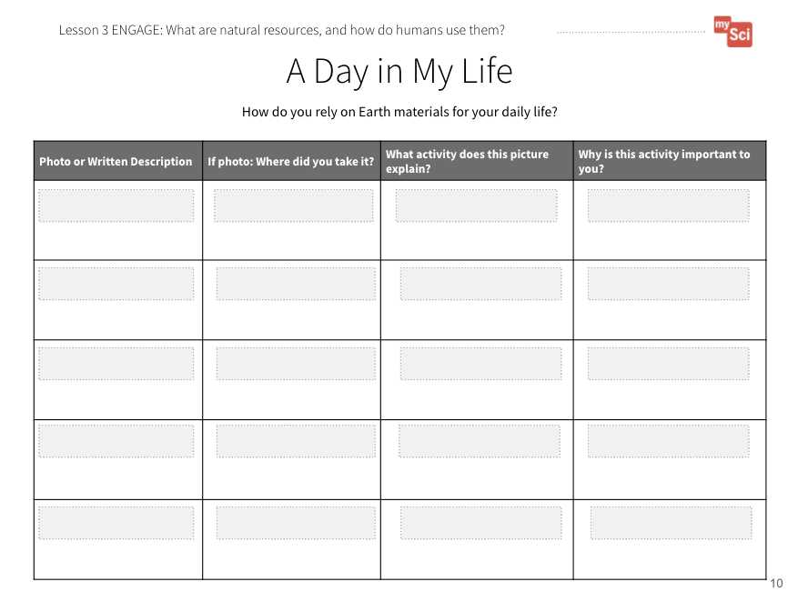  A Day in My Life  Student Journal page | Begin the lesson by revisiting the Driving Question Board. Highlight questions connected to the learning goals of this lesson by calling attention to questions about natural resources and how people use them. If no questions directly relate, use prompts to build on student questions, supporting them to think about what they observed on a farm and how farmers might use resources to grow food.  Say to students:  Today’s activity will support us in answering this question (ex: What are natural resources and how do humans use them). By answering this question, we will be able to build on our understanding of how using natural resources might affect the farm and Earth’s systems.  Say to students:  - How do you think you are connected to the systems on our planet?  Allow students to Turn and Talk, then share a few answers.  - Let’s collect some data to see how we are connected to the Earth.  Using self-documentation technique, ask students to examine their typical day (this could be in their home, at school, and places they go after school or on the weekend) to identify the objects and routines that are important to their lives. Students can either take photos using an iPad or other take-home device, or they can draw pictures. Have them record their data on A Day in My Life Student Journal page.  Launch the activity with students on the first day of this lesson, having them begin with their school day. Model with students the types of things they should track that might not be immediately obvious to them. They can then take photos or draw pictures over the next evening and before school. If you have time, you could do this over a weekend to get more data.

EXPLORE
Students analyze data about their daily lives to see patterns of natural resources they commonly use.
A Day in My Life  Student Journal page  System and System Models  A system can be described in terms of its components and their interactions. | Once students have gathered this data, have them share their photos or pictures with other students. You could have students upload the photos to a Google Slideshow or Flipgrid, for instance, so that students can sort and compare data about their lives. Provide questions for students to discuss with their groups such as:  - Do you see any patterns?  - Do you notice that many kids watched television, played video games, or read a book at night?  - Did many students use cars or other transportation to get to and from school, or music/sports practice?  - Did many students include meal time photos?  After they compare and sort, ask students:  - What are the parts of Earth’s systems involved in the things you used and did during your day? Allow students to share ideas with a small group. Have students create a model as they work together. Circulate and listen to students as they share and prompt them to think about how the things they do each day relate to what they are learning about farms.  Bring the class together and ask:  - How might we think about our everyday activities and Earth’s systems? How does this connect to our problem (farms produce food but can harm Earth’s systems)?  Students have learned about systems and system models, so listen for ideas about the components of Earth’s systems that their activities affect and how these components interact. If not, prompt them to consider:  - What did our observations tell us about our interactions with Earth’s systems?  - How are the components in our models interacting?  - What questions do you have about these components and their interactions?   Make a class chart like the following. As you make the chart, point out that though these objects may be human-made, they are made from natural resources that come from Earth’s systems, such as water, air, organisms, minerals and rocks (metals), and soil.  If students are struggling to make connections, ask questions such as:  - What are the pages of a book made from?  - Where does the plastic for your video game console come from?  - Where did the materials to make your meal or your clothing come from?  You can also have students return to the journal pages from Lesson 2 to review aspects of Earth’s systems.  Say to students:  - One common thread that you all might have noticed is that we use energy like electricity, natural gas, or gasoline to live our typical lives. What do you wonder about this? (Students may wonder how we are able to get this energy, and what effects this might have on the Earth and on us.)
   | Natural Resources
  Object or Routine | Things We Needed from Earth’s Systems to Make Object/Routine | Energy Source We Needed for it to Work
  Example: Driving to School | Metal, plastic parts and rubber tires (oil), battery (minerals like lithium), paint (water) | Gasoline
  Example: Eating Dinner | Soil, Water, Plants, Animals, Metal, plastic from oil (for oven or microwave), clay (for ceramic plates), wood (for paper plates, napkins, or table and chairs | Electricity or natural gas for appliances to work, Gas to transport food from farm to grocery store to home, and to process the food in a factory

EXPLAIN
Students obtain information to explain how energy resources form.
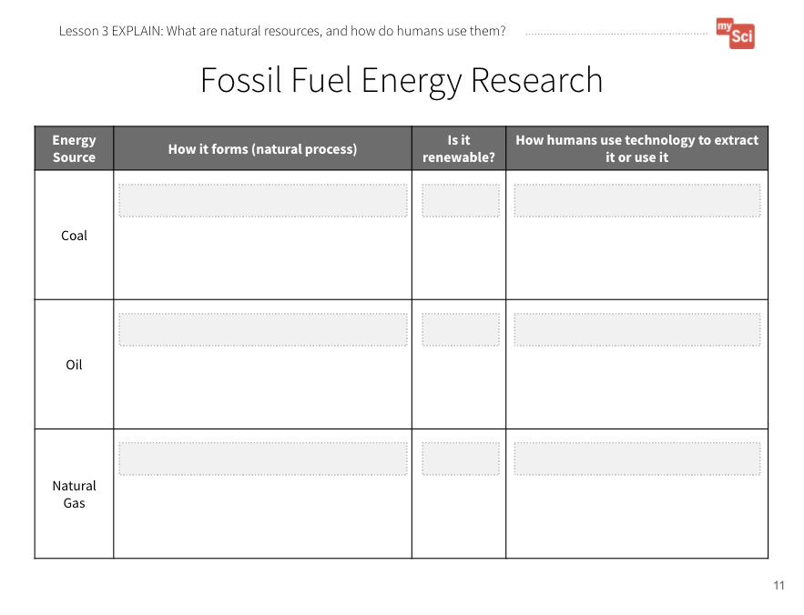  Fossil Fuel Energy Research Student Journal page  Formative Assessment  ESS3.A: Natural Resources Energy and fuels that humans use are derived from natural sources, and their use affects the environment in multiple ways. Some resources are renewable over time, and others are not.  Obtaining, Evaluating, and Communicating Information  Obtain and combine information from books and other reliable media to explain phenomena.  Attending to Equity:  The “Nine Surprising Things Made with Oil” video does not include narration. You may need to narrate this video while watching if you have students who need support with reading. | Say to students:  - In order to answer some of these questions, what kinds of information do you need and how might you go about finding this information?  If students are struggling, say to students:  - Scientists use research to see what is known and to generate new questions. How can we use research to see how we are able to have electricity, gasoline, and oil for our daily lives?  Provide students access to one or both of the following resources, as well as the Fossil Fuel Energy Research Student Journal page. Say to students:  - We need to keep track of our information in one spot.  To help students develop the practice of obtaining information, provide one resource. In the following lesson they will be provided with multiple resources, and asked to combine information. You can walk through the resource (Coal) and model how to take notes on important information.  - EIA Energy Kids  You can have students work in small groups to do this. Another way to approach this is to have different groups research coal, oil, or natural gas, then jigsaw together to share information. Students can share this research on paper or digitally, but be sure that their research contains the specifics outlined on the journal page. Students can draw pictures of the processes they research or write down the information.  Once students have finished, ask:  - Where do fossil fuel energy sources come from, and which Earth systems are they from? (They are formed from the buried (geosphere) remains of plants and animals (biosphere)).  - Why are these energy resources important to us? (Students should come to the conclusion that the energy that comes from natural resources is used to make the things we use in our lives, and to make them work.)  - What do we mean when we describe fossil fuels as non-renewable? (These resources will not replenish over human timescales because they take millions of years to form.)  This activity is a chance to formatively assess students' understanding of the SEP Obtaining, Evaluating, and Communicating Information and DCI ESS3.A. See the student journal answer key for an example. If students are struggling to obtain information to describe how energy is derived from fossil fuels, read the resource as a class, pausing frequently to check if you have come across information needed to fill out the journal page.  Go back to the chart you created in the Explore part of the lesson. Ask students:  - How can we revise this chart to better show our use of natural resources for energy?  - What has to happen for us to be able to have the energy to do the things we like and need to do in our daily lives?  Students may add coal as an energy source for electricity, and oil as the root product of gasoline. Many people use gas for cooking. Have them trace their day back to the energy sources needed to do their daily activities.  You can watch the following videos with students to help them understand how natural resources are used to make objects we interact with daily:  Nine Surprising Things Made with Oil (0:44) from Oil Field Team and  Welcome to the Neighborhood (3:14) from Crash Course Kids.

ELABORATE
Students refine a model of a farm and illustrate the natural resources used and produced there.
Farm Model  Student Journal page | Show students the data charts and photos that detail how energy is used for growing and harvesting crops and livestock on farms (In Section 2 Curriculum Slides). Refer to the notes section in the slide to describe each of the images.  Say to students  - We’ve been considering our farm from the perspective of Earth’s systems, and how they interact. But humans are using natural resources in certain ways to keep their farm operating smoothly. In the previous lessons we developed a “Gotta Have It Checklist” to show the components and relationships we needed to include in the models. What would you add to the checklist today to make our models show how natural resources are being used on a farm?  Examples of things the model’s “gotta have” might include:  - Any natural resources or products made from natural resources found on the farm (For example, did they include any farm equipment, water, fuel for energy, metal for grain silos and fencing, etc.)  - How energy is used on a farm, and what energy sources are used (For example, if the farmer uses a milking machine, what powers it?)  As students revise their models, ask them to discuss:  - Whether the resource is used by the farmer or produced by the farmer (Ex. Soil is used by the farmer to grow crops, crops are produced by the farmer for food, clothing fibers, and building materials)  - What the natural resource is used for (Ex. Soil is used to grow crops, fossil fuels are used to power building and farm equipment)  Ask students:  - Could animal waste be considered a natural resource?  - Why do you think it might be?  Allow students to share their ideas. Students should use their understanding of what natural resources are, and begin to discuss their rationale for why animal waste should be considered a natural resource, or why it should not be considered a natural resource. You will return to this idea in lesson 6.

EVALUATE
Students evaluate each other’s farm models and give feedback.
Formative Assessment  ESS3.A: Natural Resources Energy and fuels that humans use are derived from natural sources, and their use affects the environment in multiple ways. Some resources are renewable over time, and others are not.  Developing and Using Models  Develop a model using an example to describe a scientific principle.  System and System Models  A system can be described in terms of its components and their interactions. | Have students share their models with a partner or another group and give each other feedback using the “Gotta Have It Checklist”.  - How do their models compare with each other’s?  - What natural resources did they include in their models and why?  - Did they identify animal waste as a natural resource in their model?  Students will continue to refine this model over time. Bring the class back together, and ask students to share out the differences and similarities in their models. This supports students to see the different ways you can represent and label things in models. Based on their discussion, students should change their models to reflect feedback.  Return to the class consensus model that was created in the Engage portion of lesson 1. Revise the class model to include the natural resources the students described from their individual models. Ask students what labels you should put on your drawing. This helps scaffold the revision process and provides continuity throughout this unit.  This activity is a chance to formatively assess students' understanding of the SEP Developing and Using Models, DCI ESS3.A, and CCC System and System Models. See the student journal answer key for an example. If students are struggling to apply what they have learned in developing a model, use the class consensus model you created to support students to further develop their models.  To support student sensemaking across the unit, orient students back to the DQB. Ask students:  - What did we observe during today’s activity?  Record the activity and their observations. Next, ask students:  - What did we learn today?  Record their responses. If students need a reminder, they can reference their student journals.  Ask students:  - How might this help us figure out how our use of natural resources on farms affects Earth’s systems? (Students may say that natural resources are Earth materials that humans use to live. Natural resources can include things like water (hydrosphere), oil and other fossil fuels (geosphere), metals and minerals (geosphere), etc. Farms use and produce different natural resources. This could have an effect on Earth systems because we know that systems interact.)  Next, ask students:  - What new questions do you have?  Write student responses on the driving question board. (They may have new questions, such as: Can we run out of natural resources? Does our use of natural resources affect Earth systems?)  Do not provide these questions for students, instead help them start thinking about these ideas by focusing their attention to the different natural resources that they labeled on their models and how that could relate to the anchoring problem: We need farms to grow food, but the process of producing food for all of us can harm Earth systems. Have students place their questions into existing categories, or create new categories.

Lesson 4: Summary | How does our use of fossil fuels affect Earth’s systems?

Time: 3 days  Learning Targets  Obtain information about how the use of fossil fuels on a farm system affects the environment.  Develop a model to show how fossil fuel use as part of a farm system affects the environment.  Summary  - In the last lesson, students obtained information about how humans use natural resources, including energy. They refined their farm models to include natural resources used and produced on the farm.  - In this lesson, students use text resources to draw relationships between natural resource use and impacts on Earth systems.  - They figure out that the use of fossil fuels for energy causes pollution and can have negative impacts on human health, and Earth systems.  - In the next lesson, students will consider how humans use water, the impacts of our water use, and how animal waste can impact the quality of the water we use. |  | Building Towards  5-ESS2-1. (5.ESS2.A.1) | 4-ESS3-1. | 5-ESS3-1. (5.ESS3.C.1)
 |  | NGSS 3-Dimensions:
ESS3.A: Natural Resources
ESS2.A: Earth Materials and Systems
ESS3.C: Human Impacts on Earth Systems
Developing and Using Models
Obtaining, Evaluating, and Communicating Information
System and System Models
 |  | CCSS (MLS):
ELA
- 5.R.3.A.a
- 5.R.3.C.e
- 5.SL.1.A.a
- 5.SL.1.A.b

Lesson 4: Five E Quick View
ENGAGE | Students ask questions about patterns in childhood asthma data.
EXPLORE | Students obtain information from text to describe the cause and effect relationship between transportation and asthma.
EXPLAIN | Students develop a model to explain how humans' use of natural resources affects Earth systems.
ELABORATE | Students refine a model of a farm and illustrate the effects of natural resource use on Earth systems.
EVALUATE | Students evaluate each other’s farm models and give feedback.

Lesson 4: Prep List
Inside mySci kit you will find: | Items you must supply: | Preparation:
From Lesson 2:  String  Index cards | Chart paper  Student electronic devices or printed article resources  Sphere labels from Lesson 2 (hydrosphere, atmosphere, geosphere, biosphere) | Lesson 4 Student Journal pages or Printed Student Journals

Literacy Connections | Remote Learning
Key Vocabulary  pollution: a substance or thing that has harmful or poisonous effects  Supplemental Reading Resources  What is the ozone layer?  What is smog? | Interactive & Mini Lesson Videos  Hands-on at Home Suggestions  Have students write a list of what types of fossil fuels they use in their home or that they see being used in their neighborhood. Describe how that might be affecting the air where you live.

L4 – Five E Lesson Plan

ENGAGE
Students ask questions about patterns in childhood asthma data.
Attending to Equity:  This lesson includes a chance to value student knowledge if they or someone they know has asthma. By exploring asthma data, students get to figure out a meaningful phenomenon that affects their peers. Asthma disproportionately affects Black, Hispanic, and Indigenous people in America. See more about centering this type of meaningful phenomenon and cultural knowledge in this STEM Teaching Tool. | Begin the lesson by revisiting the Driving Question Board. Highlight questions connected to the learning goals of this lesson by calling attention to questions about how the Earth Systems interact, specifically how the use of natural resources might affect the atmosphere. If no questions directly relate, use prompts to build on student questions, supporting them to think about their own experiences interacting with something in the air.  Say to students:  Today’s activity will support us in answering this question (ex: How does our use of natural resources affect the air around us?). By answering this question, we will be able to build on our understanding of how using natural resources might affect the farm and Earth’s systems.  Ask students:  - Have you ever heard of asthma, or do you know someone who has asthma? (Note: You likely have a student who either has asthma or has a family member with asthma- you can tell students they can share that if they are comfortable talking about it, but do not have to.)  - Asthma is a condition that makes it hard to breathe in certain circumstances, like if you’re running or if it’s hot outside. If you have asthma, certain things in the environment can trigger an asthma attack.  - Have you ever wondered how many people around the USA have asthma? Let’s look at some data that shows rates of childhood asthma around our country. You can make observations and ask questions about the maps.  Project this interactive map from USDOT. You can point out all three maps. One map shows asthma caused by nitrous oxide, which is a gas. It also shows two types of particulate matter pollution, which are tiny pieces of solids and liquids in the air. PM_{2.5} and PM ₁₀ refer to the size of the pollutant. You can observe this data for 2 different years (2000 and 2010). You can also zoom in on this map to show your particular county. To support students to analyze the data you can use the following prompts:  - What do the different shapes on the maps mean? (These are counties)  - What do the different colors on the map mean? (Green and yellow means lower rates of asthma caused by the pollution. Orange and red means higher rates of asthma caused by the pollution - Note: at first students may articulate that the colors show more or less of the pollutant. Remind students it is showing asthma rates caused by the pollution.)  - What do you notice about asthma caused by nitrogen dioxide?  - What do you notice about asthma caused by particulate matter?  - What differences do you see between the maps?  - What questions do you have?  Record student questions on the driving question board. Examples of observations: Particulate matter seems to cause worse rates of asthma than nitrogen dioxide. Some counties seem to have worse asthma rates than others. Things seem to get a little better in 2010, but there are still high rates in some places. Questions you may anticipate hearing might include:  - Why do some counties have worse asthma numbers?  - What are nitrogen dioxide and particulate matter? Why does traffic cause pollution?  - Why does pollution cause asthma? Why was it worse in 2000 than 2010?  Consider if any of these questions are connected to the learning of this lesson. If so, highlight this question for students. Say to students:  - Today’s activity will support us in answering this question. By answering this question, we will be able to build on our understanding of the anchoring problem.  If students do not offer these questions, do not provide these questions for students; instead, help them start thinking about these ideas by focusing their attention to the different asthma numbers, any words they do not know, differences in asthma numbers during the ten year span. Have students place their questions into existing categories, or create new categories.

EXPLORE
Students obtain information from text to describe the cause and effect relationship between transportation and asthma.
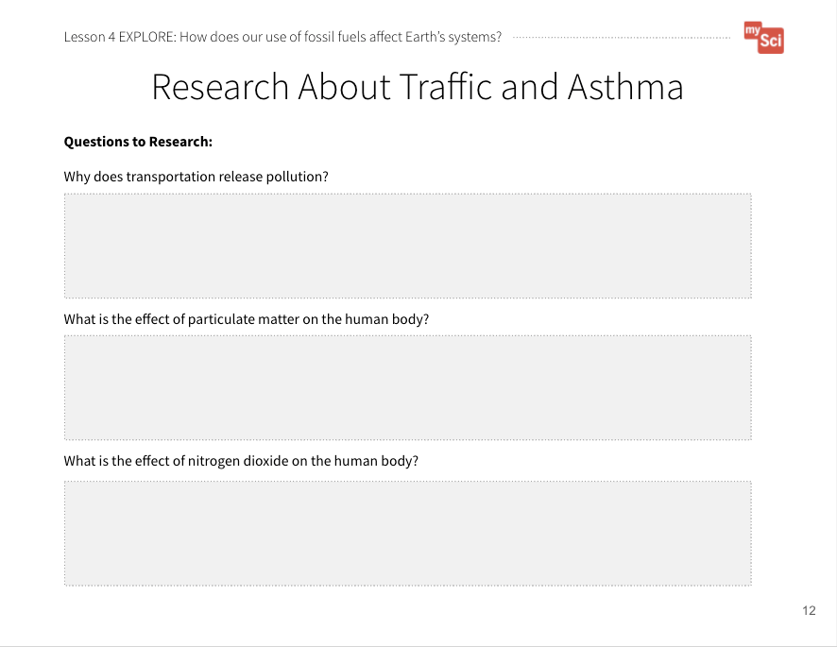  Research About Traffic  and Asthma  Student Journal page  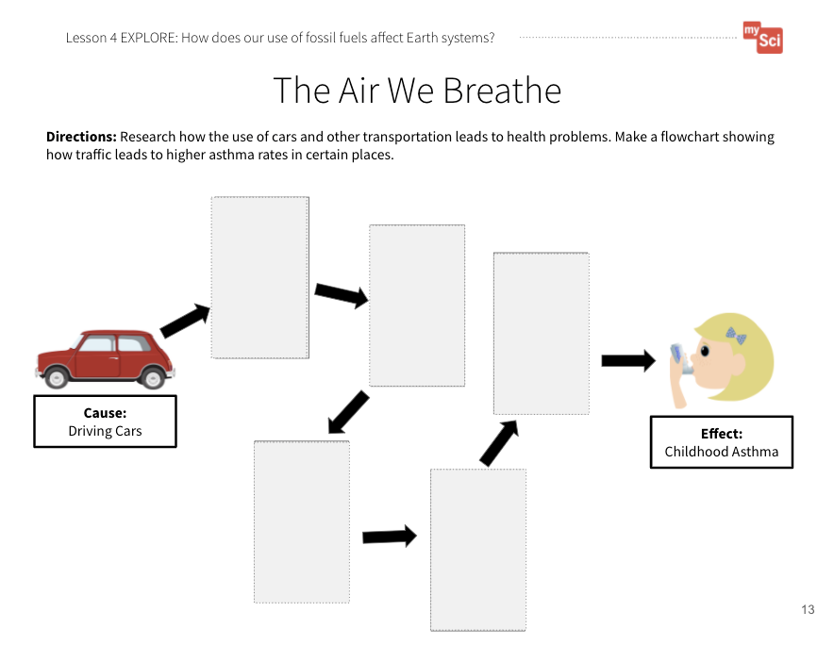  The Air We Breathe  Student Journal page  Teaching Tip:  To help students build research skills, when you click on the links, first ask students which topics they think would be most relevant to help explain the cause and effect relationship between traffic and asthma. | Say to students:  - In order to answer some of these questions, what kinds of information do you need and how might you go about finding this information?  If students are struggling, say to students:  - How were we able to answer our questions in the previous lesson about natural resources? (Students may recall that they used an internet resource to gather specific information.)  In the last lesson, students developed the practice of obtaining information, using only one resource. In this lesson, they will use multiple resources, and combine information.  Provide students the following text resources and the Research About Traffic and Asthma and The Air We Breathe Student Journal pages. Show students that they can use the first page to record important facts, then put those facts into a flowchart that shows step by step how traffic causes asthma.  - What Causes Air Pollution from NASA Climate Kids  - Clean Air Outdoors from The American Lung Association  - The most helpful starting point for research is the page titled What Makes Outdoor Air Unhealthy?. Have the students research the hyperlinks for Nitrogen Dioxide, Particulate Matter, and Transportation.  They can take time to read and take notes individually, then pair up to co-construct their flowcharts based on what they read. They can use pictures, drawings, and/or words to construct their flowcharts.  After students create their flowcharts, create a class flowchart to make sure everyone comes to a consensus about the cause and effect relationship. Take this opportunity to remind students that events have causes that generate observable patterns and highlight the evidence in the flowchart that supports the explanation that traffic can cause asthma. It is important to highlight the causal mechanism in the flowchart, highlighting that this relationship is nonlinear and complex.  Next, allow students to work in groups to choose another phenomenon related to humans' uses of natural resources, research using text and video resources, and create a flowchart to apply the CCC of cause and effect to other examples. Highlight the routine nature in which cause and effect is used in these cases to explain changes in the environment. As students work, use these prompts to support student sensemaking:  - What’s going on? Does it always work this way?  - What is the mechanism that explains this?  - How can we show this relationship and how does it help us explain what’s going on?  Examples students could choose from include:  - Coral Bleaching in the Oceans  - Oil Spills and Aquatic Life  - Earthquakes and Fracking  - Flammable Water from Fracking  - Increased Wildfires  - Coal ash spills  - Orange Water from Coal Pollution  - Other (based on student research and interest)  Some of these topics are able to be researched using the NASA and EIA Energy Kids websites. For other topics, here are other resources to find student-friendly news articles: Science Journal For Kids, Science News For Students, Washington Post For Kids, and Smithsonian Tween Tribune.  To support students in identifying reliable resources facilitate a discussion about important things to look for when examining websites: Writing Videos for Kids: How to Evaluate Sources for Reliability. From this video, highlight the following:  - Identify the author. Who are they? What is their purpose for writing the article?  - Look for common information between multiple articles on the same topic  - Look at the date the article was written. Scientific knowledge can change over time.  As a class, examine one of the resources students will be using for today’s activity. Have the students identify the author, discuss the purpose of the writing, and identify the date the article was written. To help guide them you can ask:  - Who is the author of the article?  - Where can we find the author?  - What is their purpose for writing the article? Is it to inform? To persuade? To sell us something?  - When was this article written?

EXPLAIN
Students develop a model to explain how humans’ use of natural resources affects Earth systems.
Systems Tutorial  Formative Assessment  ESS3.A: Natural Resources Energy and fuels that humans use are derived from natural sources, and their use affects the environment in multiple ways. Some resources are renewable over time, and others are not.  ESS2.A: Earth Materials and Systems Earth’s major systems are the geosphere (solid and molten rock, soil, and sediments), the hydrosphere (water and ice), the atmosphere (air), and the biosphere (living things, including humans). These systems interact in multiple ways to affect Earth’s surface materials and processes. The ocean supports a variety of ecosystems and organisms, shapes landforms, and influences climate. Winds and clouds in the atmosphere interact with the landforms to determine patterns of weather  Obtaining, Evaluating, and Communicating Information  Obtain and combine information from books and other reliable media to explain phenomena.  Cause and Effect  Cause and effect relationships are routinely identified and used to explain change. | Say to students:  - We have seen that when we use natural resources, we can cause pollution – adding a harmful or poisonous substance to the environment. Let’s break down how this affects the Earth.  Set up the spheres interaction model from Lesson 2. Here is a teacher tutorial for this activity.  You will model the process for students, using the asthma example. Use the flowchart to trace how the human use of energy for driving affects the different spheres.  Write down how the spheres are interacting on index cards, and use the clothes pins to place them along the string between two spheres.  Sample Guidance: 1. Biosphere → Geosphere- Humans extract oil from the ground. 2. Biosphere → Atmosphere- Humans burn gasoline when they drive their car, which releases pollutants into the air. 3. Atmosphere → Biosphere- Polluted air is breathed in by humans, which can cause asthma.  Next, provide each student group several index cards. Say to students:  - Now, you are going to trace the interactions of the Earth systems involved in the topic you researched. Each group will have the chance to explain their phenomenon using the sphere model.  Give students time to talk through system interactions, write them on index cards, then share out to the whole class. If students provide system interactions that are not correct, ask them to explain their thinking. Then refer to the talk moves and have students agree and/or disagree with their thinking. Use this as an opportunity for students to continue to make sense of the different systems and their interactions.  This activity is a chance to formatively assess students' understanding of the SEP Obtaining, Evaluating, and Communicating Information, DCIs ESS3.A and ESS2.A, and CCC Cause and Effect. You can examine the flow charts students created (see the student journal answer key for an example) as well as observe their discussions about the interactions between Earth’s systems using the model from lesson 2.  If students are struggling to obtain information to describe the connections between human events (transportation) and pollution, read the resources as a class, pausing frequently to check if you have come across information needed to fill out the journal page.  Say to students:  - You might have noticed that things like wildfires and coral bleaching have to do with the planet warming up. Burning fossil fuels releases several pollutants, one of which is carbon dioxide gas. Let’s watch a video that shows how this affects our planet.  Show Greenhouse Effect from NASA (2:29). This idea is an above grade-level expectation. However, it is a useful conversation to provide context for the engineering designs students will engage in during Lessons 8&9.  After the video, use a student research example (about wildfires, for example) to talk about how greenhouse gases such as carbon dioxide and methane increase the greenhouse effect, or warming of the Earth.

ELABORATE
Students refine a model of a farm and illustrate the effects of natural resource use on Earth systems.
Farm Model  Student Journal page | Ask students:  - How do you think energy use on farms impacts Earth systems? Why? (Students should connect the use of fossil fuels on farms to decreased air quality which impacts human health. They may also discuss how air pollution affects other Earth systems.)  - In the last lessons we have used a “Gotta Have It Checklist” to show the components and relationships we needed to include in the models. What would you add to the checklist today to make our models show how fossil fuels used on a farm affect the environment?  Examples of things the model’s “gotta have” might include:  - How fossil fuel use affects the atmosphere  - How fossil fuel use affects the biosphere (Ex. human health)

EVALUATE
Students evaluate each other’s farm models and give feedback.
Farm Model  Student Journal page  Formative Assessment  ESS3.A: Natural Resources Energy and fuels that humans use are derived from natural sources, and their use affects the environment in multiple ways. Some resources are renewable over time, and others are not.  ESS2.A: Earth Materials and Systems Earth’s major systems are the geosphere (solid and molten rock, soil, and sediments), the hydrosphere (water and ice), the atmosphere (air), and the biosphere (living things, including humans). These systems interact in multiple ways to affect Earth’s surface materials and processes. The ocean supports a variety of ecosystems and organisms, shapes landforms, and influences climate. Winds and clouds in the atmosphere interact with the landforms to determine patterns of weather  ESS3.C: Human Impacts on Earth Systems Human activities in agriculture, industry, and everyday life have had major effects on the land, vegetation, streams, ocean, air, and even outer space. But individuals and communities are doing things to help protect Earth’s resources and environments.  Developing and Using Models  Develop a model using an example to describe a scientific principle.  System and System Models  A system can be described in terms of its components and their interactions. | Have students share their models with a partner or another group and give each other feedback using the “Gotta Have It Checklist”.  - How do their models compare with each other’s?  - What interactions between fossil fuels and Earth’s systems did they identify?  - Students will continue to refine this model over time.  Bring the class back together, and ask students to share out the differences and similarities in their models. This supports students to see the different ways you can represent and label things in models. Based on their discussion, students should change their models to reflect feedback.  Return to the class consensus model that was created in the Engage portion of lesson 1. Revise the class model to include the interactions between fossil fuels and Earth’s systems the students described from their individual models. Ask students what labels you should put on your drawing. This helps scaffold the revision process and provides continuity throughout this unit.  This activity is a chance to formatively assess students' understanding of the SEP Developing and Using Models, DCI ESS3.A and ESS2.A, and CCC System and System Models. See the student journal answer key for an example. If students are struggling to apply what they have learned in developing a model, use the class consensus model you created to support students to further develop their models.  To support student sensemaking across the unit, orient students back to the DQB. Ask students:  - What did we observe during today’s activity?  Record the activity and their observations. Next, ask students:  - What did we learn today?  Record their responses. If students need a reminder, they can reference their student journals.  Ask students:  - How might this help us figure out how our use of natural resources on farms affects Earth’s systems? (Students may say that humans use fossil fuels for their everyday activities, but the use of fossil fuels can be bad for the environment. They may provide specific examples of how the burning of fossil fuels releases pollution into the atmosphere that can cause problems for living things.)  Next, ask students:  - What new questions do you have? Write student responses on the driving question board. (They may have new questions, such as: How can we reduce the effect that the use of fossil fuels has on the environment? Do other natural resources have an impact on the environment? Are there other ways to get energy instead of fossil fuels?)  Do not provide these questions for students, instead help them start thinking about these ideas by focusing their attention to the different interactions between fossil fuel use and Earth systems that they labeled on their models and how that could relate to the anchoring problem: Farms use a large amount of resources. This can have a negative impact on the environment. Have students place their questions into existing categories, or create new categories.

Lesson 5: Summary | How does our use of water affect Earth’s systems?

Time: 3 days  Learning Targets  Analyze and graph data to explain the distribution of the salt and freshwater on Earth in terms of volume..  Revise a model to explain how water use and waste production on farms interacts with Earth’s systems.  Summary  - In the last lesson students explained how our use of fossil fuels affects Earth systems.  - In this lesson students analyze and graph data to show how water is distributed on Earth. They obtain information about how human activities can affect the amount and quality of our water resources.  - Students figure out that the amount of freshwater available for human use is limited. Many activities, including farming, can deplete water resources. Human activities can also cause water resources to become polluted.  - In the next lesson, students will set up biodigesters to investigate if we can use farm waste as a natural resource for energy. |  | Building Towards  5-ESS2-2. (5.ESS2.C.1) | 5-ESS2-1. (5.ESS2.A.1) | 5-ESS3-1. (5.ESS3.C.1)
 |  | NGSS 3-Dimensions:
ESS2.C: The Roles of Water in Earth’s Surface Processes
ESS2.A: Earth Materials and Systems
ESS3.C: Human Impacts on Earth Systems
Using Mathematics and Computational Thinking
Developing and Using Models
System and System Models
Scale, Proportion, and Quantity
 |  | CCSS (MLS):
Optional
- MLS 5.NF.A.1/MLS 5.NF.A.2

Lesson 5: Five E Quick View
ENGAGE | Students ask questions about water use farms.
EXPLORE | Students use models to visualize amounts of different kinds of water on Earth, and how our waterways are connected.
EXPLAIN | Students construct explanations about how humans' use of water resources affects Earth’s systems.
ELABORATE | Students develop a model to show how farms use water and how animal waste can pollute water resources.
EVALUATE | Students evaluate each other’s farm models and give feedback.
EXTEND | Students use a model to explain how we can create drinkable water from saltwater.

Lesson 5: Prep List
Inside mySci kit you will find: | Items you must supply: | Preparation:
100mL Graduated cylinder  10mL Graduated cylinder  Food coloring  Pipette (1mL)  1 Petri dish | Computer with internet access  Chart Paper  Water | Lesson 5 Student Journal pages or Printed Student Journals

Literacy Connections | Remote Learning
Key Vocabulary  aquifer: large bodies of underground rock that contain fresh groundwater  freshwater: water that does not contain a large amount of salt (like river or lake water)  saltwater: water that contains a lot of salt (like ocean water)  volume: the amount of space an object takes up  Supplemental Reading Resources  The Dead Zone  High and Dry | Interactive & Mini Lesson Videos  How Is the Water on Earth Distributed? Mini-Lesson  How Does Your Water Use Compare to the Rest of the World? Mini-Lesson  Hands-on at Home Suggestions  Have students track what they use water for, and how many minutes they use water per day.

L5– Five E Lesson Plan

ENGAGE
Students ask questions about water use farms.
Begin the lesson by revisiting the Driving Question Board. Highlight questions connected to the learning goals of this lesson by calling attention to questions about the use of water on the farm and how it might affect Earth’s systems. If no questions directly relate, use prompts to build on student questions, supporting them to think about what they observed on a farm and pointing out the instances where farmers use water and highlighting examples of how water is used on a farm.
Say to students:
Today’s activity will support us in answering this question (ex: How does our use of water affect Earth’s systems?). By answering this question, we will be able to build on our understanding of how using natural resources might affect the farm and Earth’s systems.
Show students the following video: The Ogallala Aquifer (Stop at 1:36) from the National Science Foundation. After students have observed the video, ask:
- What do you observe about water on farms? (Farms need water to grow food. Some farms pump water out of the ground.)
If students don’t offer these responses you can ask:
- What do you think farms use water for?
- Where do you think farms get this water?
Say to students:
- Water is. another important natural resource humans use. All life on Earth depends on water.
Then ask:
- Are there any problems that you can think of related to the use of water on farms? (In the video farmers were using big watering systems. They look like they use a lot of water.)
If students don’t offer these responses you can ask:
- What did you notice about the tools farmers used to water the plants?
- How much water do you think it takes to water all of those plants we saw in the video?
Then ask:
- What questions do you have?
(Students may ask: Where else can farmers get water besides underground? How does the water get in the ground? Can farms run out of water? ) It is okay if students do not offer these questions.
Revisit the Driving Question Board. Review the words, phrases, or questions used to categorize student questions. Have students consider where they might place these new questions about water on farms. Consider if any of these questions are connected to the learning of this lesson. If so, highlight this (these) question for students.
Say to students:
- Today’s activity will support us in answering this question. By answering this question, we will be able to build on our understanding of the anchoring problem.

EXPLORE
Students use models to visualize amounts of different kinds of water on Earth, and how our waterways are connected.
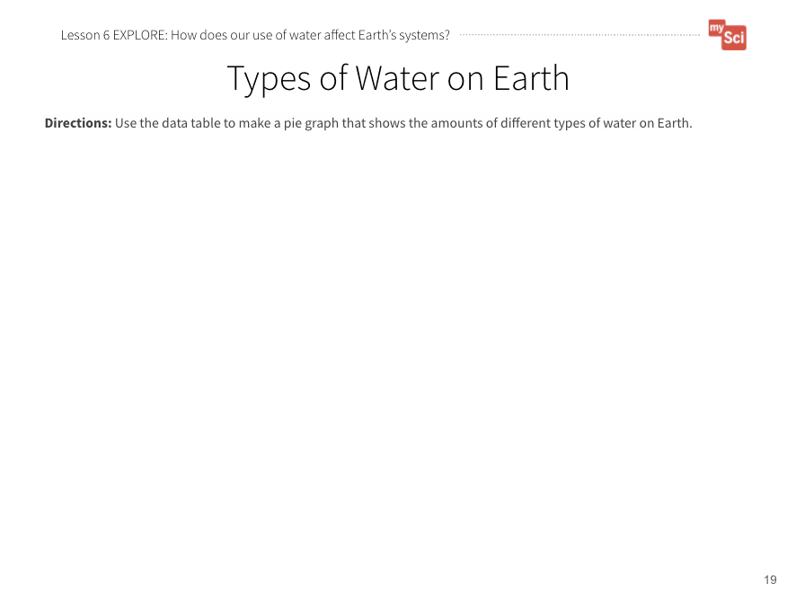  Types of Water on Earth  Student Journal page  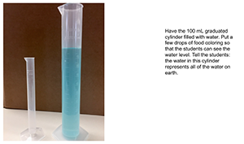  tutorial  Teaching Tip:  This is an opportunity to integrate math standards. Students can change the decimals to fractions, notice the magnitude of difference between the numbers, compare different numbers on the chart, or make a number line to show the scale of difference between numbers. The CCC of this lesson is Scale, Proportion, and Quantity. It can be challenging for students to visualize the vast difference between large percentages and 1/1000 of a percent, so these discussions can help students make sense of the data. | Say to students:  - Let’s start by thinking about how we use water, and the forms of water on Earth.  Use the USGS water cycle maps and have students look at the maps. The focus here is not on the process of the water cycle, but rather to visualize the different places we can find water on Earth. It is recommended to use the “beginner” version of this map since it is not as crowded with words. Ask:  - What are the different types of water you see? (Oceans, rivers, lakes, streams, ground water, ice)  - Is ocean water the same as river or lake water?  - How are they different? (Students may or may not know that ocean water is saltwater, while rivers and lakes are freshwater without high amounts of salt. If no one mentions this, point out that difference.)  Ask students:  - What type of water do we use as humans for drinking, watering plants, and taking care of farm animals? (Freshwater from rivers, lakes, streams, and groundwater) Freshwater is very important for human activities. Let’s explore how much of each type of water resource we have on Earth.  Show the data table of the amounts of types of water on Earth (in Section 2 curriculum slides). Have students make observations and ask questions about the data.  Say to students:  - We noticed that there were big differences in the amounts of types of water on Earth. Let’s make a model to make it easier to understand these differences in amount.  Set up the graduated cylinder demo. Here is a teacher tutorial showing the setup. The detailed procedure for this activity can be found in Appendix C Lesson 5 Water Demonstration Procedure.  Ask students:  - What did you notice about how we measured the amount of water? What is volume? Why is this unit of measure important  Explain to students that volume is a standard unit used to measure the amount of space something takes up. Scientists use standard units, instead of everyone using their own units, in order to measure quantities accurately and communicate with one another.  Give students time to take the data from the chart (in Section 2 curriculum slides) and make a graph of the data on the Types of Water on Earth Student Journal page. Be sure not to show students the student journal page until after they discuss which type of graph to make.  There are different ways to approach this. You could have students make a pie chart, but first discuss why this is the best way to represent this kind of data. You could have students graph only the amount of freshwater vs. saltwater, or have them graph the different kinds of freshwater.

EXPLAIN
Students construct explanations about how humans' use of water resources affects Earth’s systems.
Formative Assessment  ESS2.C: The Roles of Water in Earth’s Surface Processes Nearly all of Earth’s available water is in the ocean. Most fresh water is in glaciers or underground; only a tiny fraction is in streams, lakes, wetlands, and the atmosphere.  Using Mathematics and Computational Thinking  Describe and graph quantities such as area and volume to address scientific questions.  Scale, Proportion, and Quantity  Standard units are used to measure and describe physical quantities such as weight and volume.  Teaching Tip:  Students can track their own water usage using the USGS website, or their own tracking method. | Have students work in groups to analyze their graphs. To support students to do this, ask:  - Which slice of the pie chart is the biggest? What does that tell you?  - Which slice of the pie chart is the smallest? What does that tell you? (The saltwater slice is the biggest. The freshwater slice is the smallest. This means most of the water on Earth is salt water.)  Ask students:  - What claim can you make about humans and freshwater on Earth, based on the data table and graph you made? (Most of Earth’s water is found in the ocean. We don’t have a lot of usable freshwater on Earth.)  Give students time to work on developing their claims individually first. Then they can share them with their groups to come up with group claims. Finally, each group shares their claims with the class.  This activity is a chance to formatively assess students' understanding of the DCI ESS2.C, SEP Using Mathematics and Computational Thinking and CCC Scale, Proportion, and Quantity. See the student journal answer key for an example. If students are struggling to create their graphs, walk through graphing one data point as a class. If students are struggling to develop their claims, provide them with sentence starters.  Say to students:  - Humans use water to drink, bathe, water their lawns, in the production of energy, etc. We also need a lot of it to keep up with all of the food we need to grow. We saw that groundwater is less than 1% of water on Earth. However, it makes a majority of the freshwater available for us to use. Let’s see what the effects are of our use of groundwater for farming.  Remind students of the video they watched at the beginning of the lesson. Then, have students pair up and look at their farm models (Farm Model Student Journal page). Say:  - Aquifers are large bodies of underground rock that contain fresh groundwater. How does what we saw in the video apply to our farm models?  - Use your model to talk to a partner about how humans are affecting Earth’s systems by using groundwater for farming. (Listen for students discussing how humans (biosphere) take water (hydrosphere) out of the aquifers in the ground (geosphere) to water crops. The water can’t be replaced fast enough, so the groundwater gets too low.)  If students do not mention the system in their discussions, use these probing questions:  - Which system is water a part of?  - Which system are humans a part of?  - Which system are aquifers located in?  - What do you think happens to the aquifer as farmers use the water?  Show students the following video:  The Ogallala Aquifer (5:37) from the National Science Foundation.  Have them focus on the problem that comes from using water from the aquifer. The students can then add to their ideas they discussed prior to watching the video.

ELABORATE
Students develop a model to show how farms use water and how animal waste can pollute water resources.
Farm Model  Student Journal page  Attending to Equity:  People from different cultures across the globe view water as a sacred resource that deserves to be protected. You could read the children’s book We are Water Protectors by Carole Lindstrom to examine how Indigenous people of North America have rallied to protect the waters of the land. Missouri has many natural springs that have been important to both native tribes and early European settlers. | Say to students:  - We now know that farms use a lot of water and we have limited amounts of freshwater on Earth. If we have limited fresh water, we want to make sure that the water stays clean so that it can be used.  - How do you think farms contribute to the cleanliness of Earth’s fresh water?  - What are some things that are produced as a result of farming?  - What happens after the cows or other animals are fed? Where does that poop go?  - What happens if it rains when there is poop on the ground?  - Let’s consider a farm that produces a lot of animal waste. When rain falls or water moves over the ground, some of that waste may get picked up and moved with it. Let’s see where it goes.  To help students develop their explanations further, project the following resource for students: River Runner. Locate an area near your school that appears to be farmland.(Students should observe that water in Missouri eventually ends up in the Mississippi River, and ultimately the Gulf of Mexico in Louisiana.)  - What do you think might be some issues with animal waste running into rivers, lakes, and the ocean?  - Has anyone seen a lake or pond that looks like this before? (Show the photos of dead zones and pond eutrophication In Section 2 Curriculum Slides. Use the descriptions in the slides to provide context for students.  Say to students:  - There are multiple activities that contribute to these phenomena including deforestation, sewage discharge, fertilizer that is applied to people's lawns or golf courses to maintain green fairways, fertilizer applied on farms, and animal waste. There are many contributing factors to this problem, but we are going to focus on animal waste.  - What do you wonder about animal waste and how it contributes to the dead fish and algae growth? (Students may wonder – what is it about animal waste that is causing dead fish, and lots of algae growth? )  Say to students:  - What do we need to know to be able to answer that question? (We need to know what animal waste is made of, and how it is connected to the ocean if farms are not in the ocean. We need to know how the animal waste gets in the water. We need to know why this is important to us.)  Say to students:  - Let’s watch a video that shows what is happening to cause water pollution. As you’re watching, think about how you could represent this on your farm model.  Show What is Eutrophication? by USOceanGov (1:03).  It is not critical that students understand the process of eutrophication (this is an above grade level expectation). The purpose of this video is to introduce students to one effect of water pollution so that they can visualize the harm it can cause.  Have students draw on their farm models (Farm Model Student Journal page) to show how farm animal waste can pollute different water sources. Ask students what they should add to their “Gotta Have It” checklist so that their models are showing what they want them to show. Their models should show:  - How water is being used on the farm  - Where the water is coming from  - Animal waste  - Something to show how the animal waste is affecting the water  - How the pollution gets from a farm to a water source that is not near the farm  As students are making their models, this is a good time to reinforce vocabulary about Earth systems, and ask students to point out how our water use affects Earth systems. For example, they might say that the biosphere (farming) is affecting the hydrosphere (lakes and oceans) by adding too much waste. This then circles back to affect the biosphere (too much algae grows, so aquatic animals die).

EVALUATE
Students evaluate each other’s farm models and give feedback.
Formative Assessment  ESS2.A: Earth Materials and Systems Earth’s major systems are the geosphere (solid and molten rock, soil, and sediments), the hydrosphere (water and ice), the atmosphere (air), and the biosphere (living things, including humans). These systems interact in multiple ways to affect Earth’s surface materials and processes. The ocean supports a variety of ecosystems and organisms, shapes landforms, and influences climate. Winds and clouds in the atmosphere interact with the landforms to determine patterns of weather  ESS3.C: Human Impacts on Earth Systems Human activities in agriculture, industry, and everyday life have had major effects on the land, vegetation, streams, ocean, air, and even outer space. But individuals and communities are doing things to help protect Earth’s resources and environments.  Developing and Using Models  Develop a model using an example to describe a scientific principle.  System and System Models  A system can be described in terms of its components and their interactions. | Have students share their models with a partner or another group and give each other feedback using the “Gotta Have It Checklist”.  - How do their models compare with each other’s?  - What interactions between water, animal waste, and Earth’s systems did they identify?  Students will continue to refine this model over time. Bring the class back together, and ask students to share out the differences and similarities in their models. This supports students to see the different ways you can represent and label things in models. Based on their discussion, students should change their models to reflect feedback.  Return to the class consensus model that was created in the Engage portion of lesson 1. Revise the class model to include how farms use water resources, and how farming can impact water quality. Ask students what labels you should put on your drawing. This helps scaffold the revision process and provides continuity throughout this unit.  This activity is a chance to formatively assess students' understanding of the SEP Developing and Using Models, DCI ESS2.A and ESS3.C, and CCC System and System Models. See the student journal answer key for an example. If students are struggling to apply what they have learned in developing a model, use the class consensus model you created to support students to further develop their models.  To support student sensemaking across the unit, orient students back to the DQB. Ask students:  - What did we observe during today’s activity?  Record the activity and their observations. Next, ask students:  - What did we learn today? (We examined how humans’ use of natural resources can impact the amount of usable water and the quality of water on Earth.)  Record their responses. If students need a reminder, they can reference their student journals.  Ask students:  - How might this help us figure out how our use of natural resources on farms affects Earth’s systems? (Students may say that farms need water to grow food, and that using too much water can deplete the resource. They may also discuss how human activities can cause water pollution. For example, animal waste can be moved by water to different locations on Earth. The nutrients in the waste can lead to dead zones in lakes and oceans)  Next, ask students:  - What new questions do you have?  Write student responses on the driving question board. (They may have new questions, such as:  - How can we reduce the amount of animal waste that gets into our waterways?  - How can we reduce the amount of water we use, so we don’t deplete it?)  Do not provide these questions for students, instead help them start thinking about these ideas by focusing their attention to the different interactions between water use and Earth systems that they labeled on their models and how that could relate to the anchoring problem: Farms use a large amount of resources. This can have a negative impact on the environment. Have students place their questions into existing categories, or create new categories.

EXTEND (Optional)
Students use a model to explain how we can create drinkable water from saltwater.
If students demonstrate success with DCI ESS2.C and begin to wonder about solutions to the problem, you can provide them with this extension. It is not expected that every student completes this extend activity.
- So much of Earth’s water is saltwater, but there are ways to make saltwater safe for people to drink. Today we are going to make an evaporation still to desalinate (take the salt out) of water.
You will need the following materials for the model: A large container, small container, rubber band, plastic wrap, ball bearings, salt, food coloring, and water.
For online directions and sketches for setting up the activity visit Desalinate Water from Wikihow.

Lesson 6: Summary | How can we use animal waste as a natural resource?

Time: 2 days  Learning Target  Plan and conduct an investigation to see how we can use animal waste as a natural resource on the farms.  Summary  - In the previous lesson, students analyzed and graphed data of the amount of freshwater and saltwater on Earth. They used this information to explain why it is important to protect water from pollution and depletion.  - In this lesson, students will plan investigations to explore what environmental factors affect the amount of natural gas produced.  - Students figure out that animal waste can create natural gas. We can use experimental design to consider how to opitimize the amount of gas produced from waste in a biodigester. This idea will be further investigated in Lesson 9, as a solution to energy use on farms.  - In the next lesson, students use Samso as a case study to examine how people can reduce their own negative impacts on Earth’s systems. |  | Building Towards  3-5-ETS1- 3. (5.ETS1.C.1)
 |  | NGSS 3-Dimensions:
ETS1.C: Optimizing the Design Solution
Planning and Carrying Out Investigations

Lesson 6: Five E Quick View
ENGAGE | Students make observations and ask questions about a model biodigester.
EXPLORE | Students brainstorm ways to investigate how to produce and capture gas from waste to use as an energy source.
EXPLAIN | Students plan and set up an investigation about the environmental factors that affect gas production.
ELABORATE | Students develop a plan for collecting data about the environmental factors that affect gas production.
EVALUATE | Students ask new questions about farm resources, the impact on the environment, and solutions to this problem.

Lesson 6: Prep List
Inside mySci kit you will find: | Items you must supply: | Preparation:
(16) small clear travel size plastic bottles  (1) 4 oz. bag of soil  1 Large yellow funnels  Small bottle of vinegar  40 balloons  1 set of yellow measuring spoons  2 coffee stirrers  Roll of string (from previous lessons) to measure balloon circumferences | If students do not choose the type of scraps used variable: a uniform mixture of pureed fruit and vegetable scraps to evenly divide among biodigester bottles (Note: Choose items that will break down relatively fast. Lettuce, blueberries, and bananas work well, for example.)  If students do choose the type of scraps used variable: make the mixture based on their experimental design.  If students choose temperature as their variable: a refrigerator and a sunny, warm place.  Food processor or blender to make a puree of the scraps  Water  Rulers | Puree the food scraps the morning or evening before this lesson.  Lesson 6 Student Journal pages or Printed Student Journals

Literacy Connections | Remote Learning
Key Vocabulary  biodigester: a container that collects gas created by living things as they break down food  decomposer: an organism, such as bacteria or fungi, that breaks down dead organisms  constraint: what the design is limited by or cannot do  criteria: what the design must have or be like  Supplemental Reading Resources  What is compost? | Interactive & Mini Lesson Videos  Hands-on at Home Suggestions  Have students collect kitchen scraps and watch them decompose either outside or in a cup covered with cellophane. What factors make them decompose faster or slower?

L6 – Five E Lesson Plan

ENGAGE
Students make observations and ask questions about a model biodigester.
Note:  The biodigester time lapse video depicts the biodigester during 72 hours of recording. | Begin the lesson by revisiting the Driving Question Board. Highlight questions connected to the learning goals of this lesson by calling attention to questions about animal waste. If no questions directly relate, use prompts to build on student questions, supporting them to think about what they observed on a farm and pointing out examples of animal waste on farms.  Say to students:  Today’s activity will support us in answering this question (ex: How can we use animal waste as a natural resource?). By answering this question, we will be able to build on our understanding of how using natural resources might affect the farm and Earth’s systems.  Ask students:  - What did we learn about in the previous lesson? What do you remember about connections we made between farming and fresh water? Did we learn anything in the last lesson that connects to animal waste? (Freshwater makes up a small portion of the water on Earth and farms use a lot of fresh water. We also know that farms can pollute water when animal poop washes into rivers and streams.)  Say to students:  - What can farmers do with all the poo? What ideas do you have?  Students may say you could collect the poop in some sort of storage device. If they do not say this, ask:  - What if we designed a container for the poop with a lid on it so that way nothing can escape?  - What do you think would happen? Why do you think that?  Allow students to share their ideas with the class.  - Let’s look at one example of a way that farmers can store animal waste.  Show the time lapse video of the biodigester.  - What do you notice happens over time? (The balloon was not inflated, but got inflated over time).  - What do you think is happening? (Some students may point out that there is gas in the balloon.)  If students have completed mySci Unit 24 the concept of gas particles taking up space is a review (DCI PS1.A). If they have not completed mySci Unit 24, it is okay just to get students thinking that gas is filling up the balloon, but it is not expected that they understand the particle level of the states of matter at this point. If students do not make the connection that there is gas inside the balloon ask:  - What do you think is filling the balloon up?  - What do you know about balloons?  - What is typically inside a balloon?  Then ask:  - What do you wonder? (Potential student questions may include, but are not limited to: Why did the balloon inflate? What happened inside the jar? Did air get inside the balloon from outside?)  Say to students:  - This is a basic model of a biodigester (bio = life, digest = break down) set-up to collect natural gas from waste. The natural gas from the food waste formed in the plastic bottle and collected in a balloon.

EXPLORE
Students brainstorm ways to investigate how to produce and capture gas from waste to use as an energy source.
Attending to Equity:  In this exploration, students are given an opportunity to design their own investigation procedure to figure out what conditions will make the most natural gas from food scraps. This allows students to feel like “active and valued sensemakers” in their classroom science community. See more in this STEM Teaching Tool.  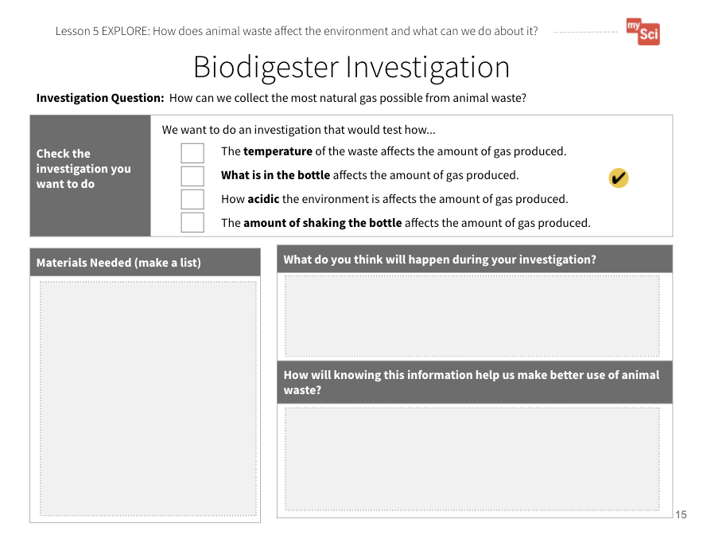  Biodigester Investigation  Student Journal pages | Say to students:  - We just discussed that gas is filling the balloon of our biodigester. Does anyone know of any gas that is used for energy? Recall what we learned about fossil fuels from lesson 4. (Students may discuss the gas (gasoline) that runs cars or the natural gas they may use to cook with at home).  Say to students:  - The gas captured by the biodigester can be used as a natural gas energy source. We want to figure out how to create a biodigester that creates the most gas from animal waste. This is the criteria for the designs. We know we can’t actually use animal waste in the classroom- that would not be safe.  - What else could we use as a model of animal waste? (We will use food scraps. Animals eat fruits and vegetables, and this is a part of their waste, so it is a good substitute.)  Say to students:  - If we want to make the best use of animal waste, we need the best environment possible to make gas. Different groups can test different types of bottle environments to see which conditions make the most gas to use. Let’s brainstorm the different things we could change about the environment of the bottle.  To support this, show students the materials they have available to them. This will help narrow their suggestions. Discuss these as the constraints of their design. Record the different suggestions students come up with on chart paper.  There are opportunities to bring in life science connections – for example, if you have completed mySci unit 21 you can review the concepts from DCIs LS2.A and LS2.B. However, if you have not completed mySci unit 21 you should skip this section as students have not yet made sense of these concepts. The idea to review is decomposition or decomposers (there are bacteria, both on food and in soil, that help break down the food waste). The living bacteria release gas as a by-product of their own digestion, or breakdown, of the food (this is above grade level, so it is not crucial that you students understand this process).  You may need to scaffold with students to discuss that bacteria are living, so just like you and me, they have a certain type of environment where they survive best. We have a range of temperatures where we survive best, and so do bacteria. We have a particular amount of acidity where we survive best, and so do bacteria. Bacteria make the most gas when they are “happiest”.  Provide students with the first Biodigester Investigation Student Journal page. There are four different types of investigations listed, but students may come up with other ideas as part of the class discussion that you can approve based on classroom constraints. It is ok if two groups do the same variable – tell students this will just help us get more data.  In groups, let them explore the materials and think about what they could investigate, and what that would tell them about using waste as an energy source. Discuss with students that the materials are constraints, or what their designs are limited by.

EXPLAIN
Students plan and set up an investigation about the environmental factors that affect gas production.
Biodigester Investigation  Student Journal pages  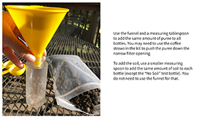  Biodigester Set Up Tutorial | Give students time to fill out the second and third Biodigester Investigation Student Journal pages to solidify their plans. You may want to “sign-off” on their procedures before they can have access to the materials. Discuss with students the importance of including each of the 4 different scenarios so that the class can come together at the end of the investigation and create the best biodigesters possible for the design challenge.  If students are struggling to come up with a procedure, walk a group or the whole class through using one of the experiment options as an example. If other groups finish early, you can use their procedure as an example.  Say to students:  - Now that we have planned our investigations, let’s set up our biodigesters.  Give students time to set up their experiments.  You may use the Biodigester Set Up Tutorial as a reference when helping your students set up their biodigesters. Note that the example includes using water for the biodigesters. If students choose to make their environment more acidic, they would use vinegar or a mixture of vinegar and water.

ELABORATE
Students develop a plan for collecting data about the environmental factors that affect gas production.
Biodigester Investigation  Student Journal pages | Give students time to look at other group set ups and what they are testing. You could have one student share out, or have them do a gallery walk to view the other investigations. Say to students:  - Now we need to decide how we will collect our data. We need to collect data in a similar way so that we can compare group results and see which factors allowed for the best production of natural gas.  Have students use the fourth Biodigester Investigation Student Journal page to create their data table. You may need to scaffold so that students can make the connection that they could take numerical measurements by wrapping string around their balloons as they fill up with gas, and then laying the string on a ruler. You may notice that the balloons inflate and deflate over time, but any production of gas should be counted (the balloons may not be airtight).  Students can also use qualitative data, like seeing bubbles forming when they tap on or gently shake the biodigester. Help students develop a plan to check their biodigesters every day for the rest of the unit.

EVALUATE
Students ask new questions about farm resources, the impact on the environment, and solutions to this problem.
Formative Assessment  ETS1.C: Optimizing the Design Solution Different solutions need to be tested in order to determine which of them best solves the problem, given the criteria and the constraints.  Planning and Carrying Out Investigations  Plan and conduct an investigation collaboratively to produce data to serve as the basis for evidence, using fair tests in which variables are controlled and the number of trials considered. | The Biodigester Investigation Student Journal pages are a chance to formatively assess students' understanding of the SEP Planning and Carrying Out Investigations and the DCI ETS1.C. If students are struggling to plan and carry out their investigation, pick one investigation that is different from what the student groups choose and develop the procedure as a class to model the process.  To support student sensemaking across the unit, orient students back to the DQB. Ask students:  - What did we observe during today’s activity?  Record the activity and their observations. Next, ask students:  - What did we learn today? (We observed that waste can produce gas. We observed this as a balloon inflating) Record their responses. If students need a reminder, they can reference their student journals.  Ask students:  - How might this help us figure out how our use of natural resources on farms affects Earth’s systems? (Students may say that farms use energy from fossil fuels, like natural gas. Waste can produce gas that could be used as an energy resource on a farm.)  Next, ask students:  - What new questions do you have?  Write student responses on the driving question board. (They may have new questions, such as: What other ways can we protect the environment on farms? How can we reduce the amount of fossil fuels we use even more? Are biodigesters the only solution? Do biodigesters have any impacts on Earth systems?)  Do not provide these questions for students, instead help them start thinking about these ideas by focusing their attention to the problem that biodigesters are helping to solve to help orient them to thinking about other solutions and how that could relate to the anchoring problem: Farms use a large amount of resources. This can have a negative impact on the environment. Have students place their questions into existing categories, or create new categories.

Section 3: Quick View How can farmers use resources wisely to protect Earth’s systems?
LESSON /  LEARNING TARGET | VIDEO & TEXT RESOURCES | REMOTE LEARNING |  | KEY TAKEAWAY | VOCABULARY  Quizlet Link  Glossary Link
LESSON /  LEARNING TARGET | VIDEO & TEXT RESOURCES | INTERACTIVES & MINI LESSON VIDEOS | HANDS-ON AT HOME SUGGESTIONS | KEY TAKEAWAY | VOCABULARY  Quizlet Link  Glossary Link
Lesson 7:  How can people use resources in a way that is less harmful to the Earth?  Obtain and combine information about how humans use science ideas to protect Earth systems.  Revise a model of a farm system to explain how farms could create energy in a way that protects Earth’s resources.  (3 days) | Island in Denmark Produces More Energy Than it Consumes  Waste Becomes Important Part of Island Circuit  CK-12 text | Big Changes in the Big Apple  Prince EA Video  Why Do Some People Use Renewable Resources for Energy? Mini-Lesson | Have students watch the video Island in Denmark Produces More Energy Than it Consumes and share what they learned with their family to think about ways they could use renewable energy. | Students figure out that humans can make changes to how we use natural resources for energy that have less harmful impacts on Earth systems. One way to do this is by using renewable resources such as wind, solar, water, and biofuel. | renewable resource
Lesson 8:  How can we use farms to harness wind energy?  Design, test, and share a wind turbine that can harness energy from the wind.  (3 days) | Wind Turbines  Energy 101 How do wind turbines work?  William Kamkwamba on Building a Windmill  Advantages and Challenges of Wind Energy  Wind Power Another Crop to Harvest |  | Have students look at a ceiling or box fan at their house. Draw what the blades look like. How do they think the fan works? Alternatively, have students make a pinwheel. Draw a model to show how the pinwheel is able to move. | Specific technology is used to harness wind as an energy source. Farms have a lot of space that can be used for wind turbines. Even renewable energy sources have some disadvantages, so it is best to have a wide variety of renewable energy sources. | constraint  criteria  engineer  prototype
Lesson 9:  How can we use farm animal waste?  Compare multiple solutions to explain the optimal conditions for converting animal waste into energy.  Develop a final model to explain how using our resources wisely helps protect Earth systems.  (3 days) | Much A-Doo About Poo  Digesting the Facts about Renewable Natural Gas |  |  | Biodigester technology is used in a specific way so that the most natural gas is produced from animal and food waste. This technology does not add to greenhouse gas emission, and so it harms the Earth less than fossil fuel use. | No new vocabulary

Lesson 7: Summary | How can people use resources in a way that is less harmful to the Earth?

Time: 3 days  Learning Targets  Obtain and combine information about how humans use science ideas to protect Earth systems.  Revise a model of a farm system to explain how farms could create energy in a way that protects Earth’s resources.  Summary  - In the previous lesson, students designed biodigesters in order to determine the optimal setup for generating the most gas from waste.  - In this lesson, students will use Samsø as a case study to examine how humans can change their impacts on the environment.  - Students figure out that humans can make changes to how we use natural resources for energy that have less harmful impacts on Earth systems. One way to do this is by using renewable resources such as wind, solar, water, and biofuel.  - In the next lesson, students will engage in the engineering design cycle to develop a wind turbine that can be used to produce energy. |  | Building Towards  5-ESS3-1. (5.ESS3.C.1) | 4-ESS3-1
 |  | NGSS 3-Dimensions:
ESS3.C: Human Impacts on Earth Systems
ESS3.A: Natural Resources
Developing and Using Models
Obtaining, Evaluating, and Communicating Information
System and System Models
Energy and Matter
 |  | CCSS/MLS :
ELA
- 5.R.1.A.b
- 5.SL.1.A.a
- 5.SL.1.A.b

Lesson 7: Five E Quick View
ENGAGE | Students engage in a discussion about what they have learned about human activities and how they can harm Earth systems.
EXPLORE | Students obtain and combine information about how Samso used science and engineering ideas to positively affect Earth systems.
EXPLAIN | Students communicate information about how Samso used science and engineering ideas to positively affect Earth systems.
ELABORATE | Students develop a model of a farm that shows how we can use science ideas to reduce harmful effects on Earth’s systems.
EVALUATE | Students evaluate each other’s farm models and give feedback.

Lesson 7: Prep List
Inside mySci kit you will find: | Items you must supply: | Preparation:
8 copies of Energy Island, by Allan Drummond  The Tree Lady, by Joseph Hopkins |  | Lesson 7 Student Journal pages or Printed Student Journals

Literacy Connections | Remote Learning
Key Vocabulary  renewable resource: a resource that is replaced by nature faster than it is used  Supplemental Reading Resources  Hot for Hybrids  Solar Power  Houston Reduces Human Impacts  Hydroelectricity  Nuclear Power  Reducing Plastic Waste  Earthshot Prize | Interactive & Mini Lesson Videos  Prince EA Video  Why Do Some People Use Renewable Resources for Energy? Mini-Lesson  Big Changes in the Big Apple  Hands-on at Home Suggestions  Have students watch the video Island in Denmark Produces More Energy Than it Consumes and share what they learned with their family to think about ways they could use renewable energy.

L7 – Five E Lesson Plan

ENGAGE
Students engage in a discussion about what they have learned about human activities and how they can harm Earth systems.
Begin the lesson by revisiting the Driving Question Board. Highlight questions connected to the learning goals of this lesson by calling attention to questions about how people can help the environment. If no questions directly relate, use prompts to build on student questions, supporting them to think about their everyday experiences using resources and questions they might have about reducing their impact.
Say to students:
Today’s activity will support us in answering this question (ex: How can people use resources in a way that is less harmful to the Earth?). By answering this question, we will be able to think about possible solutions that farmers can use to protect Earth’s systems.
Say to students:
- We have explored a lot of the harmful effects human activities can have on our planet. What are some of the effects we have when we use fossil fuels and water resources, for example?
Give students time to Turn and Talk.
Listen for ideas such as: fossil fuels give off pollution, which affect Earth systems, like the air and water; fossil fuels are non-renewable resources, and get depleted over time; water use depletes groundwater; farming can cause animal waste to pollute water.
Have students share their ideas and record them on the board or on chart paper. Ask students:
- What similarities do you notice across the effects you shared?
- Are there any that we could combine into one category?
- What would we call the new category?
After you have guided the students through creating categories ask them:
- What do you think are some solutions to these problems? (The purpose of this is to get the students thinking. You are not looking for correct answers. They will explore solutions as they move through the lesson. Some categories that might arise from this discussion include: air pollution, water pollution, resource overuse/depletion.)

EXPLORE
Students obtain and combine information about how Samso used science and engineering ideas to positively affect Earth systems.
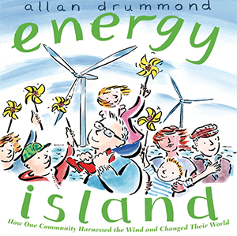  Read-Aloud Guide  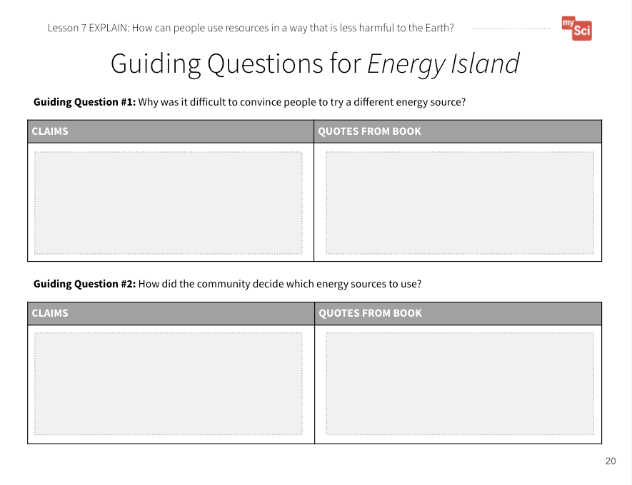  Guiding Questions for Energy Island Student Journal pages  Career Connections:  EGFI - Environmental Engineers  PBS Learning Media: Renewable Energy Scientist (2.35) | Students will continue to build on the SEP Obtaining, Evaluating, and Communicating information. In lesson 3, students developed the practice of obtaining information, using only one resource. In lesson 4, they used multiple resources, and combine information. In this lesson students will again use multiple resources and combine information. They will use this information to create presentations to communicate this information.  Divide the students into eight groups. Provide each group with the following resources:  -  Energy Island  - Island in Denmark Produces More Energy Than it Consumes  - Website: Waste Becomes Important Part of Island Circuit  Students will work in groups to use the resources listed in order to develop a slide or poster about Samsø. Students will use the Guiding Questions for Energy Island Student Journal pages to help them gather information for their presentation.  Discuss that a “claim” is what you think is true, and “evidence” is an observation or data that supports your claim. Students will make claims based on the book, video, and article and provide specific evidence for each claim. Make it clear that they can have more than one claim and that they can have more than one piece of evidence to support each claim.  Once students have obtained information from their resources, they can use a combination of pictures, drawings, and text to create their slide or poster presentations. For example, students may want to draw a model of the island that includes descriptions based on their research.  Presentations should include information about the resources the island uses, why they use these resources, and the benefits of using these resources.

EXPLAIN
Students communicate information about how Samso used science and engineering ideas to positively affect Earth systems.
Attending to Equity:  Historically women have been leaders in social and environmental movements, however their contributions often go unrecognized. You could read the children’s book The Tree Lady to examine the story of Kate Sessions, a woman who worked to make a positive impact on her community.  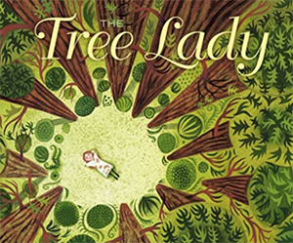  Read-Aloud Guide  Formative Assessment  ESS3.C: Human Impacts on Earth Systems Human activities in agriculture, industry, and everyday life have had major effects on the land, vegetation, streams, ocean, air, and even outer space. But individuals and communities are doing things to help protect Earth’s resources and environments.  Obtaining, Evaluating, and Communicating Information  Obtain and combine information from books and other reliable media to explain solutions to a problem.  Communicate scientific and/or technical information orally and/or in written formats, including various forms of media and may include tables, diagrams, and charts.  Energy and Matter  Energy can be transferred in various ways and between objects. | When all groups are finished, have them share out with the class what they found. There are two different options for having students share.  Option 1: Students hang their posters around the room and then rotate around the room to look at the posters. While they walk around to each poster, students record the natural resources each group discussed as well as the benefits of using those resources. Once everyone has visited each poster, have students circle repeating natural resources in order to find patterns across the presentations.  Option 2: Each group presents their poster to the class. While one group is presenting, the other groups record the natural resources each group discussed as well as the benefits of using those resources. Once every group has presented, have students circle repeating natural resources in order to find patterns across the presentations.  Bring the class back together and review the problems that were discussed at the beginning of the lesson. Ask students:  - Do you think the people of Samsø provided a solution to any of these problems?  - If so, what was their solution?  - What did you notice about the resources they used on Samsø?  - How are they different than the energy resources we learned about in previous lessons? (Students may notice they moved away from using fossil fuels, replacing them with things like the wind, the sun, and plants. They may discuss that these resources get depleted over time. Students may also notice that they use multiple different resources to address their energy needs.)  Say to students:  - What makes Samsø Island so special is that they are using renewable resources. This means that the resources can be replaced by nature faster than they are used. Sun, wind, biofuels, and water are energy sources that can be replaced quickly by nature. Let’s compare non-renewable and renewable energy sources.  Use this opportunity to develop connections across the science domains using the CCC of energy and matter. Ask students:  - What forms of energy are involved in these systems?  - What energy transformations are taking place as the community uses renewable resources?  - How is the energy from the sun transferred in different ways?  Give students time to read the hyperlinked CK-12 text and watch the embedded video on renewable resources.  This activity is a chance to formatively assess students' understanding of the SEP Obtaining, Evaluating, and Communicating Information and DCI ESS3.C. See the student journal answer key for an example. If students are struggling to figure out how to organize their information for the presentation,

ELABORATE
Students develop a model of a farm that shows how we can use science ideas to reduce harmful effects on Earth’s systems.
Farm Model  Student Journal page  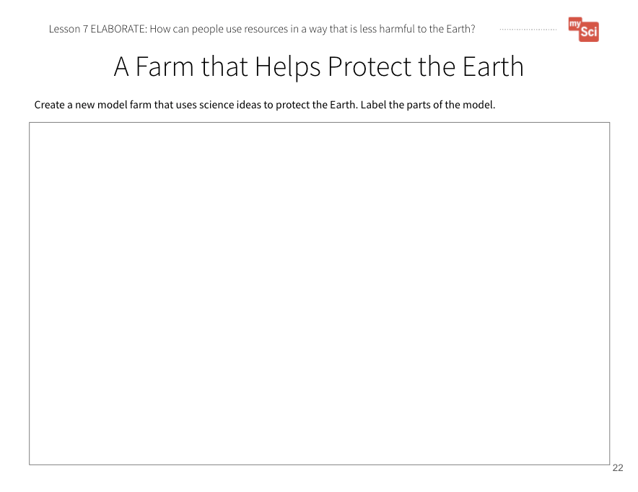  A Farm That Helps Protect the Earth Student Journal page | Say to students:  - During this unit, we have developed a farm model. In the model we identified:  - The different Earth systems and natural resources represented  - Interactions between the Earth systems  - Effects of resource use on the Earth systems  - Now, we are going to create a new farm model that includes our vision for what a farm that creates less impacts on Earth systems could look like.  Give students the A Farm That Helps Protect the Earth Student Journal page.  - Just like in our original farm model, we need to use a “Gotta Have It Checklist” to show the components and relationships we need to include in the models.  - What would you add to the checklist today to make our models show how a farm can use natural resources in a way that doesn’t harm Earth systems as much?  Examples of things the model’s “gotta have” might include:  - Renewable fuel sources for tractors and other farm equipment  - Renewable energy sources for electric power

EVALUATE
Students evaluate each other’s farm models and give feedback.
Formative Assessment  ESS3.C: Human Impacts on Earth Systems Human activities in agriculture, industry, and everyday life have had major effects on the land, vegetation, streams, ocean, air, and even outer space. But individuals and communities are doing things to help protect Earth’s resources and environments.  ESS3.A: Natural Resources Energy and fuels that humans use are derived from natural sources, and their use affects the environment in multiple ways. Some resources are renewable over time, and others are not.  Developing and Using Models  Develop a model using an example to describe a scientific principle.  System and System Models  A system can be described in terms of its components and their interactions. | Have students share their models with a partner or another group and give each other feedback using the “Gotta Have It Checklist”.  - How do their models compare with each other’s?  - What new resources did they identify?  Students will continue to refine this model over time. Bring the class back together, and ask students to share out the differences and similarities in their models. This supports students to see the different ways you can represent and label things in models. Based on their discussion, students should change their models to reflect feedback.  Return to the class consensus model that was created in the Engage portion of lesson 1. Revise the class model to include ways to create energy using renewable resources the students described from their individual models. Ask students what labels you should put on your drawing. Continuing to revisit and revise the class model provides continuity throughout this unit.  This activity is a chance to formatively assess students' understanding of the SEP Developing and Using Models, DCI ESS3.C, and CCC System and System Models. See the student journal answer key for an example. If students are struggling to apply what they have learned in developing a model, use the class consensus model you created to support students to further develop their models.  To support student sensemaking across the unit, orient students back to the DQB. Ask students:  - What did we observe during today’s activity? (We observed a community in Denmark.) Record the activity and their observations.  Next, ask students:  - What did we learn today? (We learned that there are communities that are making changes in the natural resources they use for energy, in order to protect the environment.)  Record their responses. If students need a reminder, they can reference their student journals.  Ask students:  - How might this help us figure out how farmers can use resources wisely to protect Earth’s systems? (Students may say that farms could use renewable resources such as the wind, the sun, or animal waste.)  Next, ask students:  - What new questions do you have?  Write student responses on the driving question board. They may have new questions, such as:  - Are there other places that have made changes like Samsø? Are there other types of renewable resources?  - Can renewable resources harm the environment?  - Could I power my home with renewable resources?  - How do you build a wind turbine?  - How does a wind turbine make energy from the wind?  - How do you build solar panels?  - How does a solar panel make energy from the sun?  Do not provide these questions for students, instead help them start thinking about these ideas by focusing their attention to the solutions that the people of Samsø came up with and how that could relate to the anchoring problem: Farms use a large amount of resources. This can have a negative impact on the environment. Have students place their questions into existing categories, or create new categories.

Lesson 8: Summary | How can we use farms to harness wind energy?

Time: 3 days  Learning Target  Design, test, and share a wind turbine that can harness energy from the wind.  Summary  - In the previous lesson, students used Samsø as a case study to examine how humans can change their impacts on the environment.  - In this lesson, students engage in the engineering design cycle to develop a wind turbine that can be used to produce energy.  - Students figure out that wind turbines can be used to harness energy from the wind, and transfer it to energy that can be used as a resource. They learn that they can use the engineering design cycle to develop and test solutions, and make improvements to these solutions using evidence and feedback from others.  - In the next lesson, students analyze their biodigester data and obtain information in order to consider how farms can best make use of animal waste as a resource. |  | Building Towards  4-PS3-2.( 4.PS3.B.1) | 3-5-ETS1- 2. (5.ETS1.B.1) | 3-5-ETS1- 3.
 |  | NGSS 3-Dimensions:
PS3.A: Definitions of Energy
PS3.B: Conservation of Energy and Energy Transfer
ETS1.A: Defining and Delimiting Engineering Problems
ETS1.B: Developing Possible Solutions
Developing and Using Models
Planning and Carrying Out Investigations
Energy and Matter

Lesson 8: Five E Quick View
ENGAGE | Students share initial ideas about wind turbines and how they work.
EXPLORE | Students design and test a wind turbine with parts that act as a system to harness wind energy.
EXPLAIN | Students obtain and communicate information to see how others designed wind turbines to best harness wind energy. Students use models to explain how their design worked to harness energy from the wind.
ELABORATE | Students obtain information to inform how to redesign their wind turbines.
EVALUATE | Students evaluate their wind turbine designs using a rubric.

Lesson 8: Prep List
Inside mySci kit you will find: | Items you must supply: | Preparation:
The Boy Who Harnessed the Wind by William Kamkwamba and Bryan Mealer  (8) 4x4x12” cardboard box  (8) 12” dowels  Ball of string  8 mini basket  (8) 3-inch Styrofoam balls  32 popsicle sticks  24 sheets of cardstock  1 roll of duct tape | Coins or other weights for in the baskets (must be the same for all teams)  Provide a scale or balance for this activity. A spring scale is recommended.  Rocks for weighting the bottom of the box  Electric fan  Scissors  Hot Glue  Timer or stopwatch | Lesson 8 Student Journal pages or Printed Student Journals

Literacy Connections | Remote Learning
Key Vocabulary  engineer: a person who designs and builds things that solve a problem  prototype: a first model or design of something  Supplemental Reading Resources  Energy for Life  Catch the Breeze | Interactive & Mini Lesson Videos  Hands-on at Home Suggestions  Have students look at a ceiling or box fan at their house. Draw what the blades look like. How do they think the fan works? Alternatively, have students make a pinwheel. Draw a model to show how the pinwheel is able to move.

L8 – Five E Lesson Plan

ENGAGE
Students share initial ideas about wind turbines and how they work.
Begin the lesson by revisiting the Driving Question Board. Highlight questions connected to the learning goals of this lesson by calling attention to questions about how farms might use renewable resources, like wind, for energy. If no questions directly relate, use prompts to build on student questions, supporting them to think about the ways that farms might harness and use energy to do their work.
Show students a video of wind turbines on farmland from Jeanne Norris (in Section 3 curriculum slides). Ask students:
- What do you observe? Have you ever seen these before?
- One of the types of renewable energy we saw used on Samsø Island was wind energy. What do you observe from the video? (Students may notice that the wind turbines are on farms because they see plowed soil, farm buildings, etc.)
- What new questions do you have about wind energy?
Say to students:
Today’s activity will support us in answering our question (ex: How can we use farms to harness wind energy?). By answering this question, we will be able to design, test, and evaluate possible solutions that farmers can use to protect Earth’s systems.

EXPLORE
Students design and test a wind turbine with parts that act as a system to harness wind energy.
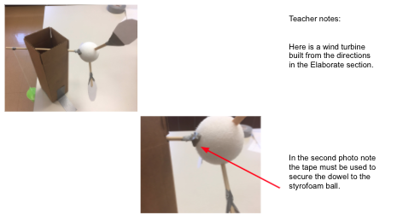  tutorial  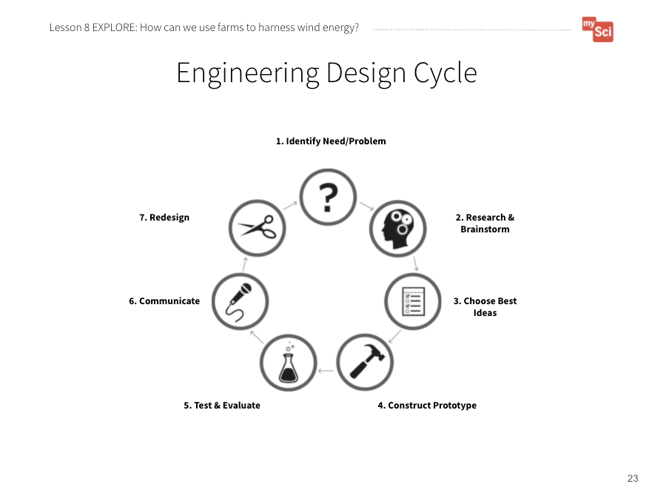  Engineering Design Cycle  Student Journal page  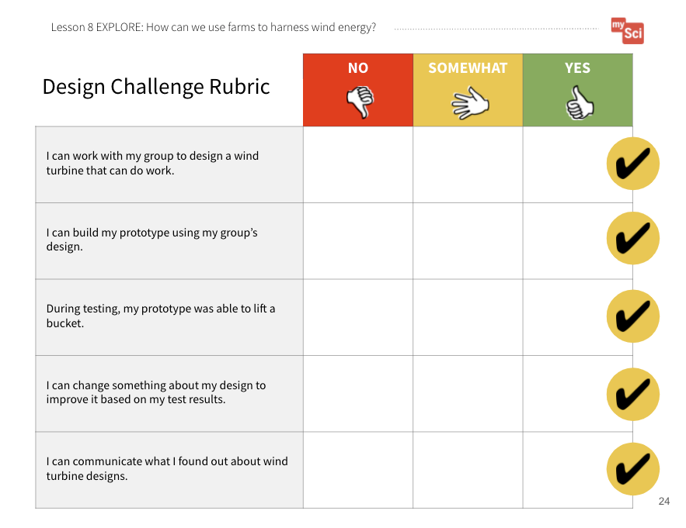  Design Challenge Rubric  Student Journal page  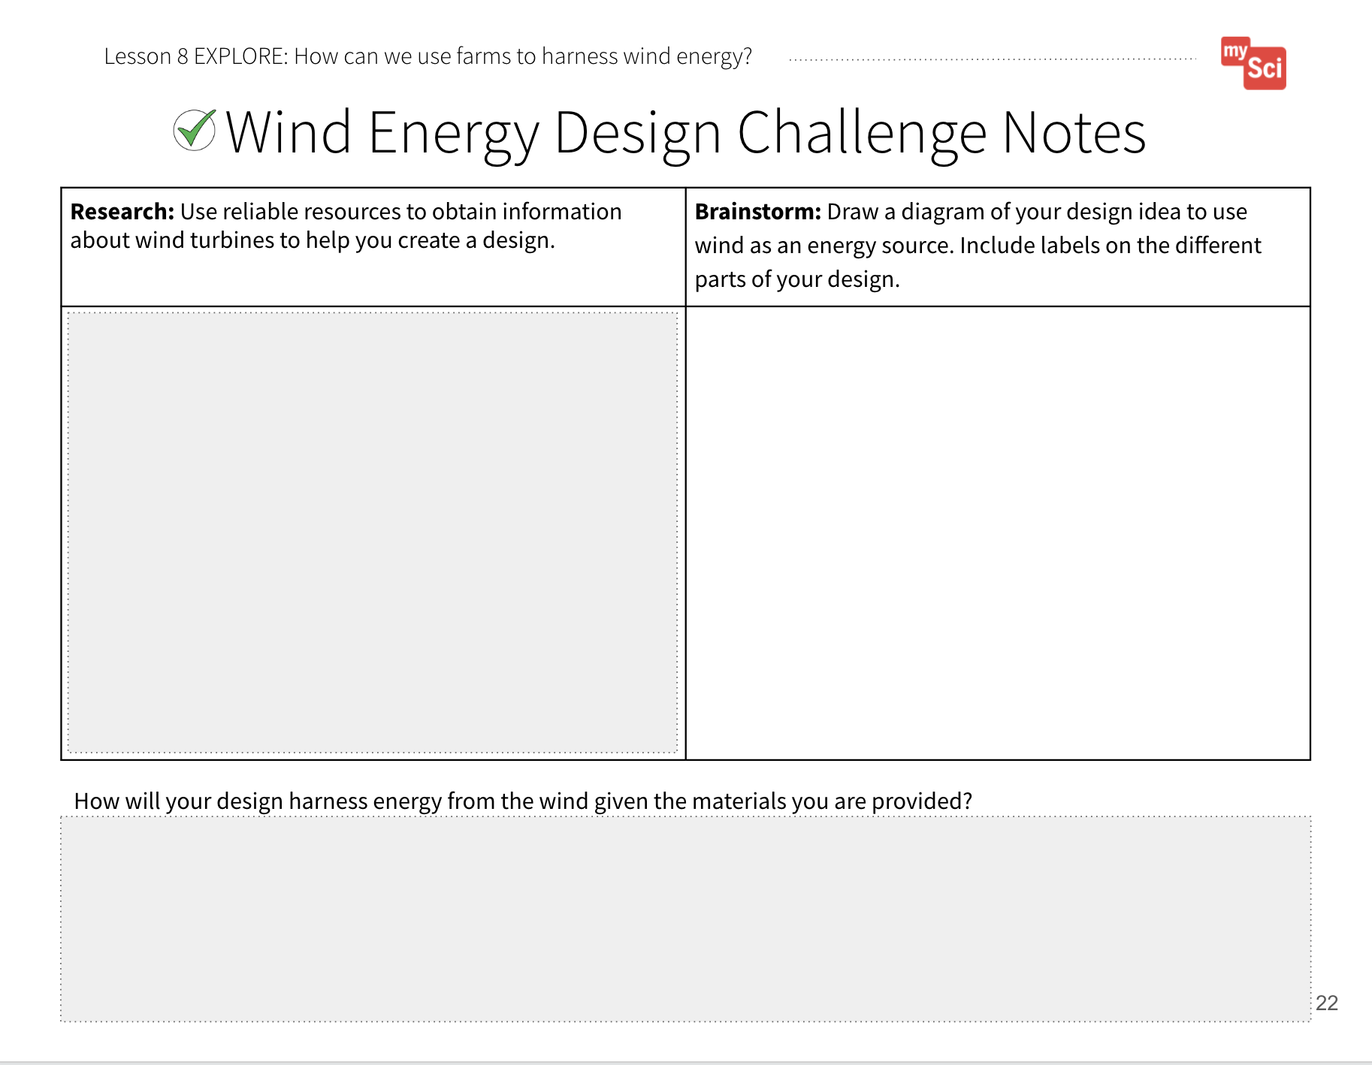  Wind Energy Design Challenge Notes Student Journal pages  Attending to Equity:  Engineering challenges are a great opportunity to show students how to “fail forward” and manage frustration. In order to allow students to bring their funds of knowledge to the table during engineering design challenges, allow them to help generate the list of criteria and constraints of the challenge. Here is a STEM Teaching Tool that discusses this topic. | Almost every mySci unit incorporates the engineering design cycle. At this point, students should be familiar with the cycle. If not, remind students that engineers are people who work to design and build solutions to problems we face. Say to students:  - Engineers create new inventions that solve problems.  Show students the Engineering Design Cycle Student Journal page and talk through each step. It is important for students to understand the cycle is a simplification of a complex process, and is not rigid. You won’t necessarily complete steps 1-7, in that order. For example, you may redesign, and then retest, and communicate. Or, as part of your redesign, you may have to do more research.  Ask students:  - What is the most important problem we’ve been exploring in this unit? (We need energy to live our daily lives, but some sources of energy pollute the Earth more than others.)  Ask students:  - How could you use the design cycle to develop solutions, using wind turbines, that could help solve this problem?  Next, show students the Design Challenge Rubric Student Journal page. Ask students to compare the rubric to the engineering design cycle.  - How does each category of the rubric relate to the design cycle?.  Divide your class into six groups. Tell students that they will take on the role of an engineer as they work in groups to design their own wind turbines.  Have a conversation about criteria (what the solution must do or be like - In this case the criteria is to design a wind turbine that transfers energy) and constraints (what you are limited by or cannot do – In this case the constraints are time and materials). This is a review from lesson 6.  Show them the materials they have available to them. Let them brainstorm in their groups how they could use the given materials to build a wind turbine that can harness energy from the wind.  Bring the class back together, and have students discuss how they think the materials could be used to build a wind turbine that meets the criteria. Say to students:  - We need to be able to observe evidence that energy is being transferred using these materials. How might we use the bucket, string, and pennies to do that? (If students do not say it, discuss with students how you can lift these materials using the wind turbine).  - Is there any other evidence we could look for to know that energy is being transferred in our designs? (Students may say: the blades might move, the wind turbine could make a sound)  There is an opportunity to review 4th grade physical science standards around energy transformations (mySci Unit 20, DCI PS3.A).  If students are struggling to see how these materials could form a wind turbine, display “Bucket Lift Drawing” (in Section 3 curriculum slides) and point out how the materials are used to make the turbine.  Have students access the Wind Energy Design Challenge Notes Student Journal pages. Individually, students research and brainstorm. Prior to this lesson, students have been provided with resources to research. In this lesson, students will be expected to research on their own. Review the guidelines for identifying reliable resources from lesson 4. Below are resources to support students if they are struggling:  - How to Make a Windmill  - Windmill  - Wind Energy Facts Video for Kids.  - Alliant Energy Whispering Willow Wind Farm 360-degree Tour  Based on their research, students should create an initial model of a wind turbine. Have students share their models with their groups. They should use evidence from their research to support their design ideas.  Use the following questions to help students discuss their individual models with one another, and determine what a group model would look like:  - How will this design solve the problem?  - Why do you think this design is the best choice?  - Would combining any of your ideas create a better solution?  - Why do you think that?  Based on their discussions, have groups choose the best ideas from their research and brainstorming. They should then draw a model of their group prototype. Remind students that it is important to label the parts of the design, the materials they will use for those parts, and how much material will be used.  After they show you their prototype, they can work together to construct it using the materials they have chosen.  Refer back to the Engineering Design Cycle Student Journal page. After students construct their prototype, they can test and evaluate it.  Explain to students that they must do a fair test. To do this, show them the fan that will be used for testing and the coins that will serve as the weight in the bucket.  Here is a teacher tutorial for the wind turbine activity.  Say to students:  - The materials here are what everyone will be able to use for their wind turbines and they are the same for each group. Is there anything else that we should keep the same to make sure it is a fair test?  Keep a list of their responses on the board.  Decide how you will measure your success as a class.  Example 1: Speed Challenge: Use a timer and measure how long it takes the bucket to reach the top of the windmill. (Use the same fan on the same setting, the wind turbine is the same distance from the fan, each team lifts the same amount of coins, each team lifts the same distance, teams have the same amount of time to work)  Example 2: Distance Challenge: Use a ruler to measure the maximum height the bucket reaches before it stops. (Use the same fan on the same setting, the wind turbine is the same distance from the fan, each team lifts the same amount of coins, teams have the same amount of time to work)  Example 3: Weight Challenge: See which wind turbine can lift the most pennies in the bucket. (Use the same fan on the same setting, the wind turbine is the same distance from the fan, each team lifts the same distance, teams have the same amount of time to work.)  If students miss any of these variables, prompt them. For example, if they miss “same distance from the fan” ask if it would be a “fair test” to place one wind turbine right next to the fan and one far away. As a class, determine the length of the string (40 cm is good), the weight of the bucket (or number/type of coins) and any other variables that would be controlled for a fair test.

EXPLAIN
Students obtain and communicate information to see how others designed wind turbines to best harness wind energy. Students use models to explain how their design worked to harness energy from the wind.
Formative Assessment  PS3.A: Definitions of Energy Energy can be moved from place to place by moving objects or through sound, light, or electric currents.  PS3.B: Conservation of Energy and Energy Transfer Energy is present whenever there are moving objects, sound, light, or heat. When objects collide, energy can be transferred from one object to another, thereby changing their motion. In such collisions, some energy is typically also transferred to the surrounding air; as a result, the air gets heated and sound is produced.  Developing and Using Models  Develop a model using an example to describe a scientific principle.  Planning and Carrying Out Investigations  Plan and conduct an investigation collaboratively to produce data to serve as the basis for evidence, using fair tests in which variables are controlled and the number of trials considered.  Energy and Matter  Energy can be transferred in various ways and between objects. | Once all groups are done testing, ask the groups to communicate their design and test results to the class. Ask students:  - Why do you think it is important that we share our designs and results with each other?  - How will this help us improve our designs?  Students can share the design they chose for their wind turbine, and why they thought it would be the most effective at transferring energy. After each group shares, provide space for other groups to give feedback. Tell students that they must provide at least one piece of feedback for each group. Make sure feedback is helpful, specific, and kind.  Examples of feedback students may provide:  Praise: Tell why you like it/why it is a strength.  Questions: Ask questions about components of the plan that are unclear.  Polish: Tell what is confusing/provide suggestions for improvement.  After seeing what students have come up with, have students obtain information about how wind turbines harness the wind to create electricity.  Show students the link to this slide: Wind Turbines from the US EPA. Focus their attention on the photo of a wind farm at the top of the slide.  To further help students explain how wind turbines use technology to harness wind energy and transform it into electricity, show this  Energy 101 video (3:16) from the Office of Energy Efficiency and Renewable Energy.  Here is a reading that can also help support this topic: How do wind turbines work? from Alliant Energy.  Be sure to focus students on the role of windmill technology and how this technology has evolved over time to meet the needs of humans (from windmills to wind turbines). It is not crucial that students understand the complexities of a wind turbine. Students should focus on the wind moving the blades, which causes energy to be produced in the form of electricity.  Have students use chart paper or whiteboards to create a chart. On one side of the chart students can draw a model of their design, and use their data and what they have learned to explain how energy is being transferred. For example, students may say energy was transferred from the fan to the blades. We know this because the blades and dowel rod began to move. They may also notice that the wind turbine makes noise as the wind moves the blades and the basket moves upward. This caused the bucket to lift. On the other side of the chart, students can draw an actual wind turbine, and show how energy transfer is occurring. Have students use the models to make comparisons. What are the limitations of their prototypes? How are they similar to an actual wind turbine? How are they different?  This activity is a chance to formatively assess students' understanding of the SEPs Planning and Carrying Out Investigations and Developing and Using Models , PS3.A and PS3.B, and CCC Energy and Matter. See the student journal answer key for an example. If students are struggling, develop a class comparison

ELABORATE
Students obtain information to inform how to redesign their wind turbines.
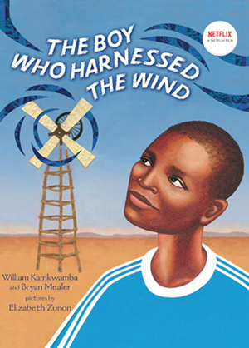  Read-Aloud Guide | Read the book, The Boy Who Harnessed the Wind by William Kamkwamba and Bryan Mealer.  Next show William Kamkwamba on Building a Windmill from William Kamkwamba via TED.  Ask students:  - How many times do you think William had to design and redesign before he had a result he was satisfied with?  - How did he modify his design? Let’s go back to the end of the story when William’s turbine was successfully operating.  - How did he get feedback from others? (The doubters clapped and cheered for him, one man told him “Well done!”).  Say to students:  - Now, you are going to have time to redesign your prototype and see if you can make a change to improve your wind turbine. Keep the following in mind when redesigning:  - What you observed in your initial design  - What you observed in other groups’ initial designs  - The feedback you received from classmates  - Information about how wind turbines work  - Information from The Boy Who Harnessed the Wind  Time permitting, have students retest their designs, and communicate the results to their classmates. Did their designs improve? What evidence do they have to support this?

EVALUATE
Students evaluate their wind turbine designs using a rubric.
Design Challenge Rubric  Student Journal page  Formative Assessment  ETS1.A: Defining and Delimiting Engineering Problems  Possible solutions to a problem are limited by available materials and resources (constraints). The success of a designed solution is determined by considering the desired features of a solution (criteria). Different proposals for solutions can be compared on the basis of how well each one meets the specified criteria for success or how well each takes the constraints into account.  ETS1.B: Developing Possible Solutions  Research on a problem should be carried out before beginning to design a solution. Testing a solution involves investigating how well it performs under a range of likely conditions.  At whatever stage, communicating with peers about proposed solutions is an important part of the design process, and shared ideas can lead to improved designs  Tests are often designed to identify failure points or difficulties, which suggest the elements of the design that need to be improved.  Planning and Carrying Out Investigations  Plan and conduct an investigation collaboratively to produce data to serve as the basis for evidence, using fair tests in which variables are controlled and the number of trials considered. | Evaluate student’s wind turbine designs outlined in the Wind Energy Design Challenge Notes Student Journal pages according to the Design Challenge Rubric S Student Journal page. Also allow students to self-evaluate using the rubric.  To support student sensemaking across the unit, orient students back to the DQB. Ask students:  - What did we observe during today’s activity? (We observed how well different wind turbine designs addressed the problem we are trying to solve. ) Record the activity and their observations.  Next, ask students:  - What did we learn today? (Wind turbines transfer wind energy to electrical energy. We also learned about how engineering can be used to design solutions to problems. We learned how to use evidence from our tests and communication with others to revise our designs to better solve the problem.)  Record their responses. If students need a reminder, they can reference their student journals.  Ask students:  - How might this help us figure out how farmers can use resources wisely to protect Earth’s systems? (Students may say that farms could use renewable resources such as the wind, the sun, or animal waste.)  Next, ask students:  - What new questions do you have? Write student responses on the driving question board. (They may have new questions, such as:  - How many wind turbines would you need to power a farm? How much space do wind turbines take up on a farm?  - What do we use for energy when it is not windy?)  Do not provide these questions for students, instead help them start thinking about these ideas by focusing their attention to what we might need to consider about wind turbines and energy. Have students place their questions into existing categories, or create new categories.

Lesson 9: Summary | How can we design a farm that protects Earth Systems?

Time: 3 days  Learning Targets  Compare multiple solutions to explain the optimal conditions for converting animal waste into energy.  Develop a final model to explain how using our resources wisely helps protect Earth’s systems.  Summary  - In the last lesson, students engaged in the engineering design cycle to develop a wind turbine that could be used to produce energy.  - In this lesson, students will analyze their biodigester data and obtain information in order to consider how farms can best make use of animal waste as a resource. They will obtain information about the advantages and disadvantages of wind turbines and biodigesters and revise their farm using what they have learned about these solutions over the course of the unit.  - Students figure out that biodigester technology is used in a specific way so that the most natural gas is produced from animal and food waste. This technology harms the Earth less than fossil fuel use. Farms have a lot of space that can be used for wind turbines and/or biodigesters. Even renewable energy sources have some disadvantages, so it is best to have a wide variety of renewable energy sources.  - This unit prepares students for middle school studies in climate change and unequal distribution of natural resources on Earth. |  | Building Towards  5-ESS3-1. (5.ESS3.C.1) | 3-5-ETS1- 2. (5.ETS1.B.1)
 |  | NGSS 3-Dimensions:
ETS1.C: Optimizing the Design Solution
ESS3.C: Human Impacts on Earth Systems
Developing and Using Models
System and System Models
Constructing Explanations and Designing Solutions
 |  | CCSS (MLS):
ELA
- 5.SL.1.A.a
- 5.SL.1.A.b
Optional
- 5.DS.A.1

Lesson 9: Five E Quick View
ENGAGE | Students communicate what they have figured out about how humans affect the environment.
EXPLORE | Students analyze data to see how different factors affect how much natural gas is produced from waste.
EXPLAIN | Students compare data to make a claim about the optimal conditions to produce natural gas from animal waste.
ELABORATE | Students compare the advantages and disadvantages of wind turbine and biodigester design solutions.
EVALUATE | Students refine their farm models to include solutions that address the anchoring problem of farms using resources that affect the environment.
POST-  ASSESSMENT | Students take the Post-Assessment.

Lesson 9: Prep List
Inside mySci kit you will find: | Items you must supply: | Preparation:
No new materials | Biodigester set ups (from Lesson 6) | Biodigester Investigation Student Journal pages  Farm Model Student Journal page  A Farm That Helps Protect the Earth Student Journal page  or Printed Student Journals  Copy and administer the post-assessment

Literacy Connections | Remote Learning
Key Vocabulary  No new vocabulary  Supplemental Reading Resources  Startup wants to convert manure into sustainable fertilizer while trapping greenhouse gases | Interactive & Mini Lesson Videos  Hands-on at Home Suggestions

L9 – Five E Lesson Plan

ENGAGE
Students communicate what they have figured out about how humans affect the environment.
Begin the lesson by revisiting the Driving Question Board. Highlight questions connected to the learning goals of this lesson by calling attention to questions about design considerations for farms that seek to protect Earth’s systems. If no questions directly relate, use prompts to build on student questions, supporting them to think about the solutions that farmers can use to better protect Earth’s systems as they prepare food for all of us.
Say to students:
Today’s activity will support us in answering our question (ex: How can we design a farm that protects Earth’s systems?). To answer this question, we will apply scientific ideas to solve this design problem and combine our best ideas to create and compare possible solutions that farmers can use to protect Earth’s systems.

EXPLORE
Students analyze data to see how different factors affect how much natural gas is produced from waste.
Attending to Equity:  Investigation results that are confusing or surprising offer important moments of “productive uncertainty” that can be used to deepen understanding. Providing sentence stems for respectful argumentation can be helpful. See more in this STEM Teaching Tool.  Biodigester Investigation  Student Journal pages | Say to students:  - In the last lesson, we looked at how people design solutions to address problems caused by how we use natural resources. We saw how farms can use wind as an energy source. We also set up our own energy solution, biodigesters, so that we could see how we can use farm animal waste in ways that aren’t as harmful to the Earth. (You may need to remind students of the life science connections from Lesson 6, such as- decomposers break down waste into natural gas.)  - Let’s analyze our data to see which conditions met our criteria - making the most amount of gas from waste - given the materials constraints.  Have students get into their groups and finalize the data they will present to the class using the Biodigester Investigation Student Journal pages. To guide students in determining what to share, tell them they will need to share what conditions they investigated as part of their experiment, qualitative and quantitative data (measurements of balloon inflation which represents the amount of gas produced) they collected, and what claim they can make about which environment has better conditions for the most natural gas to be produced.  Optional Math Connection: You could choose to have students create a line plot of their data to share as a mathematical representation. They would create a plot to see how the amount of gas changed each day.

EXPLAIN
Students compare data to make a claim about the optimal conditions to produce natural gas from animal waste.
Formative Assessment  ETS1.C: Optimizing the Design Solution Different solutions need to be tested in order to determine which of them best solves the problem, given the criteria and the constraints.  Constructing Explanations and Designing Solutions  Generate and compare multiple solutions to a problem based on how well they meet the criteria and constraints of the design problem | As students present their findings, create a class chart that summarizes it. The class chart should include each group's condition, and the quantitative and qualitative data they collected. After results have been communicated, ask:  - How would you design a biodigester that had the perfect environment to create the most natural gas? Use evidence from our class data to support your claim.  Give students time to talk in their small groups, then come to a class consensus about the ideal biodigester. (For example, students might say that the best biodigester is warm, has soil added to it, and is not too acidic.)  This activity is a chance to formatively assess students' understanding of the SEP Constructing Explanations and Designing Solutions, DCI ETS1.C. If students are struggling to apply what they have learned in constructing explanations, focus their attention back to the evidence to help them identify how a particular condition meets or does not meet the criteria.  Say to students:  - We figured out that it is possible to use waste as an energy source. Let’s see how this works on a farm. As you watch the video, think about how the technology compares to our model set up of a biodigester, and how that technology affects the environment.  Watch Much A-Doo About Poo (3:40) from PBS Learning Media.  Afterwards, discuss the focus topics mentioned above. (For example, students should note that large-scale biodigesters similarly capture the waste in a container, but then put it in an electricity-producing engine. This technology makes sure the gas is burned for energy, instead of just going into the atmosphere causing pollution)  Ask students:  - How else do the materials from a biodigester get used? (The leftovers can be used as fertilizer to grow plants such as corn and hay, which can then be used to take care of the animals.)

ELABORATE
Students compare the advantages and disadvantages of wind turbine and biodigester design solutions.
Advantages and Disadvantages Student Journal | Say to students:  - We have modeled two different solutions to address the problem of farms using resources, which can harm the environment. Do you think one solution is better than the other?  - Do you think there are advantages to both solutions? What all should we consider when deciding if one solution is better than the other?  - Think of ideas other than how well they produce energy.  To help students think of pros and cons, provide students the following resources to learn more about wind energy and biodigesters:  - Advantages and Challenges of Wind Energy from the U.S. Department of Energy  - Wind Power Another Crop to Harvest from the American Clean Power Association  Students can use the Advantages and Disadvantages Student Journal to organize the information from the resources.

EVALUATE
Students refine their farm models to include solutions that address the anchoring problem of farms using resources that affect the environment.
Farm Model  Student Journal page  A Farm That Helps Protect the Earth Student Journal page  Formative Assessment  ESS3.C: Human Impacts on Earth Systems Human activities in agriculture, industry, and everyday life have had major effects on the land, vegetation, streams, ocean, air, and even outer space. But individuals and communities are doing things to help protect Earth’s resources and environments.  ETS1.C: Optimizing the Design Solution Different solutions need to be tested in order to determine which of them best solves the problem, given the criteria and the constraints.  Developing and Using Models  Develop a model using an example to describe a scientific principle.  System and System Models  A system can be described in terms of its components and their interactions. | Revisit A Farm That Helps Protect the Earth Student Journal page. Say to students:  - Let’s look at our new vision for farming and add to the models we’ve developed.  Have students refine their models based on the new information from the wind turbine design and biodigester designs.  Say to students:  - We need to use a “Gotta Have It Checklist” to show the components and relationships we need to include in the models. What would you add to the checklist today to make our models show how farmers can use resources in a way that protects Earth’s systems?  Examples of things the model’s “gotta have” might include:  - One, Both, or Neither: Wind Turbine and Biodigester  - Reasoning for the decision based on the advantages and disadvantages of the solutions  - Representations of how the solution(s) transfers energy  - Optimal design for the solution(s) based on evidence from designs  This activity is a chance to formatively assess students' understanding of the SEP Developing and Using Models, DCIs ESS3.C and ETS1.C, and CCC System and System Models. See the student journal answer key for an example. If students are struggling to apply what they have learned in developing a model, use the class consensus model you created to support students to further develop their models.  To support student sensemaking across the unit, orient students back to the DQB. Ask students:  - What did we observe during today’s activity? (We observed how different conditions for biodigesters yield different amounts of natural gas. )  Record the activity and their observations. Next, ask students:  - What did we learn today? (Biodigesters that have soil and are warm make the most natural gas. We also learned about how engineering can be used to design solutions to problems. We learned how to use evidence from our tests to help us decide which design is the best. We also compared and contrasted our wind turbine and biodigester design solutions)  Record their responses. If students need a reminder, they can reference their student journals.  Ask students:  - Based on what we have learned throughout this unit, how can farmers use resources wisely to protect Earth’s systems and why is it important? (Students may say that farms could use renewable resources such as wind energy and biodigesters in place of fossil fuels to protect Earth’s resources. This is important because Earth systems interact, and farms are part of these systems. When farms use fossil fuels for energy and water, it can take a long time for these resources to replenish. This is because fossil fuels are nonrenewable, and there is a limited amount of freshwater on Earth. Also, animal waste can pollute the atmosphere and hydrosphere, but biodigesters provide a solution to this problem by containing the waste and using it to make natural gas that can be burned for fuel.)  To help students answer this question, have them refer back to the previous lessons on the DQB and look at what they learned from each lesson. You can also have students compare their original farm models to their new farm models to help them reflect using the Farm ModelStudent Journal page and A Farm That Helps Protect the Earth Student Journal page.  Next, ask students:  - What remaining questions do you have?  Write student responses on the driving question board. (They may have new questions, such as: What other human activities can harm Earth’s systems? How do my activities harm Earth’s systems, and what can I do about it?) The teacher can leave these questions on the driving question board and encourage students to use their knowledge of how to obtain information to see if they can find the answers.  Administer the Post Assessment. You can use this data to see how students have grown in their knowledge and skills, and to figure out next teaching steps. If students are still struggling with a specific DCI, CCC, and/or SEP consider revisiting the lesson(s) where that concept is covered.

