Question Number | Evidence | Interpretation
1.  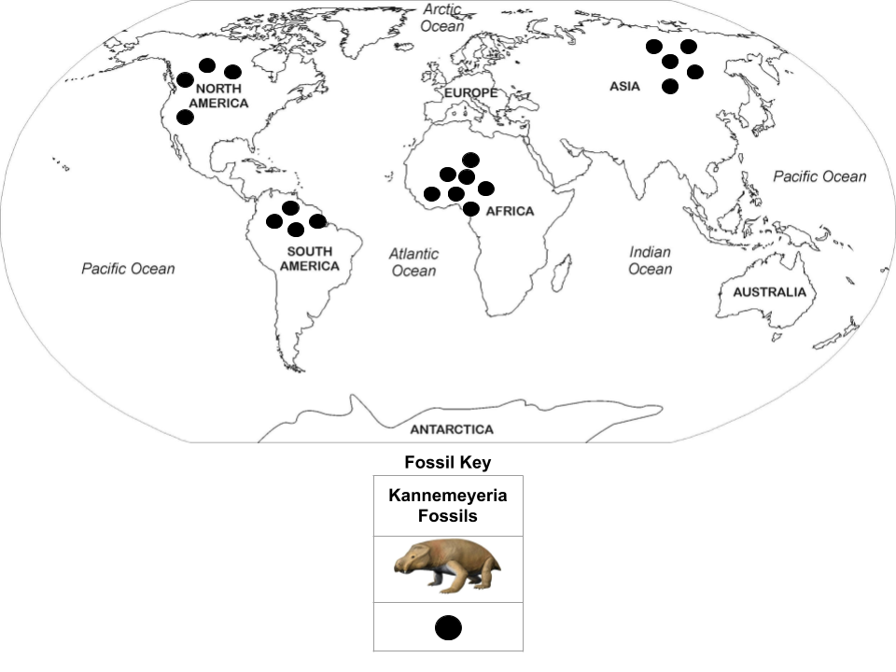 | Part A. Explanation  _______________________________________  _______________________________________  _______________________________________  _______________________________________  _______________________________________  _______________________________________  _______________________________________  _______________________________________ | Part B. Explanation  _________________________________________  _________________________________________  _________________________________________  _________________________________________  _________________________________________  _________________________________________  _________________________________________  _________________________________________  _________________________________________
2. 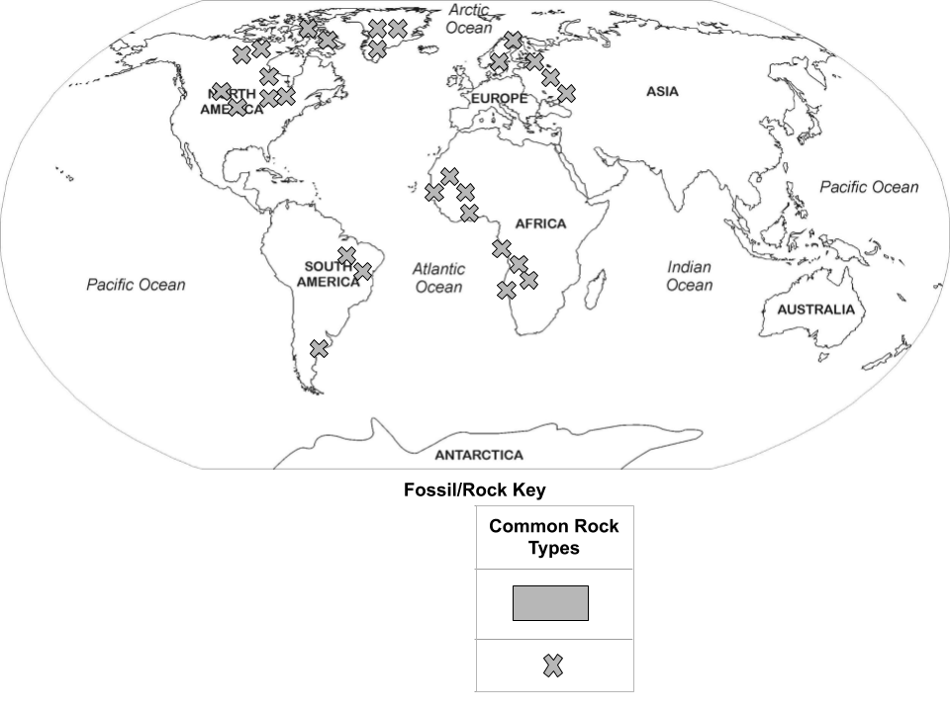 | Evidence (Patterns):  _______________________________________  _______________________________________  _______________________________________  _______________________________________  _______________________________________  _______________________________________ | (Cause):  _________________________________________  _________________________________________  _________________________________________  _________________________________________  _________________________________________  _________________________________________  _________________________________________
3.  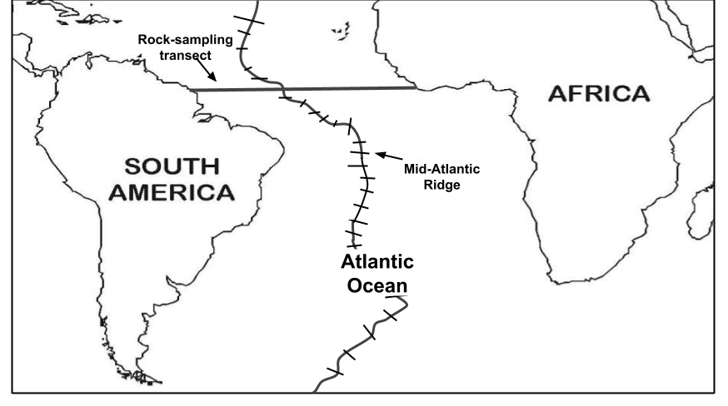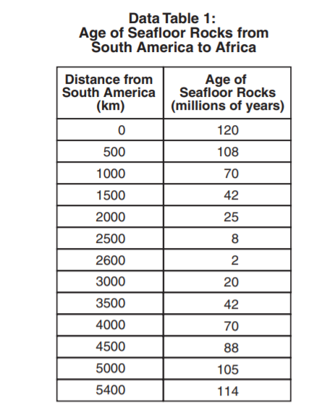 | Part A. Evidence (Patterns):  _______________________________________  _______________________________________  _______________________________________  _______________________________________  _______________________________________  _______________________________________  _______________________________________  _______________________________________  _______________________________________  _______________________________________  _______________________________________  _______________________________________  _______________________________________  _______________________________________  _______________________________________  _______________________________________  _______________________________________  _______________________________________  _______________________________________ | Part B. (Cause):  _________________________________________  _________________________________________  _________________________________________  _________________________________________  _________________________________________  _________________________________________  _________________________________________  _________________________________________  _________________________________________  _________________________________________  _________________________________________  _________________________________________  _________________________________________  _________________________________________  _________________________________________  _________________________________________  _________________________________________  _________________________________________  _________________________________________

4. Evidence (Patterns):

___________________________________________________________________________________________________________

___________________________________________________________________________________________________________

___________________________________________________________________________________________________________

___________________________________________________________________________________________________________

___________________________________________________________________________________________________________

___________________________________________________________________________________________________________

___________________________________________________________________________________________________________

___________________________________________________________________________________________________________

