Cell Phone Signal Assessment Task

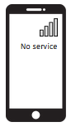
A group of students are working together on a project for school in the downstairs basement area of their local library. The basement is entirely underground, with no windows. The friends begin to get a little hungry, and so Melody tries to use her cell phone to place a call to order pizza to be delivered. However, her cell phone doesn’t have a signal and the call won’t go through. The friends all think this is strange, because they know that there is a cell tower right outside of the library. The drawing below shows the layout of the library, the basement, and the communication systems in and around the library, and you may refer to this drawing throughout the task.

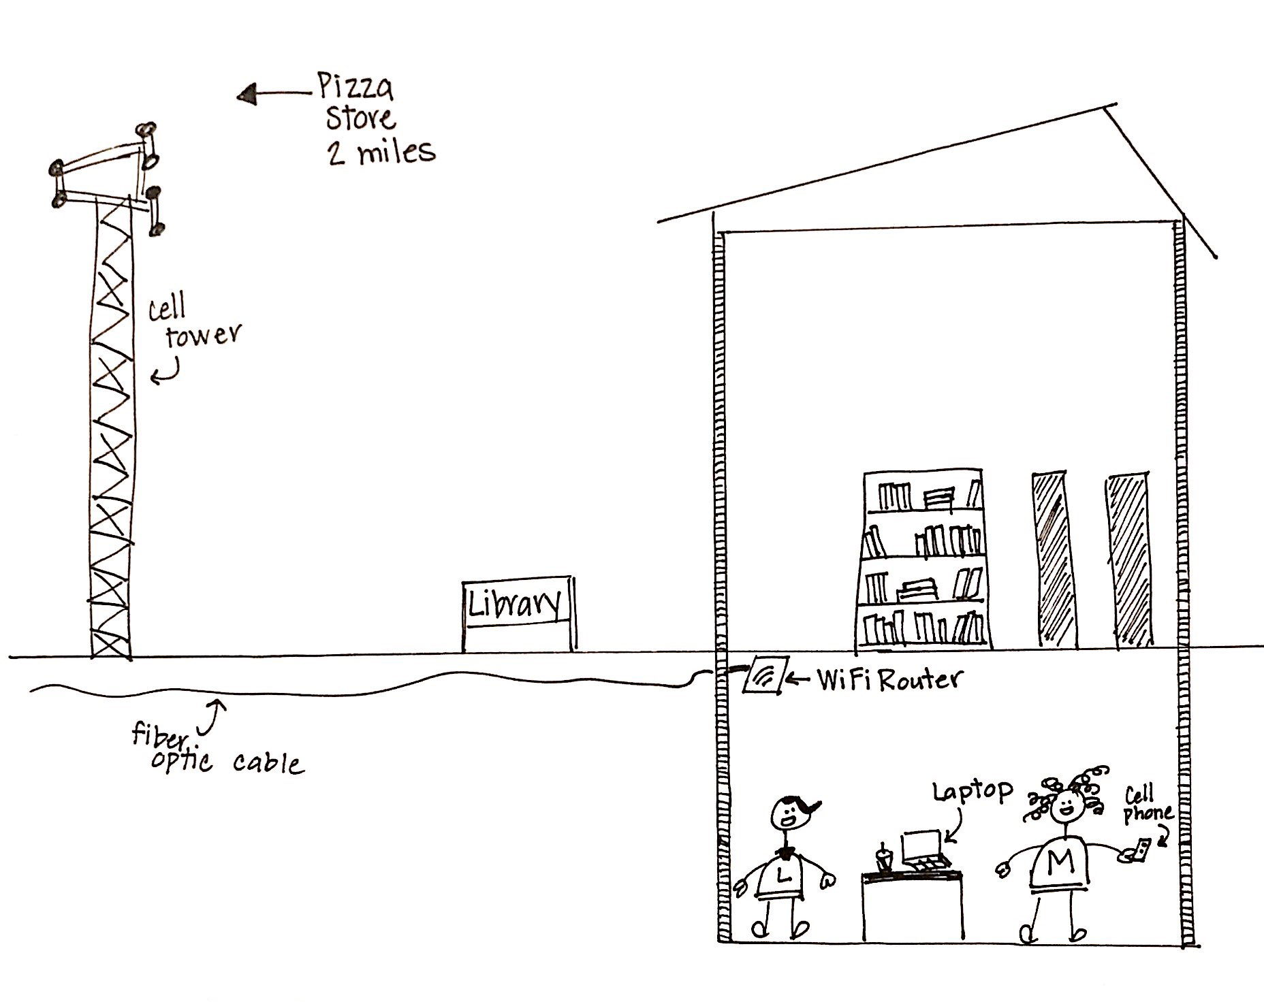

Prompt #1
1a: Given the model below of the information transfer from Melody’s phone to the pizza store, indicate with an “X” the location where the problem is occurring with the cell signal. What type of wave behavior is associated with this problem?

Information Transfer in Melody’s Cell Phone Communication System
Melody’s Cell Phone
Pizza Store Phone
Cell Phone Tower

Wave Behavior: ________________________________________

1b: The chart below provides information about how building material can impact a cell phone signal. Cell phone signal is measured in units called decibel-milliwatts (dBm). In order to connect to make a call, the phone needs to be able to send and/or receive between 50 and 100 dBm. The chart shows the number of dBm that are absorbed or blocked by various building materials, shown in “signal loss”. Based on this information, construct an explanation to describe which material has most likely been used in the building that Melody and the students are working in. Assume (for simplicity’s sake) that the library walls are built of a single material, not a combination.

Building Material | Effect on Cell Phone Signal (dBm)
Concrete | -55.2
Reinforced Concrete | -53.8
Metal | -41.0
Tinted or low-emissivity glass | -32.0
Brick | -15.3
Lumber | -3.27
Traditional glass | -0.07
Drywall | -0

Prompt #2
When Melody’s phone wouldn’t connect to call for pizza, she decided to use the WiFi connection on her cell phone to order pizza using the pizza store’s website. Using the diagram of the library below as well as evidence from the data table in prompt #1, explain why Melody was able to connect to the pizza store via the WiFi internet communication system, but not her phone’s cellular network system.

Prompt #3
3a. This WiFi internet communication system has several components shown (out of order) below. Use symbols, arrows, and words to connect the components of this model of the Wi-Fi communication system Melody used to order the pizza.

pizza store’s communication system
Melody’s cell phone
Wi-Fi router at the library
fiber optic cables

3b. Construct an explanation of how energy flows into and out of the internet communication system to enable Melody to communicate with the pizza store, including how the information changes forms during its transfer.

Prompt #4
After Melody had trouble calling the pizza store, her friends wanted to help. Melody’s friends made the following explanations and solutions to help Melody solve her problem:

Mark: “The phone’s information waves don’t have anything to carry it to the tower. You need to plug the phone into the outlet in the wall so that the signal can go through the wire.”

Luca: “The phone’s information waves can’t get to the tower because you’re holding it too tightly. You just need to hold the phone up above your head so that the signal can find your phone.”

Monique: “The phone’s information waves are being blocked by something here in the basement. You need to go outside to an open area so that the signal is stronger.”

Explain which friend you feel has the best solution to Melody’s problem. Justify your choice with reasoning from your understanding of how information travels in communication devices, or by pointing out errors in the incorrect students’ thinking.

Choice:

Reasoning:

