Survivors Stranded!
You and a group of survivors were stranded after your plane crashed near a remote island off the coast of New Zealand. ​
Water is necessary for human survival; however, the only water available is saltwater from the ocean. ​
While humans can safely ingest small amounts of salt, the salt content in seawater is much higher than what can be processed by the human body. Eventually the body will dehydrate and shut down.
This survival expert recommends you use a solar still made from plastic bottles washed up on the shore:
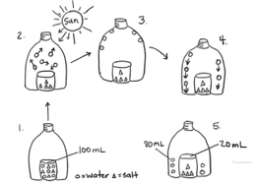
Prompt A: Use the steps in the model to explain how the salt is removed from the water in the solar still. In your explanations, include how changes in states of matter make the solar still work as a system. ​

