Experiencing the Formative Assessment Cycle
Alignment Data for Grade 3–5
Science and Engineering Practices | Disciplinary Core Ideas | Crosscutting Concepts
Developing and Using Models  Grade 3–5 Element  - Use models to describe phenomena. | Structure and Properties of Matter  Grade 3–5 Element  - Matter of any type can be subdivided into particles that are too small to see, but even then the matter still exists and can be detected by other means. A model shows that gases are made from matter particles that are too small to see and are moving freely around in space can explain many observations, including the inflation and shape of a balloon and the effects of air on larger particles or objects.  - The amount (weight) of matter is conserved when it changes form, even in transitions in which it seems to vanish. | Systems and System Models  Grade 3–5 Element  - The total weight of the substances does not change. This is what is meant by conservation of matter.

Prompt and Performance Outcome
Prompt A from Survivors Stranded Task | 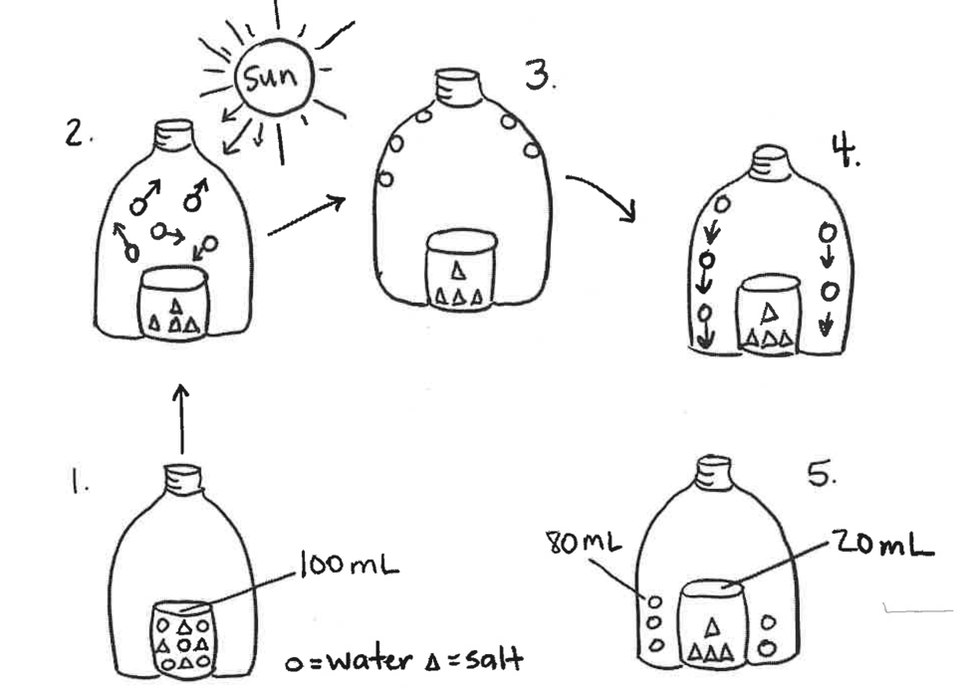  Use the steps in the model to explain how the salt is removed from the water in the solar still. In your explanations include how changes in states of matter make the solar still work as a system.
Performance Outcome | Use a model to describe how changes in states of matter cause the movement and conservation of matter even when it seems to vanish.

Evidence that students have met this performance outcome:
Students describe relationships between components of the model (macroscopic observable matter [e.g., salt, air, water], particles of matter that are too small to be seen, and the sun), including:
- Between (a) macroscopic matter and (b) tiny particles that cannot be seen (i.e., the idea that tiny particles of matter that cannot be seen make up matter that we can see);
- Between (a) the sun and (b) the movement of tiny particles;
- Between (a) the movement of tiny particles and (b) the solar still phenomena (e.g., evaporating liquids, substances that dissolve in a solvent); and
- Between the weight of all of the matter in the bottle (a) before and (b) after it is heated.
Students describe that matter being composed of tiny particles too small to be seen can account for salt separating from water in a solar still.

Part I. Analyze Student Work
- Color-code the sample student responses in the left column according to what dimensions the response is showing evidence of (SEP - green, DCI - blue, CCC - purple). Keep in mind that not every response will show evidence of all three dimensions. Continually refer back to your alignment table and performance outcome above.
- Then label each row of student work as Emerging, Developing, or Proficient in the right column. You may color-code the boxes as orange (Emerging), yellow (Developing), and green (Proficient) if that helps you see patterns across the student work.
Sample Student Work | Emerging, Developing, or Proficient (DCI) | Emerging, Developing, or Proficient (SEP) | Emerging, Developing, or Proficient (CCC)
Student 1: In the first bottle, you can tell that the circles and triangles are meaning salt water. When you put the bottle in the sun, the water evaporates and then condenses onto the side and when you flick it, all the water droplets fall on to the rim of the water bottle.
Student 2: I think it is removed through the outside of the bottle. It evaporates. The changes in states of matter make the solar still work by evaporating up into the sky.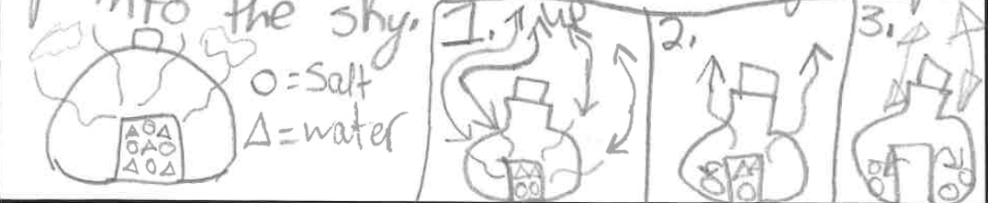
Student 3: The water evaporates and catches the outside of the bottle and the water will be pure water, not salt water as shown in the model. What makes the solar still effective is that it uses the evaporation to change the state of matter back to regular water.
Student 4: The sun evaporates the water and then it changes back to water.
Student 5: In Step 1, you can see that there is 100 ml of saltwater but in Step 2, the sun causes the water to evaporate, so the water molecules (circles) are floating inside the bottle as gas and the salt (triangles) stay in the glass. In Step 3, the water condenses on the inside of the bottle and then falls to the bottom in Step 4. So this is how you have 80 ml of pure water separated from 20 ml of salt in Step 5, which equals the same total ml as it started with.

Part II. Identify Trends in Student Work

Once you have sorted the student responses, look across the student work and consider: What made you label a response as Emerging? Developing? Proficient?

- First, review the student responses that are at the Developing Level:
  - Identify Trends in Strengths: What are the students at this level doing well with the dimension(s)? In the top middle column, record criteria that indicate trends in strengths of this level of student responses.
  - Identify Trends in Needs: What are the students at this level struggling with in terms of the dimensions? In the bottom middle column, record criteria that indicate trends in needs of this level of student responses.
  - Review your criteria and make sure they reference evidence of each dimension being measured and do not focus on features of students’ responses that the assessment is not trying to measure (like vocabulary, sentence structure, amount of detail, etc.).

- Repeat this process for Emerging and Proficient student responses.

Strengths
Emerging | Developing | Proficient
DCI:  SEP:  CCC: | DCI:  SEP:  CCC: | DCI:  SEP:  CCC:
Needs
Emerging | Developing | Proficient
DCI:  SEP:  CCC: | DCI:  SEP:  CCC: | DCI:  SEP:  CCC:

To find common trends across the class:
- First look at the Strengths section of the table.
  - Review the trends in strengths across the different levels. What is a trend you see that is representative of a good portion of the students you sorted?
  - Highlight that trend across the “Strengths” row to focus on what many students are presently able to do in relation to the performance outcome dimensions.

- Next, look at the Needs section of the table.
        - Review the trends in needs across the different levels. What need is emerging for a good proportion of the students? What are most of the students struggling to show evidence of in terms of the three dimensions?
        - Highlight that trend across the “Needs” row to focus on what many students need more support with to progress with this PE or dimensions.

- Summarize a common strength and common need below:

Common Strength | Common Need
Most of my students…  DCI:  SEP:  CCC: | Most of my students…  DCI:  SEP:  CCC:

Part III. Plan an Instructional Move That Will Address Trends

- What are some reasons for students showing this trend? What might students not have had enough exposure to in prior instruction that made it difficult for students to show evidence of these dimension(s) on the assessment? Could we be seeing this trend because of the way the prompt itself is written or structured?

- What instructional moves would best meet your original learning goal and address the primary reason(s) for the trend you’ve identified?

- Consider your role. What would you be able to do with this data to support students’ learning?

