Briceville Task

Briceville, Tennessee has experienced a significant change in its economy over the past century. There are several factors that could explain this change. In order to develop an explanation for the economic changes noted in Briceville, we will obtain and evaluate evidence from the following information:

- Population trends in Briceville
- Natural resource availability in the Briceville geographic area
- History of the use of coal as an energy resource in the United States

Prompt A - Population Trends in Briceville: Use the data table below to answer questions regarding the population change in Briceville.

Population Table of Briceville, Tennessee
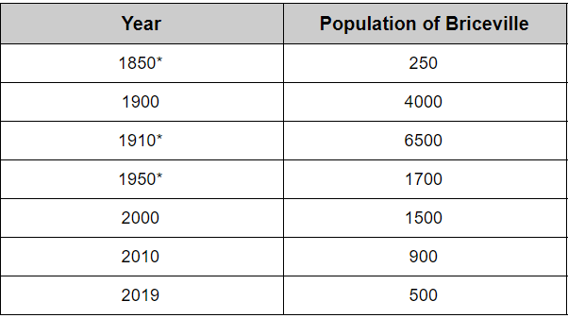

Describe the relative trend(s) in the population table above for the years 1850 - 2019.

Explain how the trend stated above could have had an economic impact on the community of Briceville.

Prompt B- Natural Resource availability in the Briceville Geographic Area: Evaluate the information obtained from the following map, text, and graph to answer the prompt.
Figure 1- Map of Bituminous Coalfields of Eastern Tennessee by county.  The shaded region in the figure shows the location of major coal deposits in Tennessee as well as the location of Briceville, TN. | 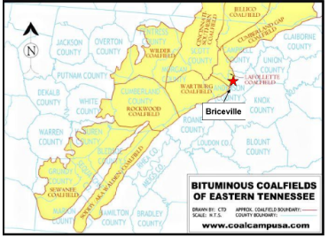  Copyright © 2001-2020 Chris DellaMea. Retrieved from http://coalcampusa.com/tennessee-coal-mines/tennessee-coal-mines.htm

Text 1: Surface Mining vs. Underground Mining | The process of removal of essential mineral ores or geological substances from the earth is called mining. These materials are of great value to humans and can be used for several purposes.  Mining is conducted basically in two ways: underground mining or surface mining. Underground mines are large tunnels that are dug deep into the ground to reach minerals that are too far underground to be reached from surface mining. Surface mines, also called strip mines, are large pits where dirt and rock are removed to expose the minerals without the need to dig large tunnels.  Both types of mining have advantages and disadvantages. Surface mines are cheaper, safer, and can recover more of the coal. However, surface mining also scars the landscape and destroys habitats.  Underground mining is more expensive and more dangerous for the miners. However, it does not damage the surface area surrounding the mine as all of the work is below ground.

Graph 1: Coal Production over Time Based on Underground vs. Surface Mined Coal in the United States
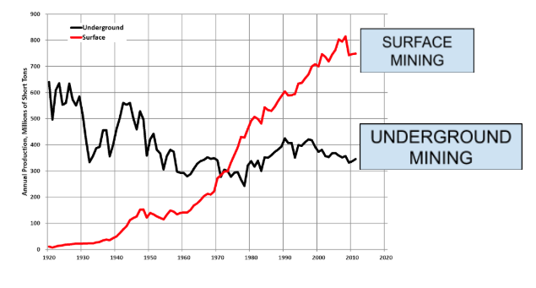
Years shown: 1920 – 2020

Retrieved from https://www.wikiwand.com/en/History_of_coal_mining_in_the_United_States

Complete the table using information from Text 1:

Underground Mining | Surface Mining
Advantage:  Disadvantage: | Advantage:  Disadvantage:

Using the information in Graph 1, describe the overall trend for the amount of coal produced (annual production) using each type of mining (surface vs. underground).

Briceville’s coal deposit required underground mining. What kind of economic impact could this have had on the community? Circle one: Negative or Positive

Explain how the availability and type of coal could have had this type of economic impact on Briceville.

Prompt C - History of the Use of Coal as an Energy Resource in the United States: Obtain information from the bullets below to use in completing the graphs and prompt that follows.

Text 2: Use of Coal as an Energy Resource | - Coal has been used to generate electricity in the United States since 1882.  - At one time, there were hundreds of thousands of people working in the coal mining industry in rural communities.  - Miners made decent, stable income.  - The use of coal as a primary source of electricity began to decline after the 1950’s.  - New technologies allowed natural gas to be obtained.  - Natural gas was considered to be clean, cost-competitive, and plentiful.  - Coal mine owners began replacing human miners with digging machines and mobile coal loaders.

1. Create a graph to communicate the relationship between the use of coal and the use of natural gas found in the information in the Text 2 bullets above. Include the following on the graph:

Use a dashed line (- - - -) to show the overall trend in coal as a primary source of electricity over time.
Use a solid line ( $-$ ) to show the overall trend in the supply of natural gas available over time.

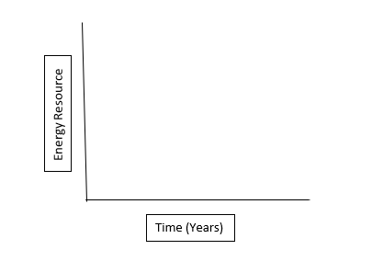

2. Create a graph to communicate the relationship between the number of coal-removing machines and the number of employed coal miners as stated in the Text 2 bullets in the information above. Include the following on the graph:

Use a dashed line (- - - -) to show the overall trend in the number of employed coal miners in the US
used to obtain and produce coal.
Use a solid line ( $-$ ) to show the overall trend in the use of machines to obtain and produce coal.
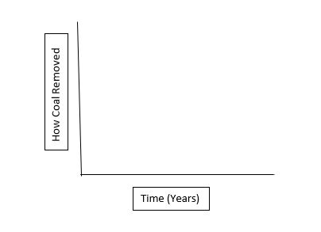

3. Use the bulleted items in Text 2 above to complete the table below. Identify one item that could be classified as having a positive economic impact on Briceville and one item that could be classified as having a negative economic impact on Briceville.

Positive Economic Impact | Negative Economic Impact

Prompt D- What the heck happened to Briceville, Tennessee? What factors have affected Briceville during the past 100 years to cause the changes noted in the photographs? What has been the impact of each factor on the community?

Use the information that you evaluated in Parts A, B, and C of this task to develop an explanation for the changes noted in Briceville.

Claim:
Briceville, Tennessee has experienced a significant negative change in its economy over the past century. There are several factors that could explain this change.

Evidence:  - Evidence statement 1  - Evidence statement 2  - Evidence statement 3 | Reasoning:  1. The reason the evidence from #1 supports my claim is  2. The reason the evidence from #2 supports my claim is  3. The reason the evidence from #3 supports my claim is

Definitions:

Mineral Ores - a special type of rock that contains a large enough amount of a particular mineral (usually a metal) to make it economically practical to extract it from the earth. Examples include copper, iron, gold, etc.

Human Interactions - Describes the ways that humans interact with the environment. For example, people depend on the environment for food, water, timber, natural gas etc. People adapt the environment to fulfill their own needs. People modify the environment positively or negatively like drilling holes, building dams, removing forests, etc.

Impacted - strongly affected.

Economic Factors - The things that affect the economy of an area, such as employment rate, types of jobs, amount of income, number and types of businesses, and demand for different types of goods and services.

