Weather Task: “Are We Getting a Snow Day?”

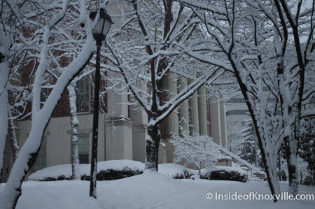
COPYRIGHT © 2020 · FOCUS CHILD THEME ON GENESIS FRAMEWORK · WORDPRESS · Retrieved from https://insideofknoxville.com/2014/02/downtown-knoxville-snow-photographs-february-13-2014/

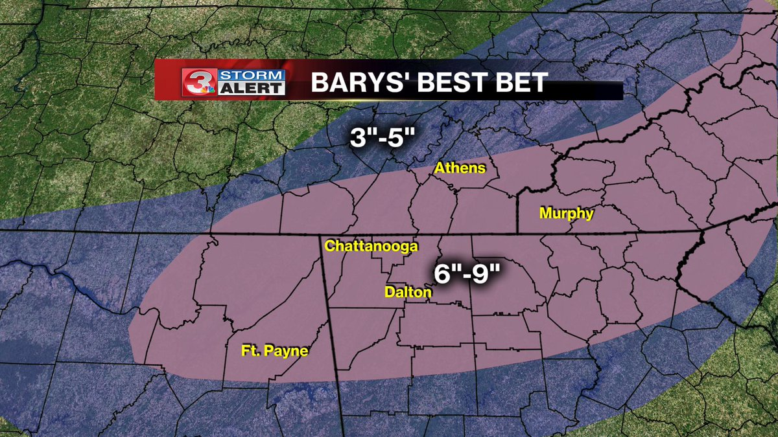
Normally, Knoxville receives more snow each winter than Chattanooga. On January 31, 2015, meteorologists predicted that both Knoxville and Chattanooga would get snow the next day. Both cities were preparing for snow and students were anxiously waiting to see if school would be cancelled. On February 1, 2015, it ended up snowing in Chattanooga but not in Knoxville, and students in Chattanooga got a snow day. How and why could a more southern city like Chattanooga receive more snow?
© WRCB TV, Storm Alert 3, Retrieved from twitter.com/wrcbweather/status/570330100601729024
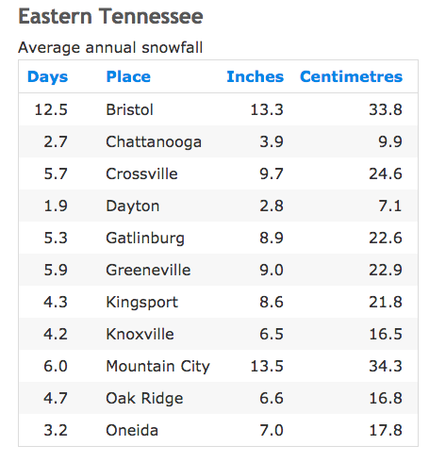
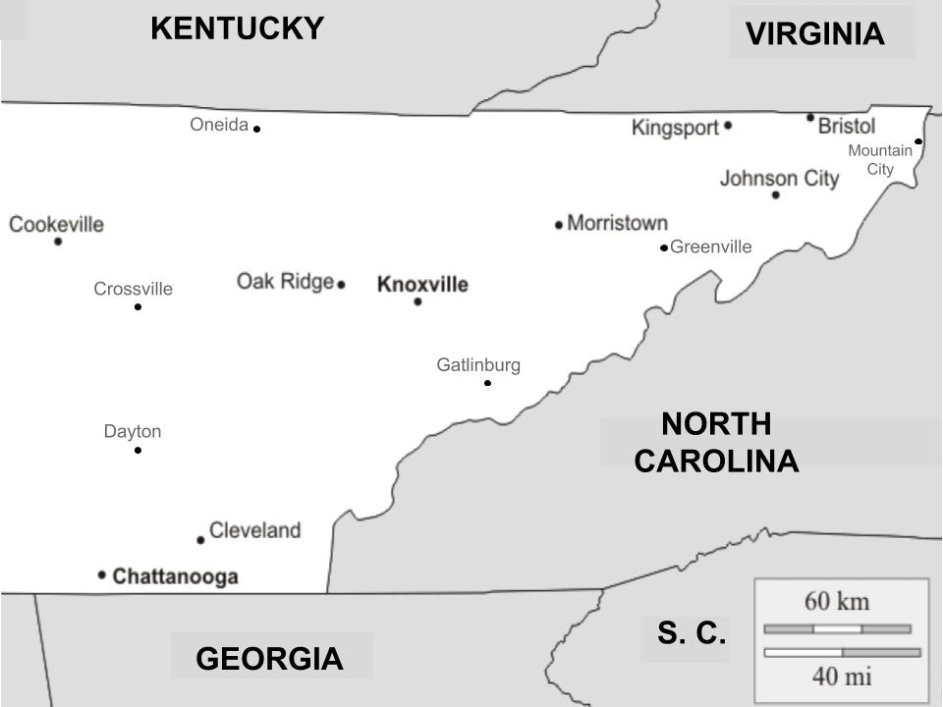

Copyright © 2020 Current Results Publishing Ltd. From: www.currentresults.com/Weather/Tennessee/annual-snowfall.php

Task 1:
Use the scenario above and the table below to answer the following questions. The scenario shows the average annual snowfall in Eastern Tennessee and the table shows the weather during the week of the weather event.

 | Mon | Tues | Wed | Thurs | Fri
High Temperature (°F)/(°C) | 43 / 6.1 | 50 / 10 | 42 / 5.6 | 53 / 12 | 60 / 16
Low Temperature (°F)/(°C) | 29 / -1.7 | 38 / 3.3 | 28 / -2.2 | 39 / 3.9 | 45 / 7.2
Precipitation (inches/centimeters) | 0.0 / 0.0 | 1.0 / 2.5 | 1.5 / 3.8 | 0.0 / 0.0 | 1.6 / 4.1
Average Wind Speed (mph/kph) | 15 / 24 | 10 / 16 | 7 / 11 | 10 / 16 | 10 / 16

Part A: Based on the scenario and the weather data in the table above, on which day and in which city was snowfall happening?
- Wednesday in Knoxville
- Tuesday in Knoxville
- Wednesday in Chattanooga
- Monday in Chattanooga

Part B: Explain your selection from Part A and include your reasoning for why snow would not be predicted on the other days and not in the other city.

____________________________________________________________________________

____________________________________________________________________________

Below is a partially completed weather map of Eastern Tennessee during a normal snow event for Knoxville. Look at the map closely. You will use the map to answer the parts of Task 2.

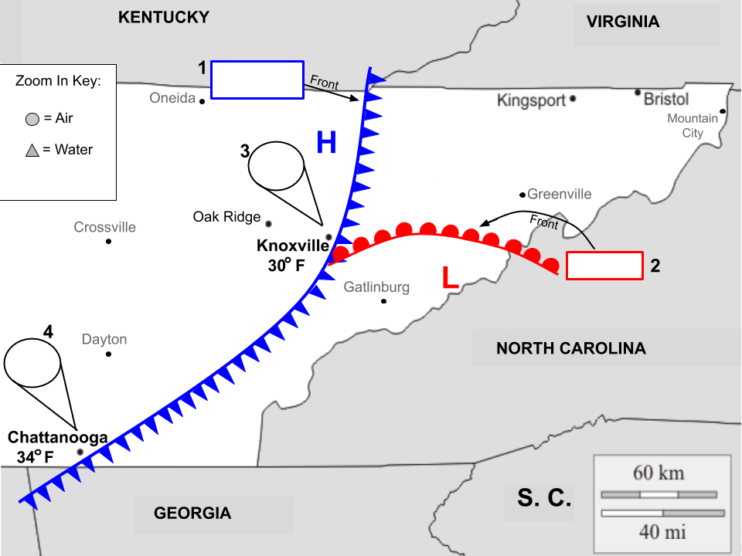

Task 2: Complete the following parts of the map and use the map to answer the questions.

Part A: Label the type of front in zoom in feature #1. Describe the air, moisture conditions, and any severe weather associated with this type of front below.

____________________________________________________________________________________________________________________________________________________________

Part B: Label the type of front in zoom in feature #2. Describe the air, moisture conditions, and any severe weather associated with this type of front below.

____________________________________________________________________________________________________________________________________________________________

Part C: Draw (on the map) and explain (below) what the air pressure and moisture levels of the two different cities would look like using the zoom in features #3 and #4. Be sure to use the key on the map.

For example, Miami, FL typically has warm air and high humidity (moisture). The zoom in feature and explanation for Miami would look like this:

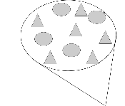 | The air particles (circles) are spread out because Miami’s air is warmer, making it less dense. The humidity is high, so there are many water particles (triangles) in the air. If the moisture in the air increases during the day, the water particles will condense and precipitation will happen in the form of rain.

Zoom in feature #3: ______________________________________________________________________________ ______________________________________________________________________________
Zoom in feature #4: ______________________________________________________________________________

______________________________________________________________________________

Part D: Explain how the interactions between the air masses (using the air pressure and moisture conditions you described in your zoom-in circles) resulted in the normal weather conditions of the two cities.

In Knoxville: ______________________________________________________________________________
______________________________________________________________________________

In Chattanooga: ________________________________________________________________
______________________________________________________________________________

Task 3: Use all of the maps and data tables above to address the question:
Part A: What factor(s) could lead to the typical pattern of Knoxville receiving more annual snowfall than Chattanooga?

________________________________________________________________________________________________________________________________________________________________________________________________________________________________________________________________________________________________________________________

Task 4: Below is a partially completed weather map of Eastern Tennessee.
Part A: Draw on this map to develop a model that shows the conditions that needed to emerge for the unusual effect of snow in Chattanooga and not Knoxville on February 1, 2015.

Guidance: Be sure to draw in a cold front, warm front, High pressure, Low pressure, and use the zoom in circles to represent the air density and moisture levels.

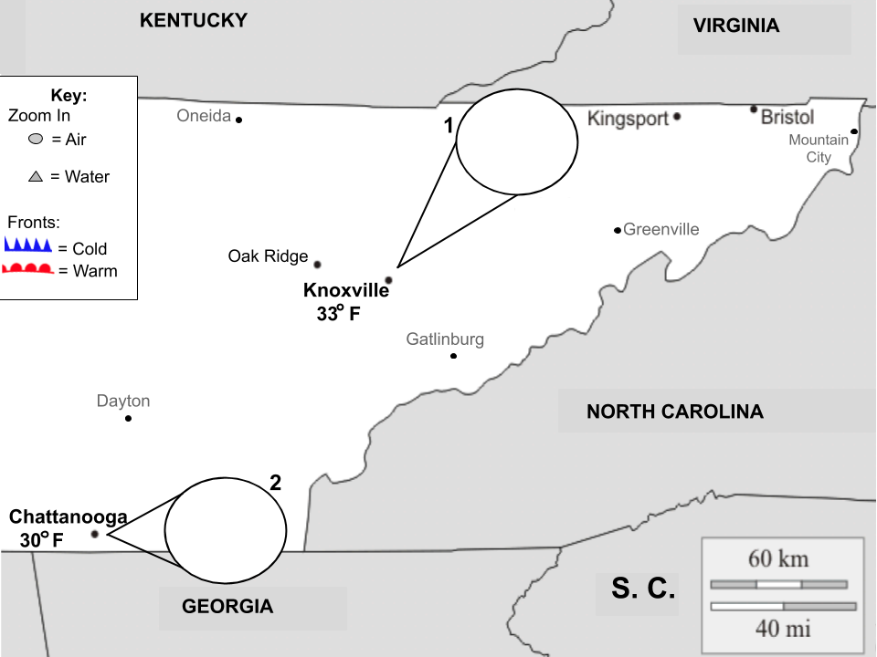

Part B: Describe how your map explains snow in Chattanooga and not Knoxville on February 1, 2015.
____________________________________________________________________________________________________________________________________________________________

Task 5: In a weather report on January 28th, a meteorologist predicted, “There is a 60% chance of snow in Knoxville and a 15% chance of snow in Chattanooga on February 1st.” On February 1st, snow fell in Chattanooga but not in Knoxville.

Part A: Why are weather maps (weather models) not 100% accurate at predicting the weather?
__________________________________________________________________________________________________________________________________________________________________________________________________________________________________________

Student Checklist for Snow Day Assessment

Directions: Read all of the checklist before beginning the Tasks. Check off the boxes when each task is completed.

- I have described my thinking in choosing a day and city.

- Part A- I have labeled the front on the map and described any conditions associated with that type of front.

Part B- I have labeled the front on the map and described any conditions associated with that type of front.

Part C- I have used the key to draw air density and moisture levels in the zoom features on the map for both cities.

Part D- I have described the weather conditions that Knoxville and Chattanooga experienced on that map.

- I have identified a factor(s) that would cause a typical pattern of more snow in Knoxville.

- I have used the list of items in the Guidance section to draw on the map to show the conditions that needed to emerge for the unusual effect of snow in Chattanooga and not Knoxville on February 1, 2015.

- I have explained the accuracy of weather maps and why meteorologists use a percent chance in weather forecasts.

