Using the Social Studies Curriculum Framework

The Curriculum Framework for Social Studies is an organizer to assist Local Education Agencies (LEAs) in writing curriculum. The framework is based upon the Academic Standards of Chapter 4 of PA School Code. The Academic Standards for Social Studies, adopted in 2002, and the Early Learning Standards, adopted in 2016, both went through the regulatory and review process. Updated voluntary Social Studies standards (2009) also cite concepts to be learned. These standards do not specifically cite content to be learned, but concepts to be assessed.
Pennsylvania relies on the locally elected school board to make decisions concerning the content of Social Studies to be taught in the classroom. Social Studies teachers are responsible for teaching “Plato to NATO”. The Academic Standards and the curriculum framework are designed to assist educators in focusing instruction of selected content so that students develop thinking skills to learn the concepts of civics and government, economics, geography, and history. Utilizing the framework will prepare students for adult life and learn the skills to be a responsible, involved citizen as is charged in Chapter 4 of the Pennsylvania School Code:
§ 4.11. Purpose of public education.
(a) This section and § 4.12 (relating to academic standards) describe the purpose of public education and its relationship with the academic standards.
(b) Public education prepares students for adult life by attending to their intellectual and developmental needs and challenging them to achieve at their highest level possible. In conjunction with families and other community institutions, public education prepares students to become self-directed, life-long learners and responsible, involved citizens.

Prior to using the curriculum framework, educators should read the introduction in each Academic Standard document to gain an understanding of the holistic nature of Social Studies.
Assessment should focus on the concepts, using the Essential Questions and Big Ideas to guide assessment practices.
Every student has the right to having voice and choice, informed by knowledge of government, history, economics, and geography. Content as well as instruction should be designed to meet individual student needs.

How to Read the Curriculum Framework and Use the Academic Standards
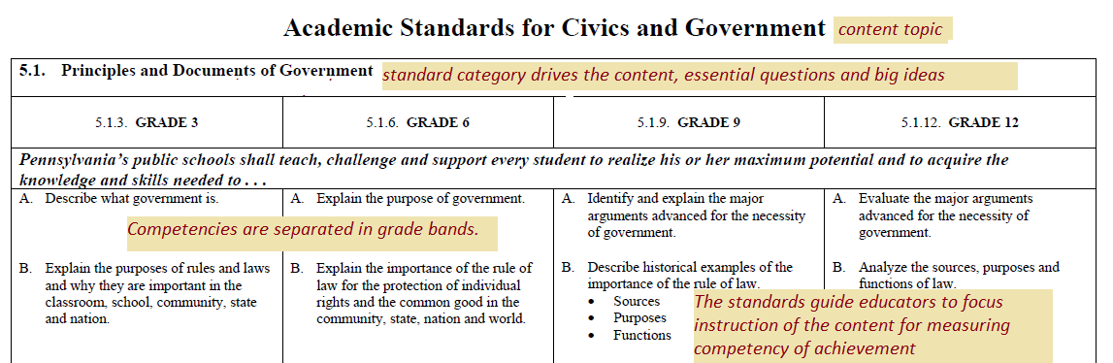

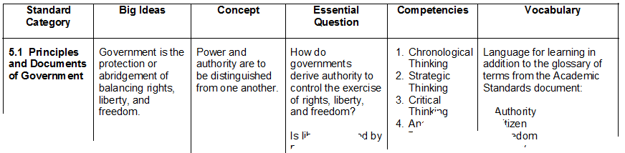
Framework

Big Ideas Declarative statements that describe concepts that transcend grade levels. Big Ideas are essential to provide focus on specific content for all students.
Concepts Describe what students should know (key knowledge) as a result of this instruction specific to grade level.
Competencies Describe what students should be able to do (key skills) as a result of this instruction, specific to grade level. Reference the Academic standard for specific competencies.
Refer to the Academic Standards for guidance in creating the competencies. The competencies of social studies are to develop the thinking skills to have students reach the big ideas and concepts of the Academic Standards. The Academic Standards for Social Studies are written to guide the educator to what the student has to know and be able to do in the standard category. Please reference the specific grade bands for the competencies for students to demonstrate the following:
- Analytic Thinking – parts, break down complexity to useable information
- Critical Thinking – “If- then”, rational, reasonable thinking, problem solving
- Strategic Thinking – planning, what to do with the information
- Chronological Thinking – Thinking across time and space (temporal)
Essential Questions Questions connected to the SAS framework specifically linked to the Big Ideas. They should frame student inquiry, promote critical thinking, and assist in learning transfer.
Vocabulary The vocabulary for learning is the concept vocabulary and not content vocabulary. Please add the concept vocabulary to the terms in the glossary of each Academic Standard for students to have a working vernacular to demonstrate their understanding.

