The Pennsylvania Science, Technology & Engineering, Environmental Literacy Sustainability (STEELS) Assessment Foundations Toolkit
Facilitation Guide for Module 2:
Assessing Rigorous STEELS Learning for All Students

In 2022, Pennsylvania adopted the Science, Technology & Engineering, Environmental Literacy Sustainability (STEELS) standards, new learning goals for K–12 students based on research of how students learn best. The three professional learning modules in the STEELS Assessment Foundations Toolkit are designed to support participants in building a foundation in how to
monitor and further student learning of the STEELS standards. To see an overview of the toolkit modules and goals, click here.
This document provides facilitation guidance for Module 2, which supports participants in building a common understanding of quality STEELS-based assessments in which all students, including those who are historically underserved in science and engineering classrooms, are able to demonstrate their ability to apply reasoning to make sense of the world around them and solve problems.
Table of Contents
Module 2 Description page 2
Goals page 3
Language Considerations page 4
Materials Required and Session Preparation page 5
Module Overview page 7
Key to Icons in Facilitator Guide page 10
Detailed Professional Learning Leader Notes page 11
Module 2 Evaluation Sample Questions page 43


Title: Assessing Rigorous STEELS Learning for All Students

Module 2 Description: In this session, participants will learn about key features of high-quality and rigorous assessments that allow all students to show what they know in STEELS.
Timing: This session is designed as a full day 4.5-hour session with the following components:
- Opening: Introduction to the STEELS Standards and Module 2 (10 minutes)
- Session 2.1 Phenomena, Multiple Dimensions, and Sense-Making (50 minutes)
- Session 2.2 Assessments That Require Student Reasoning (45 minutes)
- Session 2.3 Assessments That Support All Students (1 hour 10 minutes)
- Session 2.4 Rigorous Expectations for All Students (1 hour 30 minutes)

These time estimates do not include introductions, icebreakers, breaks, or lunch. Professional learning facilitators should incorporate those as needed.
Audience: The audience for this module is K–12 classroom teachers, school leaders, or curriculum coordinators.
Modifications for Different Grade Bands: While the featured example tasks in Module 2 are designed for grade 5 students, the student sense-making and innovations reflected can provide helpful insights for teachers of any grade band.
Prerequisite Knowledge: Participants must have prerequisite knowledge about phenomena/problems, three dimensions, and how they look in assessments. This can be accomplished by completing Module 1 in this toolkit or through other means. This session builds on that knowledge.

Module | Goal
Module 2:  Assessing Rigorous STEELS Learning of All Students | Build a common understanding of quality STEELS- based assessments in which all students, including those who are historically underserved in the STEELS classroom, are able to demonstrate their ability to apply reasoning to make sense of the world around them and solve problems.
Session 2.1  Phenomena, Multiple Dimensions, and Sense-Making | Participants reflect on their visions of meaningful learning and deepen their understanding of the relationship between phenomenon/problem-based tasks, sense-making, and their interdependency in assessment.
Session 2.2  Assessments That Require Student Reasoning | Participants deepen their understanding of how an assessment can elicit students’ ability to use multiple dimensions to make sense of something and that the presence of a phenomenon or problem does not guarantee reasoning.
Session 2.3  Assessments That Support All Students | Participants consider the perspective of students who may feel left out of our vision for STEELS education and deepen their understanding of the assessment features that can support all students to make their thinking visible on an assessment.
Session 2.4  Rigorous Expectations for All Students | Participants deepen their understanding of how to ensure rigorous expectations for all students with appropriate scaffolds.  Participants will describe the relationship between phenomena, multiple dimensions, sense-making, equity, and rigor.

- Multi-dimensional: Why “multi-dimensional” and not “three-dimensional”? The Next Generation Science Standards (NGSS) often refer to the three dimensions, including the Disciplinary Core Ideas (DCIs), Science and Engineering Practices (SEPs), and Crosscutting Concepts (CCCs). The PA STEELS standards also have those three dimensions, but this
assessment toolkit refers to “multiple dimensions” for two reasons: (1) the STEELS includes Technology & Engineering standards, which are two-dimensional and include Disciplinary Core Ideas (DCIs) and Technology and Engineering Practices (TEPs); and (2) some quality assessments elicit student learning of two dimensions at a time rather than three.
- Practices: Throughout this document, “practices” are often used broadly to mean both Science and Engineering Practices (SEPs) and Technology and Engineering Practices (TEPs), which are a part of the STEELS. The SEPs are derived from the Next Generation Science Standards, while the TEPs are from the ITEEA Standards for Technological and Engineering Literacy.

Materials Required and Session Preparation
Printouts Needed
Item | Session Needed | Description
Survivors Stranded Version A | Session 2.2 | 1 per participant
Survivors Stranded Version B | Session 2.2 | 1 per participant
Student Profiles | Session 2.3 | 1 copy to tape around walls for Gallery Walk
Cognitive Complexity Framework One- Pager | Session 2.4 | 1 per participant
Resources Needed
Item | Session | Description
Chart paper | All | 1 packet
Sticky Notes (at least two colors — currently written for yellow and blue) | Session 2.3 | 1 small stack of two colors of sticky notes per participant; additional stickies on table
Tape | Session 2.3 | To tape student profiles on wall
Blank paper or notebook to draw and revise models | Sessions 2.1 and  2.4 | 1 per participant

Preparation
Item | Session | Description
Sense-Making Chart paper | Session 2.2 | One piece of chart paper titled, “Sense-Making,” posted at the front of the room for the whole group  discussion
Student Profiles | Session 2.3 | Print 1 copy of each of the Student Profiles. Tape the profiles around the room.

Item | Session | Description
Equitable Features Debrief Chart paper | Session 2.3 | One piece of chart paper titled, “Equitable Features,” posted at the front of the room for the whole group discussion
Rigor/DOK Debrief Chart paper | Session 2.4 | One piece of chart paper titled,  “Rigor/DOK,” posted at the front of the room for the whole group  discussion

Module Overview
Time | Purpose | Content
Opening  10 min | Participants understand the context and need for this assessment toolkit learning experience. | - Overview of the STEELS standards  - Overview of toolkit big  picture goals and Module 2 goals  - Any other logistics
Session 2.1 Phenomena, Multiple Dimensions, and Sense-Making
(50 minutes)

Time | Purpose | Content
Vision Reflection  10 min | Participants reflect on their visions of meaningful STEELS teaching and  learning and elicit initial ideas about sense-making and equity in  assessments. | - Reflect on and define vision for science, technology, engineering, and environmental  literacy and sustainability education (or refer to Session 1.1 Vision Chart  from Module 1).  - Provide working definition of multi-dimensional  learning and phenomena/ problems in assessment.
Initial Models  40 min | Participants deepen their  understanding of the relationship between phenomenon/problem-  based tasks, sense-making, and their interdependency in assessment. | - Develop individual models describing the relationship between multi-dimensional, phenomena, and sense-making.  - Compare models and reflect.

Session 2.2 Assessments That Require Student Reasoning (45 minutes)

Time | Purpose | Content
Reasoning  40 min | Participants will develop a shared understanding of how an assessment can elicit students’ ability to use multiple dimensions to make sense of something and that the presence of a phenomenon or problem does not guarantee reasoning. | - Compare two tasks with the same phenomenon and reflect on the level of student sense-making required.  - Develop a list of sense- making features.
Connect to Context  5 min | Participants consider the extent to which these features are reflected in their current programs. | Reflection on the assessments your students interact with and their features.

Session 2.3 Assessments That Support All Students

(1 hour, 10 minutes)

Time | Purpose | Content
All Students  25 min | - Participants consider the  perspective of our students who may feel left out of our vision.  - Participants deepen their understanding of what equity means for multi-dimensional STEELS assessments. | Consider students often  left out of STEELS content areas and barriers that  prevent them from feeling challenged, supported, and connected.
Equitable Features  40 min | Participants will develop a shared understanding of the features that can support all students to make their thinking visible on an assessment. | - Identify supports/features that would help a student show what they know.  - Revisit two tasks from 2.2 and analyze tasks for equitable features.
Connect to Context  5 min | Participants consider the extent to which these features are reflected in their current STEELS programs. | Reflection on the assessments your students interact with and their features.

Session 2.4 Rigorous Expectations for All Students (1 hour, 30 minutes)

Time | Purpose | Content
Rigor  55 min | Participants deepen their  understanding of the task design features that support rigorous expectations for all students. | - Consider what rigor is and how is it used.  - Participants briefly analyze two tasks for equity and  rigor and consider effective ways to measure rigor.  - Discuss new cognitive complexity framework based on sense-making and analyze a task with that lens.  - Individual reflection
Revise Models  25 min | Participants will revise their model describing the relationship between phenomena, multiple dimensions, and sense-making to include equity and rigor/DOK. | - Revise models from 2.1 to also include rigor and equity.  - Discuss implications when one piece of the model isn’t there.
Connect to Context  10 min | Participants will reflect on the policies and processes that affect  rigorous assessments for all students. | - System-level reflection

Key to Icons in Facilitator Guide

Throughout the following facilitation guidance, you’ll see three icons:

Resource Icon: This icon will appear when the toolkit references or uses a concrete resource that may be helpful for participants following the session. A complete list of these resources can be found in the Resource Folder.

Sense-Making Icon: Based on the research of how adults learn, we know it’s most effective for participants to construct learning and lead the learning with their ideas.
Therefore, throughout these modules we want to avoid lecturing or simply providing the “right answer” — we need participants to grapple with the ideas and figure out key
takeaways, with help and guidance from the facilitator. This Sense-Making Icon will appear in key moments when participants are making sense of something, indicating those conversations should not be cut or rushed.

Formative Assessment Icon: These are key moments when it may be particularly helpful for you as a facilitator to listen and gain insights about the current thinking of your participants and use them to inform your facilitation moves.

Detailed Professional Learning Leader Notes
Session: 4 hours and 25 minutes
Slides 1–8 Intro/Welcome (10 min)
Slides 9–20 Session 2.1 Phenomena, Multiple Dimensions, and Sense-Making (50 minutes)
Slides 21–29 Session 2.2 Assessments That Require Student Reasoning (45 minutes) Slides 30–43 Session 2.3 Assessments That Support All Students (1 hour, 10 minutes)
Slides 44–59 Session 2.4 Rigorous Expectations for All Students (1 hour, 30 minutes)
Opening (10 minutes)
STEELS and Module Introduction (10 minutes)

Slides | Content
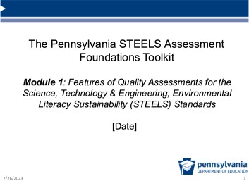 | Facilitation Step (<1 min):  Welcome participants to the Module 2 session and introduce the facilitation team.
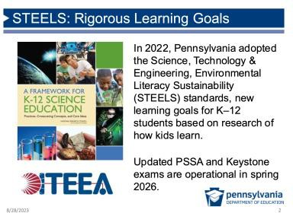 | Facilitation Note: Slides 2 and 3 are repeated across each module. If you are facilitating these modules together, you may choose to skip over these two slides.  Possible Narrative (<1 min):  - In 2022, Pennsylvania adopted the Science, Technology & Engineering, Environmental Literacy Sustainability (STEELS) standards. The standards reflect the research about how students learn best.  - PSSA and Keystone exams are being updated for the new standards and will be operational as of spring 2026.

Slides | Content
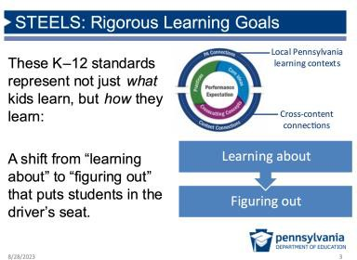 | Possible Narrative (<1 min):  - These K–12 standards represent not just what kids learn, but how they learn. They offer a vision in which science instruction and assessments shift from “learning about” to “figuring out” through phenomenon- or problem-  driven learning and performance.  - This is a move away from memorizing disconnected facts; rather, students should be investigating phenomena as they engage in practices and learn about disciplinary core ideas using crosscutting concepts.  - In addition, Pennsylvania is emphasizing the importance of local Pennsylvania learning contexts and cross-content connections to increase relevance and coherence of student learning.
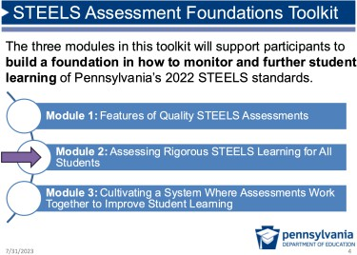 | Possible Narrative (<1 min):  - This toolkit is a professional learning experience to shift the culture of assessment and build capacity in what it looks like to assess progress towards the Pennsylvania STEELS standards.  - The first module focused on features of quality science assessments, and this second one will build on that, helping us consider how assessments are eliciting the learning of all students and holding them to the rigorous expectations reflected in STEELS.
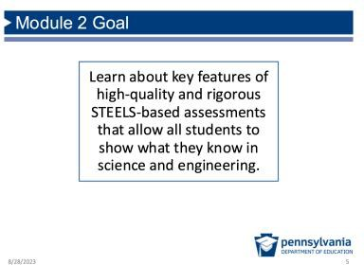 | Facilitation Step (<1 min):  Display slide and read module goal aloud or provide  participants with a moment to read. Explain that the next slide will show how we’ll achieve it.

Slides | Content
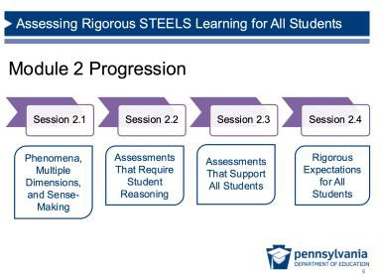 | Facilitation Step (2 min):  Display slide to share module progression, and provide a very brief description of each session within the module:  - Session 2.1: We’ll think about the relationship between phenomenon/ problem-based tasks, sense-making, and their interdependency in assessment.  - Session 2.2: Then, we’ll dig into how an assessment can  elicit students’ ability to use multiple dimensions to make sense of something.  - Session 2.3: Then, we’ll consider the features that can support all students to make their thinking visible on an assessment.  - Session 2.4: Finally, we’ll think about how to ensure rigorous expectations for all students in assessment.
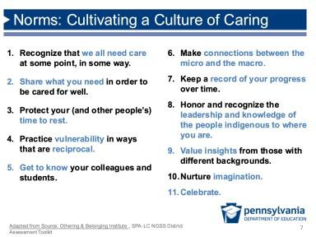 | Purpose: This slide is meant to be a relatively quick reflection on caring to frame norms for this professional learning session. In the following slide, we will also talk about what it would mean for assessment to be a “caring practice.”  Possible Narrative (3 min):  - This slide is based on a set of norms developed by UC Berkeley’s Othering and Belonging Institute, which is a  group committed to advancing more inclusive, fair, and just practices.  - For our work together to be meaningful and productive,  I’d like you to think about what it means to cultivate a culture of caring in our professional learning environment.  - Take a moment to read the slide. While you read, think about what these features mean and how they might support our work together.  Facilitation Step:  Give a couple of participants a chance to share out ideas with the whole group.

Slides | Content
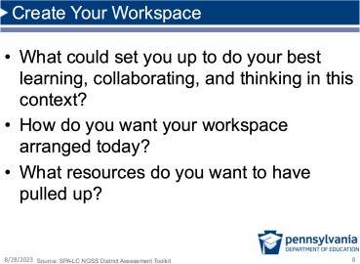 | Facilitation Note (2 min):  - You may choose to provide a moment for participants to “get comfortable” before diving into this learning session.  - Feel free to adapt this slide or to include any other session logistics here that may help participants to get ready for the session.  Facilitation Step:  Give participants a couple of minutes to get situated and ready for the session.
Session 2.1 Phenomena, Multiple Dimensions, and Sense-Making

(45–50 mins)
Where we are going in this session:
Participants reflect on their visions of meaningful science learning and articulate their initial ideas about the relationship between phenomena/problems, multi-dimensional learning, sense-making, and their interdependency in both instruction and assessment.
Where we are NOT going in this session:
This session provides time for participants to articulate their initial ideas by developing and comparing models. They do not need to have a final or consensus model. Encourage participants to share all ideas in their model and avoid suggesting that models need to contain certain components or that this is one “correct” way to draw a model.
Vision Reflection (5 min if participants have completed Module 1. 10 min if participants have not completed Module 1)

Slides | Content
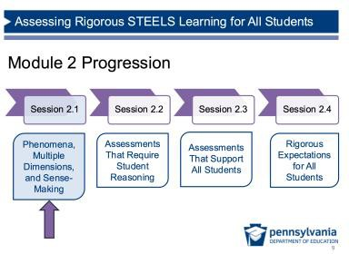 | Purpose of This Session: Participants reflect on or develop their visions of meaningful STEELS teaching and learning.  Facilitation Step (<1 min):  Transition to Session 2.1

Slides | Content
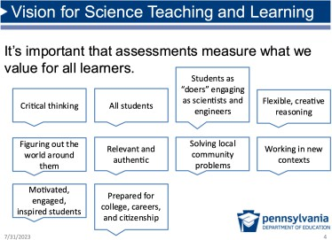 | Facilitation Step (2–5 min):  - If your group has just completed Module 1 (2 min), remind the participants about the Vision conversation in Session 1.1. Point to your chart paper artifact.  - If your group did not complete Module 1.1 (or if it’s  been some time between modules) (5 min), have them think about their ideal vision for STEELS education, turn and talk with a partner, and discuss what on the screen most resonates with them, why, and what else they’d add/change.  Transition:  Share that we are continuing to work to build a shared understanding of assessments that support this vision we developed together.
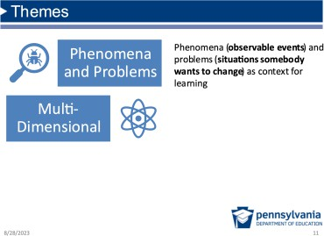 | Facilitation Step (1 min):  Note: This slide is animated, and the definition will appear after an additional click.  - If participants have completed Module 1.1, refer to these themes that were surfaced during the three task comparison activity related to phenomena and multiple dimensions.  - Tell participants that we’re going to dig into these themes now, but first we’ll share some working definitions. Click to make definition appear.  - If participants have not completed Module 1.1 (5 min), don’t click to reveal the definition right away.  - Individual reflection: Start by having participants read the definitions of these two items.  - Partner conversation: Ask participants to discuss with a partner to describe these terms in their own words.  - Whole group: Hear a few answers, then share definitions (connecting them to the answers discussed).

Slides | Content
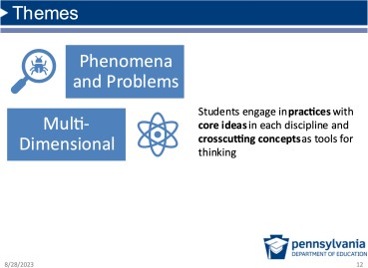 | Facilitation Step (1 min):  - This slide shares the definition of multi-dimensional learning.  - Participants have already done a lot of thinking about each of these two things (whether as pre-requisite  learning for this module or through Module 1 activities).  Possible Transition Narrative:  We’re now going to think about the relationship between them more deeply, and we’re going to add a third component.
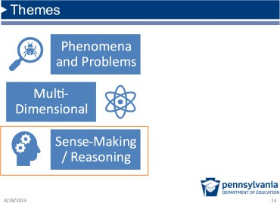 | Facilitation Step (1 min):  - Ask participants to raise their hands if they’ve heard the term “sense-making” in relation to the new STEELS standards.  - Let participants know they are going to have some time to make sense of what exactly is meant by sense-making, and they will begin by sharing their initial ideas about this concept.

Initial Models (40 minutes)

Slides | Content
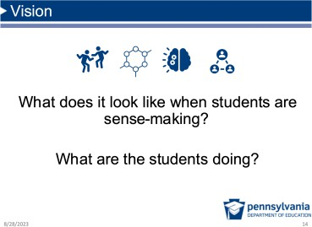 | Vision (10 min)  Purpose of This Section: Participants deepen their understanding of the relationship between  phenomenon/problem-based tasks, sense-making, and their interdependency in assessment by developing individual models.  Facilitation Step:  - Individual: Give participants a few minutes to journal their response to the question: “What does it look like when students are sense-making?”

Slides | Content
- Shoulder Partner: Give them time to compare ideas with a shoulder partner.
- Whole Group: Have a few people share whole group.
Possible Responses:
- Students are talking and collaborating, building on each other’s ideas.
- Students feel free to share their thoughts without worrying about being “penalized” for getting something wrong (because they’re figuring something out).
- Students are revising ideas when they get new information or figure something out.
- Students are bringing in their prior knowledge and experiences because what they’re learning in class is connected to their own world.
- Students are writing, developing, and revising models.
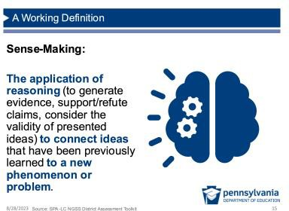 | Facilitation Step (1 min):  - Share the working definition that we can use to think about sense-making.  - Connect the working definition to ideas just shared by the group, highlighting any similarities or differences.  Possible Transition Narrative:  - Now that we have an idea about what sense-making is, we’re going to think about how this concept of sense- making relates to some other important concepts  introduced in Module 1 (if you participated in Module 1).  - We’re going to ask you to use models to share how you’re thinking about the relationship between these important concepts.

Slides | Content
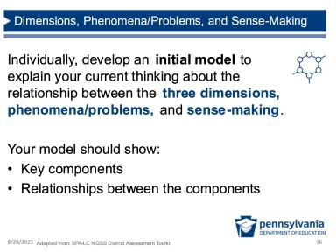 | Facilitation Step (5 min):  Have participants get out their notebooks or pass out blank pieces of paper.  - Individual work time: Direct participants to individually  create an initial model that explains current thinking  about the relationship between the multiple dimensions, phenomena/problems, and sense-making.  - Purpose of initial model: Emphasize that this is a safe space to get initial ideas out, share in small groups, and revise them individually, so there is no chart paper  consensus model or whole group share out at this point. Making this purpose clear may help those who are feeling “stuck” — there are no wrong answers here.  - Get creative: Emphasize any type of model is ok as long as it includes the key components and relationships between the components. Some people are more  comfortable with words or drawings, and that’s ok.
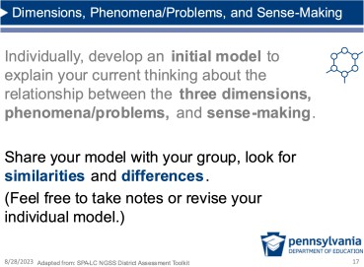 | Facilitation Step (10 min):  - Have participants share their models with their small groups (~3 people) and look for similarities and  differences.  - Let them know they’re free to revise their individual models or add notes.  Formative Assessment: This is a good opportunity to walk around and formatively assess participants’ current ideas about the relationship between  multiple dimensions, phenomena/problems, and sense- making. This may help determine some areas to address during the full group debrief.  Sense-Making: This is an important sense-making moment for participants as they are thinking about how the components of the model depend on each  other.

Slides | Content
Share Out (5 min):
Invite a couple of individuals to share one way their thinking changed after looking at other models.
Facilitation Note:
As a reminder, participants are not developing consensus models on chart paper at this point. At the end of this
module, they will create revised, consensus models based on their new understanding.
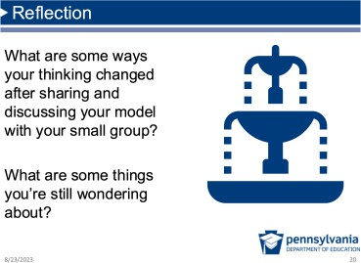 | Reflection and Brief Share Out (5 min)  Facilitation Step:  - Provide an opportunity for an individual reflection following the small group conversations.  - Ask one or two people to share out.
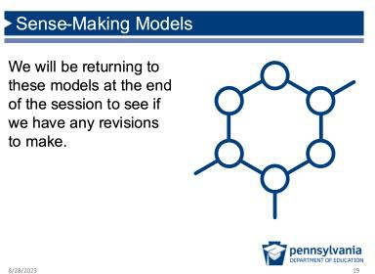 | Facilitation Step (1 min):  - Note that we will be returning to these models at the end of the session and working with colleagues to revise.  - To help prepare for that, say that participants may want to take notes throughout the day if they have ideas related to their model.  Possible Transition Narrative:  (If not using the next hidden slide)  Now that we’ve gotten some ideas about what sense-making is, we’re going to answer the question: So how do we assess a student’s ability to do this?

Slides | Content
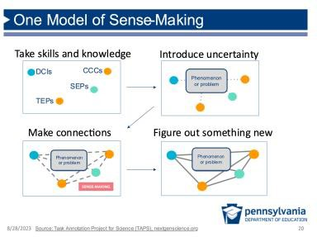 | Hidden Slide  Facilitation Step (2 min):  - This slide is hidden as it might distract from the models your participants just created. But, if you decide this would be helpful to share, this is just one model of sense- making (rather than the “right” answer).  - Describe model (see sample narrative below, plus additional explanation in the linked resource below).  - Provide a moment to have participants review the model. Connect its features with the conversation the group just had.  Possible Narrative:  - If we start in the upper left corner, you’ll see these dots represent a bunch of individual, disconnected skills and knowledge.  - If we introduce uncertainty, a phenomenon or problem for students to start wondering about, this provides an opportunity for students to start making useful connections between skills and content.  - This action when students actively use these dimensions together to explain that uncertainty or solve those problems, which is sense-making.  Possible Transition Narrative:  Now that we’ve gotten some ideas about what sense-making is, we’re going to answer the question: So how do we assess a student’s ability to do this?  Resource: See page two of this Task Annotation Project in Science (TAPS) resource about sense- making in assessments for more details about this  model.

Session 2.2: Assessments That Require Student Reasoning (45 minutes)
Where we are going in this session:
Participants deepen their understanding of how an assessment can elicit students’ ability to use multiple dimensions to make sense of something and that the presence of a phenomenon or problem does not guarantee student use of reasoning.
Where we are NOT going in this session:
The purpose of this session is not for participants to engage in a task that they can necessarily repeat in their classrooms or school, but rather to engage in a common experience as learners to elicit the
features of sense-making.
Reasoning (40 minutes)

Slides | Content
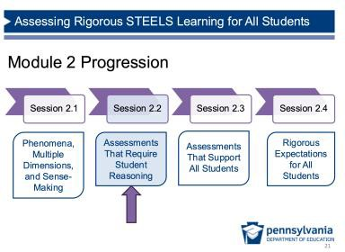 | Facilitation Step (<1 min):  Introduce Session 2.2, in which we will develop a common understanding of assessments that require student reasoning using multiple dimensions.
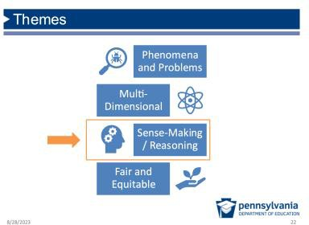 | Facilitation Step (<1 min):  - Refer back to the features of quality assessments and  direct participants to the third feature: how assessments can measure student sense-making and reasoning.  - Note that equity is now added back in this list from Module 1. If your participants did not participate in Module 1, explain that fair and equitable is an essential feature we’ll be digging into today as well.
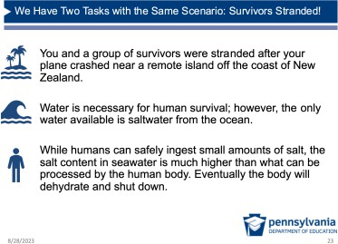 | Purpose of This Section: Participants experience the phenomenon of a task.  Facilitation Step (1 min):  Introduce the scenario of the task that participants will be analyzing shortly.

Slides | Content
Possible Narrative:
(If participants have completed Module 1)
- In Module 1, we analyzed one small excerpt from this task.
- You may remember that the Survivors Stranded video showed how a survival expert used plastic water bottles to desalinate sea water.
- We’re now going to analyze two versions of the task that use that same scenario.
Possible Narrative:
(If participants have NOT completed Module 1)
- To develop a common understanding of what sense- making looks like in STEELS assessments, we will be analyzing a task called Survivors Stranded.
- We will analyze two versions of the task with the same scenario/phenomenon.
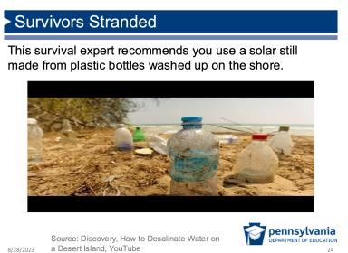 | Video (2 min)  Survivors Stranded video (1 min 34 sec): https://www.youtube.com/watch?v=rUET3PnPZng&feature= youtu.be  Facilitation Step:  - If participants have completed Module 1 recently, skip the video.  - If participants have NOT completed Module 1, play the scenario video for the Survivors Stranded task.
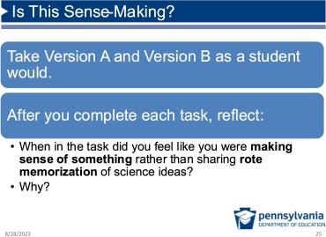 | Prep: Pass out Version A and Version B of the Survivors Stranded Task for each participant.  Purpose of This Section: Participants determine features of tasks that elicit use of multiple dimensions to make sense of the phenomenon by comparing two versions of a task that use the same phenomenon.  Participants Complete and Analyze Their Task Responses (22 min)

Slides | Content
Facilitation Step:
- Take tasks. Direct participants to individually take Version A and Version B (7 min/task).
- After taking each task, direct participants to reflect on each task) using the following prompt (8 min):
  - When did you feel like you were making sense of something rather than sharing rote memorization of science ideas? Why?
- Participants should be ready to share their analysis with their group.
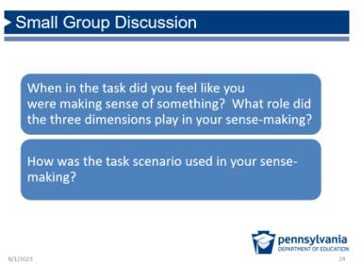 | Small Group Discussion (5 min)  Facilitation Step:  Share the two questions on the screen and ask participants to discuss them in small groups.  Formative Assessment: This is a good opportunity to walk around and formatively assess participants’ current ideas about sense-making. Listen for the  ideas that show both (1) the integrated use of multiple  dimensions and (2) the frequent use of information from the scenario which is more likely to be associated with sense- making.  Sense-Making: This is an important sense-making moment for participants as they are thinking about how two tasks with the same phenomenon elicit  different levels of sense-making. This indicates there are additional components necessary for sense-making beyond a phenomenon.

Slides | Content
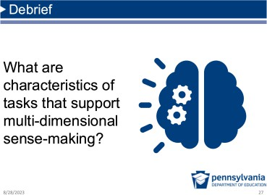 | Prep: One piece of chart paper titled, “Sense-Making,” posted at the front of the room for the whole group discussion  Whole Group Debrief (8 min) Facilitation Step:  - Identify characteristics of sense-making: Ask participants to use their analysis of Versions A and B of the Survivors Stranded task to describe characteristics of tasks that support sense-making.  - Share out: Invite at least one participant from each group to share. Encourage participants to build on one  another’s ideas.  Possible Participant Responses:  - The phenomenon or problem from the task scenario drives the task and scenario information is required to answer the questions.  - Students are making sense of a new phenomenon/problem (not one they’ve seen or figured out before) (e.g., connecting and transferring ideas to a  new solar still design at the end to try to figure that out).  - Students use multiple dimensions (SEPs, DCIs, CCCs, TEPs) together to successfully explain the  phenomenon/problem. (Note: The purpose here is not to start trying to identify specific targeted dimensions at this point.)  - Students are explaining; the task cannot be completed with a single word response.  - Students are not memorizing and regurgitating rote knowledge.

Slides | Content
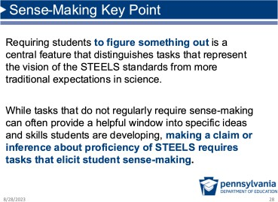 | Facilitation Step (<1 min):  Ask one to two participants to read the key points on sense- making aloud.  FAQ Facilitation Note:  At this point, one or more participants may ask questions  similar to the following. Possible talking points are provided.  “But will the state test prioritize this?”  - There will be some scenario-based items on the state test, and we need to prepare students for those. All items will be multi-dimensional.  - Phenomenon-based instruction leads to deeper learning with students more likely to retain information, be  engaged, and motivated. This will better prepare them for even the items that are not scenario-based.  - With this in mind, we need to rethink some of the  traditional ways we’ve “prepared” students for the state test. Memorizing science facts will no longer be sufficient.

Connect to Context (5 minutes)

Slides | Content
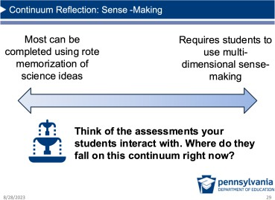 | Connect Learning to Context (5 min)  Possible Narrative:  - Now that we have a common understanding of what scenario-driven multi-dimensional sense-making looks like, think about the current assessments your students interact with, including various types of assessment.  - Where do your current assessments fall on the sense- making continuum? Take a moment to reflect.  Facilitation Step:  Invite a few participants to share out their reflections.

Session 2.3: Assessments That Support All Students (1 hours, 10 min)
Where we are going in this session:
Participants consider the perspective of students who may feel left out of science and engineering fields and deepen their understanding of what equity means for multi-dimensional STEELS-based assessments.
Where we are NOT going in this session:
The focus of this session is not about equitable features that would be provided to a smaller student subgroup (e.g., emerging multilingual learners); but rather, these features should be available for all students to benefit from more accessible assessments of STEELS learning goals.
All Students (25 minutes)

Slides | Content
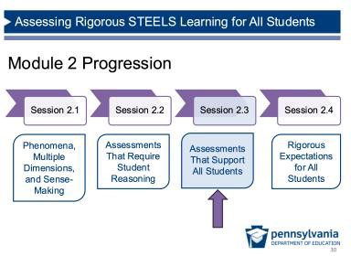 | Facilitation Step (<1 min):  Transition to Session 2.3 where we will focus on assessments that support all students to meet our vision for science  learning and performance.
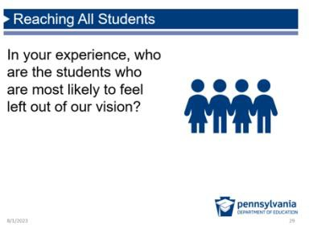 | Facilitation Step (8 min):  - Have participants consider the prompt: What kind of kids are often left out of STEELS? (Refer to the Vision discussed in Session 2.1.)  - Provide participants with a couple of minutes to journal (3 min) individually before discussing as a small table group (4 min).  - Let participants know you will consider how high-quality STEELS learning experiences can play a role in helping all students see themselves in the content.  Possible Transition Narration:  We’re now going to use a Gallery Walk activity to think about how the design of learning experiences can ensure that all students are connected to science and engineering.

Slides | Content
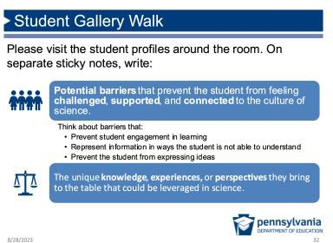 | Prep: Print one copy of each of the Student Profiles. Tape the profiles around the room. Provide all participants with a small stack of at least two colors of sticky notes.  Gallery Walk Total Time: 17 min  Facilitation Step (1 min):  - Introduce the Task: Share a few details about the student profiles that are posted around the room, using the  details on the slide.  Guide participants to do the following:  - Gallery Walk to add stickies (7 min): Participants will take a [yellow] and a [blue] stack of sticky notes. Walk around the room, read through student profiles, and on the  yellow sticky notes add potential barriers that prevent the student from feeling challenged, supported, and connected to the culture of STEELS. On the blue sticky  note, share knowledge, experience, or perspective that students might bring to the table.  - Gallery Walk to read stickies (5 min): Give participants time to walk around and read other comments on the profiles.  - Share out whole group (4 min): Ask participants to share a trend they noticed or something that surprised them.
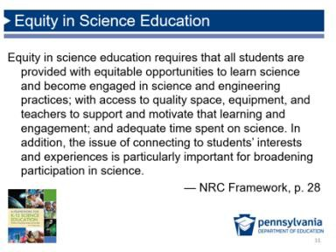 | Facilitation Step (<1 min):  Give participants a moment to read this quote from A  Framework for K–12 Science Education about equity or invite a participant to read aloud.  Ask participants to think about which phrases or words stand out to them.

Slides | Content
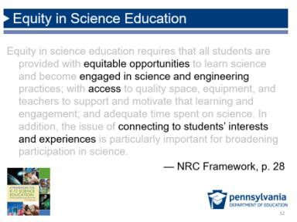 | Possible Narration (<1 min):  These are some key words I noticed. We’re seeking to engage students and give them access to rigorous STEELS experiences while letting them know STEELS is for them by connecting to  their interests. So how do we do that?
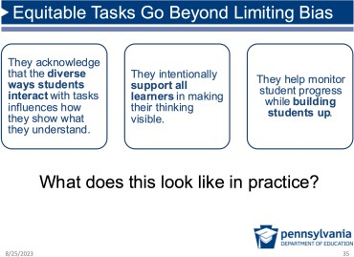 | Possible Transition Narration (<1 min):  What this emphasizes is that equitable tasks are not just concerned with being “non-biased,” but also connecting to student interest and identity, builds student confidence and provides every student with ways of showing what they know and can do.

Equitable Features (40 minutes)

Slides | Content
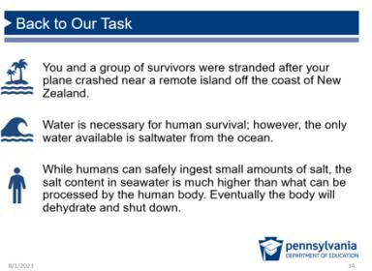 | Facilitation Step (<1 min):  Let participants know we’re returning to the Survivors  Stranded task example from the previous session in order to identify features that can support all students to make their thinking visible on an assessment.

Slides | Content
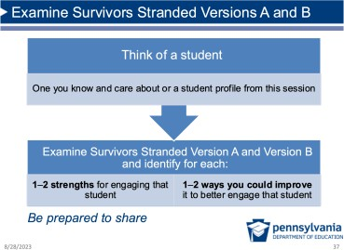 | Prep: One piece of chart paper titled, “Equitable Features,” posted at the front of the room for the whole group discussion.  Facilitation Step (11 min)  - Think of a Student (1 min): Have participants first think of a student they know and care about (or a student profile).  - Individual Version A and Version B (10 min): Have  participants read through Version A and Version B again (~5 min per task), recording ideas on a sticky note or journal about what supports/features would help their focus student to show what they know.  Sense-Making: This is an important sense-making moment for participants as they are thinking about what features, beyond phenomena and problems,  make tasks fairer and more accessible for students.
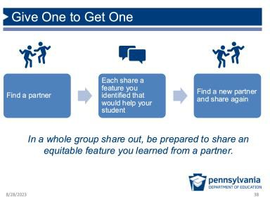 | Facilitation Step:  - Introduce “Give One to Get One” (7 min):  - Have participants take their journal or sticky notes and find a partner in the room.  - Each share a feature you identified that would help the student they’re thinking of.  - Have them find a new partner and share again.  - Whole group share out (7 min):  - Call on participants to share a feature that they heard from a partner.  - Chart responses on “Equitable Features” chart paper.  Anticipated participant responses (these are listed on the following slide)  An Equitable Task has:  - Scaffolds (e.g., model checklist, word bank, sentence starters) to support students to show what they know relative to grade-level assessment targets, not lowered expectations.

Slides | Content
- Real world relevance: Find ways for students to make connections to their experiences or something they care about.
- Multiple ways for students to respond to the task and show what they know (text, develop models, verbally).
- Multiple ways for students to receive information they need to complete the task.
- Clarity: The task is concise and coherent with easy-to- understand words.
- Builds student confidence with science and engineering by allowing students to show what they do know (rather than limited right/wrong answer options) and make choices.
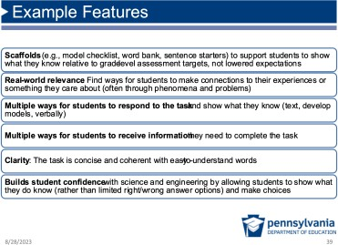 | Possible Narration (<1 min):  - Here are some ideas from previous groups who have completed this activity.  - I can see a lot of connections between what you’ve just shared and this list.  Resource:  This TAPS resource provides a deeper discussion on equitable assessment features here.
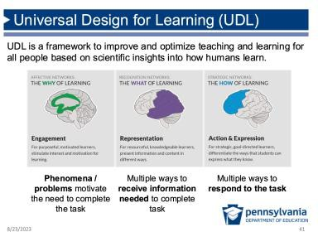 | Hidden Slide  Facilitation Step:  - This slide is hidden to minimize the amount of information given to participants in an already long session, but you may choose to use it if participants are already familiar with and use UDL.  - The slide outlines connections to equitable task features on the previous slide to the main categories of the UDL framework.  Resource: Learn more about the CAST Universal Design for Learning Guidelines here.

Slides | Content
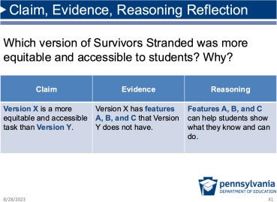 | Facilitation Step (15 min):  - Introduce Reflection: Now that we’ve heard each other’s ideas about equitable features, take a moment to reflect on which task version has more equitable features and why.  - Claim, Evidence, Reasoning:  - Individually (5 min), write down a Claim,  Evidence, and Reasoning in your notebooks about which task is more equitable.  - In partners (5 min), share your ideas.  - Whole group share out (5 min)  Possible Responses:  Version B will likely be identified as the more equitable or accessible task due to the following features:  - Coherent;  - Engaging/motivating because kids were really making sense of phenomenon;  - Included scaffolds and guidance;  - Allowed for multiple modes of responses; and  - Allowed students to show a range of student thinking and build confidence to show what they do know (not just  right/wrong answers).  Version A Equitable Features:  - Shorter; and  - May be good for students who are good at memorizing and providing right/wrong answers.  Sense-Making: This is an important conversation because (1) it connects abstract ideas to concrete  features in a real task example and (2) it connects to the rigor conversation in the next section, where we will have a parallel conversation and connect back to this one.  Formative Assessment: As you walk around and hear partner conversations, listen for those who may be focused on just one feature of equity (e.g.,  length) and who may need pushing to consider other

Slides | Content
 | features discussed. This could be helpful to address in the full group debrief, referring to either your chart paper list or the “Example Features” slide.

Connect to Context (5 minutes)

Slides | Content
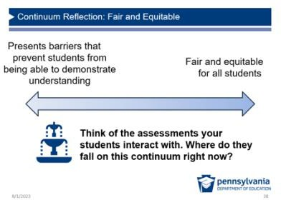 | Purpose of This Section: Participants consider the extent to which equitable features are reflected in their current STEELS programs.  Possible Narrative (3 min):  - Now that we have an improved understanding of what equity looks like, think about the current assessments your students interact with, including various types of assessment.  - Where do your current assessments fall on this continuum? Take a moment to reflect.  Facilitation Step:  Ask for a few to share out if they’re willing.
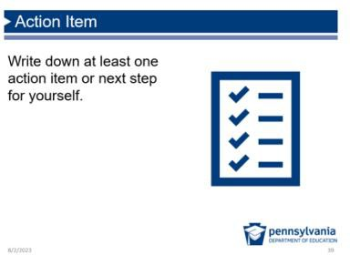 | Facilitation Step (2 min):  Encourage people to write down at least one action item or next step for themselves after the reflection.

Session 2.4: Assessments That Support All Students Rigorous Expectations for All Students (1 hour, 30 minutes)
Where we are going in this session:
Participants deepen their understanding of the task design features that support rigorous expectations for all students and are introduced to a new framework to measure rigor. The following describes the flow of learning from 2.3 to 2.4:
- In 2.3, participants realize Version B is more equitable because it is more coherent, more engaging/motivating because kids were really making sense of phenomenon, included scaffolds and guidance, allowed for multiple modes of responses, and allowed students to show a range of student thinking and build confidence to show what they do know (not just right/wrong answers).
- In 2.4, reflect on the fact that some use Webb’s DOK levels to support struggling students by moving their expectations down to Level 1 (recall, memorizing).
- In 2.4, realize Version B is more rigorous.
- If Version B is both more rigorous and equitable, participants see features that make STEELS-based assessments more rigorous and equitable and how this approach may be different than previous practices. In some cases, educators may have made work less rigorous for struggling students (Level 1 DOK questions); however, this approach is problematic because it limits students’ opportunity to learn, which is inequitable; rather, we should provide scaffolding that allows students to access more rigorous tasks.
- The need: We need a new framework for defining rigor for STEELS-based assessments. The framework presented in 2.4 isn’t framed as the only way, just one alternative way to think about DOK/rigor besides Webb’s.

Where we are NOT going in this session:
The point is not to focus on critiquing certain frameworks for measuring rigor, but rather to help participants consider how rigor with multi-dimensional assessments can be evaluated and introduce them to new frameworks to describe rigor.
Rigor (55 minutes)

Slides | Content
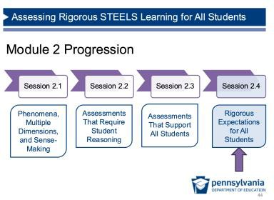 | Facilitation Step (<1 min):  Transition to Session 2.4 where we will focus on rigor of assessments.

Slides | Content
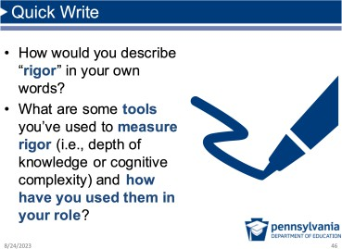 | Facilitation Step (2 min):  - Note that we’ve been digging into what the shift to multi- dimensional standards means for equity, and now we’re going to take a moment to see how this relates to rigor.  - Invite participants to start with a “Quick Write” reflection about rigor.  - The purpose of this quick write is to get people thinking about rigor and how they’ve used measurement tools.
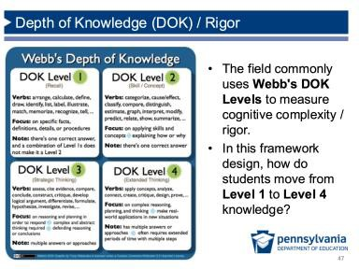 | Facilitator Step (4 min):  - Read: Provide a moment for participants to review the Webb’s DOK Levels and associated verbs.  - Quick Reflection: In this framework, how are students expected to move from Level 1 to Level 4 knowledge?  - Share Out:  Possible answers:  - In this framework, students master Level 1 before you can tackle Level 2, and so on.  - Some strategies have suggested lowering the Webb DOK Level for struggling students so they can complete tasks, but we’re going to re-examine that idea today.  Possible Transition Narrative:  To think a little bit more about how students can complete increasingly complex tasks, let’s return back to Survivors Stranded Version B.
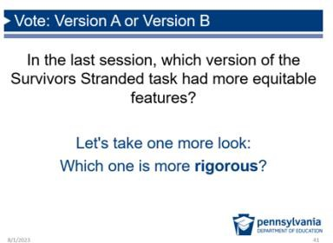 | Prep: One piece of chart paper titled, “Rigor/DOK,” posted at the front of the room for the whole group discussion.  Possible Narrative:  - Let’s revisit our Survivors Stranded conversation from the last section. Which did we determine had more equitable features? [Quick answer from group: Version B]  - We’ve established that Version B was more equitable. Now, let’s think about which one is more rigorous.

Slides | Content
Facilitation Step (15 min):
- Revisit Survivors Stranded (3 min): Encourage
participants to take just a couple minutes to look at the tasks and determine which is more rigorous. This is not an in-depth review using Webb’s — just a quick assessment of their impressions to surface participants’ own definitions of “rigor.”
- Shoulder Partner (4 min): Have participants discuss their review in partners.
- Debrief (8 min): Ask participants to share out which they think is more rigorous and why. Facilitator should chart these answers. [Answer: most will say Version B is more rigorous and asks students to complete higher-level thinking questions]

Elicit specific rationales for the rigor of Version B, such as:
- Version A includes more recall and rote knowledge.
- Version B has less rote knowledge and asks students to develop arguments and apply concepts to explain, especially in the last prompt where there is a new situation (new solar still design).
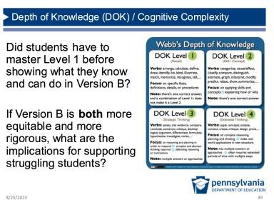 | Facilitation Step (5 min):  - Individual Reflection: Ask participants to reflect on the questions on the screen individually.  - Shoulder Partner: Discuss answers with shoulder partners again.  - Share Out: Ideas to highlight include:  - Students did not necessarily need to master “Level 1” style things like definitions before showing what they knew.  - The way to support a struggling student is NOT to decrease the rigor; rather, it is to improve  scaffolds and other equitable features to give students the opportunity to show what they know and can do relative to grade-appropriate content.

Slides | Content
Sense-Making: This conversation is an important sense-making moment for participants as it is intended to drive home an important point: we can
and should have both rigorous and equitable tasks. If people seem to be struggling or talking about specific barriers, add a shoulder partner talk to give people time to talk and build on each other’s ideas.
Facilitator FAQ:
You may receive a question like, “Don’t we have to memorize
stuff first in order to apply it and use it for sense-making?”
Possible talking points include:
- It might be helpful to consider the difference between memorizing and learning.
- Research shows learning is more likely to “stick” when activities are focused on figuring out something meaningful rather than rote memorization. This approach requires students to apply science ideas and come to understand them deeply, but it doesn’t mean they need to know everything BEFORE they start.
- Research also shows vocabulary is best introduced to students after they have learned the concept behind the vocabulary, so frontloading vocabulary before digging into the content is no longer recommended practice.
Possible Transition Narrative:
- Because of this issue that the Webb’s DOK levels may be less useful for how we are engaging and assessing students, the field has developed other ways to think about and evaluate Depth of Knowledge, or cognitive complexity in multi-dimensional science assessments.
- I want to share one other tool for measuring cognitive complexity in science assessments with you now that is based on sense-making.

Slides | Content
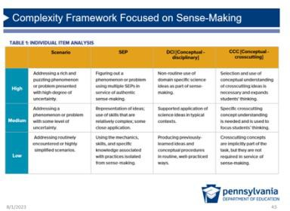 | Prep: Pass out Cognitive Complexity Framework one-pager.  Facilitation Step:  - Read one-pager (4 min): This Cognitive Complexity  Framework based on sense-making was developed by Achieve in 2019 with today’s science standards in mind. Take a moment to read through this table to familiarize yourself.  - Just one approach: Emphasize that is not the only way to measure rigor in STEELS-based assessments, but it is just one approach to consider.  - Connect to earlier conversation. Ask participants to make connections between this one-pager and the debrief  chart about rigor/DOK.  Resource: See A Framework to Evaluate Cognitive Complexity in Science Assessments here.
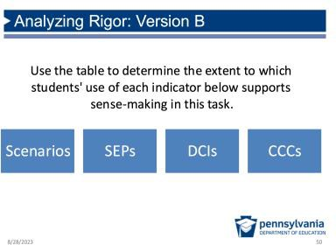 | Facilitation Step:  - Purpose of This Task: Participants will have an opportunity to practice using the Cognitive Complexity tool, in order to think about how it might be used to  evaluate if a STEELS-based task is rigorous.  - Revisit Survivors Stranded Version B (10 min): Let participants know to find a partner and go through  Version B and make a determination for each of the four indicators and whether they’re high, medium, or low complexity for each according to a brief review with this table.  - Debrief (10 min):  - Ask participants to share out their analysis for  each of the four indicators: scenarios, SEPs, DCIs, and CCCs. Where does each fall on the table and why?  - Is this new framework helpful for you? Why or why not?

Slides | Content
Facilitation Note:
To really determine the sophistication and grade- appropriateness of the DCI, SEP, and CCC in a task requires more in-depth analysis than this preliminary review. This
analysis is used to help participants consider the role of three dimensions in supporting sense-making.
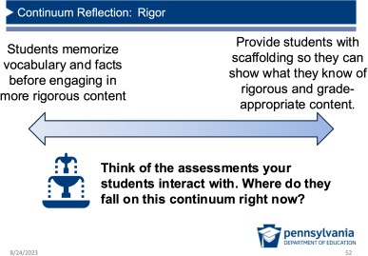 | Purpose: Participants consider the extent to which all students have access to rigorous STEELS expectations.  Possible Narrative (3 min):  - Now that we have an improved understanding of what access to rigor looks like, think about the current  assessments your students interact with, including various types of assessment.  - Where do your current assessments fall on this continuum? Take a moment to reflect.  Facilitation Step:  Ask for a few participants to share out if they’re willing.

Revise Models (25 minutes)

Slides | Content
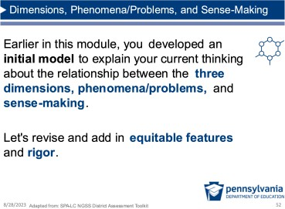 | Prep: Pass out one piece of chart paper per small group.  Purpose of This Section: Participants will revise their model describing the relationship between phenomena, three  dimensions, and sense-making to include equity and rigor/DOK.  Facilitation Step (2 min):  - Introduce model revision task: Previously, participants individually developed an initial model then compared with their colleagues.

Slides | Content
 | - Describe new components: Let them know we’re now going to revise and develop a consensus model to show the relationship between the three dimensions, phenomena/problems, sense-making, equitable features, and rigor.
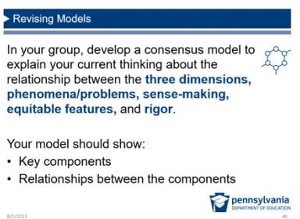 | Prep: Assign participants to small groups different than previous activities.  Model Revision (22 min):  - Individual think time (5 min): Provide some time for participants to think and take notes about (1) how they  might revise their initial models from the beginning of the session, and (2) how they might incorporate the two new components. Participants don’t need to begin revising  their individual models at this point because they will be discussing their ideas and developing new models in small groups.  - Arrange participants into new small groups (3 min) of ~3 people, bringing their individual models from earlier in the day.  - Work time (10 min): Provide work time to develop a new model in small groups.  - Gallery Walk (4 min): At the end, have participants walk around and observe other groups’ models, noting trends and differences.  Sense-Making: Revising models is a powerful activity to articulate and make sense of the learning  experiences from this module. There is no wrong answer here, and hopefully thinking about the relationship between these components strengthens overall  understanding of them individually as well as what it will take to make them a reality in Pennsylvania classrooms.

Connect to Context and Reflect (10 minutes)

Slides | Content
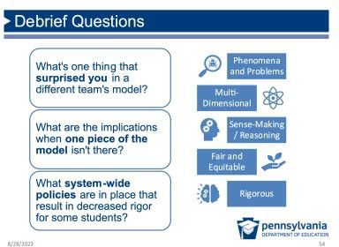 | Model Revision Debrief (5 min):  - Following the Gallery Walk, have a group discussion with the questions on the slide.  - Discussion points may include:  - All components are related and support and depend on each other.  - When one piece of the model isn’t there, the model does not work (e.g., you can’t truly assess multiple dimensions without phenomena or problems present).  - Many system-wide policies may be raised that  decrease rigor for some students: pulling students out of science block; not giving teachers adequate support or resources for students who need it; or not having enough instructional time for science. Sometimes acknowledging inequitable practices, even if they are not in one’s control, can be a first step toward improving systems. Participants may be motivated to write down one action item for themselves.
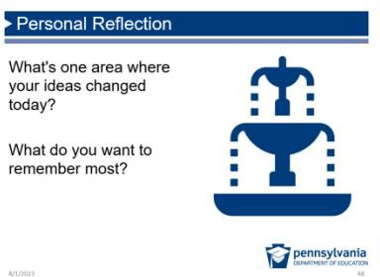 | Facilitation Step (3 min):  - Move from whole group debrief to personal reflection time.  - Ask if anybody is comfortable sharing out their reflection.

Slides | Content
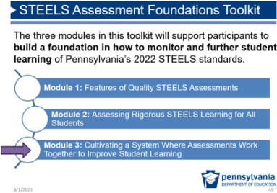 | Possible Narration:  This marks the end of Module 2. Next is a focus on cultivating a system where assessments work together to improve student learning.

Reflection and Closing (10 minutes)

Slides | Content
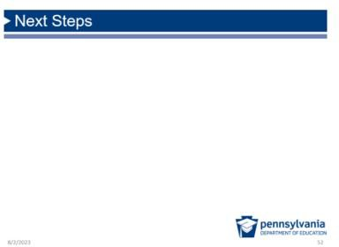 | Facilitation Step:  Share any next steps with the group.
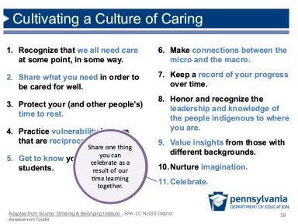 | Facilitation Step:  - Come back to the Culture of Caring list.  - Ask participants to consider one thing they can celebrate as a result of our learning together.  - Share something you as a facilitator want to celebrate about the participants’ work together throughout the learning experience.

Slides | Content
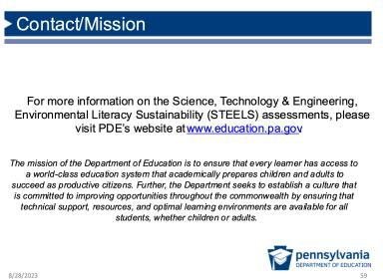

Module 2 Evaluation Sample Questions

How important was each activity in deepening your understanding of the features of high- quality assessments? (Not Important, Somewhat Important, Important, Very Important, N/A)
- Creating and revising models about the relationship between sense-making, multi- dimensions, phenomena, equity, and rigor.
- Comparing tasks to define what sense-making looks like in assessments.
- Analyzing tasks for equitable features and considering how these features could support students to make their thinking visible.
- Analyzing tasks to identify examples of features that make them rigorous.
- Reading, applying, and discussing a cognitive complexity/rigor framework based on sense-making.
- Reflecting and making connections between new learning about assessment and my own context.

How important was this activity in helping you connect and apply the learning to your own context? (Not Important, Somewhat Important, Important, Very Important, N/A)
- Creating and revising models about the relationship between sense-making, multi- dimensions, phenomena, equity, and rigor.
- Comparing tasks to define what sense-making looks like in assessments.
- Analyzing tasks for equitable features and considering how these features could support students to make their thinking visible.
- Analyzing tasks to identify examples of features that make them rigorous.
- Reading, applying, and discussing a cognitive complexity/rigor framework based on sense-making.
- Reflecting and making connections between new learning about assessment and my own context.

The timing of this activity was (Too long, about right, too short, N/A)
- Creating and revising models about the relationship between sense-making, multi- dimensions, phenomena, equity, and rigor.
- Comparing tasks to define what sense-making looks like in assessments.
- Analyzing tasks for equitable features and considering how these features could support students to make their thinking visible.
- Analyzing tasks to identify examples of features that make them rigorous.
- Reading, applying, and discussing a cognitive complexity/rigor framework based on sense-making.
- Reflecting and making connections between new learning about assessment and my own context.

Thinking about the module overall, how well do you think the module prepared you to do the following? (Not at all, slightly well, somewhat well, extremely well, N/A)
- Explain what sense-making is in my own words and why it is a key feature of high-quality science assessments.
- Describe the relationship between sense-making, phenomena, and multiple dimensions.
- Describe effective ways to examine rigor/DOK in quality science tasks.
- Identify concrete ways to ensure all students are challenged, supported, and connected to the culture of STEELS.
- Analyze a STEELS task to determine the extent to which it supports student sense- making.
How, if at all, will you use the knowledge or skills gained from this module in your work? [Open Ended]

What questions do you have after completing this module? [Open Ended] Is there any additional feedback you’d like to provide? [Open Ended]

