MLA paper set up using google docs

Step 1

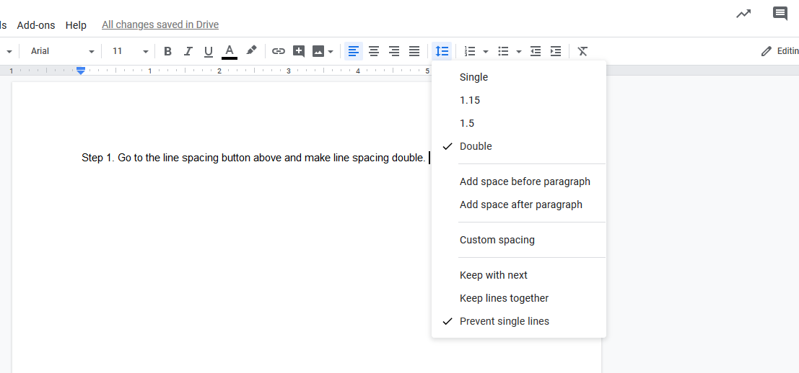

Step 2

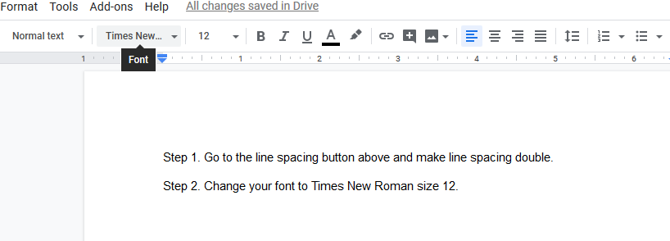

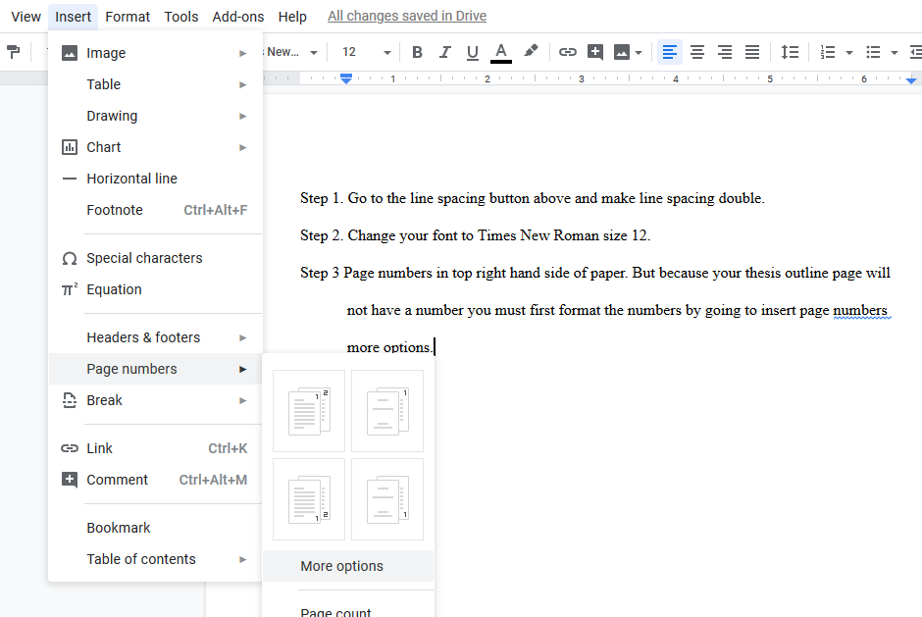

Step 3

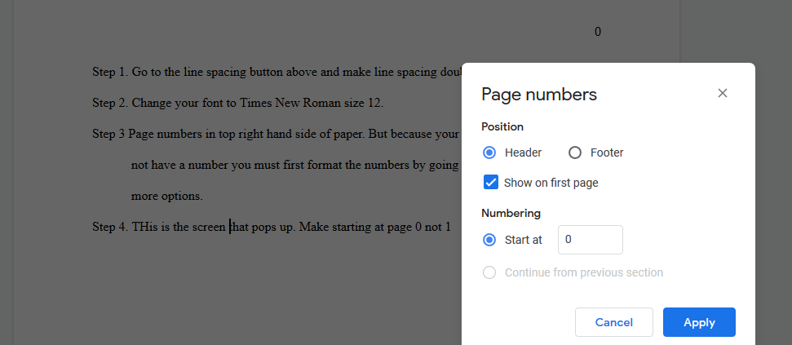

Step 4

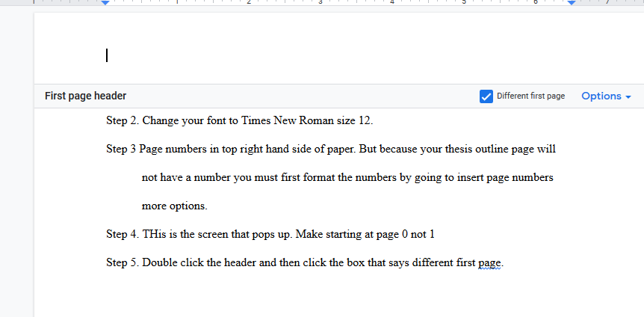

Step 5

Step 6

 Type your thesis statement and outline on the first page. NO NAME

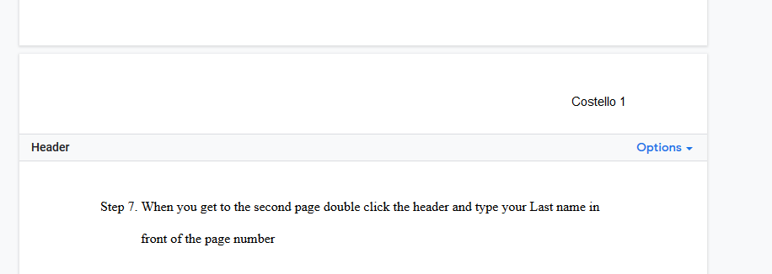

Step 8

Step 7

Type your paper being sure to include documentation

Step 9

Last page and separate page is your works cited.