Spy Poisoning

Agent Z was a spy who began working for the British government as a double agent. He was discovered speaking ill of his previous boss and within a month he was dead from Polonium-210 poisoning. How were they able to poison him with a heavy, radioactive element, and why did it kill him? Use the articles below and respond to the prompts to investigate.

Excerpt from Article 1

Agent Z: Profile of Murdered Spy

A public inquiry into the killing of former spy “Agent Z” has concluded that his old boss approved his assassination. But who was he and why did his death cause such controversy?
Agent Z was killed in November 2004. The 43-year-old had been an officer with his country’s spy agency, but he fled to Britain where he became a fierce critic of his old boss. In his final years he also became a British citizen.
At a central London hotel on 16 November 2004, he had tea with two of his former colleagues, who were also previously spies. Agent Z fell ill soon afterwards and spent the night vomiting. Three days later he was admitted to Barnet General Hospital in north London, where his condition gradually became a cause for concern. On 26 November he was interviewed by a news agency and said he was in "very bad shape" after a "serious poisoning".

This is adapted based on a real-world example.

Excerpt from Article 2
Polonium-210 Poisoning: A First-Hand Account

Polonium-210 (210Po) gained widespread notoriety after the poisoning and subsequent death of “Agent Z” in London, UK, in 2004. Exposure to 210Po resulted initially in a clinical course that was indistinguishable from infection or exposure to chemical toxins, such as thallium.
A 43-year-old man presented to his local hospital with acute abdominal pain, diarrhea, and vomiting, and was admitted to the hospital because of dehydration and persistent gastrointestinal symptoms. He was initially diagnosed with gastroenteritis and treated with antibiotics. Clostridium difficile toxin was subsequently detected in his stools, which is when he first raised the possibility of being poisoned and revealed his background and former identity, having been admitted under a new identity with which he had been provided on being granted asylum in the UK. Within 6 days, the patient had developed thrombocytopenia and neutropenia, which was initially thought to be drug induced. By 2 weeks, in addition to bone marrow failure, he had evidence of alopecia and mucositis. Thallium poisoning was suspected and investigated but ultimately dismissed because blood levels of thallium, although raised, were lower than toxic concentrations. The patient continued to deteriorate and within 3 weeks had developed multiple organ failure requiring ventilation, hemofiltration, and cardiac support, associated with a drop in consciousness. On the 23rd day after he first became ill, he suffered a pulseless electrical activity cardiorespiratory arrest from which he could not be resuscitated and was pronounced dead.
Urine analysis using gamma-ray spectroscopy on day 22 showed a characteristic 803 keV photon emission, raising the possibility of 210Po poisoning. Results of confirmatory analysis that became available after the patient's death established the presence of 210Po at concentrations about 1,500,000,000 mBq d-1. Post-mortem tissue analyses showed autolysis and retention of 210Po at lethal doses in several organs. On the basis of the measured amounts and tissue distribution of 210Po, it was estimated that the patient had ingested several 1000 million becquerels (a few GBq), probably as a soluble salt (e.g., chloride), which delivered very high and fatal radiation doses over a period of a few days.
Early symptoms of 210Po poisoning are indistinguishable from those of a wide range of chemical toxins. Hence, the diagnosis can be delayed and even missed without a high degree of suspicion. Although body surface scanning with a standard Geiger counter was unable to detect the radiation emitted by 210Po, an atypical clinical course prompted active consideration of poisoning with radioactive material, with the diagnosis ultimately being made with gamma-ray spectroscopy of a urine sample.

1. According to the articles above, Agent Z was murdered through Polonium-210 poisoning. Develop an explanation of Agent Z’s death using evidence from the articles and your knowledge of the patterns of the different types of radioactive decay. Be sure to give reasons why the other types of radioactive decay could not be responsible for his death. (You must cite direct quotes/text/data from your sources).

____________________________________________________________________________

____________________________________________________________________________

____________________________________________________________________________

____________________________________________________________________________
Learn more about Polonium-210 and its properties by reading/analyzing the information in the table provided below:
Po-210 Physical Properties | Po-210 Health Effects
Half-life = 138 days | Non-hazardous outside the body
# of protons = 84 | Dangerous via ingestion or inhaling
# of neutrons = 126 | Damages vital organs like the kidneys and liver
25 different isotopes | Cells’ DNA gets fragmented thus causing cell death
Low melting temperature
Acceptable ground/freshwater levels: 0.75 ppb or less
Acceptable human body levels: 15.5mBq d⁻¹

2. What about the human body as a system made the delivery of Polonium-210 in Agent Z’s tea, rather than it being transferred through the skin by coating the teacup handle, important for poisoning him? Use your knowledge of the patterns of radioactive decay to explain why the spy had to drink tea for this type of poisoning to work. Draw a model of the decay of polonium-210 in relation to the delivery technique (drinking tea) to explain how Polonium-210 was used to poison the spy. In your model, make sure that protons, neutrons, parent nuclide, and daughter nuclide are labeled clearly. Write an explanation of your model below your drawing or use flipgrid to explain the model you drew.
Draw model here:

____________________________________________________________________________

____________________________________________________________________________

____________________________________________________________________________

____________________________________________________________________________

____________________________________________________________________________

____________________________________________________________________________

____________________________________________________________________________

____________________________________________________________________________

3. Why was Polonium-210 used to poison Agent Z and not a different element? Francium-223 and Americium-243 are also radioactive isotopes that decay in the same way as Polonium-210. The graphs below represent the half-lives of Francium-223 and Americium-243. Sketch a graph representing the half-life of Polonium-210. Compare the three graphs to identify the pattern of radioactive decay among these isotopes and make a scientific claim as to why Polonium-210 was used instead of Francium-223 and Americium-243. Justify your claim with evidence from the graphs.
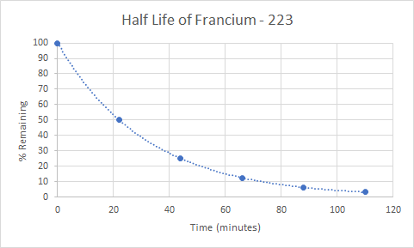

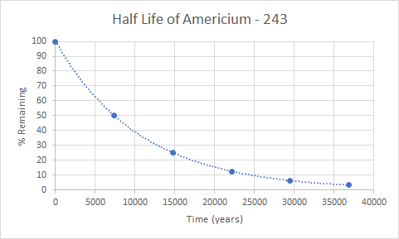

YOUR GRAPH:

YOUR RESPONSE:
____________________________________________________________________________

____________________________________________________________________________

____________________________________________________________________________

____________________________________________________________________________

____________________________________________________________________________

____________________________________________________________________________

____________________________________________________________________________

____________________________________________________________________________

____________________________________________________________________________

4. Someone dumped Polonium-210 into a freshwater lake that is used for recreational purposes such as swimming, fishing, and boating. The lake has been closed to the public due to high levels of Polonium-210 because the authorities are worried about people drinking the water while swimming or eating the fish. The current levels of Polonium-210 in the lake are 6 parts per billion. When, in number of days, will the lake be safe for recreational use again? Develop an explanation of why the lake is safe for use by analyzing evidence from the articles and the data table, as well as your graph and/or mathematical reasoning to support your claim. You must show your mathematical work to identify the pattern of half-life and cite evidence in the form of direct quotes from the text and data table provided.

____________________________________________________________________________

____________________________________________________________________________

____________________________________________________________________________

____________________________________________________________________________

____________________________________________________________________________

____________________________________________________________________________

____________________________________________________________________________

____________________________________________________________________________

____________________________________________________________________________

The following is an enrichment question:

5. At the time of his death, Agent Z had very high levels of Polonium-210 found in his body. He cannot be buried until his body is at acceptable levels and is not a threat to the freshwater supply. Using the data table for information of acceptable levels of Polonium-210 in the body, determine how long (in years and/or days) it will take for his body to reach acceptable levels to be buried. You must show your mathematical work to demonstrate the pattern of half-life.

____________________________________________________________________________

____________________________________________________________________________

____________________________________________________________________________

____________________________________________________________________________

____________________________________________________________________________

____________________________________________________________________________

____________________________________________________________________________

____________________________________________________________________________

____________________________________________________________________________

