
The Pennsylvania Science, Technology & Engineering, Environmental Literacy Sustainability (STEELS) Assessment Foundations Toolkit

Overview and Links to Resources
In 2022, Pennsylvania adopted the Science, Technology & Engineering, Environmental Literacy & Sustainability (STEELS) standards, new learning goals for K–12 students based on research of how students learn best. The three professional learning modules in the STEELS Assessment Foundations Toolkit are designed to support participants in building a foundation in how to monitor and further student learning of Pennsylvania’s STEELS standards.

This document provides descriptions and links for all three modules included in this toolkit.

Table of Contents
Overview and Links to Resources 1
Links to Modules 3
Toolkit Goals and Audience 3
Audience 3
Goals 3
Timing, Design, and Modification Considerations 4
Timing 4
Toolkit Design 4
Modification Considerations for Different Grade Band Audiences 5
Module 1 Description 6
Module 1 Goals 7
Module 2 Description 7
Module 2 Goals 8
Module 3 Description 9
Module 3 Goals 9
Professional Learning Evaluation 10

Links to Modules
Please find the folder link to the facilitation guide, slide deck, and resource folder for each of the three modules are located on the PDE SAS Portal. (Link to SAS)

Toolkit Goals and Audience

Audience
The STEELS Assessment Foundations Toolkit can be used to support learning for a variety of audiences, including district personnel such as teachers, school leaders, and curriculum specialists or educational support such as Intermediate Units, or nonformal educators with agencies or NGOs.

Goals
The three professional learning modules in the STEELS Assessment Foundations Toolkit are designed to support participants in building a foundation in how to monitor and further student learning of Pennsylvania’s STEELS standards. Each module consists of roughly one day of learning.

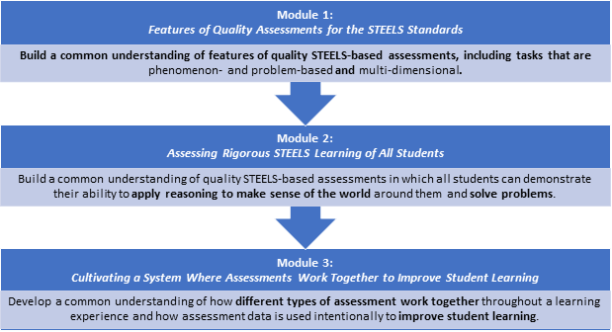

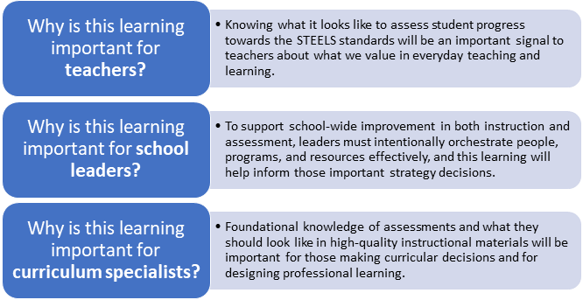

Timing, Design, and Modification Considerations

Timing
What is the total time to complete all three modules?
The modules are designed to be experienced in order, and each module is roughly one day of professional learning (~6 hours). The entire course is ~18 hours.

Toolkit Design
Based on the research of how people learn, it’s most effective to begin with participant ideas and build on these ideas. Therefore, throughout these modules, activities typically begin by surfacing participant ideas rather than providing one “right answer.” While this approach isn’t the quickest way to “get the information” to an audience, it is important for participants to grapple with the ideas and figure out key takeaways. The facilitator plays an important role in guiding conversations and helping participants build on one another’s ideas. The facilitator’s guide is designed with this in mind.

This Sense-Making Icon will appear in key moments when participants are making sense of something, indicating those conversations should not be cut or rushed. Professional learning facilitators should consider this when thinking about ways to shorten the sessions.

Modification Considerations for Different Grade Band Audiences
The three toolkit modules include examples from various grade bands, allowing learning to be most accessible to an audience of K–12 teachers. Example tasks play the role of illustrating design shifts that are applicable to all grade bands. The table below lists the grade band examples that are used for each activity along with notes for facilitators on ways they may wish to modify these activities to make them more applicable for a targeted audience of educators.

Module 1 Example Assessments
Activity | Examples Used | Modification Recommended
Task Comparison Activity (Session 1.1) | Two 6–8 tasks, one K–2 task | It is not recommended to replace the tasks in this activity. These were intentionally chosen to spark discussion and bring out the features we want elicited.
Card Sort Activity (Session 1.2) | Two versions of the card sort are provided: Grades K–5 and Grades 6–12 | Choose the card sort version that best fits your audience. If the audience spans all grades K–12, we recommend using the K–5 cards.
Gallery Walk Activity (Session 1.2) | Examples span all grade bands. | While not necessary, you may decide to limit examples to one grade band. If you make this modification, be sure to conduct an analysis to include at least some examples that do and do not show evidence of the five criteria used to spark discussion.
Evidence of Multiple Dimensions Analysis (Session 1.4) | Grade 5 example task | If completing Module 2 as well, it is recommended not to replace this task example as it is referenced in subsequent learning experiences. The takeaways from the activity can be applied to any grade band.

Module 2 Example Assessments
Activity | Examples Used | Modification Recommended
Sense-Making Analysis (Session 2.2), Equity Analysis (Session 2.3), and Rigor Analysis (Session 2.4) | Version A and Version B of Grade 5 Example Task | While the featured example tasks in Module 2 are designed for grade 5 students, the student sense-making and innovations reflected can provide helpful insights for teachers of any grade band.  It is not recommended to replace these tasks. The two versions of the task (one illustrating sense-making and one not with the same phenomenon) may be difficult and time consuming to recreate.

Module 3 Example Assessments
Activity | Examples Used | Modification Recommended
Analyzing Assessment Opportunities Across a Unit (Session 3.2) | Grade 5 Unit | It is not recommended to replace this unit. It has been vetted by a peer review panel, which identified several features this session seeks to highlight. In addition, it has science, engineering, and environment connections, representing the integrated nature of the Pennsylvania STEELS standards.

Module 1 Description
Title: Features of Quality Assessments for the Science, Technology & Engineering, Environmental Literacy Sustainability (STEELS) Standards.
Module 1 Description: In this session, participants will learn about key features of high-quality STEELS-based assessments including phenomenon- and problem-based scenarios and multi-dimensional prompts. Participants will consider the extent to which these features connect with their own vision for meaningful STEELS learning.
Timing: This session is designed to be facilitated in one day, as an approximately 5.5-hour session:
- Session 1.1: Assessments that Reflect the STEELS Vision (1 hour 55 minutes)
- Session 1.2: Phenomenon/Problem-Based Assessment Scenarios (1 hour 15 minutes)
- Session 1.3: Multi-Dimensional Assessments (1 hour 10 minutes)
- Session 1.4: Evidence of Phenomena and Multiple Dimensions (55 minutes)
These time estimates do not include introductions, icebreakers, breaks, or lunch. Professional learning facilitators should incorporate those as needed.
It may be helpful for participants to review the following as prework before engaging in the first Module:
- A Framework for K-12 Science Education
- ITEEA Standards for Technological and Engineering Literacy
- Phenomena Video
- PDE STEELS Curriculum Frameworks
- NAAEE Linking Environmental Literacy & the Next Generation Science Standards

Module 1 Goals
Session | Goal
Module 1:  Features of Quality Assessments for the STEELS Standards | Develop a common understanding of features of quality STEELS-based assessments, including tasks that are phenomenon- and problem-based and multi-dimensional.
Session 1.1  Assessments that Reflect the STEELS Vision | Participants reflect on meaningful science, technology & engineering, and environmental literacy & sustainability learning and the features of assessments that support that vision.
Session 1.2  Phenomenon/Problem-Based Assessment Scenarios | Participants deepen understandings about phenomena/problem-based learning and their role in making student learning visible and analyze features of effective phenomena/problems in tasks assessing STEELS learning.
Session 1.3  Multi-Dimensional Assessments | Participants deepen understanding of features of assessments that reveal how well students understand and can use multiple dimensions in the STEELS standards.
Session 1.4  Evidence of Phenomena and Multiple Dimensions | Participants identify evidence of phenomena and multi-dimensional learning in an example task.

Module 2 Description
Title: Assessing Rigorous STEELS Learning for All Students
Module 2 Description: In this session, participants will learn about key features of high-quality and rigorous assessments that allow all students to show what they know in STEELS.
Timing: This session is designed as a full day 4.5-hour session with the following components:
- Session 2.1 Phenomena, Multiple Dimensions, and Sense-Making (50 minutes)
- Session 2.2 Assessments That Require Student Reasoning (45 minutes)
- Session 2.3 Assessments That Support All Students (1 hour 10 minutes)
- Session 2.4 Rigorous Expectations for All Students (1 hour 30 minutes)
These time estimates do not include introductions, icebreakers, breaks, or lunch. Professional learning facilitators should incorporate those as needed.
Module 2 Prerequisite Knowledge: Participants must have prerequisite knowledge about phenomena/problems, three dimensions, and how they look in assessments. This can be accomplished by completing Module 1 in this toolkit or through other means. This session builds on that knowledge.

Module 2 Goals
Session | Goal
Module 2:  Assessing Rigorous STEELS Learning of All Students | Build a common understanding of quality STEELS-based assessments in which all students, including those who are historically underserved in the STEELS classrooms, are able to demonstrate their ability to apply reasoning to make sense of the world around them and solve problems.
Session 2.1  Phenomena, Multiple Dimensions, and Sense-Making | Participants reflect on their visions of meaningful learning and deepen their understanding of the relationship between phenomenon/problem-based tasks, sense-making, and their interdependency in assessment.
Session 2.2  Assessments That Require Student Reasoning | Participants deepen their understanding of how an assessment can elicit students’ ability to use multiple dimensions to make sense of something and that the presence of a phenomenon or problem does not guarantee reasoning.
Session 2.3  Assessments that Support All Students | Participants consider the perspective of students who may feel left out of the vision for STEELS education and deepen their understanding of the assessment features that can support all students to make their thinking visible on an assessment.
Session 2.4  Rigorous Expectations for All Students | Participants deepen their understanding of how to ensure rigorous expectations for all students with appropriate scaffolds.  Participants will describe the relationship between phenomena, multiple dimensions, sense-making, equity, and rigor.

Module 3 Description
Title: Cultivating a System Where Assessments Work Together to Improve Student Learning
Module 3 Description: In this session, participants will learn about using data from assessments to inform teaching and support learning, how assessments guide over a unit, and how assessments work together toward different purposes.
Timing: This session is designed as a 6-hour session with the following components:
- Session 3.1 Using Assessment Data to Improve Learning (1 hour, 35 minutes)
- Session 3.2 Assessments Throughout a Learning Sequence (2 hours, 40 minutes)
- Session 3.3 Different Assessments Working Together (1 hour, 45 minutes)
These time estimates do not include introductions, icebreakers, breaks, or lunch. Professional learning facilitators should incorporate those as needed.
Module 3 Prerequisite Knowledge: Participants must have prerequisite knowledge about phenomena/problems, multiple-dimensional learning, student sense-making, and how they look in assessments. This can be accomplished by completing Modules 1 and 2 in this toolkit or through other means. This session builds on that knowledge.

Module 3 Goals
Session | Goal
Module 3:  Cultivating a System Where Assessments Work Together to Improve Student Learning | Participants develop a common understanding of an assessment culture that focuses on how different types of assessment work together to improve student learning, not just check a box. Just having quality STEELS assessments is not enough — we need to create a culture that supports educators at all levels to appropriately use and know what the research shows is the most effective way to use assessment data.
Session 3.1  Using Assessment Data to Improve Learning | Participants deepen their understanding of using assessment data to improve student learning in meaningful ways.
Session 3.2  Assessments Throughout a Learning Sequence | Participants analyze varied assessment opportunities across time in a learning sequence and how those assessments support our vision for STEELS teaching and learning.
Session 3.3  Different Assessments Working Together | Participants know different STEELS assessments work together for different purposes, uses, and audiences to paint a full picture of student learning.

Professional Learning Evaluation
The Facilitation Guide for each module includes evaluation sample questions for professional learning facilitators to measure the effectiveness of their session. It is encouraged to make this a regular practice and consider what adjustments might be appropriate the next time each module is facilitated.

The questions provided assume all parts of the module are completed; professional learning facilitators should edit the questions to match any modifications made to the sessions.

