Name __________________ Date ___________________

Hurricane Destroys Boardwalk
Short Performance Assessment
Introduction
Atlantic City, New Jersey was hit by a hurricane in 2012. Click on the picture to watch the video.
￼

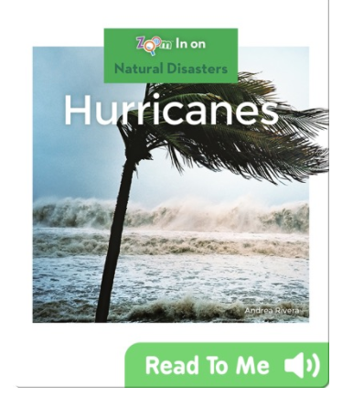
Atlantic City’s boardwalk was destroyed. They are trying to decide if they should rebuild their boardwalk with different precautions or not rebuild at all. Use the text and the graph below to help them decide.

Part A: Gather Evidence About Hurricanes

First, read the text Hurricanes to find out more about why hurricanes are a problem.

- How do hurricanes cause landscapes to change?
Hurricanes cause landscapes to change by ______________________________________.

- Do these changes happen slowly or quickly? How does this affect the damage caused?
These changes happen __________________, which affects the damage caused because ________________________________________________________________________

Now look at the graph below that shows the number of hurricanes that have affected New Jersey in the past:
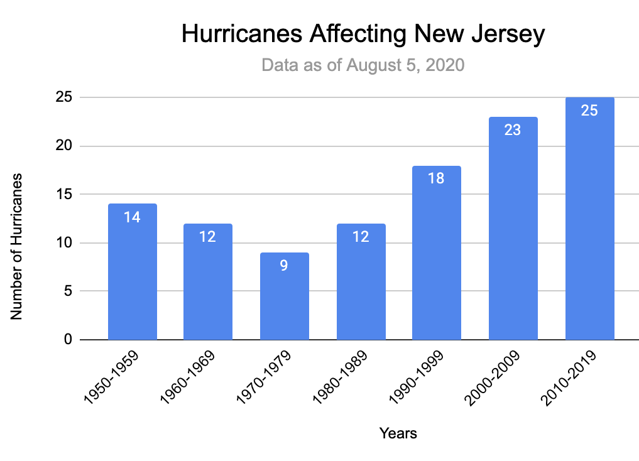

- What does the graph make you think? What patterns do you notice?

- Based on the patterns, how many hurricanes do you think there will be between 2020 and 2029?
- 27 hurricanes
- 3 hurricanes
- 10 hurricanes

Explain why you chose that answer.

Part B: Compare Solutions and Select Best Option

Help Atlantic City decide on one of the following solutions:
Solution #1 | Atlantic City should rebuild the boardwalk but with stronger building materials.
Solution #2 | Atlantic City should rebuild the boardwalk but with a barrier to hold back water from the ocean.
Solution #3 | Atlantic City should not rebuild the boardwalk. They should build a nature preserve instead.

- First compare the solutions by checking your responses to the questions in the table below:
 | Solution #1 | Solution #2 | Solution #3
Does it bring money into the town? | - Yes  - No | - Yes  - No | - Yes  - No
How does it protect against hurricanes? | - Protection from wind  - Protection from flooding  - Does not protect against hurricanes | - Protection from wind  - Protection from flooding  - Does not protect against hurricanes | - Protection from wind  - Protection from flooding  - Does not protect against hurricanes

- Now decide which of the three solutions you would pick.
  - Describe the solution you have selected by completing the sentence below:

Based on the evidence I think Atlantic City should _______________________
_______________________________________________________________

  - Complete the sentences below to help you support your solution with evidence from the reading and the graph.

Atlantic City should pick this solution because the evidence shows that
_______________________________________________________________
_______________________________________________________________
_______________________________________________________________
_______________________________________________________________
______________________________________________________________.

  - Complete the sentence below to explain why you chose that solution over the other two solutions.

I chose Solution # ___ over Solution # ___ and # ___ because _____________
_______________________________________________________________
______________________________________________________________.
_______________________________________________________________
______________________________________________________________.

