Traveling Kannemeyeria

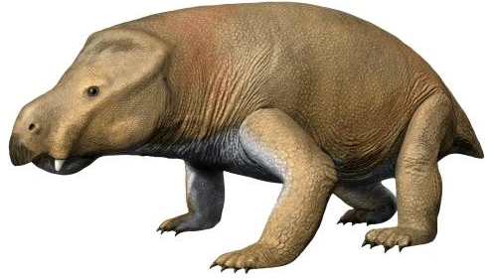
One of the greatest survivors in all of Earth’s history was a humble creature named Kannemeyerid (Kannemeyeria in groups). Fossils of Kannemeyeria are currently found in rock layers across North America, South America, Africa, and Asia.
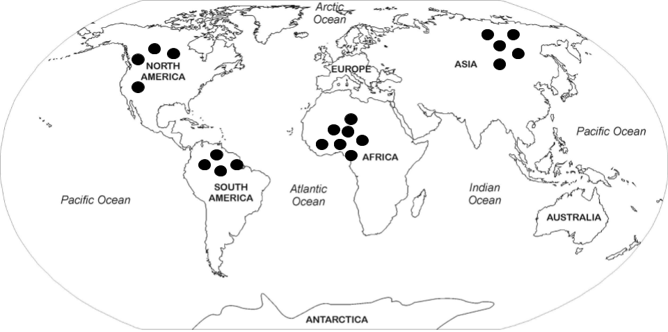
© N. Tamura

Copyright © 2020 Printable Map Collection. Theme by AdSensia.com.
The dots on the map above show the current location of most Kannemeyeria fossils.

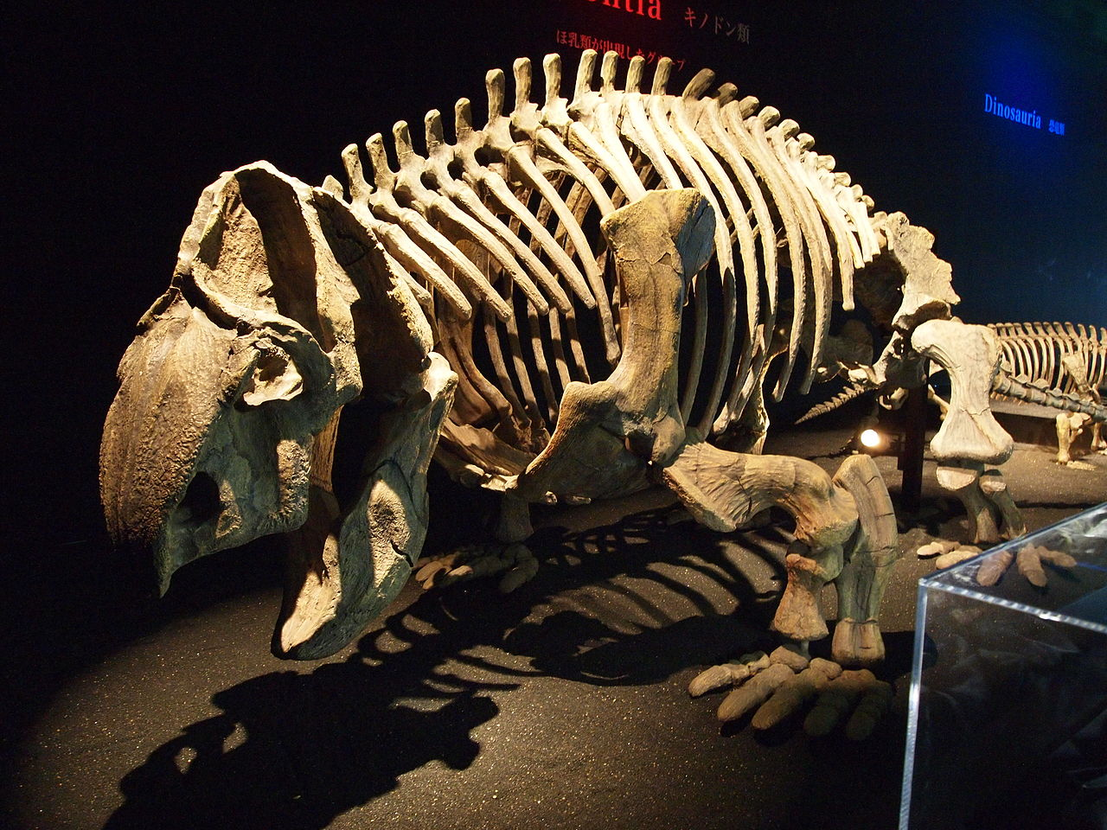
Kannemeyeria are extinct therapsid (mammal-like reptiles) that lived approximately 250 million to 230 million years ago, during the Early to Middle Triassic Period. Data from the fossils describe Kannemeyeria as herbivores (plant eaters). They were about the size of an ox or large cow, about 3 meters long, and weighed approximately 90 kg (about 200 pounds). Kannemeyeria were land-dwellers that traveled throughout plains and swamps. They stayed in warm, dry climates close to the equator. Finding these fossils in so many places is very puzzling, especially since these continents are all separated by oceans and do not all have warm, dry climates.
Copyright © Torene Project. Retrieved from www.torenecapital.com/dinosaurs-from-dawn-to-extinction

Images from: https://www.revolvy.com/page/Kannemeyeria, https://www.renderosity.com/mod/bcs/kannemeyeriadr/92173
The locations of the fossils of Kannemeyeria show an interesting pattern. The images

on the map represent the Kannemeyeria fossils. Examine the image below to collect
evidence of this pattern.

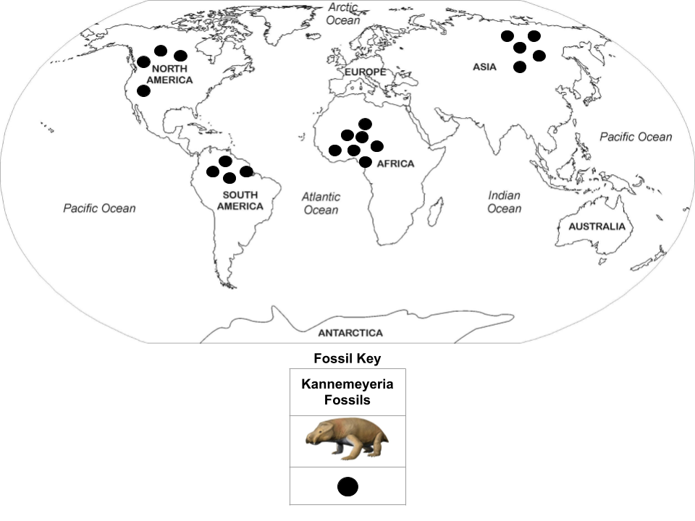
Question 1 Part A: What do you observe about the Kannemeyeria fossils above and the pattern of fossil distribution from the map above?
______________________________________________________________________________

______________________________________________________________________________

______________________________________________________________________________

Question 1 Part B: How could the Kannemeyeria, which were land dwelling animals, have
traveled to these different continents if they were unable to swim? Explain.

______________________________________________________________________________

______________________________________________________________________________

______________________________________________________________________________

Rock types near and around the location of the fossils of Kannemeyeria show an interesting
pattern. The “X” images on the map represent the same rock types. Examine the image
below to collect evidence of this pattern.

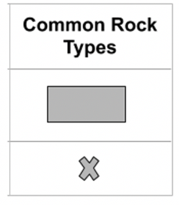
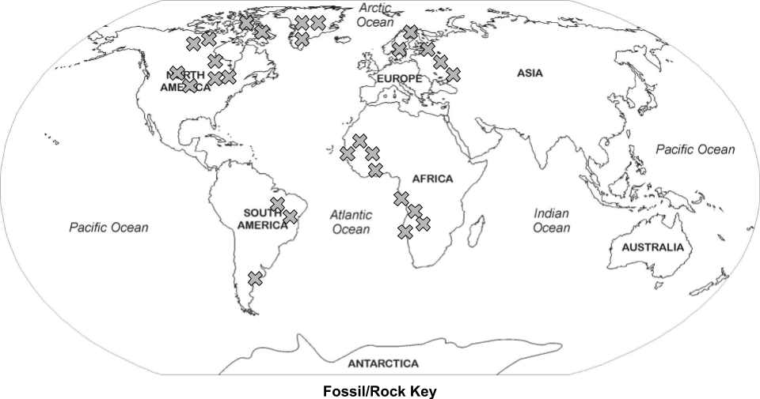

Question 2: What patterns do you notice in the locations of the matching rock types? What
could cause these particular patterns?

Evidence (Patterns):
______________________________________________________________________________

______________________________________________________________________________

______________________________________________________________________________

Evidence (Cause): ______________________________________________________________________________

______________________________________________________________________________

______________________________________________________________________________

Diagram 1 below shows data from an investigation in which scientists sampled rocks along a transect, a straight line of travel, across the Mid-Atlantic Ridge from South America to Africa. Data Table 1 shows the data collected from this investigation.

Diagram 1
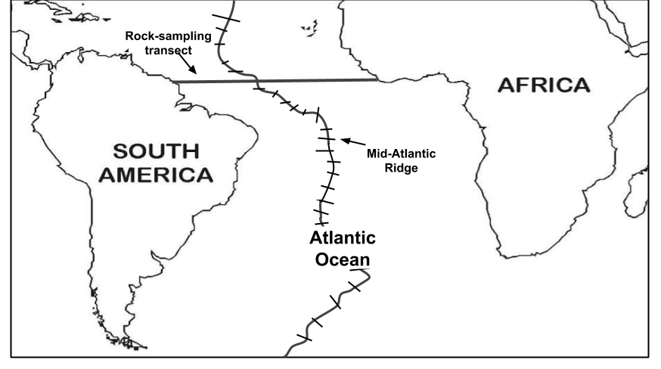 | 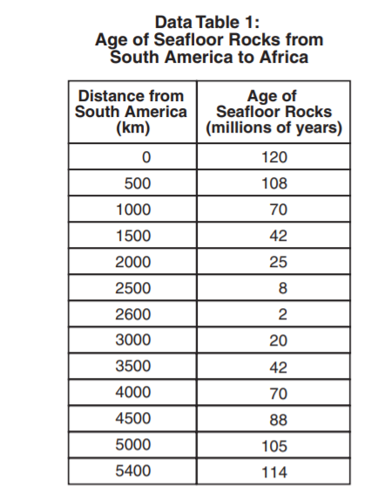
Data from: https://reporting.measuredprogress.org/NECAPPublicRI/documents/1516/Spring/NECAP_Sci_15-16_Gr8_Inquiry_Task_Booklet_Released.pdf
Some of the data from Data Table 1 is plotted along the transect below. Use the data table information and the transect below to describe the pattern of the age of the Atlantic Ocean floor from South America to Africa. What pattern can you observe?

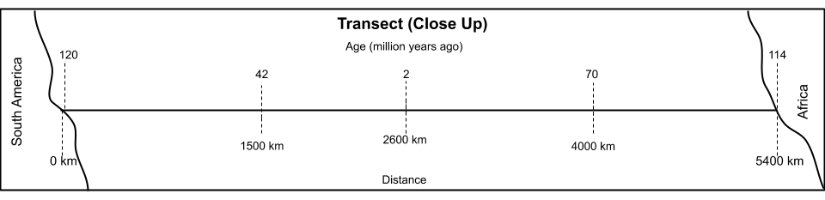

Question 3 Part A: What pattern can you observe? Evidence (Patterns)

______________________________________________________________________________

______________________________________________________________________________

______________________________________________________________________________

Question 3 Part B: What caused these patterns to occur? Evidence (Cause)
______________________________________________________________________________

______________________________________________________________________________

______________________________________________________________________________

______________________________________________________________________________

Question 4: Construct an explanation to describe how Kannemeyeria fossils have been found in such varied locations. Be sure to include the evidence you collected about Kannemeyeria fossils being found in such varied locations, rock type locations, and the pattern of seafloor rock ages between South America and Africa as evidence in your explanation.

______________________________________________________________________________

______________________________________________________________________________

______________________________________________________________________________

______________________________________________________________________________

______________________________________________________________________________

______________________________________________________________________________

______________________________________________________________________________

______________________________________________________________________________

