Heredity: Inheritance and Variation of Traits
Students who demonstrate understanding can:
Develop and use a model to describe why structural changes to genes (mutations) located on chromosomes may affect proteins and may result in harmful, beneficial, or neutral effects to the structure and function of the organism.[Clarification Statement: Emphasis is on conceptual understanding that changes in genetic material may result in making different proteins.] [Assessment Boundary: Assessment does not include specific changes at the molecular level, mechanisms for protein synthesis, or specific types of mutations.]

The performance expectation above was developed using the following elements from the NRC document A Framework for K-12 Science Education:
Science and Engineering Practices  Developing and Using Models  Modeling in 6–8 builds on K–5 experiences and progresses to developing, using, and revising models to describe, test, and predict more abstract phenomena and design systems.  - Develop and use a model to describe phenomena. | Disciplinary Core Ideas  Inheritance of Traits  - Genes are located in the chromosomes of cells, with each chromosome pair containing two variants of each of many distinct genes. Each distinct gene chiefly controls the production of specific proteins, which in turn affects the traits of the individual. Changes (mutations) to genes can result in changes to proteins, which can affect the structures and functions of the organism and thereby change traits.  Variation of Traits  - In addition to variations that arise from sexual reproduction, genetic information can be altered because of mutations. Though rare, mutations may result in changes to the structure and function of proteins. Some changes are beneficial, others harmful, and some neutral to the organism. | Crosscutting Concepts  Structure and Function  - Complex and microscopic structures and systems can be visualized, modeled, and used to describe how their function depends on the shapes, composition, and relationships among its parts, therefore complex natural structures/systems can be analyzed to determine how they function.

Heredity: Inheritance and Variation of Traits
Students who demonstrate understanding can:
Develop and use a model to describe why asexual reproduction results in offspring with identical genetic information and sexual reproduction results in offspring with genetic variation. [Clarification Statement: Emphasis is on using models such as Punnett squares, diagrams, and simulations to describe the cause and effect relationship of gene transmission from parent(s) to offspring and resulting genetic variation.]

The performance expectation above was developed using the following elements from the NRC document A Framework for K-12 Science Education:
Science and Engineering Practices  Developing and Using Models  Modeling in 6–8 builds on K–5 experiences and progresses to developing, using, and revising models to describe, test, and predict more abstract phenomena and design systems.  - Develop and use a model to describe phenomena. | Disciplinary Core Ideas  Growth and Development of Organisms  - Organisms reproduce, either sexually or asexually, and transfer their genetic information to their offspring. (secondary)  Inheritance of Traits  - Variations of inherited traits between parent and offspring arise from genetic differences that result from the subset of chromosomes (and therefore genes) inherited.  Variation of Traits  - In sexually reproducing organisms, each parent contributes half of the genes acquired (at random) by the offspring. Individuals have two of each chromosome and hence two alleles of each gene, one acquired from each parent. These versions may be identical or may differ from each other. | Crosscutting Concepts  Cause and Effect  - Cause and effect relationships may be used to predict phenomena in natural systems.
Item 1
Performance Description
A 2-point response demonstrates the student understands the Performance Expectation MS-LS3-2: Develop and use a model to describe why asexual reproduction results in offspring with identical genetic information and sexual reproduction results in offspring with genetic variation. [Clarification Statement: Emphasis is on using models such as Punnett squares, diagrams, and simulations to describe the cause and effect relationship of gene transmission from parent(s) to offspring and resulting genetic variation.]
Evidence Statements 1.a: Students develop a model (e.g., Punnett squares, diagrams, simulations) for a given phenomenon involving the differences in genetic variation that arise from sexual and asexual reproduction. In the model, students identify and describe the relevant components, including: 1.a.i: Chromosome pairs, including genetic variants, in asexual reproduction: 1.a.ii: Chromosome pairs, including genetic variants, in sexual reproduction:
The response models all possible genetic combinations in the sea star offspring by moving alleles into the response box in the following way:
- Asexual reproduction combinations: one long, black allele and one short, black allele in at least one sea star offspring.
AND
- Sexual reproduction: one long, black allele and one long, white allele AND one long, black allele and one short, white allele AND one short, black allele and one, short white allele each in at least three sea star offspring.
Examples:

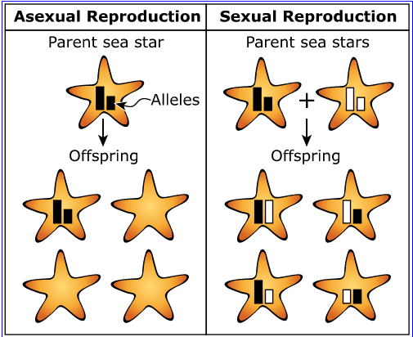

OR
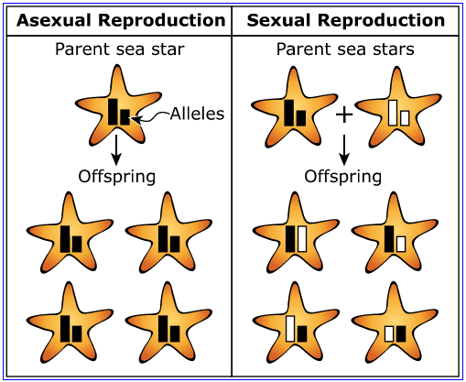

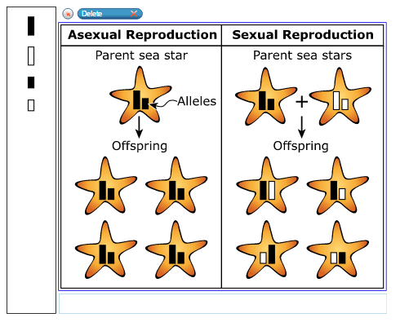
A 1-point response demonstrates the student has partial understanding of the Performance Expectations by modeling Asexual OR Sexual Reproduction correctly.
A 0-point response demonstrates the student has little or no understanding of the Performance Expectations.
General Notes:
1. Responses that…

Item 2
Performance Description
A 2-point response demonstrates the student understands the Performance Expectation MS-LS3-2: Develop and use a model to describe why asexual reproduction results in offspring with identical genetic information and sexual reproduction results in offspring with genetic variation. [Clarification Statement: Emphasis is on using models such as Punnett squares, diagrams, and simulations to describe the cause and effect relationship of gene transmission from parent(s) to offspring and resulting genetic variation.]
Evidence Statements 3.a: Students use the model to describe a causal account for why sexual and asexual reproduction result in different amounts of genetic variation in offspring relative to their parents, including that: 3.a.i: In asexual reproduction: 3.a.ii: In sexual reproduction: 3.b: Students use cause-and-effect relationships found in the model between the type of reproduction and the resulting genetic variation to predict that more genetic variation occurs in organisms that reproduce sexually compared to organisms that reproduce asexually.

Part A
The response identifies whether each statement describes asexual reproduction, sexual reproduction, or both, based on the Sea Star Offspring Allele Combinations model, by selecting boxes in the following way:
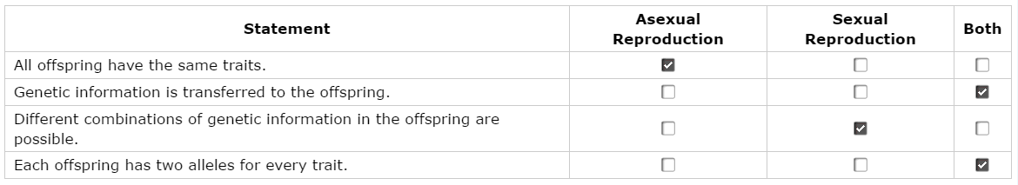

AND
Part B
The student selects option B.
A 1-point response demonstrates the student has partial understanding of the Performance Expectations by answering part A OR part B correctly.
A 0-point response demonstrates the student has little or no understanding of the Performance Expectations.
General Notes:
- Responses that …

Item 3
Performance Description
A 1-point response demonstrates the student understands the Performance Expectation MS-LS3-1: Develop and use a model to describe why structural changes to genes (mutations) located on chromosomes may affect proteins and may result in harmful, beneficial, or neutral effects to the structure and function of the organism.[Clarification Statement: Emphasis is on conceptual understanding that changes in genetic material may result in making different proteins.] [Assessment Boundary: Assessment does not include specific changes at the molecular level, mechanisms for protein synthesis, or specific types of mutations.]
Evidence Statements 1.a: Students develop a model in which they identify the relevant components for making sense of a given phenomenon involving the relationship between mutations and the effects on the organism, including: 1.a.i: Genes, located on chromosomes. 1.a.ii: Proteins. 1.a.iii: Traits of organisms.

The response shows the flow of genetic information in the tube feet cells by moving the labels into boxes in the following way:

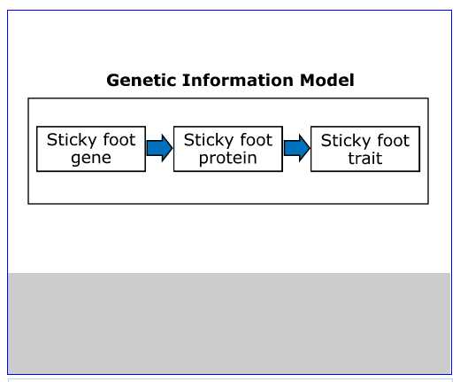
A 0-point response demonstrates the student has little or no understanding of the Performance Expectations.
General Notes:
- Responses that …

Item 4
Performance Description
A 1-point response demonstrates the student understands the Performance Expectation MS-LS3-1: Develop and use a model to describe why structural changes to genes (mutations) located on chromosomes may affect proteins and may result in harmful, beneficial, or neutral effects to the structure and function of the organism.[Clarification Statement: Emphasis is on conceptual understanding that changes in genetic material may result in making different proteins.] [Assessment Boundary: Assessment does not include specific changes at the molecular level, mechanisms for protein synthesis, or specific types of mutations.]
Evidence Statements 3.a: Students use the model to describe that structural changes to genes (i.e., mutations) may result in observable effects at the level of the organism, including why structural changes to genes:

The response describes how a mutation could result in a change to the sticky foot trait by completing the sentence in the following way:

A mutation changes the structure of the gene which can change the structure and function of the protein.

A 0-point response demonstrates the student has little or no understanding of the Performance Expectations.
General Notes:
- Responses that …

Item 5
Performance Description
A 1-point response demonstrates the student understands the Performance Expectation MS-LS3-1: Develop and use a model to describe why structural changes to genes (mutations) located on chromosomes may affect proteins and may result in harmful, beneficial, or neutral effects to the structure and function of the organism.[Clarification Statement: Emphasis is on conceptual understanding that changes in genetic material may result in making different proteins.] [Assessment Boundary: Assessment does not include specific changes at the molecular level, mechanisms for protein synthesis, or specific types of mutations.]
Evidence Statements 3.b: Students use the model to describe that beneficial, neutral, or harmful changes to protein function can cause beneficial, neutral, or harmful changes in the structure and function of organisms.

The response describes how a mutation that causes the sticky foot protein to become less sticky could affect the sea star by:

Choosing a mutation,
AND
Describing how that mutation could affect the sea star.

Examples:

Mutation: | How mutation affects the sea star:
Beneficial | - The sea star could move more easily to catch prey/avoid predators if its feet don’t stick to rocks as much.  - The mutation is beneficial because less sticky protein means the sea star can move more quickly without getting stuck on objects.
Harmful | - The sea star can’t open prey as easily as when the protein was stickier.  - The sea star can be pulled off of rocks by predators more easily.
A 0-point response demonstrates the student has little or no understanding of the Performance Expectations.
General Notes:
- Responses that …

