**ECOLOGY**

*Use the AP Biology text books to answer the following questions:*

**Chapter 52: An Introduction to Ecology and the Biosphere**

***Overview***

1. What is *ecology*?

***Concept 52.1 Ecology integrates all areas of biological research and informs environmental decision making***

2. Contrast the terms *ecology* and *environmentalism*. How does ecology relate to environmentalism?

***Concept 52.2 Interactions between organisms and the environment limit the distribution of species***

3. Read this section carefully to understand different types of experiments and observations that help explain the distribution of species. As you conclude this section, **list and describe five examples of *biotic factors***.

|  |  |
| --- | --- |
| **Biotic Factor** | **Example and Description** |
|  |  |
|  |  |
|  |  |
|  |  |
|  |  |

4. List five abiotic factors. Include an example and description of each factor’s influence on living organisms.

|  |  |
| --- | --- |
| **Abiotic Factor** | **Example and Description** |
|  |  |
|  |  |
|  |  |
|  |  |
|  |  |

5. What is *climate*? What abiotic factors are its components?

6. Study Figure 52.10 which summarizes Earth’s climate patterns and how they are formed. Label these diagrams and explain how Earth’s curvature and axis of rotation influence the amount of sunlight reaching a given area, and how these factors influence the temperature and precipitation in that area.

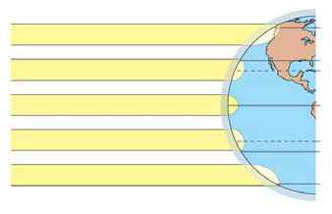

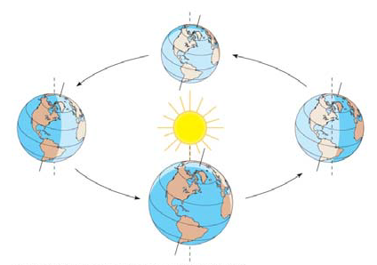

7. Use the diagram to explain the “rain shadow” effect.

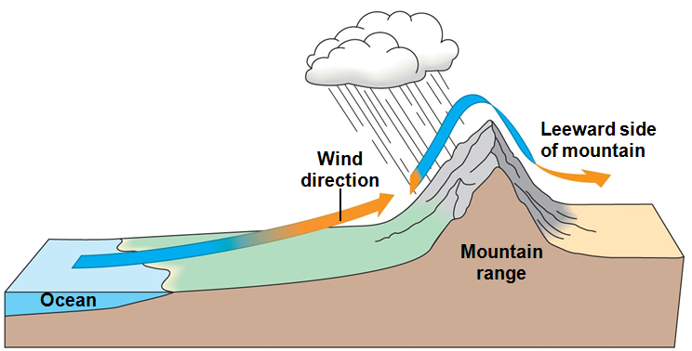

***Concept 52.3 Aquatic biomes are diverse and dynamic systems that cover most of Earth***

8. What is a *biome*?

9. What is the largest marine biome, and how much of Earth’s surface does it cover?

10. As you read this section and study Figure 52.18, you will encounter a number of new terms. Distinguish between each of the following pairs of terms:

photic/aphotic

neritic/abyssal

11. The aquatic biomes are listed in the chart. Give a description of the biome below its name, and then complete the other parts of the chart.

|  |  |  |  |
| --- | --- | --- | --- |
| **Aquatic Biome** | **Typical Autotrophs** | **Typical Heterotrophs** | **Human Impact** |
| ***Wetlands*** |  |  |  |
| ***Estuaries*** |  |  |  |
| ***Intertidal*** |  |  |  |

***Concept 52.4 The structure and distribution of terrestrial biomes are controlled by climate and disturbance***

12. Figure 52.20 shows a *climograph* for some major biomes in North America. What two abiotic factors shown here are most important in determining the distribution of the biome?

13. Label the axes of this figure, and identify each biome shown here. Try to do this based on your understanding of the figure, and then use the text to check your answers. You will use these biomes: *temperate grassland, temperate broadleaf forest, tropical forest, northern coniferous forest, desert, tundra*.

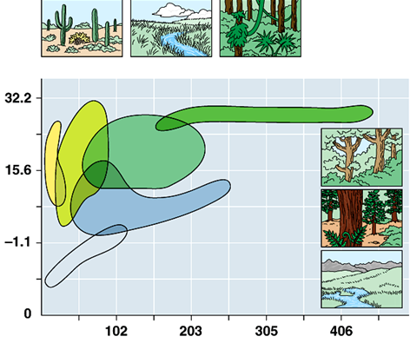

14. Describe each major terrestrial biome as to rainfall, temperature, location, and representative flora and fauna.

tropical forest

desert

savanna

chaparral

temperate grassland

northern coniferous forest/taiga

temperate broadleaf forest

tundra

***Review***: Answer the following multiple choice questions:

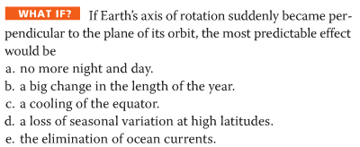 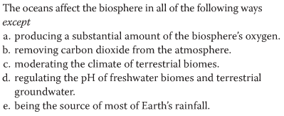

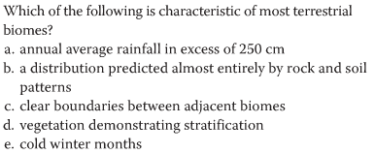 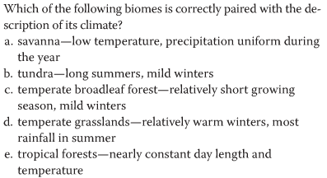

**Chapter 53: Population Ecology**

The next three chapters on population, community, and ecosystem ecology provide the academic

backbone for this unit on ecology. Each chapter is a different organizational level in ecology, starting

with population ecology. Before beginning your study of each chapter, be sure you have a clear

understanding of the terms in the chapter title.

***Concept 53.1 Dynamic biological processes influence population density, dispersion, and demographics***

1. What two pieces of data are needed to mathematically determine *density*?

2. Explain the impact of *immigration* and *emigration* on population density. (To avoid confusion between these two terms, it might help to use this memory trick: **i**mmigration is the movement **i**nto a population, while **e**migration is the **e**xiting of individuals from a population.)

3. *Survivorship curves* show patterns of survival. In general terms, survivorship curves can be classified into three types. Using the figure below, **label and explain** the three idealized survivorship patterns.

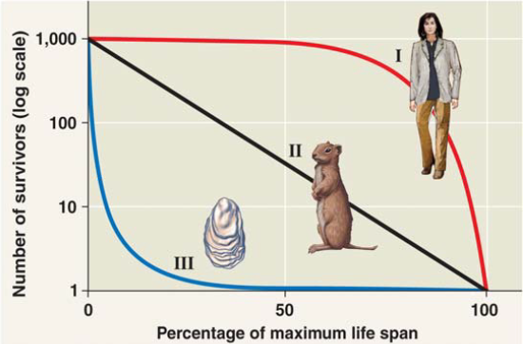

***Concept 53.2 Life history traits are products of natural selection***

4. Explain the effect of offspring care on parental survival in kestrels.

***Concept 53.3 The exponential model describes population growth in an idealized, unlimited environment***

5. What will the per capita birth and death rates be if a population is demonstrating *zero population growth*?

6. What does it mean for a population to be in *exponential population growth*?

7. What are two examples of conditions that might lead to *exponential population growth* in natural populations?

***Concept 53.4 The logistic model describes how a population grows more slowly as it nears its carrying capacity***

8. What is *carrying capacity*?

9. What are six examples of limiting resources that can influence carrying capacity?

10. In the *logistic population growth* model, the per capita rate of increase approaches zero as the __________________________ is reached. Draw a graph showing both *exponential* and *logistic* growth.

***Concept 53.5 The human population is no longer growing exponentially but is still increasing rapidly***

11. You should be able to look at *age-structure graphs* and make predictions about the future growth of the population. Using Figure 53.25, describe the key features for the three age- structure graphs and predict how the population of each country will grow.

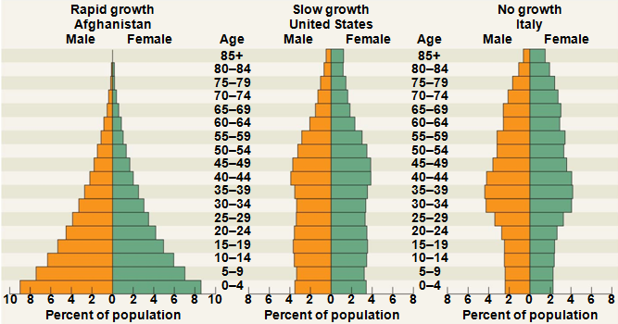

|  |  |  |
| --- | --- | --- |
| **Country** | **Key Features** | **Predicted Future Growth** |
| ***Afghanistan*** |  |  |
| ***United States*** |  |  |
| ***Italy*** |  |  |

***Review***: Answer the following multiple choice questions:

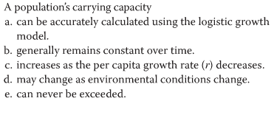 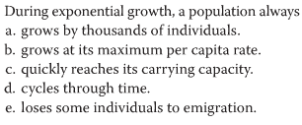

**Chapter 54: Community Ecology**

***Concept 54.1 Community interactions are classified by whether they help, harm, or have no effect on the species involved.***

1. What is a *community*? List six organisms that would be found in your schoolyard community.

2. *Predation* is a term that you probably already know. Can you give examples of some predator-prey combinations as listed below?

|  |  |  |
| --- | --- | --- |
| **Predator** | **Prey** | **Example** |
| ***Animal*** | ***Animal*** |  |
| ***Animal*** | ***Plant*** |  |
| ***Fungus*** | ***Animal*** |  |
| ***Bacteria*** | ***Animal*** |  |
| ***Fungus*** | ***Plant*** |  |

3. List three special adaptations that predator species possess for obtaining food.

4. List three ways prey species elude predators.

5. Compare the two types of mimicry.

|  |  |  |
| --- | --- | --- |
| **Type of Mimicry** | **Description** | **Example** |
| *Batesian* |  |  |
| *Müllerian* |  |  |

6. What is herbivory?

7. Describe and give an example of each of the following interactions:

|  |  |  |
| --- | --- | --- |
| **Type of Interaction** | **Description** | **Example** |
| ***symbiosis*** |  |  |
| ***parasitism*** |  |  |
| ***commensalism*** |  |  |
| ***mutualism*** |  |  |

8. Which category above includes the other three? Note that other texts may define this term more narrowly.

9. Your text uses +/– symbols to indicate how interspecific interactions affect survival and reproduction of the two species. Use this notation for each of these interactions.

|  |  |
| --- | --- |
| **Type of Interaction** | **+/+, +/–, –/–, +/0** |
| ***predation*** |  |
| ***commensalism*** |  |
| ***mutualism*** |  |
| ***parasitism*** |  |
| ***interspecific competition*** |  |
| ***herbivory*** |  |

10. What is *species diversity*? What are its two components? Why is it important?

11. What does an ecologist summarize in a *food web*?

12. Know the levels of trophic structure in food chains. Give a food chain here, including four links that might be found in a prairie community, and tell the level for each organism.

13. Name every organism in the pictured food chain, and give the trophic level in the box.

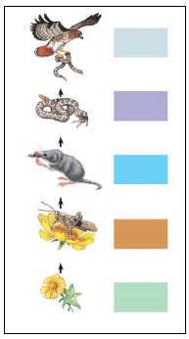

14. According to the *energetic hypothesis*, why are food chains limited in length? How much energy is typically transferred to each higher level?

***Concept 54.2 Disturbance influences species diversity and composition***

15. *Ecological succession* is the changes in species that occupy an area after a disturbance. What is the difference between *primary succession* and *secondary succession*?

**Chapter 55: Ecosystems**

***Overview:***

1. What is an *ecosystem*?

2. Where does energy enter most ecosystems? How is it converted to chemical energy and then passed through the ecosystem? How is it lost? Remember this: ***energy cannot be recycled***.

3. Besides the energy flow that you described in question 2, chemicals such as carbon and nitrogen cycle through ecosystems. So energy _____________ through an ecosystem and matter ________________.

***Concept 55.1 Physical laws govern energy flow and chemical cycling in ecosystems***

4. Both energy and matter can be neither ___________________ nor _______________________.

5. List three groups of organisms that are *photosynthetic autotrophs*.

6. What are the *primary producers* of the deep-sea vents?

7. This concept reviews trophic relationships. Know all terms in your textbook that are bolded. What are *trophic levels*? What is always at the first trophic level?

8. What are *detritivores*? What is their importance in chemical cycling? Give some examples of detritivores.

9. State the trophic level of each of the following:

cow __________ grass __________ man __________ mushroom __________

***Concept 55.2 Energy and other limiting factors control primary production in ecosystems***

10. Which ecosystem would tend to have a greater biomass/unit area, a prairie or a tropical rain forest? Explain.

11. What are some factors that limit primary productivity in aquatic ecosystems?

12. What is a *limiting nutrient*? What is the limiting nutrient off the shore of Long Island, New York? In the Sargasso Sea?

13. Phytoplankton growth can be increased by additional nitrates and phosphates. What are common sources of each of these?

14. What is *eutrophication*? What are factors that contribute to eutrophication?

***Concept 55.3 Energy transfer between trophic levels is typically only 10% efficient***

15. What is *trophic efficiency*?

16. Generally, what percentage of energy available at one trophic level is available at the next?

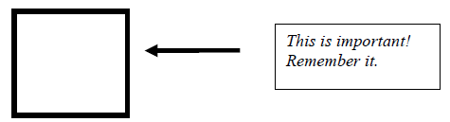

17. Consider a food chain with 1,000 *joules* (an energy unit) available at the producer level. If this food chain is grass grasshopper lizard crow, how much energy is found at the level of the crow? Show your work here.

18. Notice that most biomass pyramids have greatest biomass on the bottom of the pyramid. Label the trophic levels on the figure. Explain why the second pyramid of biomass is inverted.

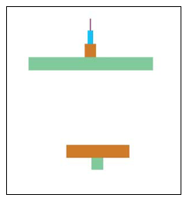

***Concept 55.4 Biological and geochemical processes cycle nutrients between organic and inorganic***

***parts of an ecosystem***

Pay particular attention to the nutrient cycles in the figures. Note the key processes in each cycle.

19. Use the figure below to describe the water cycle. Specify the roles of *evaporation*, *transpiration*, and r*ainfall*.

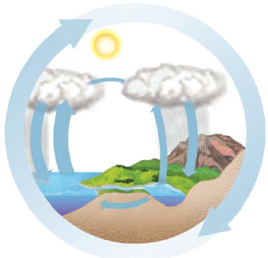

20. Use the figure on the following page to describe the carbon cycle. In doing so, explain how carbon enters the living system and how it leaves, indicate the role of microorganisms in the cycle, and identify the reservoir for carbon.

Write the equation for photosynthesis here: ______________________________________________

Write the equation for cellular respiration here: __________________________________________

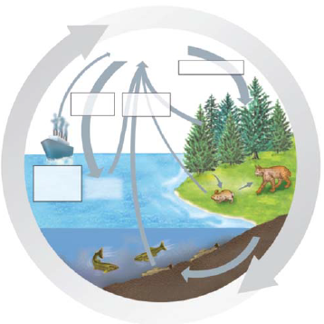

21. Use the diagram below to describe the nitrogen cycle. In doing so, indicate the role of microorganisms in *nitrogen fixation*, *nitrification*, and *denitrification*.

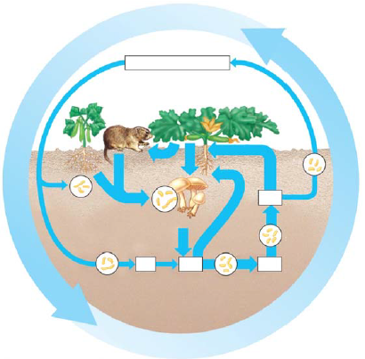

22. Review the *Case Study*: *Nutrient Cycling in the Hubbard Brook Experimental Forest*. What effect has deforestation been shown to have on chemical cycling?

***Concept 55.5 Human activities now dominate most chemical cycles on Earth***

This section looks at human impact on ecosystems.

23. How has agriculture affected nitrogen cycling? What are some negative consequences of nutrient enrichment?

24. In what ways have human activities contributed to acid precipitation? What are some negative consequences of acid precipitation?

25. Explain the process of *biological magnification*. Discuss at least one example.

26. What is meant by the *greenhouse effect*? What would life on Earth be like without this effect?

27. What is contributing to the great increase in atmospheric carbon dioxide? What are potential effects of this increase?

28. How is atmospheric ozone depleted? What are projected effects of this depletion?

***Review***: Answer the following multiple choice questions:

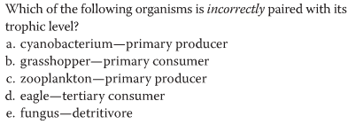 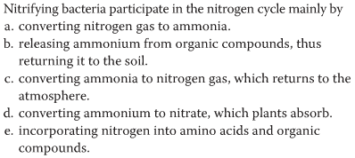

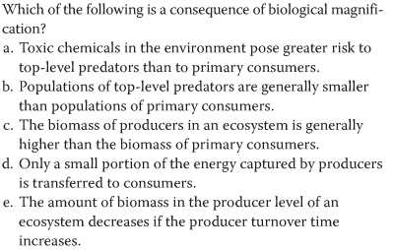 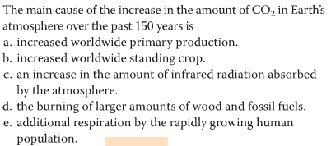

**Chapter 56: Conservation Biology and Restoration Ecology**

***Concept 56.1 Human activities threaten Earth’s biodiversity***

1. Ecologists organize biodiversity on three levels. In the table below, explain the impact of decreasing diversity in each division. Begin reading on page 1248, where the topic changes to threats to biodiversity before answering this question.

|  |  |
| --- | --- |
| **Level of Biodiversity** | **Impact** |
| *Genetic diversity* |  |
| *Species diversity* |  |
| *Ecosystem diversity* |  |

2. Explain the difference between *endangered species* and *threatened sp*ecies.

3. Use this table to organize your thoughts on how the following three threats affect biodiversity.

|  |  |
| --- | --- |
| **Threat to Biodiversity** | **How it reduces biodiversity** |
| *Habitat loss* |  |
| *Introduced species* |  |
| *Overexploitation* |  |

4. List five introduced species that present a serious threat to their new communities. Explain the damage done by each introduced species. ***Include two introduced species that are a threat in your own region of the country. Indicate these with an asterisk.

|  |  |
| --- | --- |
| **Introduced Species** | **Damage** |
| (1) |  |
| (2) |  |
| (3) |  |
| (4) |  |
| (5) |  |