Name: _____________________________________________ Date: ______________

UNIT 6: Meteorology Period: _____________ Group _______________________________

**LAB 6-4: ANGLE OF INSOLATION**

**INTRODUCTION:** There are variations in the angle at which the sun’s rays strike Earth’s surface. You have observed the changing altitude of the sun during the day and the cyclic annual variation of the attitude of the noon sun. You would also observe changes in the angle of insolation if you were to travel north or south of your present location. These changes in angle produce differences in the intensity of insolation at Earth’s surface.

**OBJECTIVE:** In this lab you will determine the relationship between the angles of insolation and the amount of energy received at Earth’s surface. You will discover that the amount of energy received depends on the time of day, the season and the latitude

**VOCABULARY:**

insolation:

angle of insolation:

intensity:

**PROCEDURE:**

**YOU MUST WEAR SAFETY GOGGLES!**

1. Calibrate your thermometers.
2. Secure the lamp to the ringstand with the light bulb shining straight down toward the lab table.
3. Place on thermometer on each of three supports that will hold them at 30⁰, 60⁰ and 90⁰ angles to the light rays.
4. The bulbs of the thermometers must:
5. All be at the same level
6. All be directly under the heat lamps.
7. Take a temperature reading before turning on the heat lamp and enter it under Time 0 on the Report Sheet.
8. Turn on the lamp and record the temperatures every minute for the next 15 minutes.
9. Plot your data on the graph using the same axes for all three curves. Place time on the horizontal axis. Use a different color for each curve and provide a key.

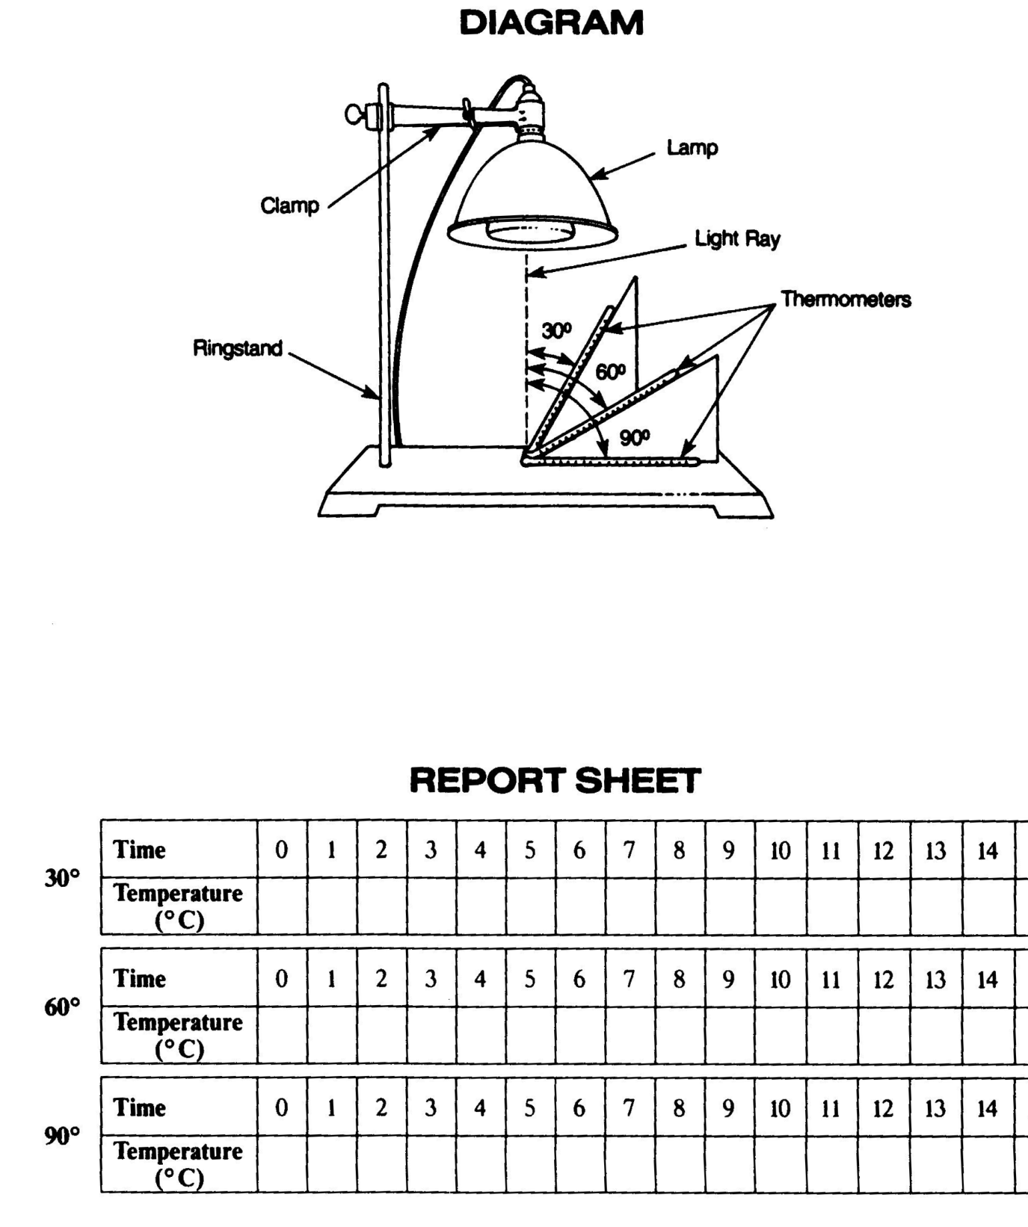

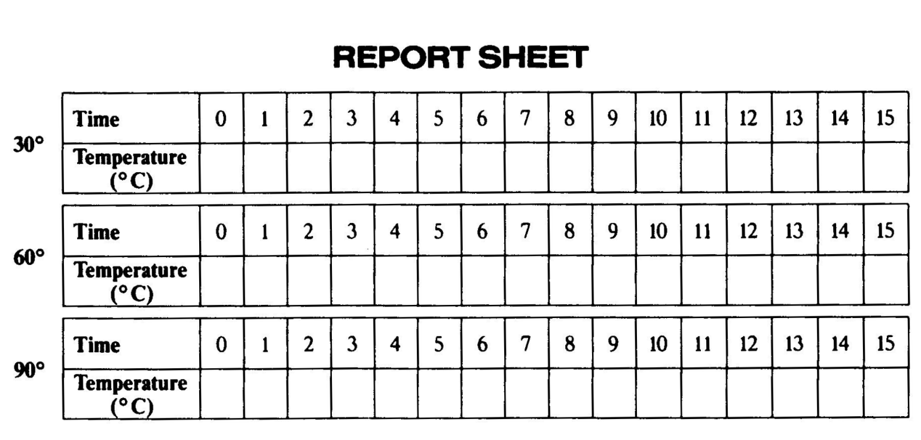

**ANGLE OF INSOLATION GRAPH**



**DISCUSSION QUESTIONS:** *(Answer in Complete Sentences on a separate piece of lined paper. You may type your answers)*

1. Why was it necessary to place all three thermometers the same distance from the light bulb?
2. Which thermometer received the most direct rays?
3. Which thermometer heated to the highest temperature?
4. How would a lower angle of insolation affect the maximum temperature of a surface?
5. Describe the relationship between the angle of insolation and the rate of heating of a surface.
6. How does the angle of insolation vary at any one place from sunrise to sunset?
7. How does the angle of insolation of the sun at noon vary at any one location during the year.
8. During the equinox (when all Earth location receive 12 hours of daylight), how do the angle and intensity of insolation change as latitude increases?
9. If during the year every Earth location receives the same number of daylight hours, why are the polar regions colder than lower latitudes?

**CONCLUSION:** What is the relationship between the angle of insolation and the rate at which the temperature changes.