Mrs. Conn’s Behavior Plan
Classroom Rules:
- Based on CT Schoolwide Rules – Adapted for Kindergarten
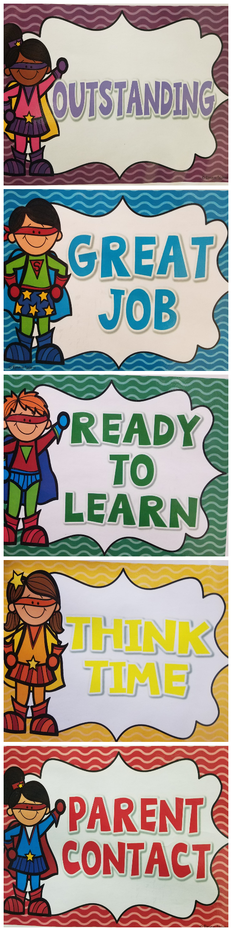
Positive Individual Recognition:
- Clipping up on the READY TO FLY! Chart
- Behavior COLOR SLIP (noting behavior & result)
- Praise/Award
- Positive note/Call home
- Stickers/Prize box
- Super Power Strips
- Choice Board
Super Power Strips:
Students can earn YELLOW strips for good behavior and positive choices. These SUPER POWER STRIPS allow student to model and copy appropriate behaviors and choices to earn their own SUPER POWER STRIPS.

Individual Consequences:
- Clipping down on READY TO FLY! Chart
- Behavior COLOR SLIP (noting behavior & result)
- Seating change: new spot or near the teacher
August 2019
Expectations of Kindergarteners’ Words, Actions, & Work:

- Be Respectful
* Raise your hand. * Talk when it’s your turn. * Listen when others are talking.
- Be Responsible
* Take pride in your work. * Follow directions quickly. * Complete your work.
- Be Honest
* Always tell the truth. * Do your own work. * Make smart choices.
- Be Kind
* Keep your hands and feet to yourself. * Say nice things. * Play nicely.
- Be Prepared
* Get ready for the day. * Pack/unpack on your own. * Complete your HW.
- Be Safe
*Use school tools correctly. *Walk. * No pushing. * Dress appropriately.

Kindergarten Interventions:
- WARNING!
2.) Think Time & Reflection -- Apology note
-- Partial or whole loss of recess
3.) Loss of Privileges -- Playing with a partner/group
-- Daily job assignments
4.) Note or Phone Call Home
5.) Extreme Situations -- Will be directed to Mrs. Dull in the office

