To solve a system of linear equations using a graph on the TI-83/84 graphing calculator, follow the example below. The purpose is to solve a system of two equations and two unknowns.
Example: Using a graph, find the solution for the equations y = 2x + 7 and y = -3x - 8.
• Press [Y=] to access the Y= editor.
• For Y1, input 2X+7.
• For Y2 input -3X-8.
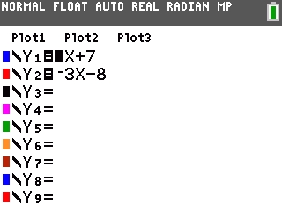
• Press [GRAPH] to graph the equations(or press [ZOOM][6] to show the graph in a standard window).
• Press [2nd] [TRACE] [5] to select the "intersect" command from the CALC menu.
• The handheld will prompt for the "First curve" which means it wants the user to select the first equation. Press [ENTER] to mark the first equation.
NOTE: Either the Y1 equation or the Y2 equation can be marked as the first equation.
• The handheld will prompt for the "Second curve" which means it wants the user to select the second equation. The handheld should also automatically jump to the second equation. Press [ENTER] to mark the second equation.
• The handheld will prompt for the "Guess?" which means it wants the user to take a guess at the solution. Using the [◄] and [►] keys, move the cursor as close as possible to the intersection point (which is the solution) and press [ENTER]. The handheld will display the solutions for both the X and Y variables as a coordinate point (-3,1).
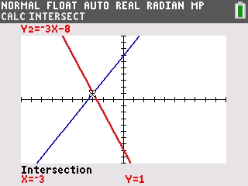
• To check the accuracy of the solution, access the TABLE by pressing [2nd] [GRAPH]. From the X column, use the [▼] and [▲] keys to scroll and locate the value (-3). When X=-3, both Y1 and Y2 are equal to 1 which means the solution is accurate.
