Name
Chapter 3: Water and Life

Living things depend on properties of water that result from its polarity and hydrogen bonding. As you work through this chapter, you will come to understand how these properties impact life processes. Be sure you understand the concept of determining pH as well as its biological significance.

Concept 3.1 Polar covalent bonds in water result in hydrogen bonding

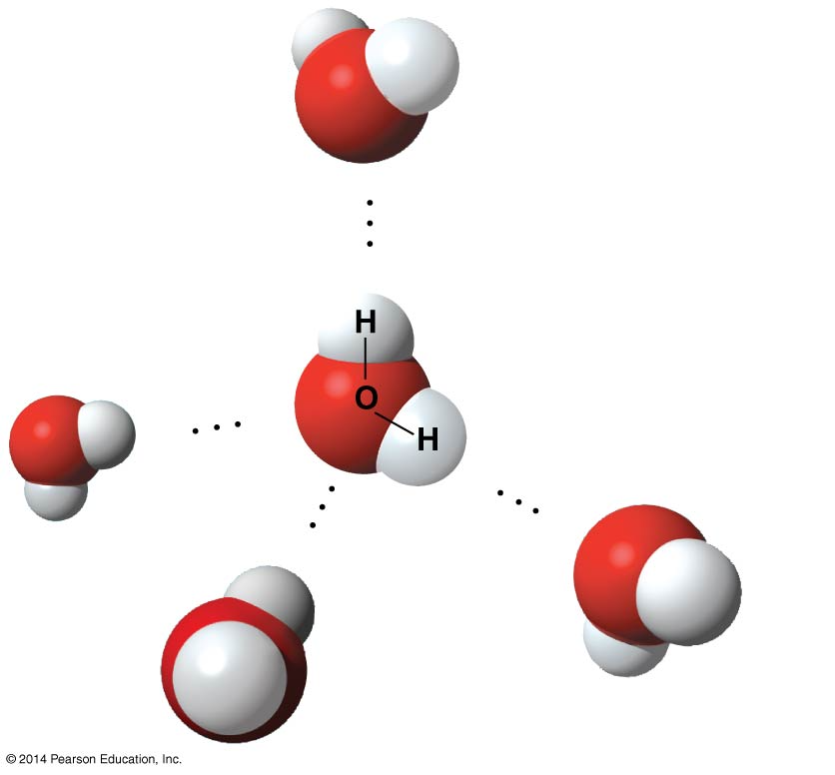
- Study the water molecules at the right. On the central molecule, label oxygen (O) and hydrogen (H). Now, add + and - signs to indicate the charged regions of each molecule. Then, indicate the hydrogen bonds.

- Water is considered a polar molecule? What does this mean?

- Explain hydrogen bonding. How many hydrogen bonds can a single water molecule form?

Concept 3.2 Four emergent properties of water contribute to Earth’s suitability for life

Hydrogen bonding accounts for the unique properties of water. Let’s look at several of these properties.

- Distinguish between cohesion and adhesion.

- Which property is demonstrated when you see beads of water on a waxed car hood?

- Which property explains the ability of a water strider to walk on water?

- The calorie is a unit of heat. Define calorie.

- Water has high specific heat. What does this mean? How does water’s specific heat compare to alcohol’s specific heat?

- Explain how hydrogen bonding contributes to water’s high specific heat.

- Summarize how water’s high specific heat contributes to the moderation of temperature. How is this property important to life?

- Define evaporation. What is heat of vaporization? Explain at least three effects of this property on living organisms.

- Ice floats! So what? Consider what would happen if ponds and other bodies of water accumulated ice at the bottom. Describe why this property of water is important.

- Now, explain why ice floats. Why is 4°C the critical temperature?

- Review and define these terms:

solvent:

solution:

solute:

- Consider coffee to which you have added sugar. Which of these is the solvent? Which is the solute?

- Explain why water is such a fine solvent.

- Distinguish between hydrophobic and hydrophilic substances. Give an example of each.

- You already know that some materials, such as olive oil, will not dissolve in water. In fact, oil will float on top of water. Explain this property in terms of hydrogen bonding.

- Now, let’s do a little work that will enable you to prepare solutions. Read the section on solute concentrations carefully, and show the calculations here for preparing a 1-molar solution of sucrose. Steps to help you do this follow. The first step is done for you. Fill in the rest.

Steps to prepare a solution:

  - Write the molecular formula.

(C12H22O11)

  - Use your periodic table to calculate the mass of each element. Multiply by the number of atoms of the element. (For example, oxygen has a mass of 16. Therefore, oxygen has a mass of 16 × 11 = 176 grams.)

  - Add the masses of each element in the molecule.

  - Add water to the total molar mass you determined and bring the solution to a volume of 1 liter. This makes 1 liter of a 1 M (1-molar) solution.

- Can you prepare 1 liter of a 0.5-molar glucose solution? Show your work here.

- Define molarity.

Concept 3.3 Acidic and basic conditions affect living organisms

- What two ions form when water dissociates?
You should have answered “hydronium (H3O+) and hydroxide ions (OH –)” in the preceding question. However, by convention, we will represent the hydronium ion as H+.

- What is the concentration of each ion in pure water at 25°C?

- Water has a pH of 7. pH is defined as the negative log of the hydrogen ion concentration [H+]. Can you now see how water is assigned a pH of 7?

- To go a step further, the product of H+ and OH– concentrations is constant at 10–14.
[H+] [OH–] = 10–14
Water, which is neutral with a pH of 7, has an equal number of H+ and OH– ions. Now, define

Acid:

Base:

- Because the pH scale is logarithmic, each numerical change represents a 10X change in ion concentration.

  - How many times more acidic is a pH of 3 compared to a pH of 5?

  - How many times more basic is a pH of 12 compared to a pH of 8?

  - Explain the difference between a pH of 8 and a pH of 12 in terms of H+ concentration.

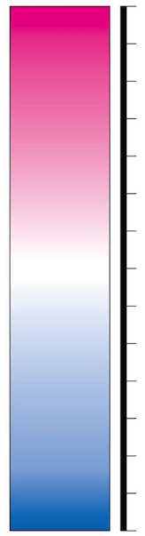
- On the pH chart, label pH 1–14. Label neutral, acid, and base. Indicate the locations of pure water, urine, gastric juice, and bleach.

- Even a slight change in pH can be harmful! How do buffers moderate pH change?

- Exercise will result in the production of CO2, which will acidify the blood. Explain the buffering system that minimizes blood pH changes.

- Discuss how CO2 emissions affect marine life and ecosystems.

Test Your Understanding Answers

Now you should be ready to test your knowledge. Place your answers here: 1. 2. 3. 4. 5.

Answer to question 20: The formula for glucose is C₆H₁₂O₆ that gives a molar mass of 180 grams. A 0.5M solution would require 90 grams of glucose, adding water to bring the total volume to 1 L.

