Topic 6: DNA and its Processes
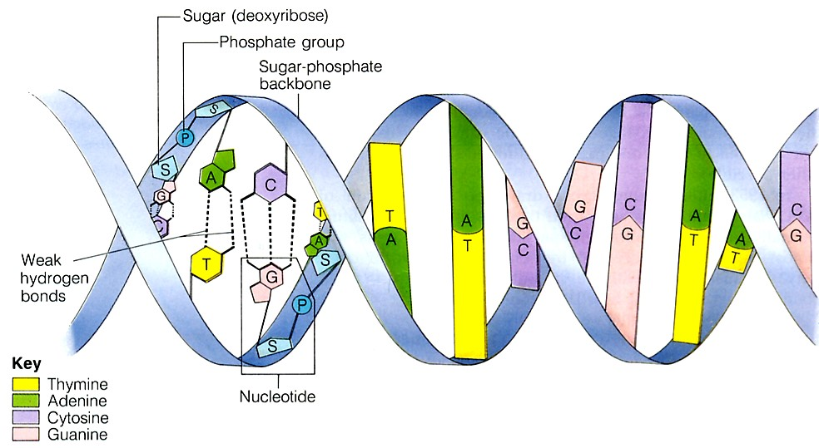

DNA Structure
Deoxyribonucleic acid (DNA) is an important biomolecule that contains our genetic code. Here is a diagram of the double helix model of DNA. Note that the monomers/building blocks of DNA are called nucleotides. Each nucleotide contains three parts
- Sugar (deoxyribose)
- Phosphate group
- Nitrogenous base (4 kinds)

DNA Replication
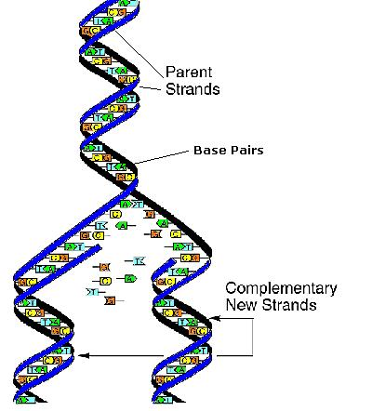
In order for new cells to pass on the genetic code, DNA must be copied inside of cells. In eukaryotic cells, this takes place inside of the nucleus, which stores the cell’s DNA. In prokaryotes, the process of copying DNA occurs in the cytoplasm. Regardless of location, the process is known as replication. Two daughter strands are formed.
- The double helix is opened up by breaking the weak hydrogen bonds
- An enzyme (DNA polymerase) comes in and adds new bases to the open strand
  - It follows base pairing rules: Adenine pairs with Thymine (straight letters A-T go together) and Cytosine pairs with Guanine (curvy letters G-C go together)
- At the end, two identical strands of DNA are formed.
- These strands are said to be complementary to each other because they follow the base pairing rules
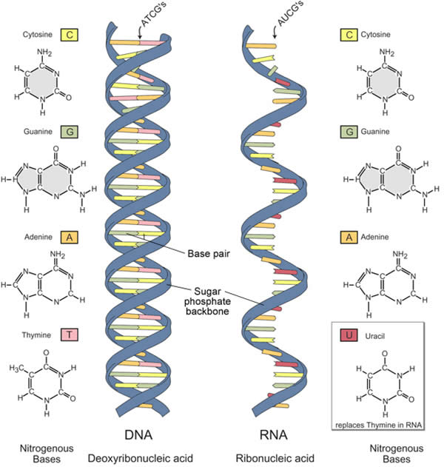

RNA Structure
Ribonucleic acid (RNA) is a similar molecule to DNA.
However, it has some key differences.
 | Deoxyribonucleic acid (DNA) | Ribonucleic acid (RNA)
Number of strands | 2 | 1
Sugar | Deoxyribose | Ribose
Base pairs | A-T G-C | A-U G-C

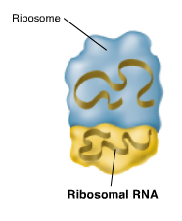
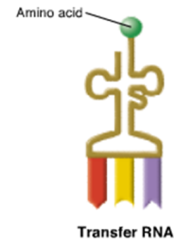
In addition to those differences, there are three different types of RNA. These different types have various shapes and functions.
Messenger RNA (mRNA) carries the transcripted message from DNA to the ribosome to make proteins
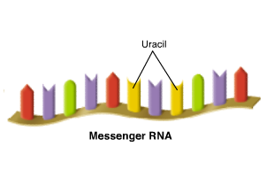
Transfer RNA (tRNA) brings the amino acids to the ribosome for protein synthesis
Ribosomal rna (rRNA) is a component of the ribosome and the site of protein synthesis

Transcription
This occurs in the nucleus of eukaryotes. In the process of transcription, an mRNA transcript is made using the double helix as a template. The double-stranded molecule of DNA separates along the hydrogen bonds. An enzyme called RNA polymerase adds in corresponding base pairs. However, instead of using Thymine to match up with Adenine, Uracil is used. For RNA, the base paring rules are A-U and G-C. At the end of this process, one piece of mRNA is created. It is complementary to the strand of DNA is was formed from.
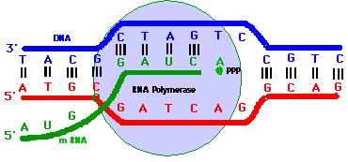

Translation
This process occurs in the cytoplasm. In the process of translation, the piece of mRNA is read by the ribosome in groups of three letters (codons). Each 3-letter portion of mRNA is referred to as a codon and codes for a specific amino acid. These codes match up to the anticodons on the bottom of the tRNA molecules. The corresponding tRNA molecule brings in the correct amino acid (building block of proteins). The ribosome joins the amino acids together to make a protein.
The diagram on the left shows replication, transcription, and translation all happening in the cell. The diagram on the right shows a chart of the 64 codons that make up the genetic code and the 20 amino acids that match up.
Each 3-letter portion of mRNA is referred to as a codon and codes for a specific amino acid. These codes match up to the anticodons on the bottom of the tRNA molecules.
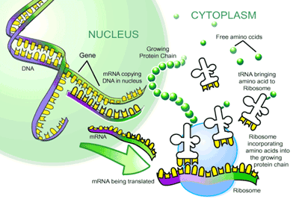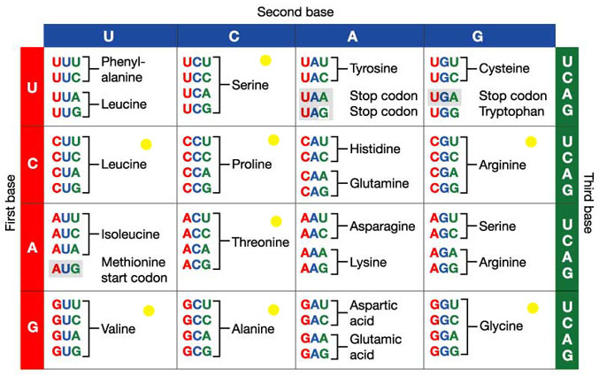
Mutations
Many different types of mutations can occur. They can either affect a few nucleotides (point mutations) or affect large portions of DNA (chromosomal mutations). These will ultimately affect the shape and size of the protein constructed, and the appearance of the cell or organism.
