Below are weather words, clothing pictures, and activity pictures.
Each season has one set of weather words, one clothing picture, and one activity picture.
Cut and paste the words and pictures so that they appear below the correct season.

Weather  Cold and snowy  Hot and sunny  Frosty and chilly  Warm and rainy | Clothing  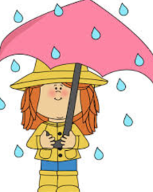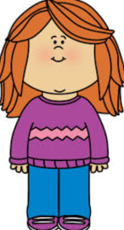  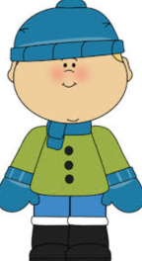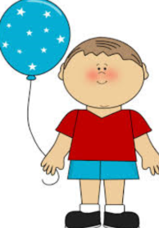 | Activity  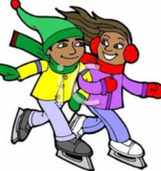  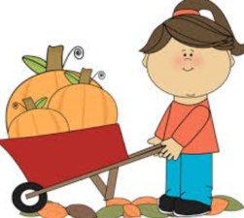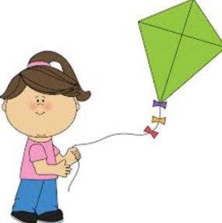

Winter | Spring | Summer | Fall

Copy and paste the tree pictures so that they appear below the correct season.
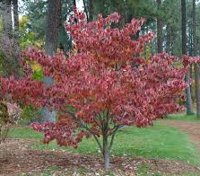 | 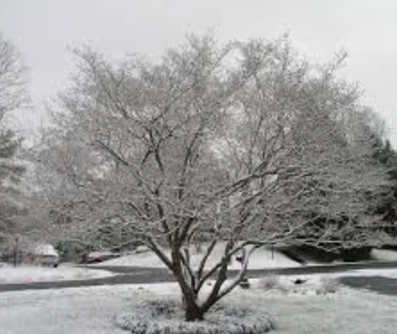 | 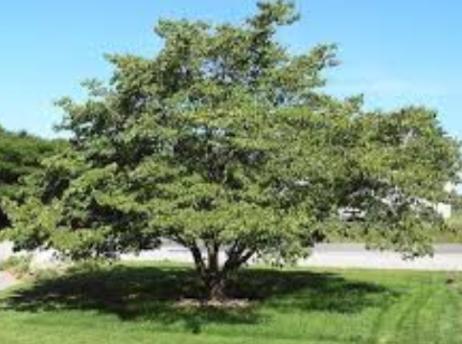 | 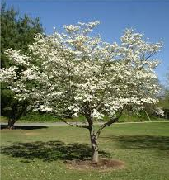

Winter | Spring | Summer | Fall

Click the cursor in the box below. Type one or two sentences describing how trees change through the seasons.

Copy and paste the bird pictures, so that they appear under the correct season.
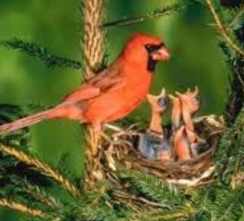 | 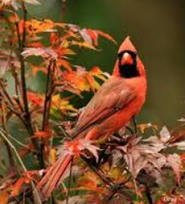 | 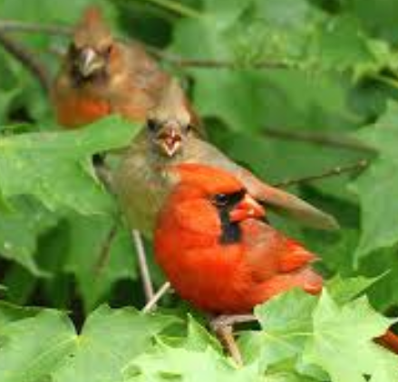 | 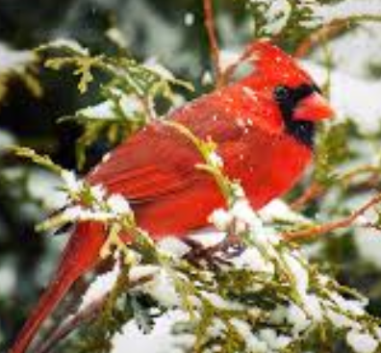

Winter | Spring | Summer | Fall

What kind of bird is this?
Type the name in the box below. Hint: Begins with the letter c.

Does this bird live in Pennsylvania?
Type yes or no in the box below.

Can you think of an animal that you see during the winter?
Type the name in the box below.

