Topic 3: Cell Transport

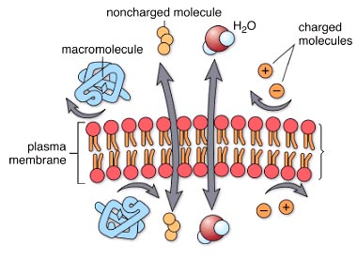
Diffusion Introduction
Water and small, non-charged molecules have no difficulty crossing the lipid portion of the membrane. Ions and charged molecules cannot cross easily, nor can large molecules. It is important that many types of substances be able to enter or leave cells. There is a variety of mechanisms by which this occurs, some requiring energy and some utilizing carrier proteins.
- Lipid - Organic compound that is insoluble in water; notably fats, oils, and steroids.
- Ions - Atom or group of atoms carrying a positive or negative charge.
- Energy - Capacity to do work and bring about change; occurs in a variety of forms.
- Carrier Protein - Protein molecule that combines with a substance and transports it through the plasma membrane.
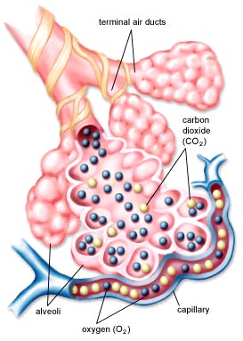
Gas Exchange in the Lungs of Humans
Gas exchange in the lungs occurs by diffusion. Carbon dioxide (CO₂) will follow its concentration gradient into the alveolus, oxygen (O₂) will follow its concentration gradient into the capillary.
- Alveolus - (pl, alveoli) - Air sac of a lung.
- Capillary - Microscopic vessel connecting arterioles to venules and through the thin walls of which substances either exit or enter blood.
Osmosis
Osmosis is the diffusion of water across a membrane. Like other molecules, water will move from an area of high concentration to an area of low concentration. The more solute there is in a solution, the lower the concentration of water in that solution. There is terminology to describe concentration differences between two solutions. A solution with higher solute concentration is hypertonic relative to one with lower solute concentration. Conversely, a solution with lower solute concentration is hypotonic relative to one with higher solute concentration. If two solutions have the same concentration they are isotonic. Water will move from a hypotonic to a hypertonic solution.
- Osmosis - Movement of water from an area of higher concentration of water to an area of lower concentration of water across a differentially permeable membrane.
- Diffusion - Movement of molecules from a region of higher concentration to a region of lower concentration.
- Solute - Substance dissolved in a solvent to form a solution.
- Hypertonic - Solution that has a higher concentration of solute and a lower concentration of water than the cell.
- Hypotonic - Solution that has a lower concentration of solute and a higher concentration of water than the cell.

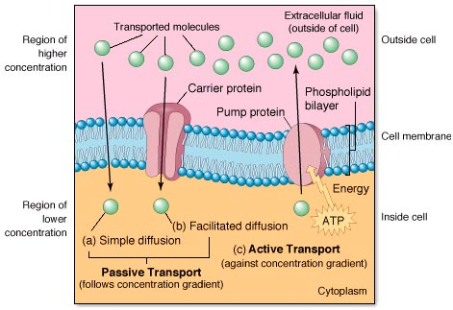
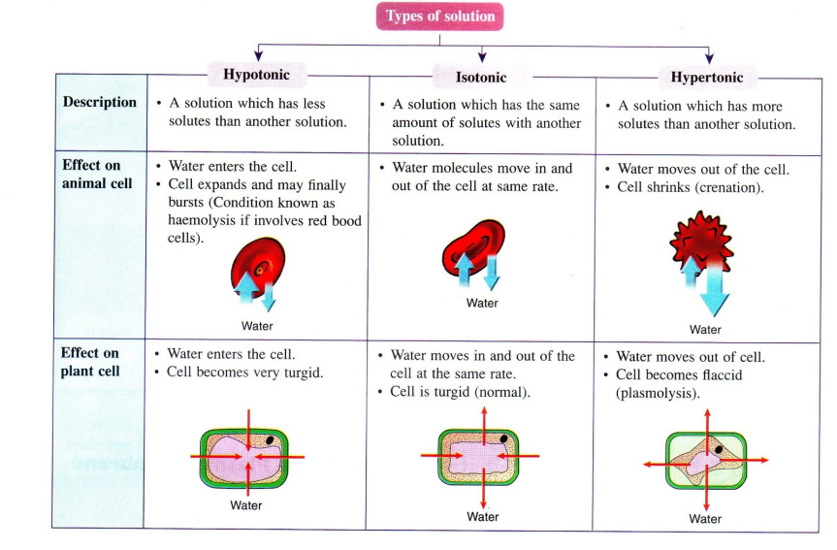

Facilitated Diffusion
Both simple and facilitated diffusion involve a substance following its concentration gradient, from high to low concentration. If the substance is lipid soluble, it readily passes through the membrane. If it is not lipid soluble, it can cross the membrane only with a specific carrier protein.

Active Transport

Introduction
Active transport involves a protein which uses ATP to pump molecules against their concentration gradients. The same protein may be used to pump two different substances in opposite directions. This is the case for the very important sodium-potassium pump.
- Active Transport - Transfer of a substance into or out of a cell from a region of lower concentration to a region of higher concentration by a process that requires a carrier and an expenditure of energy.
- ATP - Adenosine Triphosphate (ATP) - Nucleotide with three phosphate groups. The breakdown of ATP into ADP 1 Pj makes energy available for energy-requiring processes in cells.
- Sodium-Potassium Pump - Transport protein in the plasma membrane that moves sodium ions out of and potassium ions into animal cells; important in nerve and muscle cells.

