Name
Chapter 2: The Chemical Context of Life

This chapter covers the basics that you may have learned in your chemistry class. Whether your teacher goes over this chapter or assigns it for you to review on your own, the questions that follow should help you focus on the most important points. It will be assumed that have this basic material mastered in future topics. So review if necessary!

Concept 2.1 Matter consists of chemical elements in pure form and in combinations called compounds

- Define and give an example of the following terms:

matter:

element:

compound:

- What four elements make up 96% of all living matter?

- What is the difference between an essential element and a trace element?

essential element:

trace element:

Concept 2.2 An element’s properties depend on the structure of its atoms

- Sketch a model of an atom of helium, showing the electrons, protons, neutrons, and atomic nucleus.

- What is the atomic number of helium? Its atomic mass?

- Here are some more terms that you should firmly grasp. Define each term.

neutron:
proton:
electron:
atomic number:

atomic mass:

isotope:

electron shells:

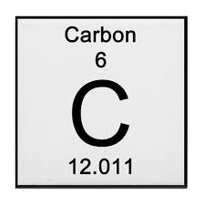
energy:

- Consider the entry in the periodic table for carbon.

What is the atomic mass? What is the atomic number?

How many electrons does carbon have? How many neutrons?

- What are isotopes? Use carbon as an example in your explanation.

- Explain radioactive isotopes and one medical application that uses them.

- Which is the only subatomic particle that is directly involved in the chemical reactions between atoms?

- What is potential energy?

- Explain which has more potential energy in each pair:

  - boy at the top of a slide/boy at the bottom

  - electron in the first energy shell/electron in the third energy shell

  - water/glucose

- What determines the chemical behavior of an atom?

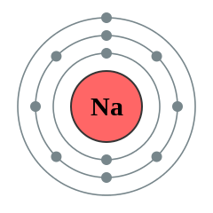

- Here is an electron distribution diagram for sodium:

  - How many valence electrons does it have? Circle the valence electron(s).

  - How many protons does it have?

Concept 2.3 The formation and function of molecules depend on chemical bonding between atoms

- Define molecule.

- Now, refer back to your definition of a compound and fill in the following chart:

 | Molecule? (y/n) | Compound? (y/n) | Molecular Formula | Structural Formula
Water
Carbon dioxide
Methane
O2

- What type of bond is seen in O2? Explain what this means.

- What is meant by electronegativity?

- Explain the difference between a nonpolar covalent bond and a polar covalent bond.

- Make an electron distribution diagram of water. Which element is most electronegative? Why is water considered a polar molecule? Label the regions that are more positive or more negative. (This is a very important concept. Spend some time with this one!)

- Another bond type is the ionic bond. Explain what is happening in the following figure below (Figure
2.12 in your text):

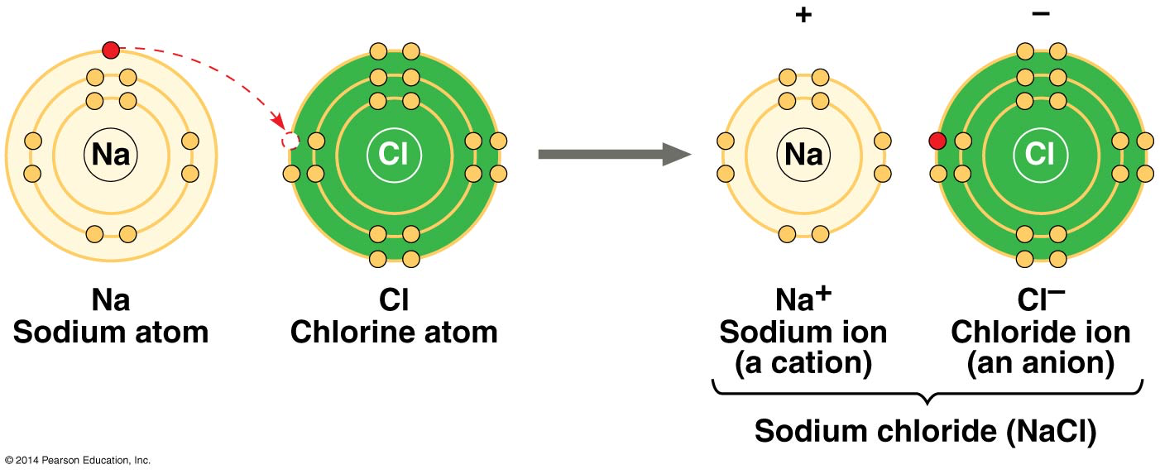

- What two elements are involved in the previous figure? List each.

- Define anion and cation. In the preceding example, which is the anion?

- What is a hydrogen bond? Indicate the partial charges and where the hydrogen bond occurs in the following figure.

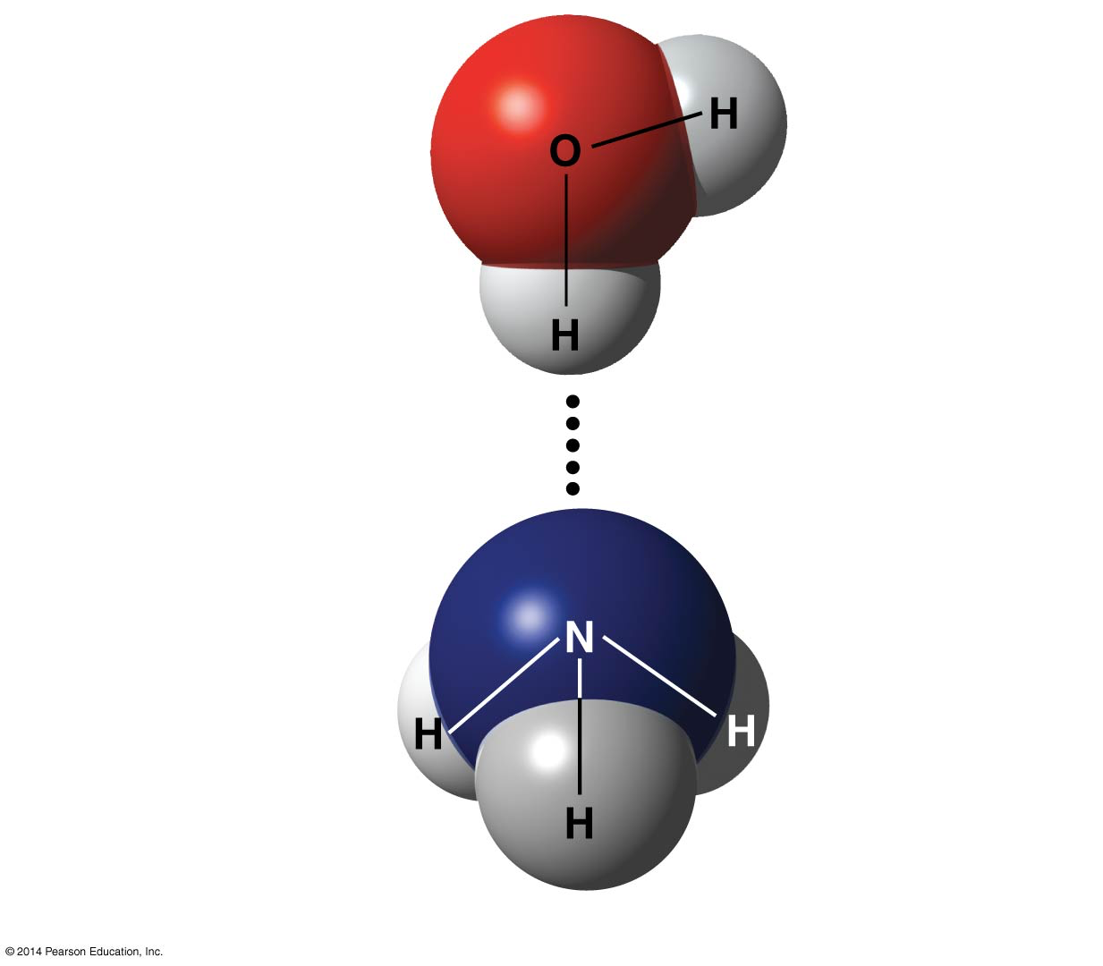

- Explain van der Waals interactions. Though they represent very weak attractions, when these interactions are numerous they can stick a gecko to the ceiling!

- Here is a list of the types of bonds and interactions discussed in this section. Place them in order from the strongest to the weakest: hydrogen bonds, van der Waals interactions, covalent bonds, ionic bonds.

STRONG

WEAK

- Use morphine and endorphins as examples to explain why molecular shape is crucial in biology.

Concept 2.4 Chemical reactions make and break chemical bonds

- Write the chemical shorthand equation for photosynthesis. Label the reactants and the products.

- For the equation you just wrote, how many molecules of carbon dioxide are there? How many molecules of glucose? How many elements in glucose?
- What is meant by dynamic equilibrium? Does this imply equal concentrations of each reactant and product?

Test Your Understanding Answers

Now you should be ready to test your knowledge. Place your answers here: 1. 2. 3. 4. 5. 6. 7. 8.

