1-1 Word Problem Practice
Variables and Expressions

1. SOLAR SYSTEM It takes Earth about 365 days to orbit the Sun. It takes Uranus about 85 times as long. Write a numerical expression to describe the
number of days it takes Uranus to orbit the Sun
.

2. TECHNOLOGY There are 1024 bytes in a kilobyte. Write an expression that describes the number of bytes in a computer chip with n kilobytes.

3. THEATER H. Howard Hughes, Professor Emeritus of Texas Wesleyan College and his wife Erin Connor Hughes attended a record 6136 theatrical shows. Write an expression for the average number of shows they attended per year if they accumulated the record over y years.

4. TIDES The difference between high and low tides along the Maine coast in November is 19 feet on Monday and x feet on Tuesday. Write an expression to show the average rise and fall of the tide for Monday and Tuesday.

5. BLOCKS A toy manufacturer produces a set of blocks that can be used by children to build play structures. The product packaging team is analyzing different arrangements for packaging their blocks. One idea they have is to arrange the blocks in the shape of a cube, with b blocks along one edge.

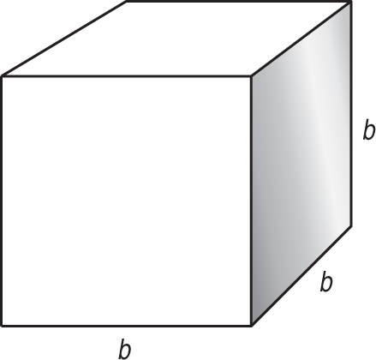

a. Write an expression representing the total number of blocks packaged in a cube measuring b blocks on one edge.

b. The packaging team decides to take one layer of blocks off the top of this package. Write an expression representing the number of blocks in the top layer of the package.

c. The team finally decides that their favorite package arrangement is to take 2 layers of blocks off the top of a cube measuring b blocks along one edge. Write an expression representing the number of blocks left behind after the top two layers are removed.

