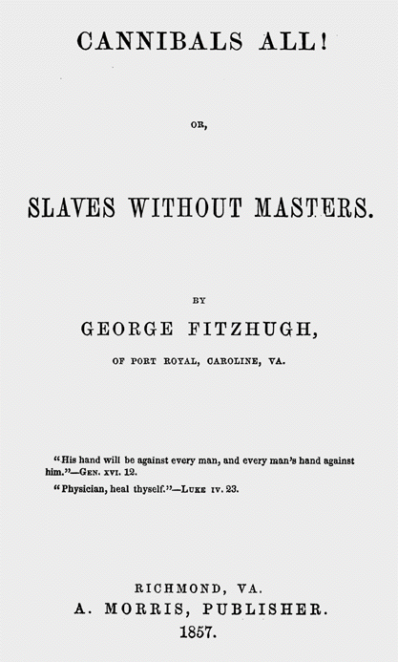

**CANNIBALS ALL!   
OR,   
SLAVES WITHOUT MASTERS.**

BY

**GEORGE FITZHUGH,   
OF PORT ROYAL, CAROLINE, VA.**

**"His hand will be against every man, and every man's hand against him." - GEN. XVI. 12.**

**"Physician, heal thyself." - LUKE IV. 23.**

**RICHMOND, VA.  
A. MORRIS, PUBLISHER.  
1857.**

**THE UNIVERSAL TRADE**

**(excerpt from Fitzhugh book, Cannibals All! Or, Slaves Without Masters**

        We are, all, North and South, engaged in the White Slave Trade, and he who succeeds best, is esteemed most respectable. It is far more cruel than the Black Slave Trade, because it exacts more of its slaves, and neither protects nor governs them. We boast, that it exacts more, when we say, "that the *profits* made from employing free labor are greater than those from slave labor." The profits, made from free labor, are the amount of the products of such labor, which the employer, by means of the command which capital or skill gives him, takes away, exacts or "exploitates" from the free laborer. The profits of slave labor are that portion of the products of such labor which the power of the master enables him to appropriate. These profits are less, because the master allows the slave to retain a larger share of the results of his own labor, than do the employers of free labor. But we not

Page 26

only boast that the White Slave Trade is more exacting and fraudulent (in fact, though not in intention,) than Black Slavery; but we also boast, that it is more cruel, in leaving the laborer to take care of himself and family out of the pittance which skill or capital have allowed him to retain. When the day's labor is ended, he is free, but is overburdened with the cares of family and household, which make his freedom an empty and delusive mockery. But his employer is really free, and may enjoy the profits made by others' labor, without a care, or a trouble, as to their well-being. The negro slave is free, too, when the labors of the day are over, and free in mind as well as body; for the master provides food, raiment, house, fuel, and everything else necessary to the physical well-being of himself and family. The master's labors commence just when the slave's end. No wonder men should prefer white slavery to capital, to negro slavery, since it is more profitable, and is free from all the cares and labors of black slave-holding.

**Thornton Stringfellow, minister in Culpepper County, VA in an essay published in the Religious Herald:**

        I propose, therefore, to examine the sacred volume briefly, and if I am not greatly mistaken, I shall be able to make it appear that the institution of slavery has received, in the first place,

         1st. The sanction of the Almighty in the Patriarchal age.

         2d. That it was incorporated into the only National Constitution which ever emanated from God.

         3d. That its legality was recognized, and its relative duties regulated, by Jesus Christ in his kingdom; and

         4th. That it is full of mercy.

       The first recorded language which was eve uttered in relation to slavery, is the inspired language of Noah. In God's stead he says, "Cursed be Canaan;" "a servant of servants shall he be to his brethren." "Blessed be the Lord God of Shem; and Canaan shall be his servant." "God shall enlarge Japheth, and he shall dwell in the tents of Shem; and Canaan shall be his servant."

**Vocabulary Help:**

**Capital –** value of goods, including the value of labor

**Appropriate –** take away

**Delusive mockery** **–** something is not what it really is

**Sanction –** okay; the right to exist

**Incorportated -**  included

**Emanated ­–** begins with or comes from

**Questions pertaining to the Readings:**

**1**. What does Fitzhugh mean with the use of the phrase, “**White Slave Trade**”?

**2**. **Who** **is inferred** as being the same as a Southern slave owner? How does this person benefit as compared to a Southern slave owner?

**3**. What **advantages** does the African-American slave have over the “**white slave**”?

**4.** What do you think is the major point in **Stringfellow**’s essay?