Hello my most Amazing Artists (and their families, too!),
Walking into the art room earlier this week was tough, knowing that it will continue to sit empty while we begin our journey of online learning. I know that I miss seeing everyone’s smiles while being creative and continuing to expand their knowledge of art. My hope is that I can provide some meaningful and fun activities for you to complete at home for these upcoming weeks. During this time, know that the most important thing you can do is to stay healthy and safe. I understand that not everyone has access to the same materials at home like we do at school so I am going to try to provide different activities for you so that you are able to choose what works best at home. This is meant to be fun and engaging so improvise as you see fit for your child/children.
Each week I plan on adding different activities so that you have different opportunities to create. The activities will vary, depending on the type of art or supplies needed. The first activities include one that has already been suggested doing from our school Instagram account, @laec_art, but wanted to provide another opportunity for more people to participate, including another challenge. For now, I have listed some online resources that you are able to access, along with the two different challenges for this first week.
Please feel free to join the new LAEC ART Facebook page. Mrs. F. and I have decided that this platform is probably the most comfortable for parents and easiest to share artwork. Anything that is to be posted will have to be approved first. We can’t wait to see what everyone is up to and will also post some art that we are working on. You can also reach out to me via email at jscholl@lehighton.org, please be sure to let me know the name of your artist when emailing. I look forward to seeing all of the beautiful masterpieces that my students create!
Until we create together again,
Mrs. Scholl
MetKids: This site from New York City’s Museum of Metropolitan Art lets kids explore the famous museum with an interactive map, behind the scenes videos, and a “time machine” that allows them to explore thousands of years of art!
https://www.metmuseum.org/art/online-features/metkids/

Art for Kids Hub: This YouTube channel hosted by Rob and his children shows you how to draw different characters from movies, cars, animals, food, honestly many, many different things. Just search on YouTube for Art for Kids Hub and the subject of your choice. I have provided a link to a tutorial on how to draw a bunny since Easter is upon us.
https://www.youtube.com/watch?v=aau6xZgIu1A

LUNCH DOODLES with Mo Willems!: The author/illustrator of the Pigeon series has created videos during our time of quarantine to encourage kids to keep drawing. I have provided the link for the first episode. https://www.youtube.com/watch?v=RmzjCPQv3y8&t=63s
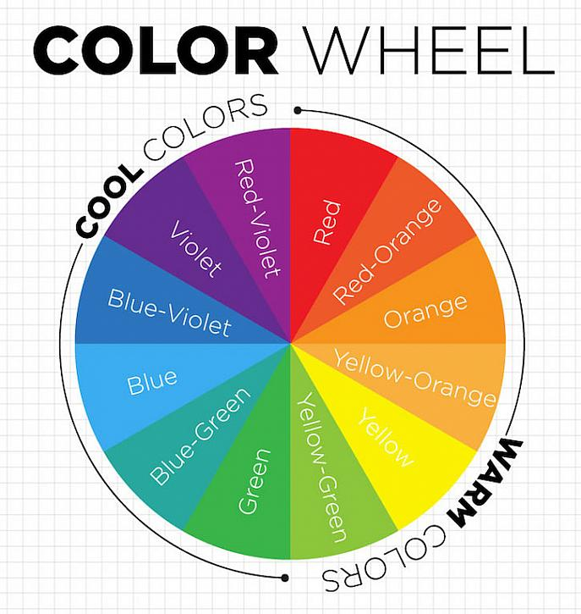
COLOR WHEEL CHALLENGE: Have students collect a variety of objects from around the house in all colors of the rainbow. Once they are collected, arrange them in the form of a color wheel.
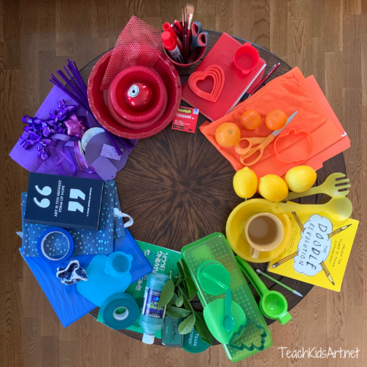

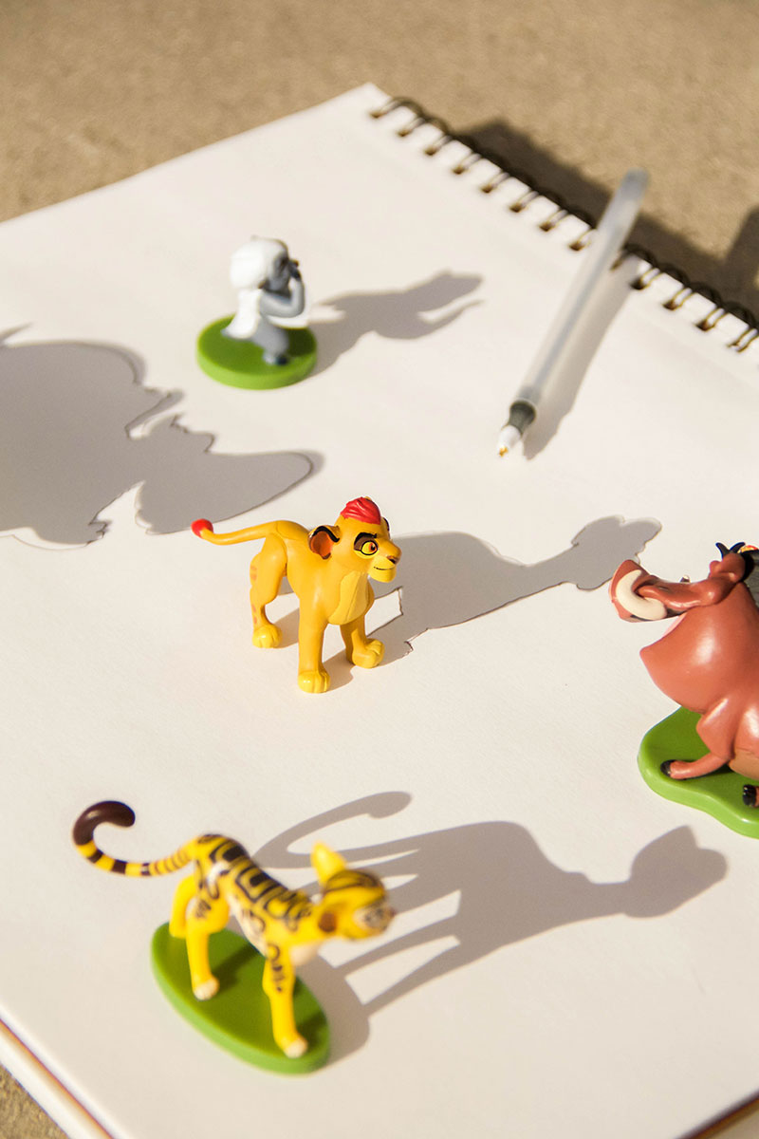
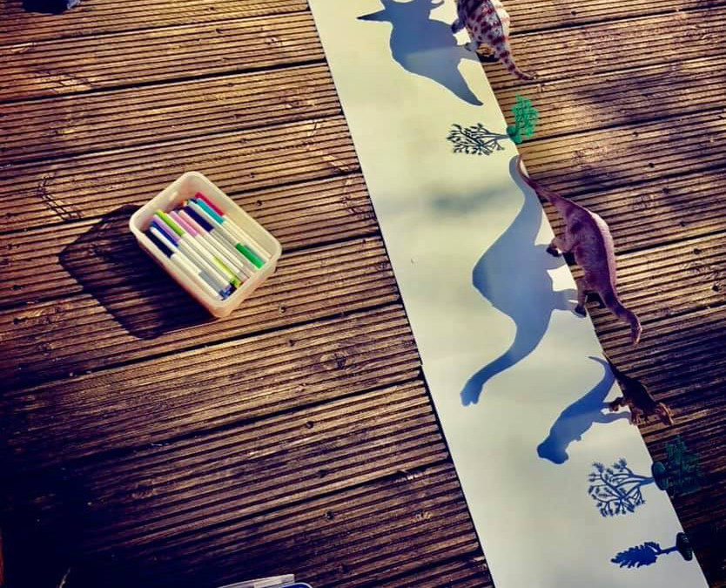
SHADOW DRAWINGS: Find objects in your home that create fun shadows, use a light source to emphasize those shadows, use paper, and draw the shadows. Similar items can be used for a themed artwork.

