Chapter 6 Quiz Review
(Lessons 6-1 through 6-3)

Part I Write the letter for the correct answer in the blank at the right of each question.

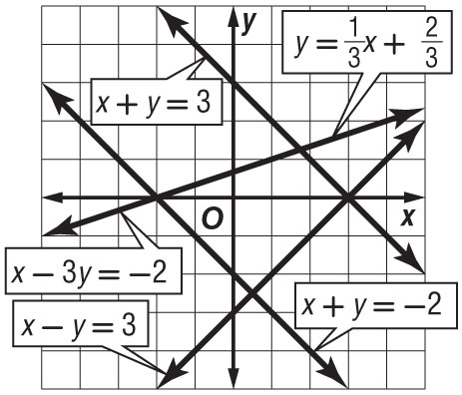
Use the graph for Questions 1 and 2. For Questions 1 and 2,
determine how many solutions exist for each system of equations.
A no solution
B one solution
C infinitely many solutions
D cannot be determined

1. x + y = 3 2. x + y = 3
x – y = 3 x + y = –2

3. The solution to which system of equations has a positive y value?
F x + y = 3 G x + y = 3 H x – 3y = –2 J x + y = 3
x – 3y = –2 x + y = –2 x + y = –2 x – y = 3

4. If y = 5x – 3 and 3x – y = –1, what is the value of y?
A 2 B –1 C 7 D –8

5. Use elimination to solve the system of equations for y. x – 5y = –6
x + 2y = 8
F $\frac{2}{3}$ G 2 H 4 J 4$\frac{2}{3}$

6. How many solutions does the system 2y = 10x – 14 and 5x – y = 7 have?
A one B two C none D infinitely many

1. _________________

2. _________________

3. _________________

4. _________________

5. _________________

6. _________________

Part II
7. Graph the system of equations. Then determine whether it has no solution, one solution, or infinitely many solutions. If the system has one solution name it.
x – 3y = –3
x + 3y = 9

8. Use substitution to solve the 4x + y = 0
system of equations. x + 2y = –7

For Questions 9–10, use elimination to solve each system of equations.
9. -3r + 3t = 9 10. 9x + 2y = –17
3r + 4t = 12 –11x + 2y = 3

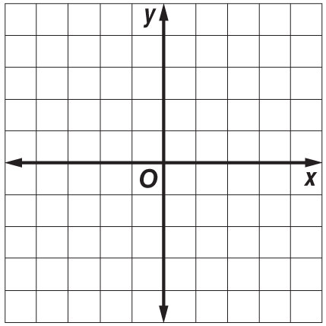
7.

_________________

8. _________________

9. _________________

10. ________________

