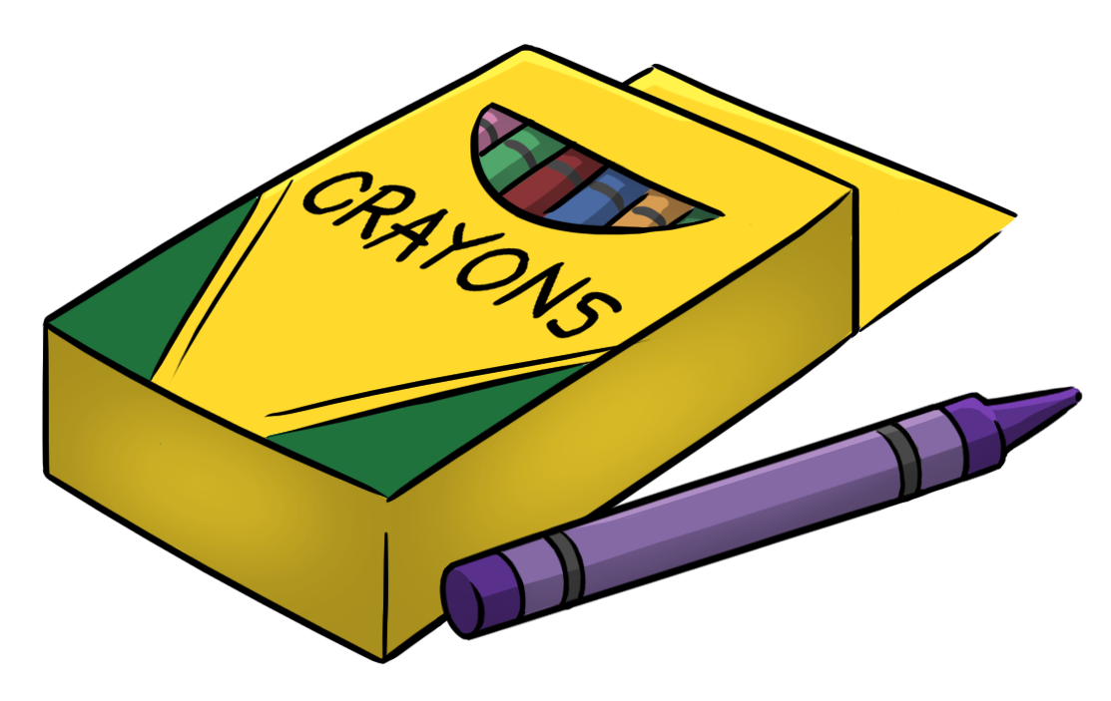
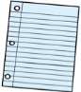
August 2019 Kindergarten ELA Plans
Sunday | Monday | Tuesday | Wednesday |  | Thursday | Friday | Saturday
 |  |  |  |  | 1 | 2 | 3
4 | 5 | 6 | 7 |  | 8 | 9 | 10
11 | 12 | 13 | 14 |  | 15 | 16 | 17
18 | 19 | 20 | 21 |  | 22 | 23 | 24
 |  |  | Teacher  In-Service |  | Teacher  In-Service | Teacher  In-Service
25 | 26 | ABC Inventory 27 |  | ABC Inventory 28 | ABC Inventory 29 | 30 | 31
Start Smart  Unit 0 Week 1  HFW: I | Kdg. Orientation  First Day of School | Chester  Rules/Routines  2:20 Back to School Assembly |  | Pete the Cat Tour | Aa  Letter a Apple  2:00 CherryDale 2:35 Dismissal | No School Labor Day
September 2019 Kindergarten ELA Plans
Sunday | Monday | Tuesday | Wednesday |  | Thursday | Friday | Saturday
August 25 | 26 | 27 | 28 |  | 29 | 30 | 31
Start Smart Unit 0 Week 1 | Kdg. Orientation  1st Day of School  DIBELS: LNF, FSF & Phonics Screener  -- Sept. 3rd – 10th | ABC Inventory  Chester  Rules/Routines | ABC Inventory  Pete the Cat Tour |  | Aa  Letter a Apple  2:00 CherryDale 2:35 Dismissal | No School Labor Day
September 1 | 2 | 3 | 4 |  | HS Open House 5 | 6 | 7
Start Smart  Unit 0 Week 1  HFW: I  *1st Rdg, HW | No School Labor Day | Bb  Big Yellow Bus | Cc, Dd  Pete The Cat I Love My Shoes |  | Ee, Ff  Elmer the Elephant | Gg, Hh  Handprint Pete
8 | 9 | 10 | 11 |  | ES Open House 12 | 13 | 14
Start Smart  Unit 0 Week 2  HFW: can | Ii, Jj | Kk, Ll | Mm, Nn  Mouse ABC Cookie Game |  | Oo, Pp  Octopus | Qq, Rr  Quilt
15 | 16 | Picture Day 17 | 18 |  | 19 | 20 | 21
Start Smart  Unit 0 Week 3  HFW: Review I, can | Ss, Tt  Letter S Snake | Uu, Vv  Umbrella Walk | Ww, Xx  Watermelon Fingerprint |  | Yy, Zz  Zebra Slider  2:30 Officer Phil | ABC Review  Molly Mouse 12:35 Dismissal
22/29 | 23/30 | 24 |  | 25 | 26 | 27 | 28
Unit 1 Week 1  Mm  HFW: the, -am | HALL – Pete Display: Names on shoes, Kids make Pete on yellow paper / “I like ___ apples.” w/Johnny Appleseed  ROOM – Pete handprint/Pencil Name Craft/Lacey Walker Owl  LFO – School Rules, Making Friends, Apples, Sharing

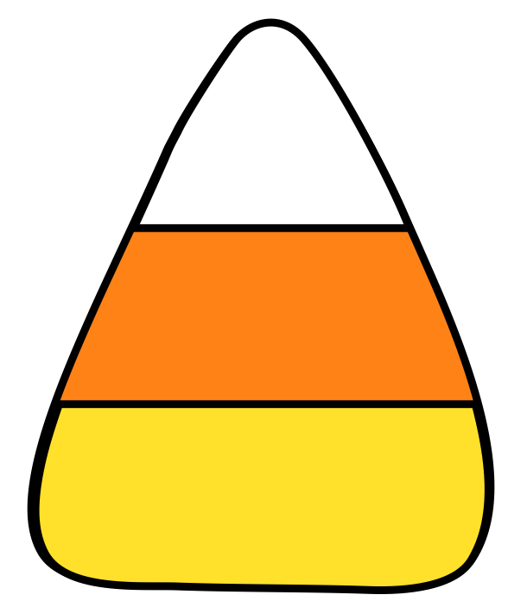
October 2019 Kindergarten ELA Plans
Sunday | Monday | Tuesday | Wednesday | Thursday | Friday | Saturday
September 29 | 30 | October 1 | Marathon Fun Day 2 | HS Visit 9:30 3 | 4 | 5
Unit 1 Week 2  Aa  HFW: we, -ap  Homecoming Week | Comprehension:  The Biggest Apple Ever | TOPIC: Apples |  | Writing:  Read story: When We’re Together  We can_________.
6 | 7 | 8 | 9 | 10 | 11 | 12
Unit 1 Week 3  Ss  HFW: see | Comprehension: There Was an Old Mummy Who Swallowed a Spider | TOPICS: Spiders, Spider Handprint facts page, Make glyph scarecrow |  | Writing:  I see a ___ spider on the _________.
13 | 14 | 15 | 16 | Fire Truck 17 | 18 | 19
Unit 2 Week 1  Pp  HFW: a, is, -an | Teacher  In-Service | Comprehension: Spark the Firefighter | TOPIC: Fire Safety | Writing:  I like to ____ in the fall. (pumpkin page for hallway)
Red Ribbon Week 20 | 21 | 22 | 23 | 24 | 25 | 26
Unit 2 Week 2  Tt  HFW: like, be, -at | Comprehension:  Bat Jamboree | TOPIC: Bats |  | Writing:  Write 2 facts about bats. | 12:35 Dismissal
27  Unit 2 Week 3  Review Week  HFW: review | 28  Comprehension:  Leaf Trouble  HALL – Pumpkin Writing “What I like to do in the fall.”, Leaf Sponge Painting  ROOM – “Along Came A Spider!” Handprint and Spider Facts  LFO – Pumpkins, Autumn, Firefighters, Trees and Leaves | Picture ReTake Day 29 | End of 9 Weeks 30  Writing: Runaway Pumpkin | Trick-or-Treat 31  Fall Fest | November 1  Make Veteran Guy for the main lobby Molly Mouse | 2

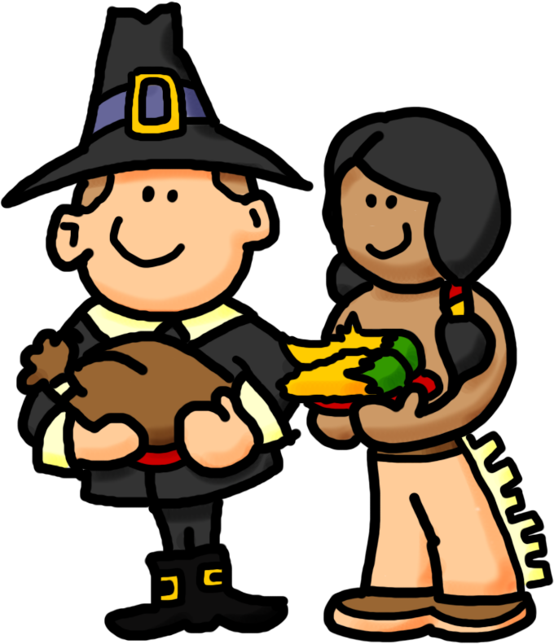
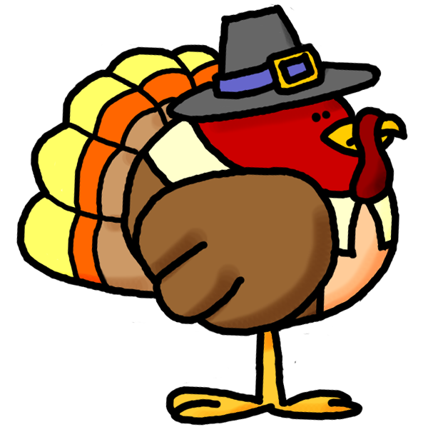
November 2019 Kindergarten ELA Plans
Sunday | Monday | Tuesday | Wednesday | Thursday | Friday | Saturday
October 27 | 28 | Picture ReTake Day 29 | End of 9 Weeks 30 | Trick-or-Treat 31 | November 1 | 2
Unit 2 Week 3  Review Week  HFW: review | Comprehension:  Leaf Trouble |  | Writing: Runaway Pumpkin | Fall Fest | Make Veteran Guy for the main lobby Molly Mouse
3 | 4 | 5 | 6 | Report Cards 7 | 8 | 9
Unit 3 Week 1  Ii  HFW: to, out, -it | Comprehension:  Turkey Tot  GR | GW – Writing:  Veterans’ Day  (for lobby) | GR  ACT: Turkey Directed Drawing/Painting | Test 3.1 today | Veterans’ Day Assembly  Intro 3.2 - Send HW  2:35 Dismissal
10 | 11 | 12 | 13 | 14 | 15 | 16
Unit 3 Week 2  Nn  HFW: and, -in  Gingerbread Unit | No School  Veterans Day | Parent Conferences | GR | GR | Molly Mouse  Test 3.2
17 | 18 | 19 | 20 | 21 | Chuck E Cheese 11:00 22 | 23
Unit 3 Week 3  Cc  HFW: go, no, -ip | Comprehension:  Pete the Cat Saves Christmas |  | HALL – Glyph Scarecrows; Sponge Paint on leaf cutouts  ROOM – Pilgrim Pete; Turkey Directed Drawing watercolors); 2 sided Indian/Pilgrim  LFO – Hibernation, Veterans Day, Thanksgiving, Winter Holidays
24 | 25 | 26 | 27 | 28 | 29 | 30
 | Pilgrims | Indians | Thanksgiving Centers  with Parents  2:35 Dismissal | Thanksgiving Vacation | Thanksgiving Vacation

December 2019 Kindergarten ELA Plans
Sunday | Monday | Tuesday | Wednesday | Thursday | Friday | Saturday
1 | 2 | 3 | 4 | 5 | 6 | 7
Unit 4 Week 1  Oo  HFW: you, help,  -ot | No School  Deer Season | Comprehension:  How Santa Got  His Job |  |  | 12:35 Dismissal
Santa Shop 8 | 9 | 10 | 11 | 12 | 13 | 14
Unit 4 Week 2  Dd  HFW: do, give,  -op | Comprehension:  Turkey Claus |  |  | Writing:  Letter to Santa | Molly Mouse  Send 4.3 HW
15 | 16 | 17 | 18 | 19 | 20 | 21
Unit 4 Week 3  Review Week  HFW: up, down,  -og | Intro 4.3 | Comprehension:  Polar Opposites | Christmas Centers with Parents – Wear PJ’s | Christmas Activities | Christmas Party  2:35 Dismissal
22 | 23 | 24 | 25 | 26 | 27 | 28
Unit 4 Week 3  Review Week  HFW: up, down,  -og | Christmas Vacation | Christmas Vacation | Christmas Vacation | Christmas Vacation | Christmas Vacation
29 | 30 | 31 | January 1 | 2 | 3 | 4
 | Christmas Vacation | Christmas Vacation | New Year’s Vacation | HALL – Triangle Christmas Tree with mini ornaments  ROOM – Rudolph’s Reindeer Cousin Writing & Craft  LFO – Hibernation, Veterans’ Day, Thanksgiving, Winter Holidays

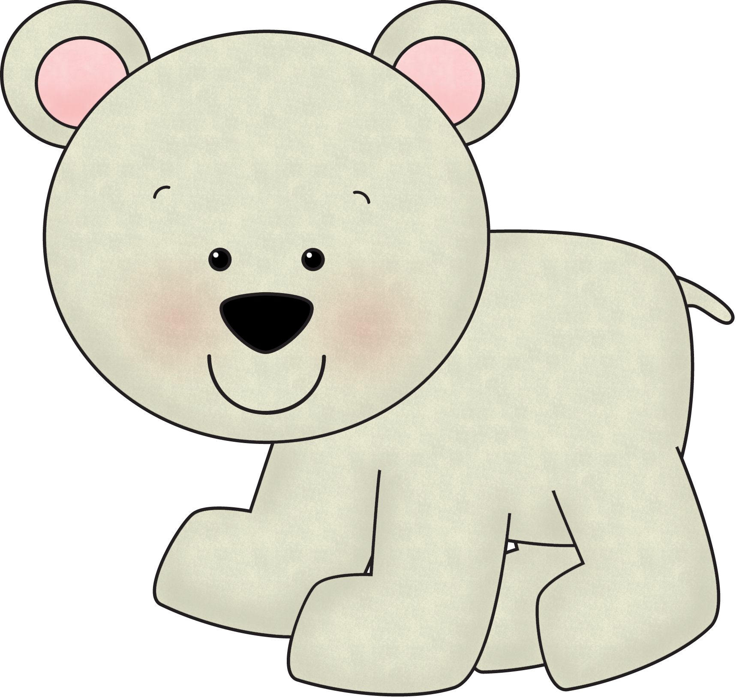
January 2020 Kindergarten ELA Plans
Sunday | Monday | Tuesday | Wednesday |  | Thursday | Friday | Saturday
December 29 | 30 | 31 | January 1 |  | 2 | 3 | 4
Unit 4 Week 3  Review Week  HFW: up, down,  -og | Christmas Vacation | Christmas Vacation | New Year’s Vacation |  | Comprehension:  Polar Opposites | Test 4.3
5 | 6 | 7 | 8 |  | 9 | 10 | 11
Unit 5 Week 1  Hh  HFW: my, that, there | Comprehension:  Sneezy the Snowman |  |  |  | Writing:  Favorite Snow Activity
12 | 13 | 14 | 15 |  | 16 | 17 | 18
Unit 5 Week 2  Ee  HFW: are  -ed | Comprehension:  Penguin’s Big Adventure | TOPIC: Penguins | Writing:  2 Facts About Penguins |  |  | Molly Mouse  12:35 Dismissal
19 | 20 | End of 9 Weeks 21 |  | 22 | 23 | 24 | CNY 25
Unit 5 Week 3  Ff, Rr  HFW: with, he  -et | No School MLK Day | Comprehension:  Penguin’s Big Adventure |  |  | Writing:  _________________ |  | Year of the Pig
26 | 27 | 28 |  | Report Cards 29 | 30 | 31 | February 1
Unit 6 Week1  Bb, Ll  HFW: little  -en | Comprehension:  Hedgehog’s 100th Day of School | HALL –  ROOM – Kid Catching Snowflake on Tongue  LFO –Dr. King, Animals of The Mitten; Polar Animals, Snow & Ice |  |  | Writing:  If I had $100 | Groundhog Day Activities

February 2020 Kindergarten ELA Plans
Sunday | Monday | Tuesday | Wednesday | Thursday | Friday | Saturday
January 26 | 27 | 28 | Report Cards 29 | 30 | 31 | February 1
Unit 6 Week1  Bb, Ll  HFW: little  -en | Comprehension:  Hedgehog’s 100th Day of School |  |  | Writing:  If I had $100 | Groundhog Day Activities
2 | 3 | 100th Day of School 4 | 5 | 6 | 7 | 8
Unit 6 Week 2  Kk, ck  HFW: she, was,  Short e review | Comprehension:  The Snow Globe Family |  |  | Writing:  _________________
9 | 10 | 11 | 12 | 13 | 14 | 15
Unit 6 Week 3  Review Week  HFW: review | Comprehension:  I Already Love You |  |  | Writing:  Who do you love? | Molly Mouse  Valentine’s Day Party 2:30
16 | 17 | 18 | 19 | 20 | 21 | 22
Unit 7 Week1  Uu  HFW: for, have  -ub | Act 80  No School for Students | Comprehension:  Hug Machine |  | Writing:  Thing 1 & Thing 2 | LOBBY – Thing 1 & 2 Handprint & Writing
23 | 24 | 25 | 26 | 27 | 28 | 29
Unit 7 Week 2  Gg & gl blend HFW: of, they  -ug | Comprehension:  Tooth Fairy Wars  HALL –  ROOM – Kid Catching Snowflake on Tongue  LFO – Groundhog Day; Presidents’ Day; Valentine’s Day; Dental Health |  |  | Writing:  _________________ |  | Happy Leap Year!

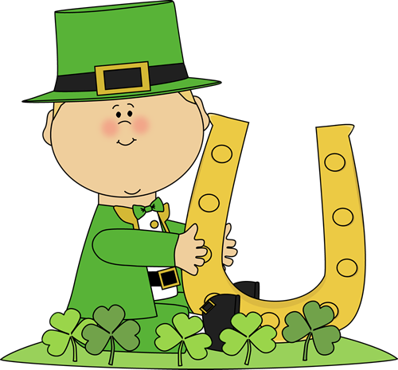
March 2020 Kindergarten ELA Plans
Sunday | Monday | Tuesday | Wednesday | Thursday | Friday | Saturday
1 | 2 | 3 | Kdg. Registration 4 | 5 | 6 | 7
Unit 7 Week 3  Xx, Vv & sl blend  HFW: said, want  -un | Dr. Seuss Activities | Comprehension:  Truck Full of Ducks |  | Writing:  _________________
Musical Week 8 | Kdg. Testing 9 | Kdg. Testing 10 | 11 | 12 | 13 | 14
Unit 8 Week 1  Jj, Qq & cl blend  HFW: here, me  -ut | Comprehension:  Green Shamrocks |  |  | Writing:  _________________
15 | 16 | 17 | 18 | 19 | 20 | 21
Unit 8 Week 2  Yy, Zz  HFW: this, what,  short u review | Comprehension:  The Koala Who Could |  |  | Writing:  _________________ | Send 4.3 HW  12:35 Dismissal
22 | 23 | 24 | End of 9 Weeks 25 | Reading Night 26 | 27 | 28
Unit 8 Week 3  Review Week  HFW: review | No School  (SD #2) | Comprehension:  Click, Clack, Peep!  The Cow That Laid the Egg |  | Writing:  _________________ | Molly Mouse
29 | 30 | 31 | April 1 | 2 | 3 | 4
Unit 9 Week 1  Long Aa  Digraph sh  HFW: help, too | Comprehension:  Click, Clack, Peep!  The Cow That Laid the Egg | HALL – Cat in the Hat & Fav. Dr. Seuss Book  ROOM –  LFO – Read Across America, Weather, St. Patrick’s Day, Baby Animals |  | Writing:  _________________

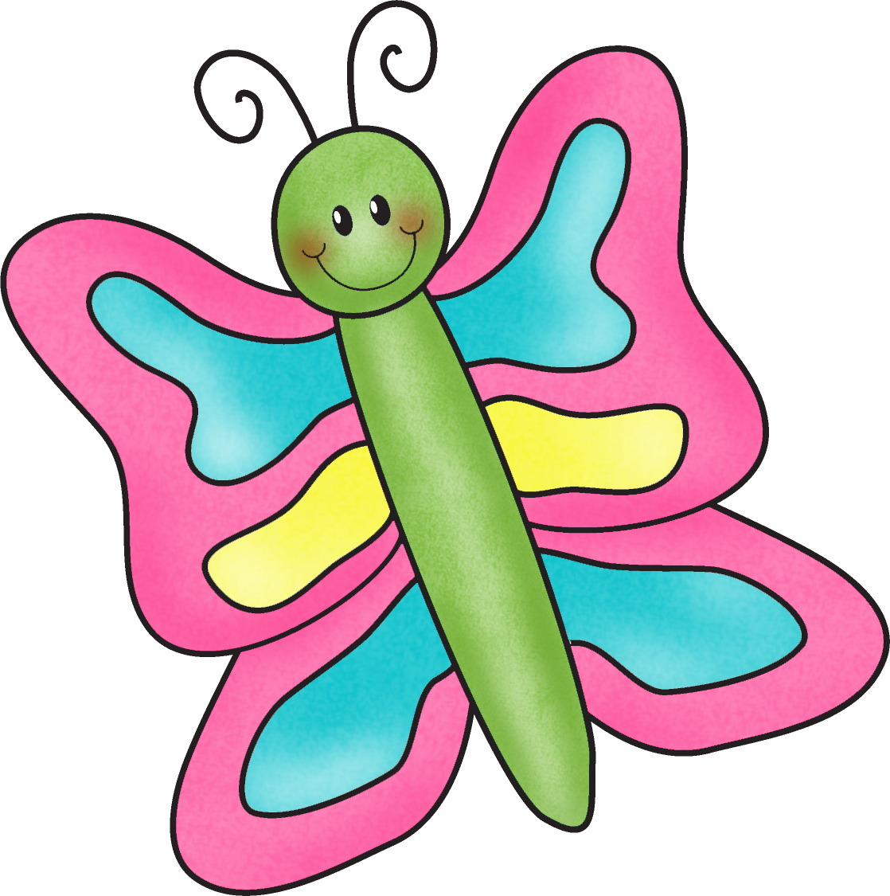
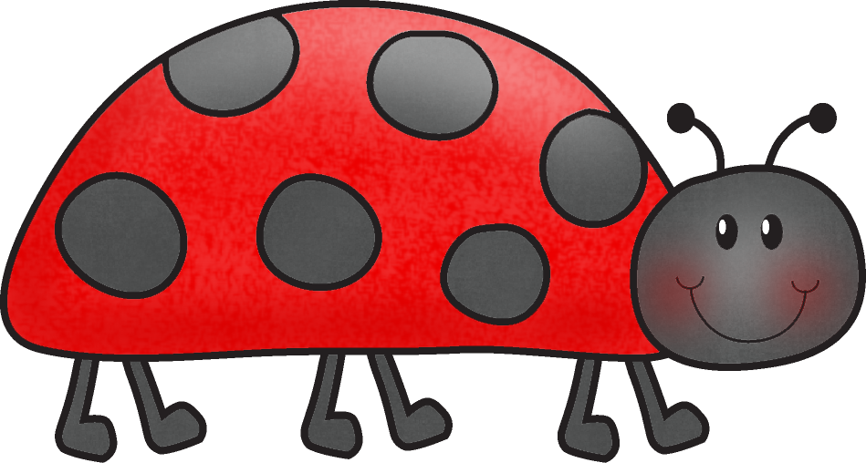
April 2020 Kindergarten ELA Plans
Sunday | Monday | Tuesday | Wednesday | Thursday | Friday | Saturday
March 29 | 30 | 31 | April 1 | Report Cards 2 | 3 | 4
Unit 9 Week 1  Long Aa  Digraph sh  HFW: help, too | Comprehension:  Click, Clack, Peep!  The Cow That Laid the Egg |  |  | Writing:  _________________
5 | 6 | 7 | 8 | 9 | 10 | 11
Unit 9 Week 2  Long Ii  Digraph sh  HFW: has, play | Easter Activities | Comprehension:  Click, Clack, Peep!  The Cow That Laid the Egg | Easter Centers  2:35 Dismissal | Easter Vacation  (SD #3) | Easter Vacation
12 | 13 | 14 | 15 | 16 | 17 | 18
Unit 9 Week 2  Long Ii  Digraph sh  HFW: has, play | Easter Vacation | Comprehension:  I Love Cake |  |  | Molly Mouse
ELA PSSAs 19 | 20 | 21 | 22 | 23 | 24 | 25
Unit 9 Week 3  Long Oo  HFW: where, look | Comprehension:  Whoosh Went the Wind |  | EARTH DAY | Writing:  _________________ | 12:35 Dismissal
MATH/Sci PSSAs 26 | 27 | 28 | 29 | 30 | May 1 | 2
Unit 10 Week 1  Long Uu  HFW: good, who | Comprehension:  Miss Fox’s Class Goes Green | HALL – Cloud Parade Writing; Count by 10s Ice Cream Cones  ROOM – Bunny Directed Drawings with watercolors; Bunny Bags  LFO – Signs of Spring, Earth Day, Butterflies, Plants |  | Writing:  _________________
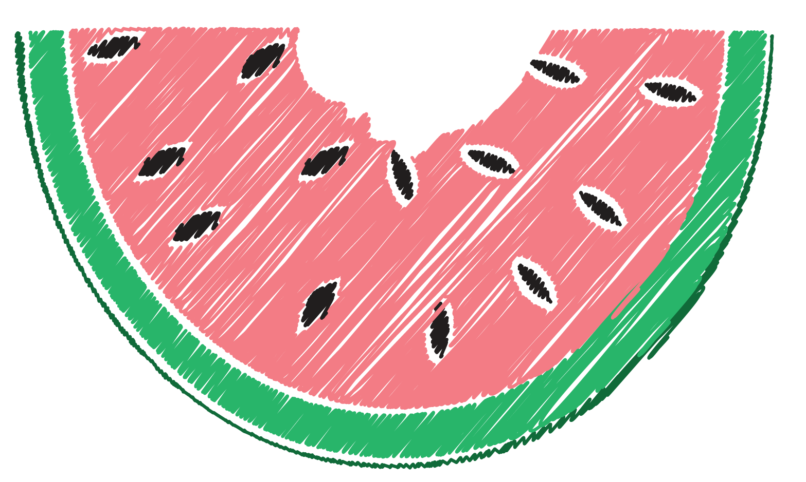
May 2020 Kindergarten ELA Plans
Sunday | Monday | Tuesday | Wednesday | Thursday | Friday | Saturday
3 | 4 | 5 | 6 | 7 | 8 | 9
Unit 10 Week 2  Long Ee  Digraph th  HFW: comes, does | No School  (SD #2) | Comprehension:  One Day in the Eucalyptus, Eucalyptus Tree |  | Writing:  _________________  K/1 Concert 7:00
10 | 11 | 12 | 13 | 14 | 15 | 16
Unit 10 Week 3  Long Vowels  HFW: review | Comprehension:  There Was and Old Lady Who Swallowed a Cow | Kdg. Field Trip to Farm |  | Writing:  _________________
LAST HW! 17 | 18 | 19 | 20 | 21 | 22 | 23
 | PreSchool Visit – AM  Incredible Cow – PM | Camp  Read- A- Lot | Camp  Read- A- Lot | Writing:  _________________  Camp  Read- A- Lot  2:35 Dismissal | No School  (SD #1)
24 | 25 | 26 | 27 | 28 | 29 | 30
Camp  Read- A- Lot | No School Memorial Day | Molly Mouse  Camp  Read- A- Lot | Camp  Read- A- Lot | Q & U Wedding | Camp  Read- A- Lot
31 | June 1 | Baccalaureate 2 | 3 | 4 | 5 | 6
Camp  Read- A- Lot | Camp  Read- A- Lot | Camp  Read- A- Lot | Last Student Day  HALL – Welcome to Camp Kindergarten Reg. Form & Sleeping Bag Kid  LFO – Summer Safety, Sea Turtles; Rainbow Fish; Mother’s Day/Father’s Day | Teacher  In-service

