CELL PHONE POLICY
- All cell phones will be turned in at the beginning of class
  - Refusal = defiance = major referral
- Students are only permitted to use cell phones when specifically stated by the teacher.
- You must turn in your device before leaving the room to go to the bathroom, your locker, etc. (during enrichment)
- You are never to take pictures or video.
- You may earn the privilege to use devices during enrichment. You may be given permission for part of enrichment as long as you have completed all of your schoolwork and you have used the majority of your time productively.
- If the cell phone policy is violated, the following will occur:
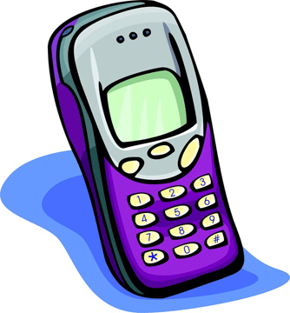
  - First offense – warning
  - Second offense –referral & parent contact
  - Third offense – 2nd referral & parent contact

(Cut here)
I have read, understand, and agree to abide by the above stated cell phone policy. In the event a violation occurs, I understand and will willingly accept the corresponding consequence.
Student Name (Printed): ______________________________________
Student Signature: ___________________________________________
Parent Name (Printed): _______________________________________
Parent Signature: ____________________________________________

