E-message #13 – Designating Schools for Support – Next Steps in the Process

Dear Colleagues,
The Pennsylvania Department of Education (PDE) is committed to sharing regular updates on the implementation of the approved Every Student Succeeds Act (ESSA) Consolidated State Plan and the Future Ready PA Index. This communication provides additional information on the process of designating and supporting schools for Comprehensive Support and Improvement (CSI) or Targeted Support and Improvement (TSI).
Under ESSA, states are required to craft and implement a system of school accountability—what ESSA calls “Annual Meaningful Differentiation.” Three key principles in the design of Pennsylvania’s system of Annual Meaningful Differentiation are:

- Equity: Identifying and focusing resources on schools and students in the greatest need of support;
- Transparency: Providing educators, parents and families, and other stakeholders with clear and meaningful reports on both school and student group performance; and
- Innovation: Leveraging flexibility to broaden conceptions of school progress, focusing on both academic and student success measures.

Beginning November 2018, Pennsylvania’s federal accountability indicators will be published and disaggregated by student group—via the Future Ready PA Index, a comprehensive framework of school progress measures that draws on feedback from thousands of stakeholders including educators, parents, and students. These indicators are academic achievement and academic growth, measures of English learner progress, high school graduation rate, chronic absenteeism (reported as regular attendance), and career readiness. It is important to note that Future Ready PA Index will report additional measures not utilized for federal accountability determinations such as data from locally-identified formative assessment systems and a range of postsecondary outcome and workforce data.

Annual Meaningful Differentiation

CSI designations will be based on school-wide performance, focusing on ESSA’s requirements to serve the lowest-performing 5 percent of all schools receiving Title I funds in the State. In addition, any high school, Title I or not, with a two-year combined 4- and 5-year adjusted cohort graduation rate of 67 percent or below also will be designated as CSI.

Pennsylvania will designate CSI schools using a three-step system of annual meaningful differentiation. Consistent with federal requirements, TSI designation will occur when one or more student groups in a school perform below the performance levels established through this three-step system, regardless of Title I status. For more specific information on CSI and TSI identification procedures, refer to E-messages #11 and #12 located on PDE’s Future Ready PA Index website: http://www.education.pa.gov/Pages/Future-Ready-PA.aspx.

Next Steps in Process

Pennsylvania will identify schools for CSI and TSI for the first time in late fall 2018. Prior to the public designation required by ESSA, the Department will provide preliminary notifications to superintendents and chief charter school administrators from local education agencies (LEAs) in which one or more schools are identified for CSI and or TSI. These same administrators will be invited to regional workshops to meet with Department staff and receive briefings on resources, supports, and methods of communication that will be made available, as well as next steps in the process.

Theory of Action

Pennsylvania has developed a “theory of action” that defines how the Department will support, provide resources, and monitor school improvement efforts of LEAs, schools, and their communities. As part of the theory of action, the Department is committed to:
- Meaningfully engaging stakeholders in designing, implementing, and monitoring a system of support for continuous improvement;
- Implementing a results-oriented cycle of improvement;
- Fostering a culture of evidence-based policies and practices; and
- Deploying regional systems of differentiated resources, supports, and interventions responsive to
LEAs’ and schools’ highest-priority needs.

LEAs will be accountable and empowered to serve schools designated for support and improvement by:
- Establishing high-quality instructional programs;
- Supporting their schools and communities in removing barriers to learning;
- Customizing support systems to meet the local needs and context of each school;
- Implementing data-informed human capital systems; and
- Organizing and allocating resources based on the needs of each school and its community.

Schools and their communities will be accountable and empowered to provide effective, engaging instruction within a supportive culture by:
- Supporting effective instructional practices in all classrooms;
- Fostering collective responsibility for the academic, social, emotional, and behavioral outcomes of all students;
- Cultivating a safe, positive, and supportive climate conducive to learning; and
- Providing high-quality professional opportunities for all administrators, teachers, and support staff.

School Improvement Plans and Implementation

All schools designated as CSI or TSI are required to develop School Improvement Plans. School plans are to be completed and approved by July 1, 2019.

CSI and TSI School Improvement Plans will be approved and monitored differently, as indicated below:

Designation | Improvement Plan Length | Final Plan Approved by:
Comprehensive Support and Improvement (CSI) | 4-Year Plan (2018-2022) | Assigned Regional Improvement Team
Targeted Support and Improvement (TSI):  Title I School | 4-Year Plan (2018-2022) | Regional IU Director
Targeted Support and Improvement (TSI):  Non-Title I School | Plan length determined by LEA | Board of School Directors/Trustees
As a first step in developing improvement plans, the Department will work alongside LEAs, schools, and their communities to conduct a comprehensive needs assessment and root cause analysis to identify tailored, evidence-based practices that reflect local conditions and context using the Essential Practices for Schools. The Essential Practices for Schools focuses on continuous improvement of instruction, empowering leadership, providing student-centered supports, and fostering quality professional development for all staff. Additional information on the Essential Practices for Schools and the needs assessment and improvement planning processes will be provided at the regional meetings in late November. In the interim, you can learn more about our approach to support and improvement by reading about our school improvement pilot.

Additional information concerning CSI and TSI will be made available on the ESSA webpage of PDE’s website over the next few months. You also are welcome to send any thoughts or questions to our team at ra-edfuturereadypa@pa.gov.

Thank you for your continued work with Pennsylvania students and your partnership in implementing the state’s ESSA Plan and the Future Ready PA Index.

Sincerely,

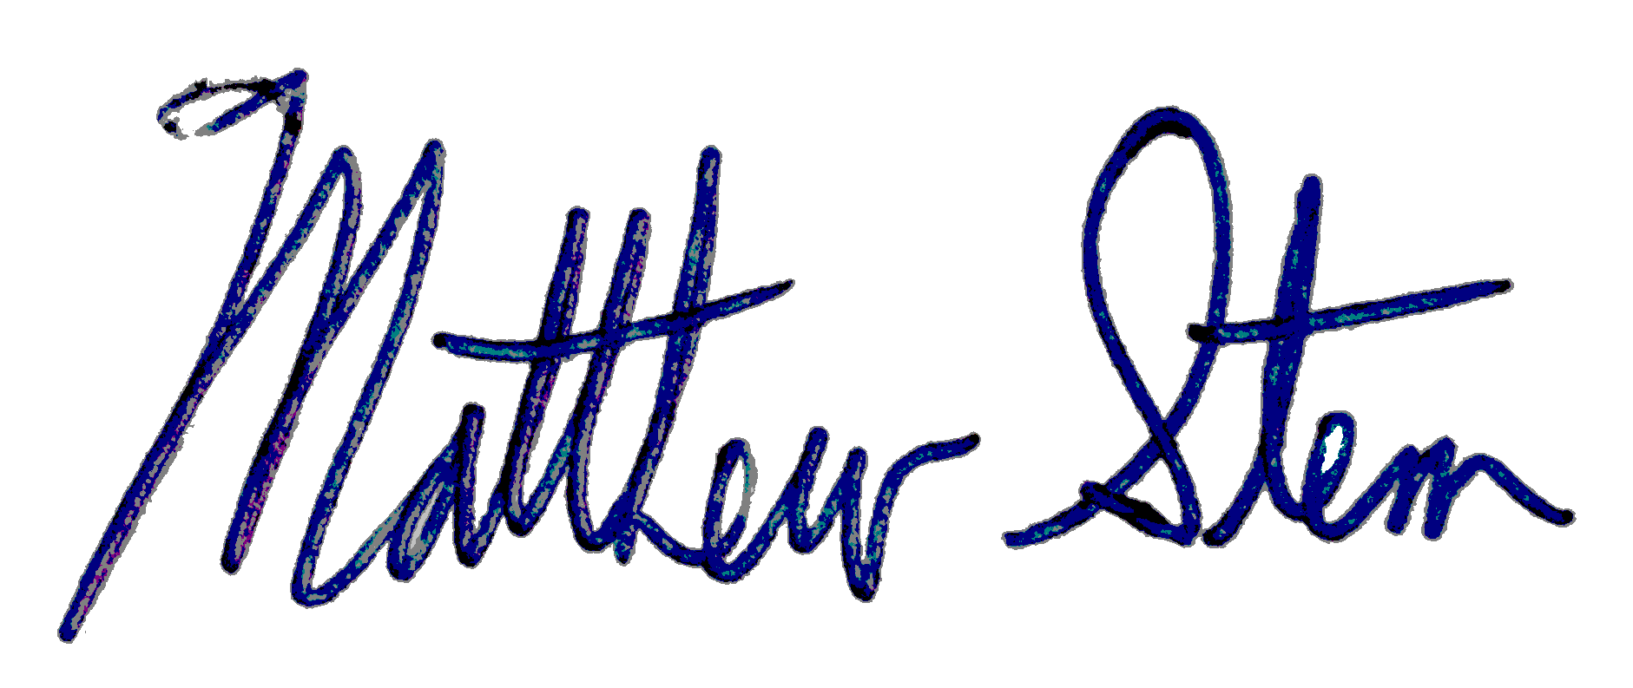

Matthew S. Stem
Deputy Secretary for Elementary and Secondary Education
Pennsylvania Department of Education

