A Day | MP1
B Day | Gym
C Day | 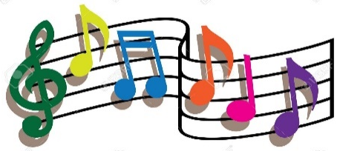  Music
D Day | Computer
E Day | Library
F Day | Computer
A Day | MP2
B Day | Gym
C Day | Music
D Day | Computer
E Day | Library
F Day | Library
A Day | MP3
B Day | Gym
C Day | Music
D Day | Computer
E Day | Library
F Day | Gym
A Day | MP4
B Day | Gym
C Day | Music
D Day | Computer
E Day | Library
F Day

