OPPOSITE SIDES OF A PENNY

By Stephen Vincent Benet, “Alexander Hamilton”

Jefferson said, “The many!”

Hamilton said, “The few!”

Like opposite sides of a penny

were those exalted two.

If Jefferson said, “It’s black, sir!”

Hamilton cried, “It’s white!”

But, ‘twixt the two, our Constitu-

tion started working right.

Hamilton liked the courtly, Jefferson liked the plain,

They’d bow for a while, but shortly

The fight would break out again.

H. was the stripling Colonel

That Washington loved and knew,

A man of mark with a burning spark

Before he was twenty-two.

1. What is the overall theme of this poem?

2. Cite evidence that favors Hamilton.

3. Cite evidence that favors Jefferson.

4. Whom do you think Benet favors?

He came from the warm Antilles

Where the love and the hate last long,

And he thought most people sillies

Who should be ruled by the strong.

Brilliant, comely and certain,

He generally got his way,

Till the sillies said, “We’d rather be dead,”

And then it was up to J.

He could handle the Nation’s dollars

With a magic that’s known to few,

He could talk with the wits and scholars

And scratch like a wildcat, too.

And he yoked the States together

With a yoke that is strong and stout.

(It was common dust that he did not trust

And that’s where J. wins out.)

C:\Documents and Settings\jstemler\Local Settings\Temporary Internet Files\Content.IE5\9PG8XC00\MC900151405[1].wmf VS 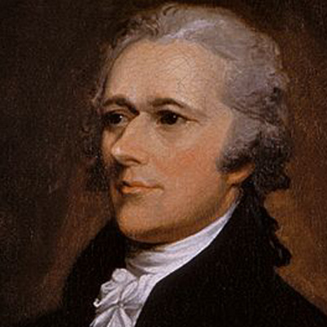

Jefferson Hamilton