**Cotton Production**

**Land**

**Settlement**

**Two Types of Cotton**

**Effects of the Cotton Gin**

**Inventor:**

**Year:**

**Cotton Gin**

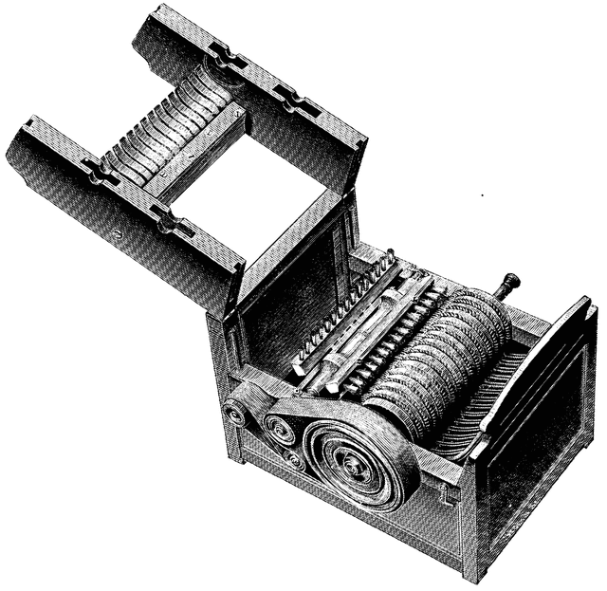

**Southern Society**

**Slavery**

**Native Americans**