Name
Chapter 1: Introduction: Themes in the Study of Life

This chapter will serve as a review of biological concepts that you may have learned in an earlier course and give you an overview of what you will study this year. It introduces the major themes of biology and provides a foundation for understanding scientific inquiry.

- In the overview, Figure 1.2 recalls many of the properties of life. Label the seven properties illustrated in the following figure, and give a different example of each.

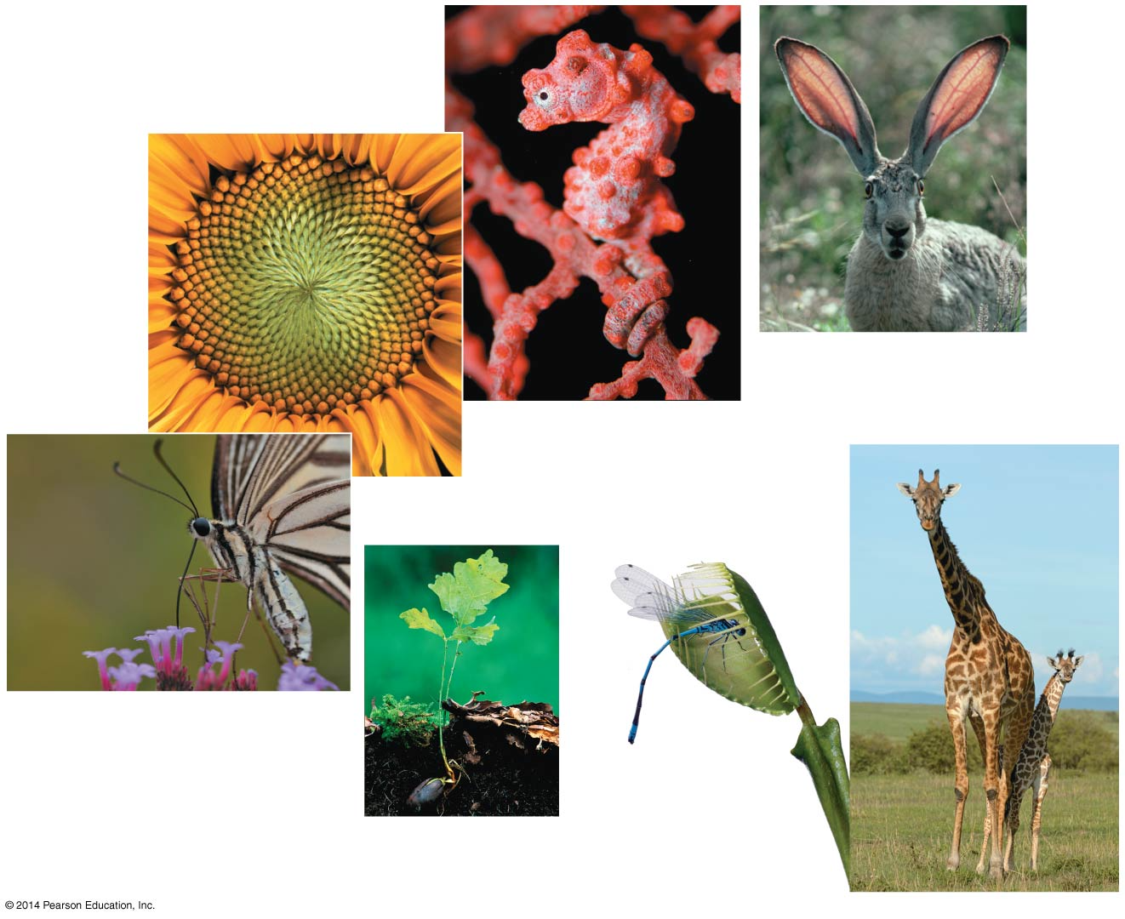

Concept 1.1 The study of life reveals common themes

- What are emergent properties? Give two examples.

- Life is organized on many scales. Figure 1.3 zooms you in from viewing Earth from space all the way to the level of molecules. As you study this figure in your text, write in a brief definition of each level.

biosphere:

ecosystems:

communities:

populations:

organisms:

organs/organ systems:

tissues:

cells:

organelles:

molecules:

- Our study of biology will be organized around recurring themes. Make a list here of the themes that are presented, and give an example that illustrates each theme. Your AP Biology course is organized around four Big Ideas. In the “AP” column, place the number of the corresponding AP Big Idea. Watch for these themes and Big Ideas throughout your study this entire year. This will help you see the big picture and organize your thinking. (Go to the Summary of Key Concepts that begins on page 24 of your text for a concise look at the themes.)

AP | Theme Description | Example

- As you read this section, you will be reminded of things you may have studied in an earlier course. Since this material will be presented in detail in future chapters, you will come back to these ideas, so don’t fret if some of the concepts presented are unfamiliar. However, to guide your study, define these terms as you come to them.

eukaryotic cell:

prokaryotic cell:

genes:

gene expression:

genome:

- Study Figure 1.9. Describe the difference between the movement of energy and the movement of chemicals in an ecosystem.

- Describe three ways in which organisms interact with either other organisms or their environment.

- Big Idea 4 deals with interactions. These interactions can be controlled by feedback regulation. Explain and give an example of each type of feedback.

Negative feedback

Positive feedback

Concept 1.2 The Core Theme: Evolution accounts for the unity and diversity of life

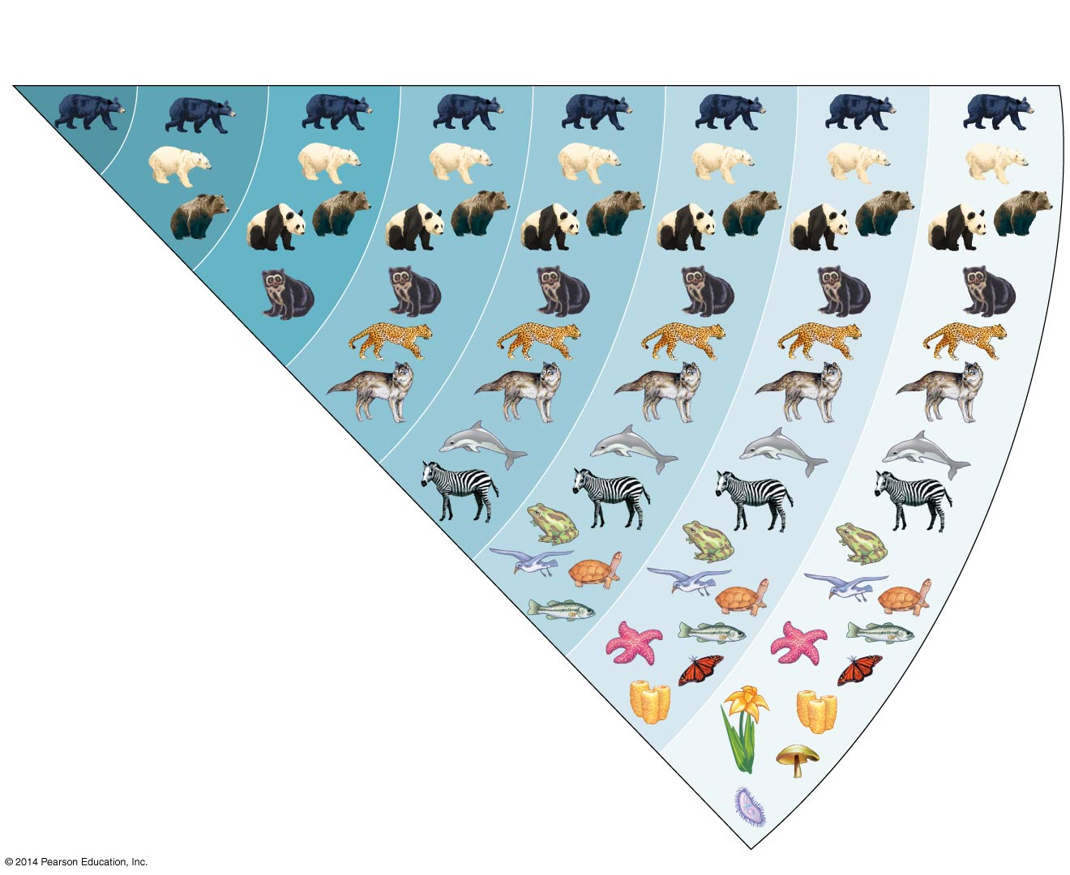
- Life is organized into groups. Study Figure 1.12 in your text, shown here.

  - Which level contains the greatest diversity of organisms?

  - Which level contains the least diversity of organisms?

  - Write out the levels of organization in order, from most inclusive to least.

  - Most people use a mnemonic device to remember these levels. If you have one, write it here.

- Taxonomy is the branch of biology that names and classifies organisms. Because of new molecular information, there have been many changes in placement of certain groups in recent years. All life is now organized into three domains. What are they? Which domain and kingdom do you belong to?

- What two main points were articulated in Darwin’s The Origin of Species?

- What did Darwin propose as the mechanism of evolution? Summarize this mechanism.

- Study Figure 1.20 in your text (found below), which shows an evolutionary “tree.” What is indicated by each twig? What do the branch points represent? Where did the “common ancestor” of the Galápagos finches originate?

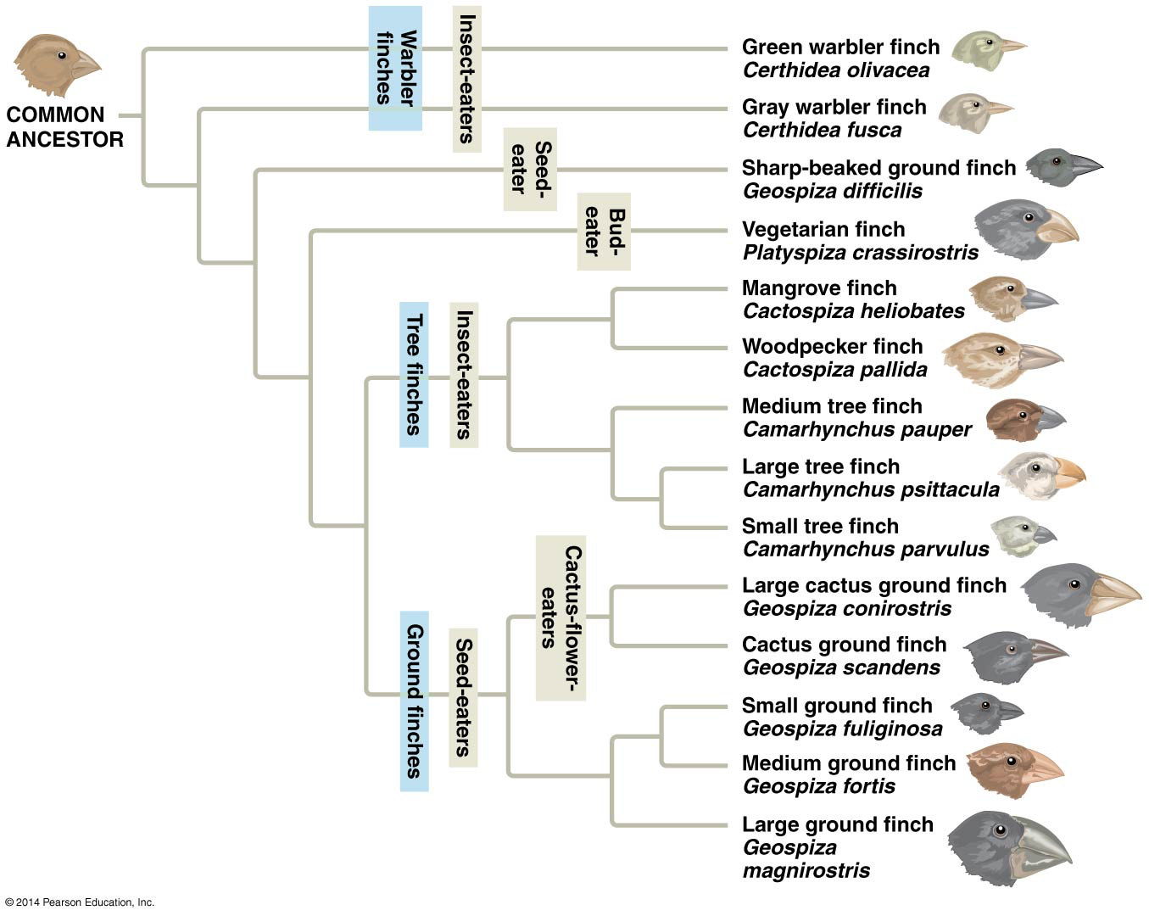

Concept 1.3 In studying nature, scientists make observations and form and test hypotheses

- In your AP Biology course, you will be involved with inquiry. What does this mean, and what may be involved?

- What is data?

- Distinguish between quantitative and qualitative data. Which type would be presented in a data chart and could be graphed? Which type is found in the field sketches made by Jane Goodall?

- In science, how do we define hypothesis?

- A scientific hypothesis has two important qualities. The first is that it is testable. What is the second?

- Can scientific hypotheses be proven? Explain your answer!

- Look at Figure 1.22 in your book. Use it to write a hypothesis using the “If . . . then . . .” format.

- What types of hypotheses do not meet the criteria of science, that is, are not testable?

- Study Figure 1.23 in your book to get a better idea of the scientific process. Notice that it does not follow the steps of what has been called “the scientific method,” but rather shows how making and testing hypotheses is interwoven with other activities to answer questions. This realistically portrays what you will encounter in your own inquiry labs. For example, in what different directions may the data you collect lead?

- What is a controlled experiment?

- Explain the difference between the dependent and independent variable. Understanding this will be useful when you analyze and graph your data.

- The text points out a common misconception about the term controlled experiment. In the mouse coloration experiment, what factors were held constant?

- Explain what is meant by a scientific theory by giving the three ways your text distinguishes a theory from a hypothesis or mere speculation.

Test Your Understanding Answers

Now you should be ready to test your knowledge. Place your answers here: 1. 2. 3. 4. 5. 6. 7. 8. 9. 10.

