Topic 1: Biochemistry and the Molecules of Life

Organic Compounds
Most of the molecules in living things are organic molecules, meaning that they contain carbon. The fact that carbon has 4 electrons in its outermost shell means that it is capable of covalently bonding with other atoms to fill its outermost shell. Organic molecules typically involve carbon bonded to hydrogen, oxygen, nitrogen and other carbon atoms. Carbon atoms bonded to each other form long chains to which atoms or groups of atoms can be attached.

- Organic Molecules - Molecule that always contains carbon (C) and hydrogen (H); organic molecules are associated with living things.
- Electrons - Subatomic particle that has almost no weight and carries a negative charge; orbits in a shell about the nucleus of an atom.
- Covalently Bonding - Chemical bond between atoms that results from the sharing of a pair of electrons.

Polymer Synthesis

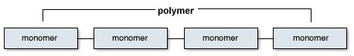
Many organic molecules consist of subunits, called monomers, that are joined together to form what are referred to as polymers.
- Monomers - One of the similar or identical molecules of which a polymer is made.
- Polymers - A macromolecule made by joining many similar or identical molecules [monomers] through similar or identical bonds.
Monomers are joined together by condensation (or dehydration) reactions, which form water molecules in the process. Polymers can also be broken into monomers by hydrolysis reactions, which use water molecules in the process.
Polymers are broken down by Hydrolysis, which is the splitting of a covalent bond by the addition of water.

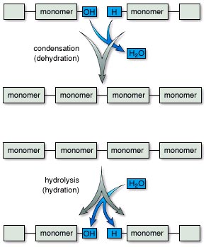

Four Kinds of Organic Molecules
There are 4 major kinds of organic molecules, carbohydrates, lipids, proteins and nucleic acids. Each of these exists as a polymer, composed of the monomers shown in the table.
- Carbohydrates - Organic compound characterized by the presence of CH₂O groups; includes monosaccharides, disaccharides, and polysaccharides; quick energy for the cell
- Lipids - Organic compound that is insoluble in water; notably fats, oils, and steroids; contain C,H and a little O.
- Proteins - Organic compound that is composed of either one or several polypeptides; used for structure, hormones, or enzymes; contain C,H,O,N, and sometimes S
- Nucleic Acids - A polymer of nucleotides; contains the genetic information/code of the cell

