Historical Event Pathfinder

Print Resources

Supreme Court Drama: Cases that Changed America

R 347.73 Bra

Literature and Its Times

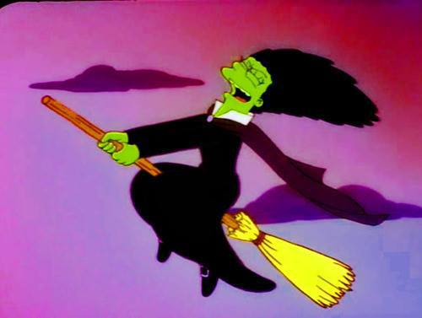
R 809 Lit

Timelines of the 20th Century

R 909.82 Bro

Chronicle of the 20th Century

R 909 Da

Timelines of the 20th Century

R 909.82 Bro

Events that Changed the World in the Twentieth Century

909.82 Ev

Today in History: A Day by Day Review of World Events

909 Tod

Events: A Chronicle of the Twentieth Century

909.82 Ev

Great Events from History

973 Ma

Specialty resources in nonfiction and reference collections

Web Resources

World book Online

**District OPAC

SIRS Decades

History.com

Pennsylvania State Library Digital Collections

https://www.statelibrary.pa.gov/GeneralPublic/Collections/Pages/Digital-Collections-at-the-State-Library-of-Pennsylvania-.aspx

Directory of Open Access Journals

https://doaj.org/

Digital Public Library of America

https://dp.la/

History- Internet Public Library

http://www.ipl.org/IPLBrowse/GetSubject?vid=13&cid=1&tid=6945&parent=6925

HathiTrust Digital Library

https://www.hathitrust.org/

The Internet Archive

https://archive.org/

