Week 5: Child Development
Goal: To promote how Child Development is integrated into FCS programs or career.

We encourage FCS professionals to copy & paste the message below & share throughout your social media platforms. Personalize the message by your own pictures of family and/or things you are teaching your students. Please use the hashtag suggestions ( #SayyestoFCS #FCSeducate#FCSactionPA) in your post.

Post for Facebook/Instagram:

Family and Consumer Sciences teachers teach students who take Child Development classes to identify characteristics in the various stages of child development. Students are also able to identify practices that develop the child’s imagination, creativity and reading and writing skills through literature. These students can analyze plans and methods to blend work and family responsibilities to meet the needs of children. Have you ever thought about how much it costs to raise a child through age 18 or even through a pandemic?
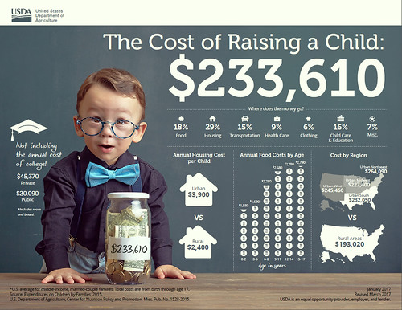https://www.usda.gov/media/blog/2017/01/13/cost-raising-child
#SayyestoFCS #FCSeducate #FCSactionPA

Post for Twitter:
FCS teaches students who take Child Development classes to identify characteristics in various stages of child development. Students are also able to identify practices that develop the child’s imagination, creativity, reading and writing skills through literature.#FCSactionPA

.
Do you need a digital resource for your students?
Research to Practice Tips
https://extension.psu.edu/programs/betterkidcare/early-care

https://www.usda.gov/media/blog/2017/01/13/cost-raising-child

https://extension.psu.edu/programs/betterkidcare/parents-families

https://www.nationwidechildrens.org/family-resources-education/700childrens/2020/05/covid-19-and-kawasaki-disease-what-parents-need-to-know

