NAME: Period

MITOSIS VS MEIOSIS

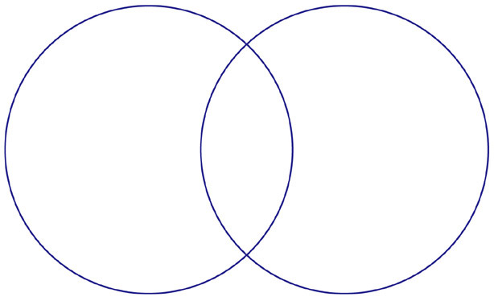
Mitosis

- Division of body cells (somatic cells).
- One round of division.
- Produces 2 cells that are identical to the original cell.
- Final result = the complete set of chromosomes are in the new cells, 46 chromosomes.
Meiosis

- Division of sex cells, sperm and egg (gametes).
- Two rounds of division
- Produces 4 cells that are completely unique from each other.
- Final result = ½ the chromosomes or 23 chromosomes of the original 46.
What is
The SAME?

Both are forms of cell division via replication.

Both produce new cells.



