NAME: Period

MITOSIS VS MEIOSIS

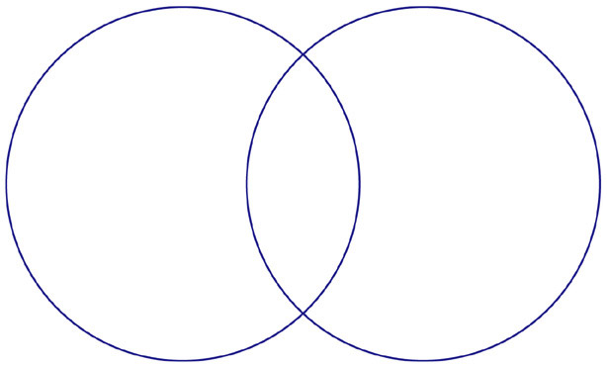
Mitosis

Meiosis
What is
The SAME?



