Outline for the Mid Term 2016/2017
Chapter 1: The Human Body: An Orientation
Full Body Diagrams using Regional Terms:
Acromial
Antebrachial
Antecubital
Axillary
Brachial
Buccal
Carpal
Cervical
Coxal
Crural
Deltoid
Femoral
Frontal
Inguinal
Mental
Orbital
Patellar
Sternal
Tarsal

Calcaneal
Femoral
Gluteal
Lumbar
Occipital
Olecranal
Popliteal
Plantar
Sacral
Scapular
Sural
Vertebral

- Anatomy vs. Physiology
- Levels of Organization of the Human Body
- Basic Functions of the Body Systems
- Homeostatic Control System
  - Positive vs. Negative Feedback Mechanisms
- 5 Survival Needs of Humans
- 8 Necessary Life Function
- Anatomical Orientation and Directional Terms
  - Superior, Cranial, Cephalad
  - Inferior, Caudal
  - Ventral, Anterior
  - Dorsal, Posterior
  - Medial
  - Lateral
  - Intermediate
  - Proximal
  - Distal
  - Superficial, External
  - Deep, Internal
- Body Planes and Section
  - Sagittal
  - Median, Midsagittal
  - Frontal, Coronal
  - Transverse, Cross
Chapter 3: Tissues
Know the description (pictures will help too), function, and location of the following:
- 9 Types of Epithelial Tissue
  - Simple Squamous Transitional
  - Simple Cuboidal Stratified Cuboidal
  - Simple Columnar Stratified Columnar
  - Pseudostratified Glandular
  - Stratified Squamous
- 9 Types of Connective Tissue
  - Bone Areolar
  - Hyanline Adipose
  - Elastic Cartilage Reticular
  - Fibrocartilage Blood
  - Dense Fibrous
- 3 Types of Muscle Tissue
  - Smooth
  - Cardiac
  - Skeletal
- Nervous Tissue
Chapter 4: Skin and Body Membranes
- 4 Types of Body Membranes (Epithelial vs. Connective)
  - Epithelial
    - Cutaneous
    - Mucous
    - Serous (Peritoneum, Pleura, Pericardium)
  - Connective
    - Synovial
- Functions of the Integumentary System
- Layers of Skin
  - Epidermis
    - Stratum basale
Other Terms to Know:
Keratin
Hypodermis
Keratinocytes
Melanin
Melanocytes:
Carotene

    - Stratum spinosum
    - Stratum granulosum
    - Stratum lucidum
    - Stratum corneum
  - Dermis
    - Papillary layer
      - Dermal papillae
    - Reticular layer
- Types of Glands
  - Exocrine
  - Sebaceous
  - Sudoriferous
  - Eccrine
  - Apocrine
- Homeostatic Imbalances
  - Cyanosis
  - Jaundice
  - 3 Types of Burns (Rule of Nines)
    - First, Second, and Third Degree
  - 6 Types of Infections and Allergies
    - Athletes Foot, Boils and Carbuncles, Cold Sores, Contact Dermatitis, Impetigo, Psoriasis
  - 3 Types of Skin Cancer (ABCD Rule)
    - Basal Cell Carcinoma, Squamous Cell Carcinoma, Malignant Melanoma
Chapter 5: Skeletal System
- Axial vs. Appendicular
- 5 Functions of the Bones
- Classification of Bones
  - Compact Short
  - Spongy Flat
  - Long Irregular
- Gross Anatomy
  - Diaphysis
  - Epiphyses
    - Epiphyseal line, Epiphyseal Plate, medullary cavity
    - Yellow vs. Red bone marrow
- Microscopic Anatomy
  - Osteocytes Central Canals Perforating Canals
  - Lacunae Osteon
  - Lamella Canaliculi
- Homeostatic Imbalances
  - Rickets Pannus
  - Osteoarthritis Gout
  - Bursitis Bone Spurs
- Bone Formation, Growth, and Remodeling
  - Ossification
  - Osteoblasts vs. Osteoclasts
- Classification of Joints
  - Functional
    - Synarthroses, amphiarthroses, diarthroses
  - Structural
    - Fibrous, Cartilaginous, Synovial
Skull Diagram, Full Body Diagram, Vertebral Column Diagram, Individual Bone Diagrams
- Cranium
  - Frontal, Parietal, Temporal, Occipital, Sphenoid, Ethmoid, Zygomatic, Maxilla, Mandible, Nasal, Lacrimal,
  - Coronal Suture, Lambdoid Suture, Squamous Suture
- Bones
  - Clavicle, Scapulae, Humerus, Radius, Ulna, Carpals, Metacarpals, Phalanges, Ossa Coxa (Coxal) Bone, Tibia, Fibula, Femur, Patella, Tarsals, Metatarsals, Calcaneus, Talus
- Vertebral Column
  - Cervical, Thoracic, Lumbar, Sacral, Coccyx
- Humerus
  - Olecranon Fossa, Coranoid Fossa, Medial Epicondyle
- Ulna (-Radius)
  - Olecranon, Trochlea, Caranoid Process
- Femur (-Tibia and Fibular)
  - Patellar Surface, Intercondylar Fossa
- Coxa
  - Ossa Illium, Ischium, Pubis, Acetabulum, Obturator Foramen
- Scapula (- Clavicle)
  - Acromion, Glenoid Cavity, Spine

Chapter 7: Nervous System
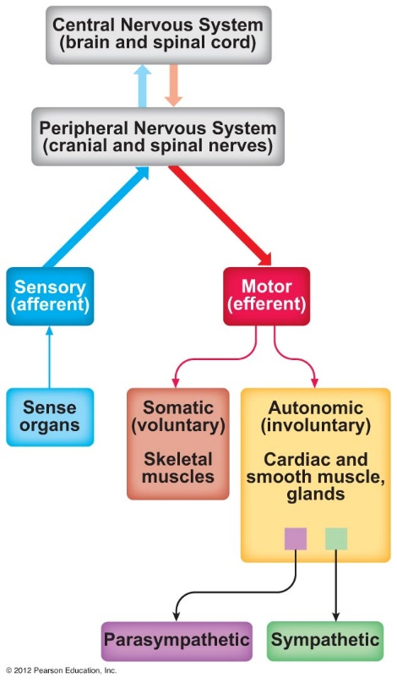
Basics
3 Functions of the Nervous System
Divisions of the Nervous System
Neuroglia – Functions and Types
Neuron Anatomy
Terms used for CNS vs. PNS
3 Types of Neurons
Irritability – Steps to Generating an Action Potential/ Impulse
Conductivity – Steps to Transmitting a Signal
Reflex and Reflex Arc
- 5 Elements
- Somatic vs. Autonomic and 2 Neuron vs. 3 Neuron Arc

Brain
*Know Diagrams from workbook page 139 and 140
Regions
- Cerebrum/Cerebral Hemispheres
  - Gyri vs. Sulci vs. Fissure
  - Frontal, Parietal, Occipital, Temporal
    - KNOW AREAS FOR EACH (where functions are located – use diagram in notes for help)
  - Precentral and Postcentral Gyrus
  - Longitudinal Fissure
  - Parieto-occipital Sulcus
  - Lateral Sulcus
  - Cortex/Grey Mater, White Mater, Basal Nuclei
    - Corpus Collosum
- Diencephalon
  - Thalamus, Hypothalamus, Epithalamus
    - Know functions and relative location of each
- Midbrain
  - Midbrain, Pons, Medulla - Reticular Formation
    - Know functions and relative location of each
    - Cerebral Peduncles and Corpora Quadrigemina (in Midbrain)
- Cerebellum
  - Know function and relative location
Protection
- Skin and Scalp
- Skull and Vertebrae
- Meninges (Dura Mater, Arachnoid Mater, Pia Mater)
- Cerebral Spinal Fluid (Choroid Plexus)
  - CSF Pathway of Flow
    - Ventricles, Central Canal, Subarachnoid Space, Arachnoid Villi, Dural Venous Sinuses
- Blood-Brain Barrier
Brain Injuries
- Concussion
- Contusion
- Cerebral Edema
- CVA / Stroke
  - Hemiplegia, Aphasia, Transischemia
- Alzheimer’s Disease
Spinal Cord
- Extent (Foramen Magnum to 1st or 2nd Lumbar)
- 31 pairs
- Cauda Equina

Chapter 8: Special Senses
Accessory Structures of the Eye (Functions)
- Eyelids and Eyelashes (Tarsal and Ciliary Glands)
- Conjunctiva
Eye Disorders
- Astigmatism
- Cataracts
- Conjunctivitis
- Glaucoma
- Hyperopia
- Myopia
- Night blindness
- Strabismus
- Presbyopia
- Ophthalmia Neonatorum
- Lacrimal Apparatus and Lacrimal Gland
- Extrinsic Eye Muscles (Do not need to know individual names)
Layers of the Eye
- Fibrous
  - Sclera and Cornea
- Vascular
  - Choroid, Ciliary Body, Iris, and Pupil
- Sensory
  - Retina (Rods and Cones), Optic Disc, Fovea Centralis
Other structures of the Eye
- Lens
- Aqueous and Vitreous Humor
Eye Reflexes
- Photopupillary
- Accommodation Pupillary
- Convergence
- Ciliary Zonules
Describe the Pathway of Light through the Eye
- Including
  - Real Image
  - Optic Chiasma
  - Optic Tracts
External Ear
- Auricle (Pinna)
- External Acoustic Meatus (Auditory Canal)
- Tympanic Membrane
Middle Ear
- Pharyngotympanic (Auditory) Tube
- Malleus, Incus, Stapes, Oval Window
Inner Ear
- Perilymph and Endolymph
- Cochlea, Vestibule, Semicircular Canals
- Vestibular Apparatus
Static Equilibrium
- Maculae
  - Hair Cells, Otoliths
Dynamic Equilibrium
- Crista Ampullaris and Cupula
- Semicircular Canals

Organs of Hearing
- Organ of Corti, Cochlea, Hair Cells, Cochlear Nerve, Temporal Lobe

Mechanoreceptors
Explain the Mechanism of Hearing

Olfaction
- Olfactory Nerve
Taste
- Papillae
  - Filiform, Fungiform, Circumvallate
- Gustatory Cells
Structure of Taste Buds
- Facial, Glossopharyngeal, Vagus Nerves

Taste Sensations
- Sweet, Salty, Bitter, Sour, Umami
Chemoreceptors

Possible Essay Questions:
Describe the 8 necessary life functions and 5 survival needs.
Explain the elements of a homeostatic control system and give an example of how it works.
Explain the ABCD rule and how it helps detect cancerous lesions.
Differentiate among the three types of joints based on structural and functional classification. Provide examples of each type of joint.
Describe the events that occur using irritability and conductivity.
Explain how each system discussed (Integumentary, Skeletal, and Nervous) help maintain homeostasis.

