Civics Module:
Register to Vote or Pledge to Vote

Standards 5.2.12.D & 5.2.D

Objective:

Students will register to vote and understand the power of the vote in expressing their voice in, and after, elections. Students will be empowered to help their peers register to vote and create a culture of voter engagement at their high school and in their community.

Outcomes:

In the classroom, school, and community, students will be able to:

CLASSROOM
- Identify at least three reasons voting matters to our democracy.
- Explain why it is important to develop a lifetime habit of voting.
- Identify obstacles to voting as well as actions that may improve voter turnout among all eligible citizens.
- Register to vote or pledge to register if they are not yet eligible.
- Identify two societal issues they care about and complete a Pledge to Vote card to remind them why it is important to vote.

SCHOOL
- Help their eligible peers register to vote.
- Establish an official Civic Engagement Club at school.

COMMUNITY
- Engage family, friends, and other adults to ensure they are registered to vote in their community.
- Identify at least one local or state election that was decided by fewer than 300 votes.
- Research and understand their state’s voting laws as outlined by the PA Department of State and understand youth voter turnout.

Time Requirement:

20 - 30 minutes, depending on depth of discussion and Q&A

Materials Needed:

- Voter Registration Forms
- Guidelines for Registering on www.votesPA.com
- Pledge to Register and Pledge to Vote cards
- This Teaching Module
- Voter Registration form with Required Fields Highlighted
- Voter Registration Posters (optional)
- Voter Registration Stickers (optional)

Students will also need their state issued ID (or driver’s license) and/or Social Security number.

Tips for Facilitation:

- Tell students a few days ahead of time that you will be doing this activity (use the Objective as your summary). Remind them to bring their driver’s license and/or Social Security number to register to vote. (Be sure to review state-specific guidelines.)

- Keep this interactive. Just as voting is an expression of one’s voice, it is important for students to share their perspectives about their responsibilities as voters and to understand that every vote matters.

- Be nonpartisan. Do not signal your support or opposition regarding any candidate, party, or policy issue. If they ask who to vote for or which party to choose, suggest that they consult resources like www.votesPA.com for a voter guide, read candidate websites or the newspaper, and talk to friends and family.

ACTIVITY: YOUR VOTE = YOUR VOICE
Class Participation: Homework Policy - The Great Debate

Look for the next general election date provided on the www.votsPA.com homepage to find out the birth date cut-off for voter registration.

Write in BIG letters on the board: “Born on or before [BIRTH DATE CUT-OFF], and a U.S. citizen?”

Let’s assume that we were going to put the homework policy up for a vote ... not just in this class, but for the entire school.

A “Yes” Vote means—
- Every teacher of core classes would assign a minimum of 2 homework assignments per week.
- There is no minimum nor maximum estimated time for completing the assignments however
- Teachers would be expected to be reasonable with their assignments since students have several core classes.
- Teachers of non-core “elective” classes have the option to assign homework as necessary.
- Homework will be included in your grade. (Teachers have the option to grade your assignments or give a grade simply based on whether or not assignments were completed.)

A “No” Vote means—
- Homework is not required. There should be adequate time in class to complete all assignments.
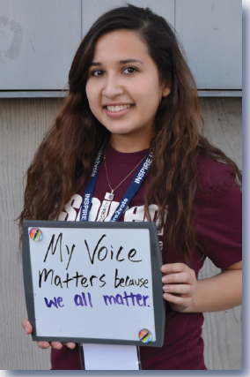
Everyone stand up. As a student of this school, each of you has a right
to express your opinion in this decision.

Starting with (Student’s Name), please count off one, two, one, two.
Now, all the “twos,” please sit down.

Those who sat down represent all the young people in the United States
who did not register to vote. They won’t have a chance to use their voice.

Everyone who is still standing, count off again, one, two, one, two.
Again, all the “twos,” please sit down.

Those who sat down this time represent all the young people who are registered to
vote, but didn’t actually vote. They’re the ones who stayed home and watched TV, played video games, or were too busy with work or school. They could have voted but chose not to.

Guess what? The quarter of you left standing get to decide on the homework policy for the entire school. You’re the ones who registered AND showed up to vote.

Poll the students remaining for the Homework Policy votes and record the numbers on the board.

How do those of you who are sitting feel about this decision? Do you feel like your views on the Homework Policy were represented? What impact will this decision have on you?

What we just did – this exercise – represents voting in a presidential election year.

During a year when only congressional representatives, state, or local candidates are running for office, the number of you left standing would be even fewer. More than likely, there would be about half as many to show up to vote.

Discuss: Why Do Young People Not Vote Very Often?

Think about it. Think about the issues that face our country. Very few people are making decisions on behalf of ALL of us. Statistics show that young people typically don’t vote. In fact, people older than 30 are twice as likely to vote as people under 30.

Elected officials know this. It’s part of the reason that issues of special concern to young people get relatively little attention in Washington and in our area.

- What are some of the reasons you hear people say about why young people don’t vote?
- Do you feel that these assumptions are accurate?
- What do you think you and your generation can do to change these assumptions?

Discuss: Voter Apathy

Voter apathy -- meaning they just don’t care -- is the most common hurdle young people face when helping their peers register to vote.

- Can you identify other examples of apathy in our school?
- What can you say to your peer who is apathetic?

Discuss: How Do Young People Make a Difference?

Before this discussion, find other state-specific examples of young people making a difference, small or large.

Young people have made a difference--in the U.S. and in our state--many times throughout the years.

- The Civil Rights Movement of the 1950s and 1960s started with students sitting in restaurants that refused to serve people of color.
- In the early 1960s, pressure from young people being drafted into the military at 18 years old because they were old enough to die for their country, but too young to vote, resulted in the lowering of the voting age.
- In 2014, Saira Blair became the youngest member to ever be elected
to the House of Delegates in West Virginia at 18 years old, beating
out her opponent who was more than 25 years older. She decided
her senior year of high school to run for office because she believed
that her generation’s voice offered fresh perspectives and ideas to
improve our communities and our nation.

*Did you know that you only need to be 21 years old to become a legislator
in Pennsylvania?

All of these young people realized the impact their voice and their vote can
have. And just like them, your influence begins with one simple step:
registering to vote.

Stop here to finish in 20 minutes. For more discussion topics, see the Extended Discussion section at the end of this module.

ACTIVITY: REGISTER, PLEDGE & GET OUT THE VOTE

STEP 1: Register to Vote or Pledge to Register

As you know, there are presidential elections every four years. However, there are elections for other offices in Pennsylvania every year.

Review election updates for upcoming state and local elections.

If you’re a U.S. citizen and will be 18 on or before the next election date, you can register to vote. That’s right. Even if you are 17 now but will be 18 before then, you CAN REGISTER today.

If you will not be 18 by the general election, you can Pledge to Register today.

Hold up the voter registration forms and Pledge to Vote cards. Tell the students that if they will be eligible to vote to take one of each.

Then hold up the Pledge to Register cards. Ask everyone who is not eligible YET to take a Pledge to Register instead.

Then pass out the cards allowing students to select the appropriate forms.

Here is our state’s registration form. Let’s begin by pointing out a few very important reminders:
- You are not officially registered to vote until this application is approved.
- If you do not receive a card within 30 days after mailing this form, please contact your county voter registration office. County contact information can be found at www.votesPA.com/county.
- This is an OFFICIAL government document. Fill out the form completely in your best handwriting.
- Use blue or black ink only!

Make sure you look at the form and carefully fill in the boxes or check each of the required items.

You will need your Social Security number OR your Driver’s License number.

Point out the Voter registration form highlighting REQUIRED INFORMATION. Use a smartboard or projector if needed.

Remember, this is an OFFICIAL government form. Use a blue or black pen only and print as nicely as possible. No pencils. No chicken scratch. Make this count. Go ahead and start filling out this form now. Does anyone need a blue or black pen?

I’ll be walking around to help you. If you have any questions about any of these forms or cards, raise your hand.

When you are done, raise your hand, and I will quickly check your form before we officially submit it to the registrar.

STEP 2: Pledge to Vote

A pledge is a promise. For those of you who aren’t able to register today, filling out a Pledge to Register acknowledges the importance of voting to our representative government and is your promise to register when eligible.

By Pledging to Vote, you are making a commitment to participate in our democracy and ensure that your voice is heard on election day. Voting is your right and privilege.

Instructions: Pledge to Vote Card
- Think of two issues that matter most to you. Keep these in mind as you complete the Pledge to Vote card. These issues will serve to remind you why it is important to vote.
- Please fill out all information.

STEP 3: Celebrate Your Right to Vote!
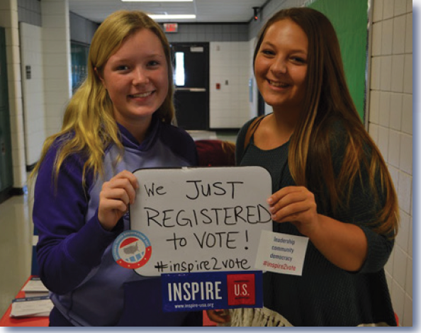
Write #StudentVotesPA on the board.

You may think “no big deal...I filled out a
form.” But remember, it’s not just any form.
This represents a law that was passed
FOR YOU.

Your voice matters. Take a selfie, Tweet, or
Instagram a photo (don’t snap a closeup
picture of your form because there is personal
information on it). Add #StudentVotesPA

Follow this hashtag and DOS on social
media. There will be information posted about
upcoming elections, deadlines, and
opportunities to meet and learn about
candidates.

@PADepartmentofState

@PAStateDept

ACTIVITY: HELP PEERS REGISTER TO VOTE

STEP 1: Identify Friends Who Should Also Register

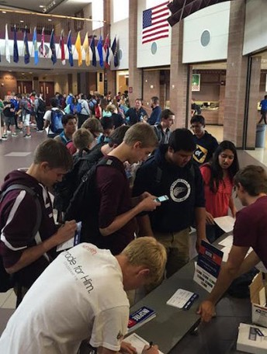
Now that you have registered to vote, you can see that the
process is simple. What if everyone in this classroom each
helped five people register? How many new voters would
we have just at our school? What if each of them reached
out to five more people? How long would it take to get all of
the seniors registered?
- Do you think it’s important for your peers to
register? Write down two or three reasons they
should.
- Can you think of five friends who would agree that
registering to vote is important? Write down their
name(s).
Would you be willing to talk to the people you listed and
encourage them to register to vote tomorrow? (Provide
school location & time.)

Every voice matters. You have the power and the right to
make sure your voice and the voices of your generation are heard.

Fact: In Pennsylvania, 17 year olds can register to vote as long as
they’ll be 18 on or before the next election day.

STEP 2: Set a Goal - The Governor’s Civic Engagement Award

What if we could get most of the eligible students at our school to register to vote? What if we could even get ALL of the eligible students to register? Let’s discuss setting some goals for the school related to voter registration.

There is a program in Pennsylvania called the Governor’s Civic Engagement Award that recognizes high schools for high achievements in voter registration. (You can visit the Governor’s Civic Engagement Award website with the class at www.votespa.com/gcea, or print out materials from the site to use as references. You can also request informational materials from the PA Department of State by contacting RA-voterreg@pa.gov.)

Schools that earn the award receive a plaque, and the students leaders are invited to attend an awards ceremony hosted by the Pennsylvania Department of State. I think we could step up to the challenge to help our school earn the award this year!

School Awards
Gold Level: 85% of eligible students are registered to vote in time for the spring primary. Student Ambassadors and the school will receive award certificates from Governor Tom Wolf/Acting Secretary of State Kathy Boockvar.

Silver Level: 65% of eligible students registered to vote in time for the spring primary.
Student Ambassadors will receive award certificates.

In order to be able to receive the award, we’ll have to carefully

Governor’s Civic Engagement Award discussion topics:
- What are the best ways to keep track of applications we receive?
- Who will be responsible at each step in the process?
- How will we measure and share our success? (Some ideas include school announcements, bulletin boards, or other school displays)

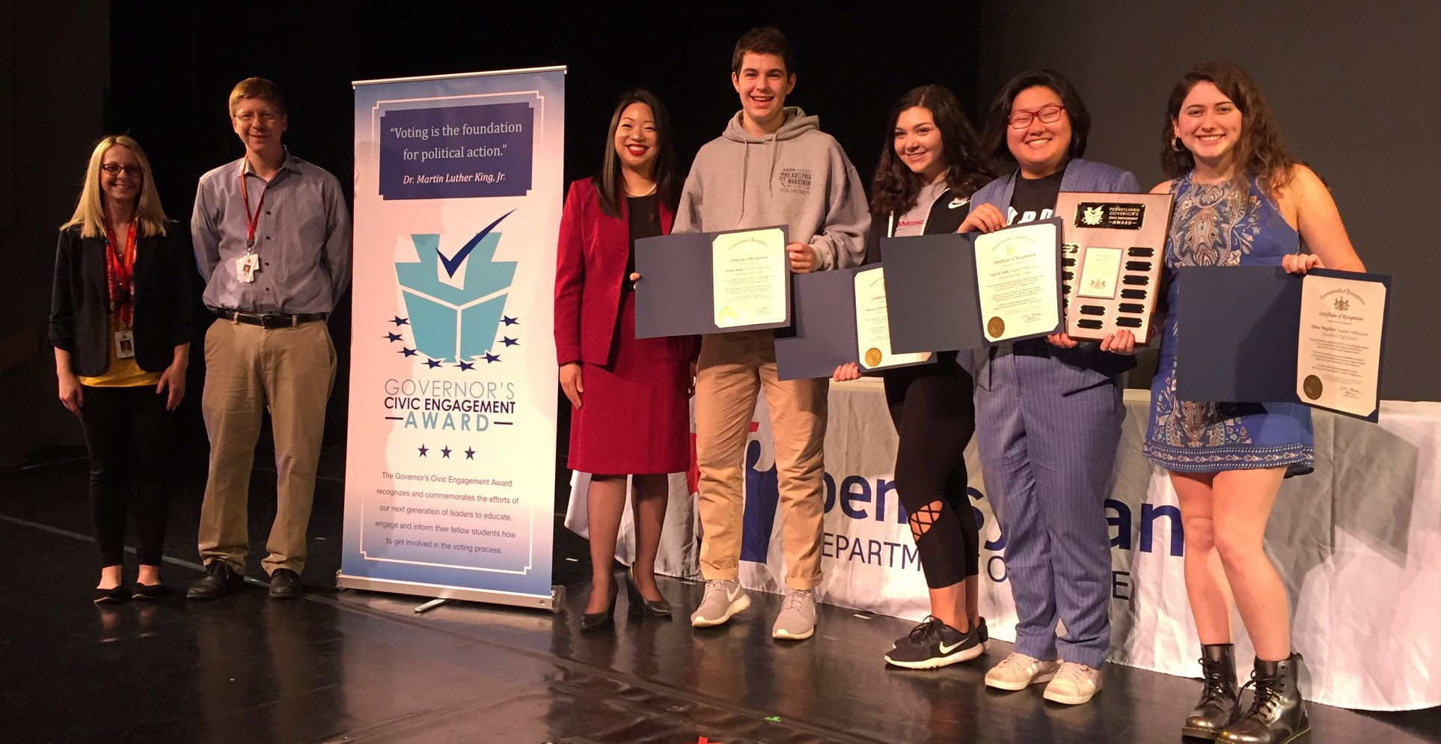

STEP 3: Craft Your Pitch

Let’s think about how this class could take the lead in helping all eligible students at our school register to vote, and helping our school earn the Governor’s Civic Engagement Award.

First, think about some of the issues you already brought up in our earlier discussions. Do you think these same issues would motivate other students to register and go to the polls?
- Take a few minutes to jot down what you might say to one of your friends in two minutes or less to encourage them to register.
- In groups of two, pretend you’re talking to this friend and share what you’d say. At two minutes, switch and have your partner read his/hers.
- Repeat the role play two to three more times with new partners if time allows to enable students to practice.

Who would like to share one of the pitches you heard, and tell us why it would compel you to register to vote?

Pitch Discussion Topics
- What would you say to someone who tells you he doesn’t want to vote because he doesn’t care about politics?
- What would you say to someone who says “Why should I vote now? I’m moving away to attend college next year.”
- What would you say to someone who says “I’m not old enough to vote?”

Give students a few minutes to refine their pitch or ask them to complete this as homework.

Step 4: Prepare for Senior Class Presentations
All teachers are pressed for time, so as we prepare to do voter registration presentations in other senior classes, we want to get right to the point. That’s why you drafted a two-minute pitch! If you only have 10-15 minutes to register everyone in a class, it’s important to allow enough time for people to complete the form(s) and ask questions.

Some teachers may give you more time to speak. If so, you might want to incorporate one or two of the activities we used when we first started talking about the youth vote (e.g., “Homework Policy Vote”). You might even want to create a Kahoot! or Quizizz interactive game to kick off your presentation.

Fact: Classroom presentations by students have been shown to
be the most effective in getting high school students to
register to vote.

Awareness—Anticipation—Action
You now know how important it is to register to vote, but your peers may not. Before we kick-off classroom presentations, what are some ways that we can encourage other students to care about voting?

Ideas may include:

Create posters around the school campus:
- Why voting matters
- How to Register to Vote
- Pledge to Register/Pledge to vote

Near the Social Studies and Government classrooms, set up an election display to share information about the candidates and their platforms.

Work with the student news channel or multi-media department to create a “Let’s get ready to vote” presentation.

- Identify student leaders on campus and recruit them to make PSA’s about the issues that concern them and why they are going to register to vote.
- Each video should end with a call to action for students to register to vote or pledge to register when they become eligible.

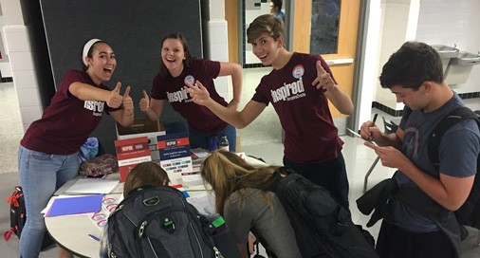

Classroom Presentation Checklist
- Contact the teacher whose classroom you’ll be addressing to confirm the date/time of your presentation.
- Adjust your presentation script as needed to make sure you stay on task and on time.
- Secure your hall pass (if needed).
- Check to be sure you have all of your materials:
  - Voter Registration Forms
  - Step-by-step Form Completion Instructions (attached to registration form)
  - This Teaching Module
  - Voter Registration form with Required Fields Highlighted
  - Pledge to Register and Pledge to Vote cards
  - Voter Registration Poster (optional)
  - Voter Registration Stickers (optional)
  - Black Pens
  - PowerPoint Presentation file/laptop/projector (if you intend to show this)
- Do the presentation.
- Review step-by-step form completion instructions with the class and hand out forms and cards for everyone to complete.
- Collect the completed voter registration forms and Pledge Cards.
- Review forms quickly to be sure they are complete.
- Turn everything in to me.
- Send the teacher a “thank you” email for allowing you the time to help your classmates to register to vote.

Presentation Discussion Topics
- What other ideas do you have for getting all seniors to register to vote?
- Could we create a competition at our school to encourage voter registration?
- Would a lunch time presentation and tabling event be a good way for seniors to register?
- Would it be a good idea to go to school club meetings to help students register to vote?

Extension Activity: Create a Student-Run Civic Engagement Club

One way to empower students to vote is by creating a club to help your peers register and support them to their first vote. Many high schools across the country have done this as a way to mobilize high school students.

Here’s an example of a high school club constitution.

Civic Engagement Club - High School Name
Sample Constitution
Purpose: Help students to shape the future of Pennsylvania and turn their inspiration into action; help the students by giving them the opportunity to vote and express their opinions by helping them register to vote and keeping them informed about upcoming elections and issues impacting our community.

Mission Statement: To create and instill a culture of participation in our democracy among all students at our high school.

Executive Board and Responsibilities: (Current School Year) Club Officers make up the Executive Board
- Advisor: (Name of Teacher) Oversee/provide advice to club members. Only votes in case of a tie.
- President: (Name of Student) Keep the entire group focused and maintain the most communication with Advisor to ensure that the club’s agenda is met and to discuss group concerns.
- Vice President: (Name of Student) Assistant executive officer and President pro tempore
who acts as the networking person within the group.
- Secretary: (Name of Student) Records and distributes primary club information and is responsible of creating the agenda along with maintaining the notes for every meeting.
- Form Keeper: (Name of Student) Collects the voter registration forms and contacts students if they are missing items within the voter registration forms.
- Public Relations: (Name of Student) Maintains the social media pages for the club and
creates new ways to advertise for voter registration, such as flyers and posters.
- Data Collector: (Name of Student) Maintains the Excel sheet with information about the students’ status pertaining to voter registration.

Elections: Members will nominate candidates for board positions. After the nominations, we will vote, starting from the bottom positions all the way to the president position. Once a member is selected they will choose whether or not they choose to accept the nomination.

Attendance: Executive board members are expected to attend all officer meetings and general meetings. Attendance is expected, but different circumstances will be taken into account.

Recalling an Officer: If in the course of the school year, an officer is deemed as derelict in his/her duties, including, but not limited to, conspicuous and habitual absences of regular officer meetings, club meetings, and/or activities, particularly without good excuse to cause, mismanagement, or gross incompetence, either by the club advisor, or the majority of the Executive Board, then a special Executive Board meeting shall take place to determine if the officer in question shall be recalled. A two-thirds majority agreement is necessary either to remove or retain the officer in question, with the advisor voting only to break a tie.
Amendments: Any amendments to the Constitution must be approved by two-thirds majority of the executive board and approved by the Advisor.

Meetings: All meetings will take place in room (#), with the exception of special meetings. Meetings are every other Friday, starting at 2:15 p.m. and ending by 3:30 p.m. approximately. Special action meetings may be determined at regularly scheduled meetings. We will discuss new action plans to help more seniors register and go over the agendas during the regular meetings.

Extension Activity: Engage Your Community

You probably know of many young people in your community that do not attend your high school. Consider how you can reach out to them and encourage them to register to vote and pledge to vote at election time. Here are some ideas to get you started.

- Take a look at your Board of Elections and/or PA Department of State website. Research an election that was decided on less than 300 votes in your state. How does this affect your community?
- Consider setting up a voter registration drive at a high school sporting event or a neighboring high school.
- Are there groups or organizations to which you belong where others your age may be eligible to register to vote? Reach out to set up a time to give them your two-minute presentation and help them register to vote.

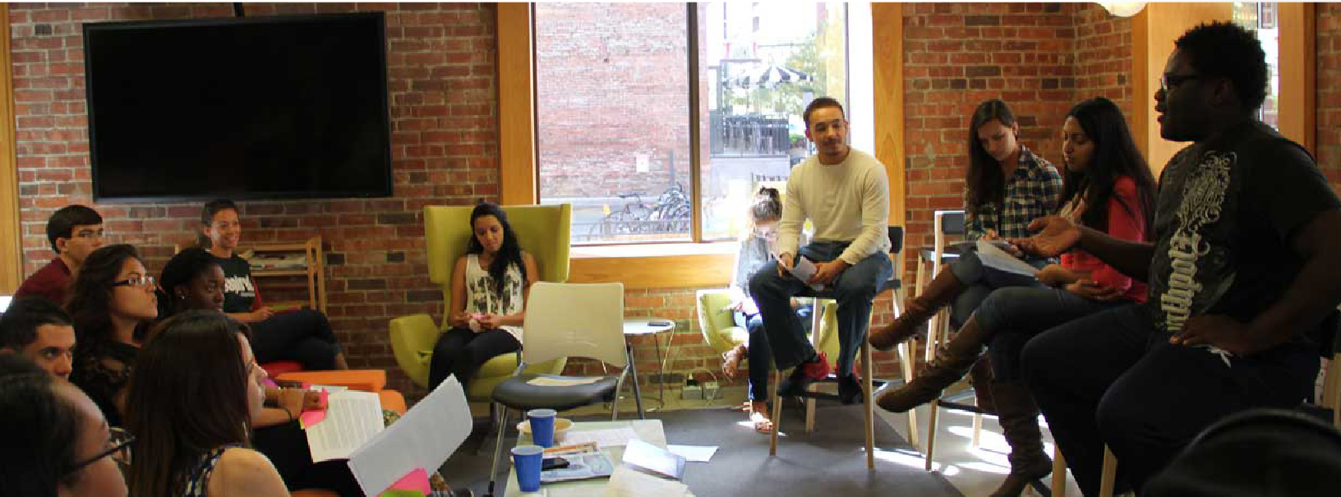
IMPORTANT: For all voter registration or pledge events, it is imperative that you, the
teacher, review all forms promptly to be sure they are accurate and complete. Within 24
hours, coordinate delivery of completed forms to local registrar. Note that this may be to more than one county, depending on the residential address of the student.

EXTENDED DISCUSSION TOPICS

Important Issues to Students
The example of an important issue to you that we used was about the homework vote. There were probably some pretty strong opinions in this classroom!

Reinforce the fact that even though students may have differing opinions on some issues, the
point is, as citizens who are or will soon turn 18 years of age, they have an opportunity to
express themselves through the power of their vote.

What are some issues that face our state or country that you’d like to have a say in?

Examples of possible issues:

- Politicians make decisions that impact the kinds of jobs and companies that come to our area. They mandate laws around safety in the workplace. They also set the minimum wage.
- Elected officials make decisions that impact how much public universities charge in tuition, what kinds of financial aid is available, what colleges have to report about crimes on campus, and many other issues affecting the health of universities.
- Regarding the military, elected officials decide policies on pay, health benefits, and education benefits for our more than 1.4 million men and women in uniform. And of course, elected officials also decide when we go to war and when we attempt peaceful approaches to conflict.
- Environmental concerns are addressed at all levels of government. Air and water quality, global warming, clean energy, and recycling are among the issues repeatedly drawing attention from lawmakers and will continue to do so throughout our lifetimes.
- Elected officials regulate the application process for obtaining firearms and determine permissible timeframes for game hunting seasons.

Thinking about these issues, why do you think it’s important for young people to vote?

The History of Voting Rights in the U.S.
When America was founded, those who could vote were white males who were 21 years old or older and owned property.

Over the last 200 years, we have gradually expanded voting to include other groups:
- Property requirements fell away in the early 19th century.
- African American men were given the right to vote in 1870 – but they were effectively kept away from the polls by Jim Crow laws until the 1960s. It took the sacrifices of hundreds of thousands of young people in the Civil War and the Civil Rights Movement to deliver these rights.
- Women were granted the right to vote, nationally, in 1920. State by state, women moved the movement forward until they finally gained the right with the 19th amendment.
- Young people 18-20 were given the right to vote in 1971, as they were serving in the Vietnam War. “Old enough to fight, old enough to vote” was the driving message behind passage of the 26th Amendment.

