Social Studies Curriculum Framework
Civics and Government

The Curriculum Framework for Social Studies is an organizer to assist Local Education Agencies (LEAs) in writing curriculum. The framework is based upon the Academic Standards of Chapter 4 of PA School Code. The Academic Standards for Social Studies, adopted in 2002, and the Early Learning Standards, adopted in 2016, both went through the regulatory and review process. Updated voluntary Social Studies standards (2009) also cite concepts to be learned. These standards do not specifically cite content to be learned, but concepts to be assessed.

Pennsylvania relies on the locally elected school board to make decisions concerning the content of Social Studies to be taught in the classroom. Social Studies teachers are responsible for teaching “Plato to NATO”. The Academic Standards and the curriculum framework are designed to assist educators in focusing instruction of selected content so that students develop thinking skills to learn the concepts of civics and government, economics, geography, and history. Utilizing the framework will prepare students for adult life and learn the skills to be a responsible, involved citizen as is charged in Chapter 4 of the Pennsylvania School Code:
§ 4.11. Purpose of public education.
(a) This section and § 4.12 (relating to academic standards) describe the purpose of public education and its relationship with the academic standards.
(b) Public education prepares students for adult life by attending to their intellectual and developmental needs and challenging them to achieve at their highest level possible. In conjunction with families and other community institutions, public education prepares students to become self-directed, life-long learners and responsible, involved citizens.

Prior to using the curriculum framework, educators should read the introduction in each Academic Standard document to gain an understanding of the holistic nature of Social Studies.

Assessment should focus on the concepts, using the Essential Questions and Big Ideas to guide assessment practices.

Every student has the right to having voice and choice, informed by knowledge of government, history, economics, and geography. Content as well as instruction should be designed to meet individual student needs

How to Read the Curriculum Framework and Use the Academic Standards

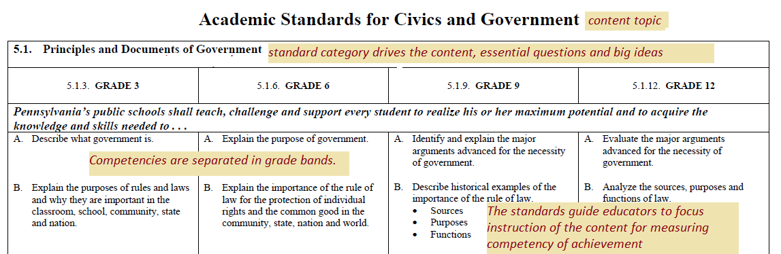

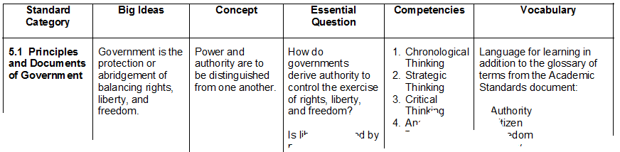
Framework

Big Ideas Declarative statements that describe concepts that transcend grade levels. Big Ideas are essential to provide focus on specific content for all students.

Concepts Describe what students should know (key knowledge) as a result of this instruction specific to grade level.

Competencies Describe what students should be able to do (key skills) as a result of this instruction, specific to grade level. Reference the Academic standard for specific competencies.
Refer to the Academic Standards for guidance in creating the competencies. The competencies of social studies are to develop the thinking skills to have students reach the big ideas and concepts of the Academic Standards. The Academic Standards for Social Studies are written to guide the educator to what the student has to know and be able to do in the standard category. Please reference the specific grade bands for the competencies for students to demonstrate the following:
- Analytic Thinking – parts, break down complexity to useable information
- Critical Thinking – “If- then”, rational, reasonable thinking, problem solving
- Strategic Thinking – planning, what to do with the information
- Chronological Thinking – Thinking across time and space (temporal)
Essential Questions Questions connected to the SAS framework specifically linked to the Big Ideas. They should frame student inquiry, promote critical thinking, and assist in learning transfer.

Vocabulary The vocabulary for learning is the concept vocabulary and not content vocabulary. Please add the concept vocabulary to the terms in the glossary of each Academic Standard for students to have a working vernacular to demonstrate their understanding.

Civics and Government
Long Term Transfer Goals
Transfer goals highlight the effective uses of understanding, knowledge, and skill that we seek in the long run; i.e., what we want students to be able to do when they confront new challenges – both in and outside of school.
Students will be able to independently use their learning to:
Support the ideals of civic rights and responsibilities as set forth in the Preamble of the United States Constitution in regard to their local, state, nation and international relationships with actions and deeds.
“The essence of Government is power; and power, lodged as it must be in human hands, will ever be liable to abuse.” - James Madison

Big Ideas | Essential Questions
Government is the protection or abridgement of balancing rights, liberty, and freedom. | How do governments derive authority to control the exercise of rights, liberty, and freedom?  Is liberty granted by power or power granted by liberty?
People with liberty and freedom have a right and a responsibility for maintaining and securing them for their posterity. | How does the exercise of rights and responsibilities differ in various forms of governments?
The workings of government vary dependent on how the government has the authority to govern. | How do the workings of government vary based on authority?
Citizens balancing their freedom and liberties in one form of government create actions that will impact citizens in other forms of government. | How do actions of citizens exercising their rights and responsibilities of freedom and liberty in one government impact citizens in other governments?

Civics and Government Curriculum Framework
Civics and Government  Standard Category | Big Ideas | Concepts | Essential Questions | Competencies | Vocabulary
5.1 Principles and Documents of Government | Government is the protection or abridgement of balancing rights, liberty, and freedom. | Power and authority are to be distinguished from one another. | How do governments derive authority to control the exercise of rights, liberty, and freedom?  Is liberty granted by power or power granted by liberty? | Refer to the grade band in the Academic Standards for specific competencies.  Use content to demonstrate:  - Analytic Thinking  - Critical Thinking  - Strategic Thinking  - Chronological Thinking | Key terms for learning in addition to the glossary of terms from the Academic Standards document:  Authority  Citizen  Freedom  Liberty  Principle  Rights
5.2 Rights and Responsibilities of Citizenship | People with liberty and freedom have a right and a responsibility for maintaining and securing them for their posterity | There is a mutual relationship between rights and responsibilities and certain rights give rise to responsibilities. | How does the exercise of rights and responsibilities differ in various forms of governments? | Refer to the grade band in the academic standards for specific competencies.  Use content to demonstrate:  - Analytic Thinking  - Critical Thinking  - Strategic Thinking  - Chronological Thinking | Key terms for learning in addition to the glossary of terms from the Academic Standards document:  Citizen  Freedom  Liberty  Responsibility  Rights
5.3 How Government Works | The workings of government vary dependent on how the government has the authority to govern. | Governments create and enforce law as the boundary between the willingness of the state to respect the interest of citizens in liberty and security. | How do the workings of government vary based on authority? | Refer to the grade band in the academic standards for specific competencies.  Use content to demonstrate:  - Analytic Thinking  - Critical Thinking  - Strategic Thinking  - Chronological Thinking | Key terms in addition to the glossary of terms from the Academic Standards document:  Authority  Due Process of Law  Freedom  Government  Liberty  Security  Sovereignty  Welfare
5.4 How International Relationships Function | Citizens balancing their freedom and liberties in one form of government create actions that will impact citizens in other forms of government. | There are benefits and consequences of relationships between various forms of government. | How do actions of citizens exercising their rights and responsibilities of freedom and liberty in one government impact citizens in other governments? | Refer to the grade band in the academic standards for specific competencies.  Use content to demonstrate:  - Analytic Thinking  - Critical Thinking  - Strategic Thinking  - Chronological Thinking | Key terms in addition to the glossary of terms from the Academic Standards document:  Freedom  Nation-state  Liberty  Policy  Relationship  Rights

