Name
Chapter 4: Carbon and the Molecular Diversity of Life

This chapter prepares you for understanding organic compounds. Functional groups determine the properties and activities of various molecules. Note how Stanley Miller’s experiment provides an important link to evolution.

Concept 4.1 Organic chemistry is the study of carbon compounds

- Study this figure of Stanley Miller’s experiment to simulate conditions thought at the time of the experiment to have existed on the early Earth. Explain the elements of this experiment, using arrows to indicate what occurs in various parts of the apparatus.

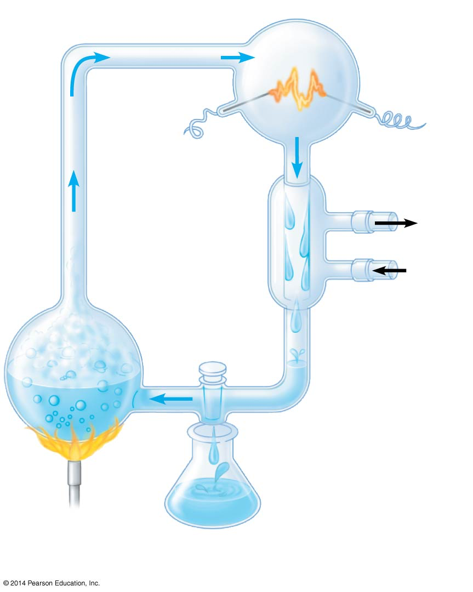

- What was collected in the sample for chemical analysis? What was concluded from the results of this experiment?

Concept 4.2 Carbon atoms can form diverse molecules by bonding to four other atoms

- Make an electron distribution diagram of carbon. It is essential that you know the answers to these questions:

- How many valence electrons does carbon have?
- How many bonds can carbon form?
- What type of bonds does it form with other elements?

- Carbon chains form skeletons of organic molecules. How can the carbon skeletons differ?

- What is a hydrocarbon? Name two. Are hydrocarbons hydrophobic or hydrophilic?

- In Chapter 2 you learned about isotopes. Since students often confuse this word with isomer, define each term here and give an example.

 | Definition | Example
Isotope
Isomer

- Variation in the architecture of molecules can cause variable biological effects. Give an example of how isomers can vary in their pharmacological effects.

Concept 4.3 A few chemical groups are key molecular function

- Here is an idea that will recur throughout your study of the function of molecules: A change in structure will change the function. You see this in enantiomers, you will see it in proteins and enzymes, and now we are going to look at testosterone and estradiol. Considering similarities between these two molecules, you know what a vastly different effect each has. Label each molecule in the following sketch and circle the differences.

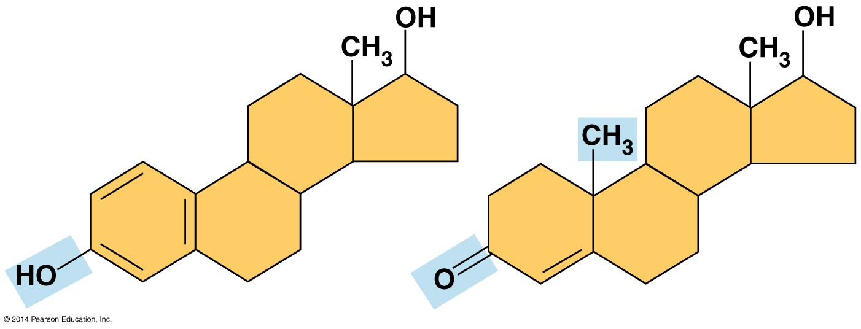

- Define functional group.

- There are seven chemical groups important in biological processes that you should know. Using Figure
4.9 in your text, complete the following chart.

 | Hydroxyl | Carbonyl | Carboxyl | Amino | Sulfhydryl | Phosphate | Methyl
Structure
Group Properties
Example

- Using the functional groups above, see if you can answer the following prompts:

- —NH2

- Can form covalent cross-links that stabilize protein structure

- Key component of ATP

- Can affect gene expression

- CH3

- Is always polar

- Determines the two groups of sugars

- Has acidic properties

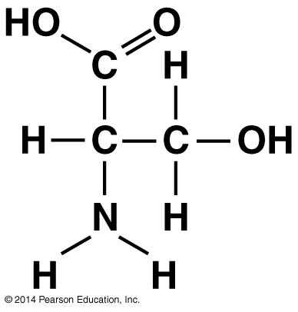
- —COOH

- Acts as a base

- Circle and identify three functional groups in the molecule shown.

Test Your Understanding Answers

Now you should be ready to test your knowledge. Place your answers here:

1. 2. 3. 4. 5. 6. 7.

