Nervous System Part 2
Structure of a Nerve
- Nerve
- Connective Tissue Coverings
  - Endoneurium, Perineurium, Fascicles, and Epineurium
- Mixed Nerves
- Reflex Arc
  - 2 Neuron vs. 3 Neuron
  - Somatic vs. Autonomic
- Irritability – Steps to Generating an Action Potential/ Impulse

- Conductivity – Steps to Transmitting a Signal

Spinal Cord
- Extent (Foramen Magnum to 1st or 2nd Lumbar)
- 31 pairs
- Cauda Equina
- Anatomy
  - Internal Grey Matter / External White Matter / Central Canal
  - Dorsal Root vs. Ventral Root
Spinal Nerves and Nerve Plexuses
- Ramus and Plexus
- Know Important Nerves of each Plexus – function and which plexus they go with
  - Cervical, Brachial, Lumbar, Sacral (Chart 7.2 page 262 can help also)
Somatic vs. Autonomic Nervous System
- Sympathetic vs. Parasympathetic in Autonomic N.S.
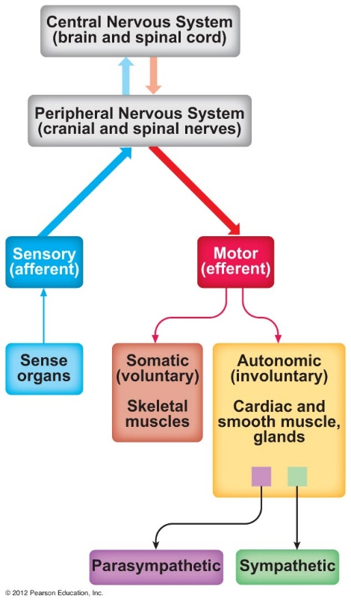
Know descriptions (functions) for ALL Divisions (and subdivisions) of the Nervous System

