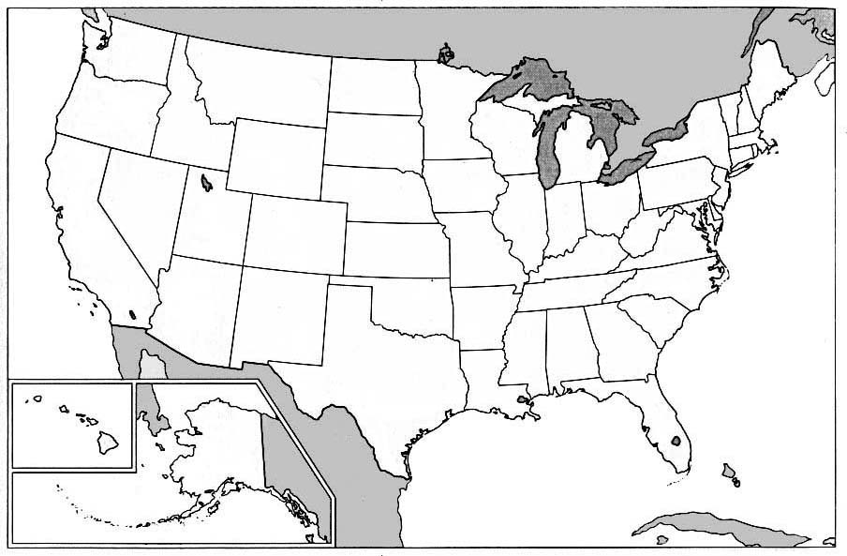
The United States of America

Name:_______________________________________________
American History Since 1900
The United States of America
State | Capital | State | Capital
1. |  | 26.
2. |  | 27.
3. |  | 28.
4. |  | 29.
5. |  | 30.
6. |  | 31.
7. |  | 32.
8. |  | 33.
9. |  | 34.
10. |  | 35.
11. |  | 36.
12. |  | 37.
13. |  | 38.
14. |  | 39.
15. |  | 40.
16. |  | 41.
17. |  | 42.
18. |  | 43.
19. |  | 44.
20. |  | 45.
21. |  | 46.
22. |  | 47.
23. |  | 48.
24. |  | 49.
25. |  | 50.

